Additional material

Figre S1 Example of reactive hyperaemia measurement

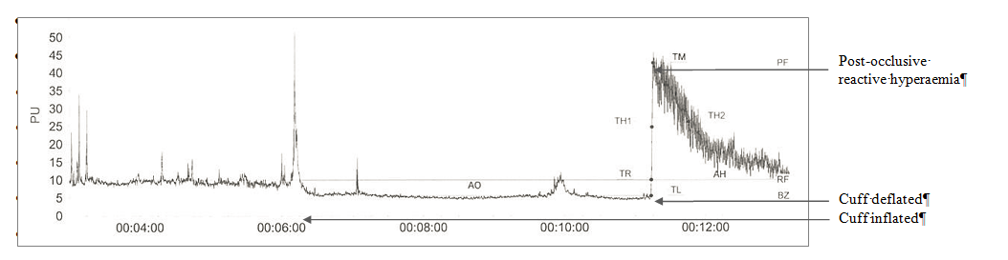

AO occlusion area (perfusion units × sec), AH hyperaemic area (perfusion units × sec), BZ biological zero (perfusion when occluded), PF peak flow (highest perfusion value after occlusion is released), PU perfusion units, RF rest flow (normal perfusion), TH1 time to half before hyperaemia (time from the release of occlusion until the perfusion value reaches half the value of the peak flow), TH2 time to half after hyperaemia (time from the release of occlusion until the perfusion value decreases halfway to the rest flow from the peak flow), TL time to latency (time until the perfusion increases after the occlusion is released), TM time to max (time until the peak flow is reached after the occlusion is released), TR time to recovery (time until the rest flow is reached after the occlusion is released)

Table S1 Insulin and free fatty acid levels at baseline and after 28 days (efficacy set)

 | Linagliptin 5 mg  n = 39* |  | Glimepiride 1–4 mg  n = 41 |  | Placebo  n = 39*
 | Baseline | Unadjusted change from baseline at day 28 | Baseline | Unadjusted change from baseline at day 28 | Baseline | Unadjusted change from baseline at day 28
Insulin fasting (mU/L) | 12.60 (0.98) | –0.65 (0.57) | 12.30 (0.88) | 6.13 (1.21) | 13.26 (1.22) | –0.25 (0.73)
Insulin 2-h postprandial (mU/L) | 41.95 (4.74) | –3.01 (1.72) | 38.60 (3.84) | 7.59 (2.89) | 43.98 (3.88) | –1.01 (2.16)
Free fatty acid fasting (mmol/L) | 0.62 (0.04) | 0.02 (0.04) | 0.61 (0.03) | –0.13 (0.03) | 0.56 (0.03) | –0.02 (0.02)
Free fatty acid 2-h postprandial (mmol/L) | 0.20 (0.02) | 0.01 (0.01) | 0.20 (0.01) | –0.02 (0.01) | 0.19 (0.01) | 0.01 (0.01)

Data are mean (standard error)
*Some values at baseline are based on n = 40

Table S2 Nitric oxide metabolite levels at baseline and after 28 days (efficacy set)

 | Linagliptin 5 mg  n = 39 |  | Glimepiride 1–4 mg  n = 41 |  | Placebo  n = 39*
 | Baseline | Unadjusted change from baseline at day 28 | Baseline | Unadjusted change from baseline at day 28 | Baseline | Unadjusted change from baseline at day 28
Nitrite fasting (µmol/L) | 1.11 (0.05) | –0.03 (0.02) | 1.10 (0.04) | 0.04 (0.04) | 1.10 (0.04) | 0.00 (0.02)
Nitrite 2-h postprandial (µmol/L) | 1.13 (0.05) | 0.02 (0.02) | 1.08 (0.04) | 0.00 (0.02) | 1.08 (0.04) | 0.02 (0.02)
Nitrate fasting (µmol/L) | 36.09 (1.76) | –0.48 (1.44) | 36.58 (1.85) | 2.38 (2.87) | 36.13 (1.60) | –0.51 (1.92)
Nitrate 2-h postprandial (µmol/L) | 32.07 (1.54) | –0.50 (1.10) | 32.48 (1.54) | 1.92 (2.28) | 32.18 (1.31) | –0.36 (1.43)
Data are mean (standard error)
*Baseline values are based on n = 40

Table S3 Fasting vascular biomarkers levels at baseline and after 28 days (efficacy set)

 | Linagliptin 5 mg  n = 39* |  | Glimepiride 1–4 mg  n = 41* |  | Placebo  n = 39*†
 | Baseline | Unadjusted change from baseline at day 28 | Baseline | Unadjusted change from baseline at day 28 | Baseline | Unadjusted change from baseline at day 28
P-selectin (μg/L) | 87.61 (3.22) | 0.37 (1.47) | 84.67 (3.05) | –0.20 (1.36) | 86.73 (3.29) | 1.39 (1.43)
E-selectin (μg/L) | 45.66 (2.54) | –1.33 (1.04) | 43.95 (2.36) | 0.84 (0.94) | 44.12 (2.45) | –1.13 (0.85)
Von Willebrand factor (%) | 106.24 (8.00) | –3.94 (6.09) | 113.66 (8.72) | 6.51 (6.33) | 97.66 (9.07) | 1.18 (5.04)
Data are mean (standard error)
*Baseline values for von Willebrand factor are based on n = 38 for linagliptin and placebo; for glimepiride, day 28 value is based on n = 40
†Baseline values for P-selectin and E-selectin are based on n = 40

