Figure S1: Cumulative Revascularization Rates, According to Baseline Coronary Procedure and Glycosylated Hemoglobin Level
Index procedure: (S1a) diagnostic catheterization (no revascularization); (S1b) CABG; (S1c) PCI.

CABG, coronary artery bypass graft surgery; HbA1c, glycosylated hemoglobin; PCI, percutaneous coronary intervention

S1a:
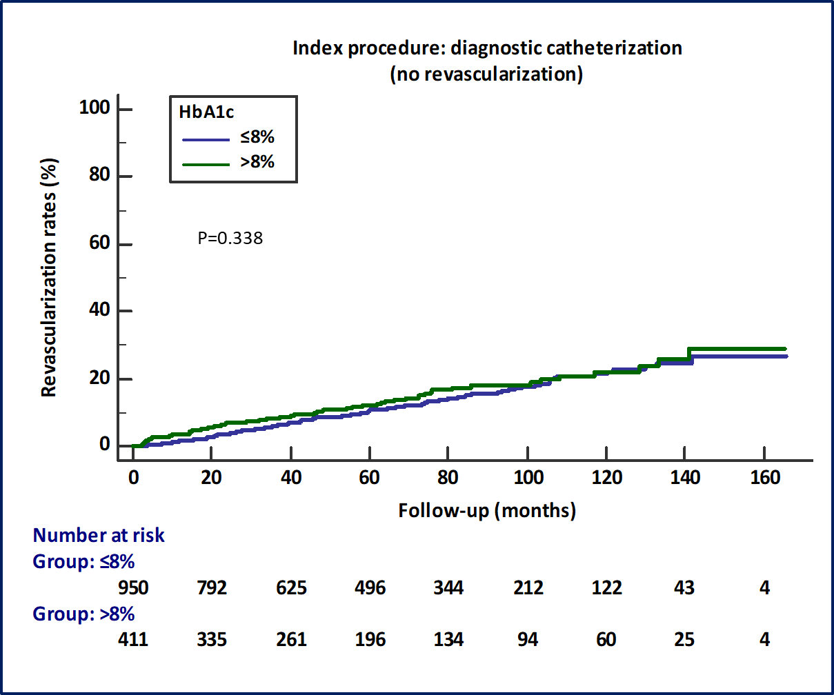

S1b:
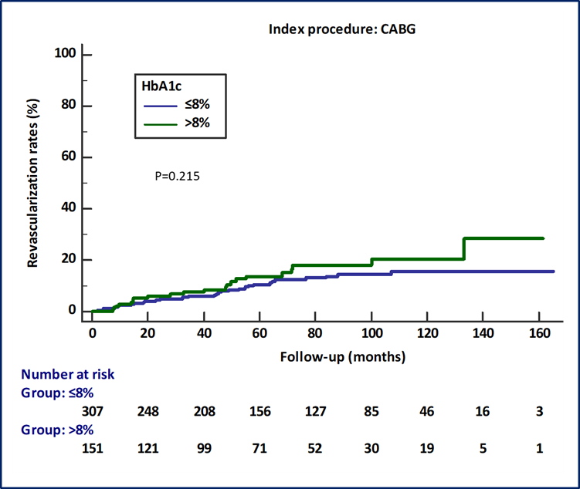
S1c:
