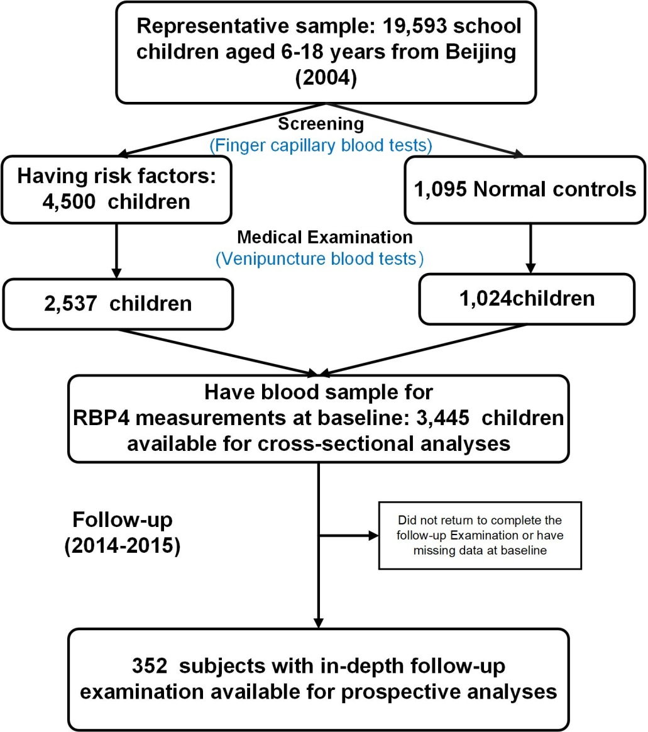
Fig. S1 Flow chart
Fig. S2 Gender- and puberty- differences in serum RBP4 levels. Data are displayed as mean ± SE. The difference between boys and girls in the same tanner group was evaluated by independent-sample T tests with * indicating P < 0.05. The difference between diverse tanner groups of the same gender was evaluated by ANOVA. Statistically significant differences (P < 0.05) in RBP4 levels between tanner groups are indicated by different letters, whereas differences between RBP4 levels in groups of the same gender with the same letter are not statistically significant.
Table S1. Baseline and follow-up characteristics of subjects in the prospective study
Variables | At baseline | At follow-up
N | 352 | 352
Age (year) | 11.9 ± 3.1 | 20.7 ± 2.8
Gender (male %) | 51.1 | 50.6
Puberty (stage 1/2/3/4/5 %) | 33.6/12.7/11.2/25.1/17.4 | -
Exercise ≥ 3 times/week (%) | 55.6 | -
Dietary score | 27.9 ± 4.5 | -
BMI (kg/m²) | 22.5 ± 4.8 | 26.23 ± 5.74
WC (cm) | 74.1 ± 12.7 | 86.5 ± 14.7
Body Fat percentage ( % ) | 25.7 ± 8.3 | 31.6 ± 10.4
SBP (mm Hg) | 108 ± 13 | 115.5 ± 14.4
DBP (mm Hg) | 68 ± 10 | 74.1 ± 10.4
TG (mmol/L) | 1.12 ± 0.55 | 1.21 ± 0.98
TC (mmol/L) | 4.16 ±0.79 | 4.56 ± 2.37
HDL-C (mmol/L) | 1.40 ± 0.31 | 1.45 ± 0.34
LDL- C (mmol/L) | 2.59 ± 0.73 | 2.60 ± 0.73
Glucose (mmol/L) | 5.13 ± 0.52 | 4.96 ± 0.93
OGTT 2h glucose (mmol/L) | - | 6.09 ± 1.99
HbA1c (%) | - | 5.40 ± 0.66
Insulin (mU/L) | 8.49 (5.23-13.13) | 7.25 (4.07-11.73)
HOMA-IR | 1.93 (1.15-2.97) | 1.56 (0.88-2.56)
ISI_{M} | - | 5.95 (3.82-9.19)
MS (%) | 15.0 | 16.1

Abbreviations: BMI, body mass index; WC, waist circumference; SBP, systolic blood pressure; DBP, diastolic blood pressure; TG, triglycerides; TC, total cholesterol; HDL-C, high-density lipoprotein cholesterol; LDL-C, low-density lipoprotein cholesterol; HOMA-IR, homeostatic model assessment of insulin resistance; IR, insulin resistance; MS, metabolic syndrome.
All values are reported as mean ± SD, median (interquartile range) or percentage.
Table S2. Baseline characteristics of subjects with or without loss to follow-up
Variables | Subjects without follow-up | Subjects with follow-up | P
N | 3,093 | 352
Gender (male %) | 51.0 | 51.1 | 0.955
Age (year) | 11.9 ± 3.1 | 11.5 ± 3.1 | 0.023
Puberty (stage 1/2/3/4/5 %) | 29.0/14.6/14.1/  23.7/18.5 | 33.6/12.7/11.2/  25.1/17.4 | 0.162
Exercise ≥ 3 times/week (%) | 57.0 | 55.6 | 0.615
Dietary score | 27.7 ± 4.3 | 27.9 ± 4.5 | 0.485
BMI (kg/m²) | 21.8 ± 4.9 | 22.5 ± 4.8 | 0.012
WC (cm) | 72.2 ± 13.1 | 74.1 ± 12.7 | 0.010
Body fat percentage ( % ) | 24.2 ± 8.6 | 25.7 ± 8.3 | 0.003
SBP (mm Hg) | 108 ± 14 | 108 ± 13 | 0.737
DBP (mm Hg) | 68 ± 10 | 68 ± 10 | 0.649
TG (mmol/L) | 1.02 ± 0.55 | 1.12 ± 0.55 | 0.001
TC (mmol/L) | 4.08 ± 0.83 | 4.16 ±0.79 | 0.083
HDL-C (mmol/L) | 1.40 ± 0.32 | 1.40 ± 0.31 | 0.971
LDL- C (mmol/L) | 2.54 ± 0.76 | 2.59 ± 0.73 | 0.212
Glucose (mmol/L) | 5.08 ± 0.56 | 5.13 ± 0.52 | 0.097
Insulin (mU/L) * | 8.49 (5.23-13.13) | 9.61 (6.01-14.65) | < 0.001
HOMA-IR* | 1.93 (1.15-2.97) | 2.16 (1.37-3.42) | <0.001
Adiponectin (μg/L)* | 5.18 (3.85-7.37) | 5.18 (3.85-7.37) | 0.223
Leptin (ng/ml)* | 6.01 (1.95-13.88) | 8.12 (2.92-17.84) | < 0.001
RBP4 (μg/ml) | 34.07 ± 11.56 | 34.42 ±10.78 | 0.448
MS % | 11.8 | 15.0 | 0.078
Abbreviations: BMI, body mass index; WC, waist circumference; SBP, systolic blood pressure; DBP, diastolic blood pressure; TG, triglycerides; TC, total cholesterol; HDL-C, high-density lipoprotein cholesterol; LDL-C, low-density lipoprotein cholesterol; HOMA-IR, homeostatic model assessment of insulin resistance; IR, insulin resistance; MS, metabolic syndrome.
All values are reported as mean ± SD, median (interquartile range) or percentage.
*Variables were ln-transformed before analysis. P values were calculated from two-sample t test for continuous variables or Chi-square test was used for categorical variables.

