DATA SUPPLEMENT

Variability of Adiposity Indices and Incident Heart Failure among Adults with Type 2 Diabetes

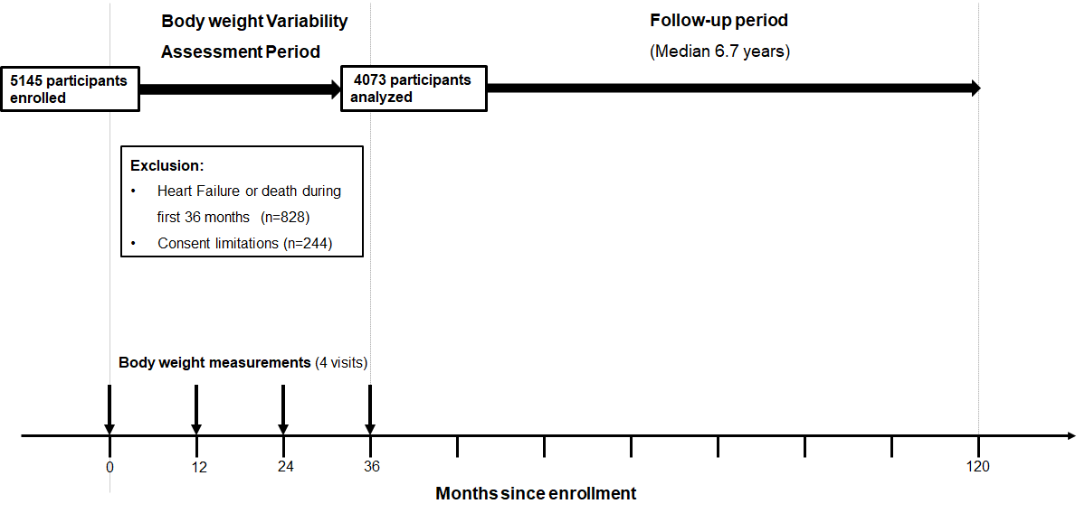
Supplementary Fig S1. Study design
Supplementary Method S1
Criteria for hospitalized heart failure (HF) were adapted from the Women’s Health Initiative, and did not include cardiogenic shock complicating MI. HF was adjudicated when the participant was hospitalized for new onset or worsened heart failure. Criteria included physician diagnosis of HF, favoring discharge over admitting diagnosis, and medical therapy for HF on admission (eg, diuretics), past medical history documenting previous imaging procedure showing impaired systolic or diastolic left ventricular function, pulmonary edema or congestion on chest x-ray during admission, and/or documentation of imaging during the admission showing dilated or poor left- or right-sided ventricular function or evidence of left ventricular diastolic dysfunction.
Supplementary Table S1. Hazard Ratios for Incident Heart Failure by Variability of Body Weight in the Look AHEAD Study
Measure of Variability | Quartiles of Body Weight Variability |  |  |  | P trend | Per SD
VIM of Body weight | Q1 | Q2 | Q3 | Q4
Model 1 | Reference | 2.08 (1.23-3.53)† | 1.54 (0.87-2.74) | 1.73 (0.96-3.10) | 0.187 | 1.04 (0.86-1.26)
Model 2 | Reference | 2.36 (1.34-4.15)† | 2.16 (1.16-4.01)* | 2.79 (1.50-5.19)† | 0.003 | 1.22 (1.02-1.45)*
Model 3 | Reference | 2.35 (1.34-4.14)† | 2.04 (1.10-3.79)* | 2.59 (1.40-4.80)† | 0.008 | 1.19 (0.99-1.42)
CV of Body weight
Model 1 | Reference | 2.12 (1.27-3.55)† | 1.30 (0.72-2.33) | 1.57 (0.87-2.82) | 0.404 | 0.99 (0.81 -1.22)
Model 2 | Reference | 2.26 (1.32-3.89)† | 1.73 (0.93-3.21) | 2.45 (1.33-4.50)† | 0.015 | 1.19 (0.99-1.45)
Model 3 | Reference | 2.27 (1.32-3.89)† | 1.76 (0.95-3.26) | 2.52 (1.38-4.62)† | 0.011 | 1.20 (1.00-1.45)
SD of Body weight
Model 1 | Reference | 1.69 (1.00-2.86) | 1.38 (0.79-2.43) | 1.68 (0.96-2.94) | 0.146 | 1.09 (0.91-1.30)
Model 2 | Reference | 1.71 (0.97-2.99) | 1.83 (1.01-3.33)* | 2.44 (1.35-4.41)† | 0.004 | 1.24 (1.05-1.45)*
Model 3 | Reference | 1.62 (0.92-2.84) | 1.59 (0.87-2.90) | 2.00 (1.09-3.66)* | 0.039 | 1.17 (0.98-1.39)
Data are hazard ratios (95% confidence intervals) unless otherwise indicated.
Model 1 adjusted for age, sex, race/ethnicity, and randomization arm.
Model 2 includes variables in model 1 with further adjustment for current smoking, alcohol drinking, use of antihypertensive medications, average systolic blood pressure, average ratio of total to high-density lipoprotein cholesterol, average hemoglobin A_{1C}, estimated glomerular filtration rate, duration of diabetes, and history of cardiovascular disease.
Model 3 includes model 2 plus further adjustment for average body weight.
AHEAD indicates Action for Health in Diabetes; CV, coefficient of variation; SD, standard deviation; VIM, variability independent of the mean; Q, quartile.
* P<0.05, † P<0.01, ‡ P<0.001.

Supplementary Table S2. Hazard Ratios for Incident Heart Failure by Variability of BMI in the Look AHEAD Study
Measure of Variability | Quartiles of BMI Variability |  |  |  | P trend | Per 1-SD increment
VIM of BMI | < 9.46 | 9.46-15.15 | 15.16-23.77 | > 23.77 | … | …
 | Reference | 3.21 (1.76-5.85)‡ | 2.18 (1.11-4.29)* | 3.61 (1.88-6.93)‡ | 0.001 | 1.22 (1.02-1.46)*
CV of BMI, % | < 1.94 | 1.94-3.10 | 3.11-4.94 | > 4.94 | … | …
 | Reference | 2.37 (1.36-4.14)† | 1.93 (1.03-3.62)* | 2.72 (1.46-5.06)† | 0.006 | 1.24 (1.04-1.49)*
SD of BMI, kg/m² | < 0.67 | 0.67-1.08 | 1.08-1.70 | > 1.70 | … | …
 | Reference | 2.69 (1.48-4.92)† | 2.42 (1.27-4.61)† | 3.17 (1.64-6.12)† | 0.002 | 1.20 (1.01-1.42)*
Data are hazard ratios (95% confidence intervals) unless otherwise indicated.
Hazard ratios are adjusted for age, sex, race/ethnicity, and randomization arm, current smoking, alcohol drinking, use of antihypertensive medications, average systolic blood pressure, average ratio of total to high-density lipoprotein cholesterol, average hemoglobin A_{1C}, estimated glomerular filtration rate, duration of diabetes, and history of atherosclerotic cardiovascular disease, average BMI and incident coronary artery disease as a time-varying covariate.
AHEAD indicates Action for Health in Diabetes; BMI, body mass index; CV, coefficient of variation; NA, not applicable; SD, standard deviation; VIM, variability independent of the mean.
* P<0.05, † P<0.01, ‡ P<0.001.
Supplementary Table S3. Hazard Ratios for Incident Heart Failure by Variability of Waist Circumference in the Look AHEAD Study
Measure of Variability | Quartiles of Waist Circumference Variability |  |  |  | P trend | Per 1-SD increment
VIM of Waist Circumference | < 168.1 | 168.1-259.8 | 259.9-392.0 | > 392.0 | … | …
 | Reference | 1.31 (0.78-2.20) | 0.84 (0.46-1.54) | 1.84 (1.07-3.16)* | 0.100 | 1.21 (1.05-1.38)†
CV of Waist Circumference, % | < 1.87 | 1.87-2.89 | 2.90-4.44 | > 4.44 | … | …
 | Reference | 1.01 (0.60-1.69) | 0.74 (0.41-1.33) | 1.90 (1.13-3.21)* | 0.070 | 1.24 (1.07-1.45)†
SD of Waist Circumference, cm | < 2.08 | 2.09-3.22 | 3.23-4.86 | > 4.86 | … | …
 | Reference | 1.31 (0.78-2.21) | 0.84 (0.46-1.54) | 1.83 (1.07-3.14)* | 0.105 | 1.20 (1.05-1.38)†
Data are hazard ratios (95% confidence intervals) unless otherwise indicated.
Hazard ratios are adjusted for age, sex, race/ethnicity, and randomization arm, smoking, alcohol drinking, use of antihypertensive medications, average systolic blood pressure, average ratio of total to high-density lipoprotein cholesterol, average hemoglobin A_{1C}, estimated glomerular filtration rate, duration of diabetes, and history of cardiovascular disease, average waist circumference, and incident coronary artery disease as a time-varying covariate.
AHEAD indicates Action for Health in Diabetes; CV, coefficient of variation; SD, standard deviation; VIM, variability independent of the mean.
* P<0.05, † P<0.01, ‡ P<0.001.

Supplementary Table S4. Hazard Ratios for Incident Heart Failure by Variability of Body Weight in the Look AHEAD Study
Measure of Variability | Quartiles of Body Weight Variability |  |  |  | P trend | Per SD
VIM of Body weight | Q1 | Q2 | Q3 | Q4
 | Reference | 2.65 (1.48-4.74)† | 2.17 (1.15-4.10)* | 2.90 (1.54-5.46)† | 0.004 | 1.24 (1.04-1.48)*
CV of Body weight | Q1 | Q2 | Q3 | Q4
 | Reference | 2.40 (1.37-4.18)† | 1.97 (1.05-3.71)* | 2.77 (1.49-5.17)† | 0.005 | 1.25 (1.04-1.51)*
SD of Body weight | Q1 | Q2 | Q3 | Q4
 | Reference | 1.68 (0.94-2.98) | 1.61 (0.87-3.00) | 2.23 (1.20-4.14)* | 0.019 | 1.22 (1.02-1.45)*
Data are hazard ratios (95% confidence intervals) unless otherwise indicated.
Hazard ratios are adjusted for age, sex, race/ethnicity, and randomization arm, current smoking, alcohol drinking, use of antihypertensive medications, average systolic blood pressure, average ratio of total to high-density lipoprotein cholesterol, average hemoglobin A_{1C}, estimated glomerular filtration rate, duration of diabetes, and history of cardiovascular disease, average body weight, and incident coronary artery disease as a time-varying covariate.
AHEAD indicates Action for Health in Diabetes; CV, coefficient of variation; SD, standard deviation; VIM, variability independent of the mean; Q, quartile.
* P<0.05, † P<0.01, ‡ P<0.001.
Supplementary Table S5. Hazard Ratios for Incident Heart Failure after additional adjustments for Variability in Other physiologic parameters
Measure of Variability | Hazard ratios (95% CI) |  |  |  | P trend | Per 1-SD increment
Variability of body mass index
VIM of BMI | Reference | 2.93 (1.61-5.35)‡ | 2.13 (1.08-4.19)* | 3.44 (1.77-6.68)‡ | 0.002 | 1.18 (0.97-1.44)
CV of BMI | Reference | 2.20 (1.26-3.84)† | 1.74 (0.93-3.27) | 2.32 (1.24-4.38)† | 0.030 | 1.17 (0.95-1.43)
SD of BMI | Reference | 2.42 (1.32-4.42)† | 2.28 (1.20-4.34)* | 2.68 (1.37-5.24)† | 0.012 | 1.13 (0.93-1.37)
Variability of Waist circumference
VIM of WC | Reference | 1.31 (0.78-2.20) | 0.85 (0.47-1.55) | 1.80 (1.04-3.11)* | 0.120 | 1.24 (1.07-1.42)†
CV of WC | Reference | 0.93 (0.56-1.56) | 0.74 (0.41-1.32) | 1.70 (1.00-2.88) | 0.135 | 1.22 (1.05-1.43)*
SD of WC | Reference | 1.26 (0.75-2.11) | 0.83 (0.46-1.52) | 1.67 (0.97-2.86) | 0.177 | 1.19 (1.03-1.36)*
Hazard ratios were obtained from Cox proportional hazards models adjusted for age, sex, race/ethnicity, randomization arm, current smoking, alcohol drinking, use of antihypertensive medications, average systolic blood pressure, average ratio of total to high-density lipoprotein cholesterol, average hemoglobin A_{1C}, estimated glomerular filtration rate, duration of diabetes, history of atherosclerotic cardiovascular disease, SD of systolic blood pressure, SD of hemoglobin A_{1C}, SD of heart rate, and average BMI (or average WC). For VIM, average BMI (or WC) were not included in the models.
BMI indicates body mass index; CI, confidence interval; CV, coefficient of variation; SD, standard deviation; VIM, variability independent of the mean; WC, waist circumference
* P<0.05, † P<0.01, ‡ P<0.001.

