SUPPLEMENTAL MATERIAL

Figure S1. Plots of the negative log of KM survival distribution estimate (–log[S(t)]) versus time by event type
Figure S2. Weibull probability plots with 95% confidence intervals by event type

Figure S1. Plots of the negative log of KM survival distribution estimate (–log[S(t)]) versus time by event type
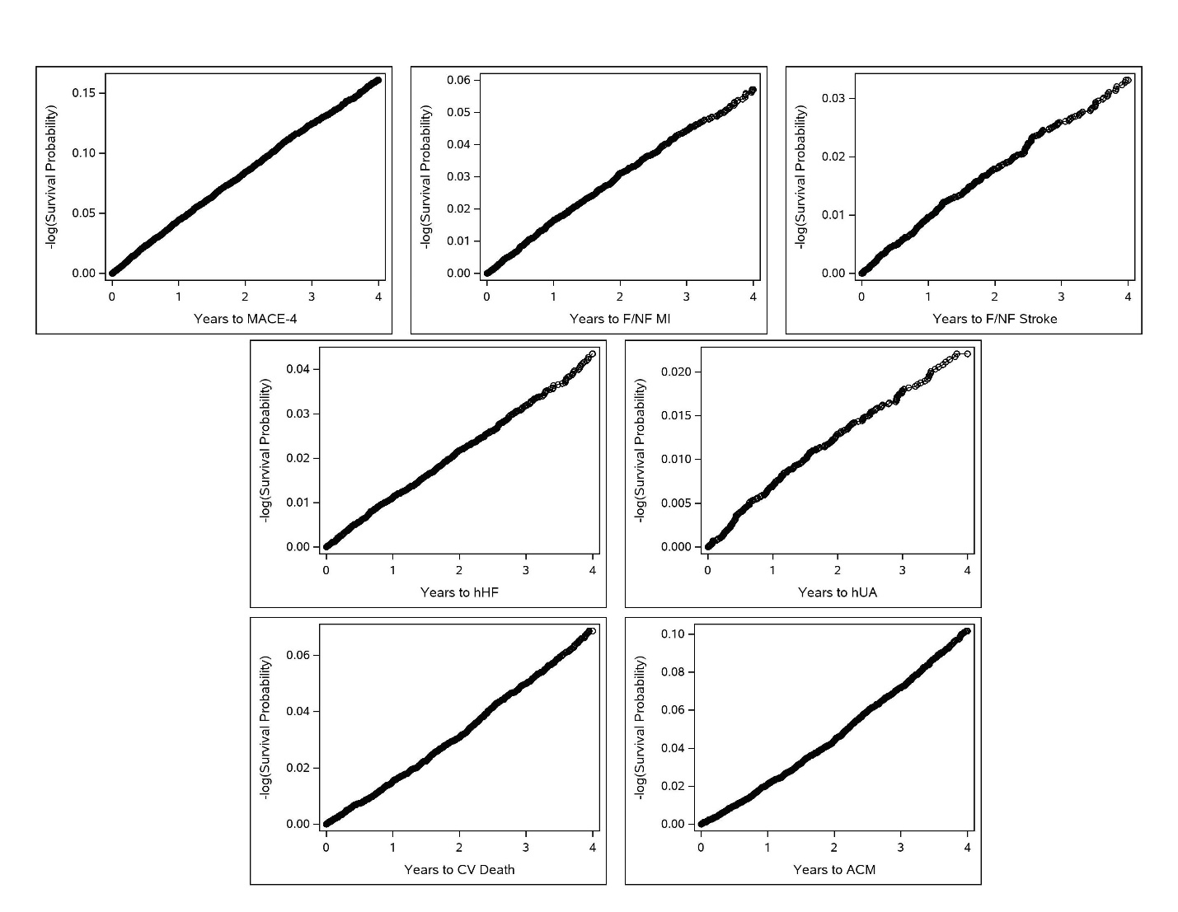

Figure S2. Weibull probability plots with 95% confidence intervals by event type
