1. qPCR original CT data
 |  | miR-198  Ct mean | U6  Ct mean |  | BIRC5  Ct mean | GAPDH  Ct mean
1号病人 | cancer | 34.93 | 21.7 |  | 22.6 | 22.79
 | adj | 36.75 | 26.09 |  | 30.39 | 27.09
2号病人 | cancer | 35.13 | 21.23 |  | 20.98 | 20.43
 | adj | 35.07 | 25.81 |  | 27.86 | 25.01
3号病人 | cancer | 36.19 | 20.52 |  | 27.75 | 21.8
 | adj | 31.57 | 24.4 |  | 33.52 | 25.7
4号病人 | cancer | 30.72 | 20.35 |  | 26.36 | 23.22
 | adj | 30.02 | 21.13 |  | 31.99 | 24
5号病人 | cancer | 27.31 | 20.21 |  | 31.83 | 22.35
 | adj | 26.88 | 20.31 |  | 32.98 | 22.92
6号病人 | cancer | 34.2 | 24.69 |  | 24.52 | 20.61
 | adj | 31.66 | 25.95 |  | 24.92 | 20.71
7号病人 | cancer | 30.64 | 17.25 |  | 30.11 | 28.49
 | adj | 25.49 | 23.67 |  | 34.27 | 29.75
1.1 Original Ct mean of RCC samples for figure 1C and figure 2B
1.2 Original Ct mean of A498 cell line transfected with miR-198 for figure 2f
 | BIRC5  Ct mean | GAPDH  Ct mean
mimic | 27.368 | 18.71
miR-198 | 27.054 | 18.59

2. Western blot original figure for figure 2E
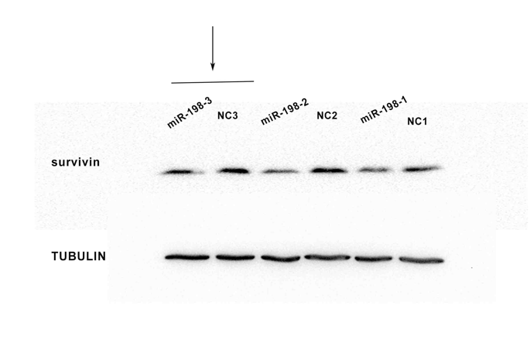

3. Western blot original figure for figure 2G

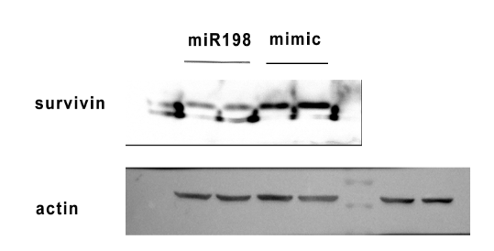

4.Western blot original figure for figure 5D
