Figure S1:The cell viability of HCC-LM3(IC50=143.2 µM) and Hep-3B (IC50=141.1 µM) cell lines after the treatment of differential doses of MDZ at 24h.

Figure S2: MDZ inhibited the migration in HCC cell lines with the presence of mitomycin-C. On the basis of the original experimental methods, Mitomycin-C (1 µg/mL; GLPBIO) was present throughout the wound healing assays to avoid the interference of cell proliferation. Representative images (A) and quantification (B) of wound healing assay on HCC-LM3 and Hep-3B cell lines after the treatment of MDZ.*p<0.05, **p<0.01.

Figure S3: (A) The binding sites and motif of human transcription factor NF-κB in PD-L1 were predicted by the JASPAR database.(B) The human CHIP data results of the peak between NF-κB and promoter region of PD-L1(GSE2360959).

A
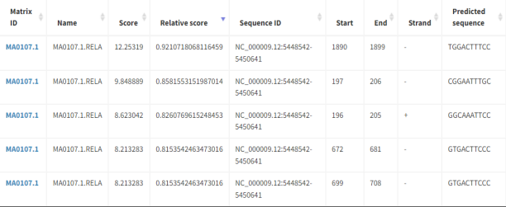
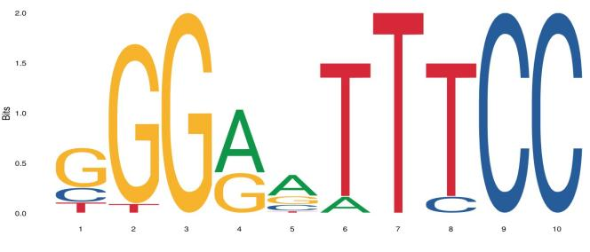

B
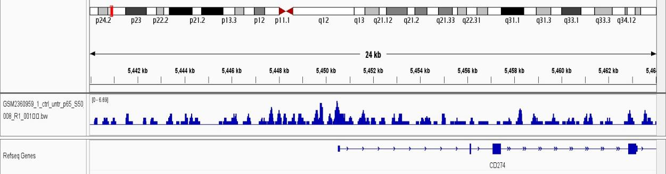

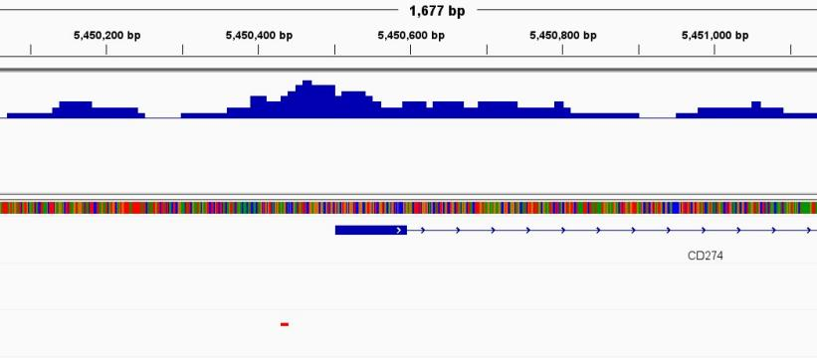

motif:TGGACTTTCC

Figure S4: The expression of cell clustering maker genes measured by mass cytometry and presented in the form of TSNE plot.

