a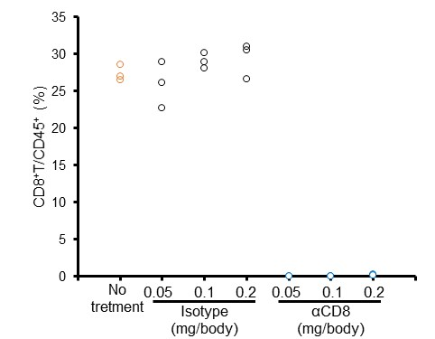
b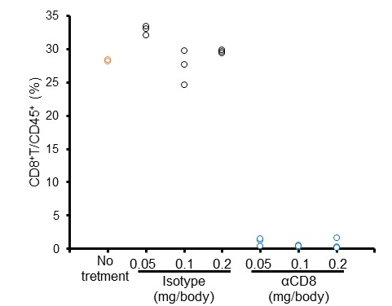
Figure S1: Examination of antibody dose and time to disappearance of CD8⁺ T cells
C3H/HeN mice were administered a single intraperitoneal dose of control IgG (0.05, 0.1 or 0.2 mg/body) or anti-CD8 antibody (0.05, 0.1 or 0.2 mg/body). Left inguinal lymph nodes were collected from mice 4 or 7 days after antibody administration and analyzed by flow cytometry. Symbols indicate individual ratios. (a) CD8⁺T/CD45⁺ cell ratio in lymph nodes 4 days after antibody administration. (b) CD8⁺T/CD45⁺ cell ratio in lymph nodes 7 days after antibody administration.

