Additional Material

Loci | Total Number of Samples | He | Frequency of unique alleles
AS1 | 379 | 0.373236 | 6
AS2 | 427 | 0.781991 | 9
AS3 | 478 | 0.862258 | 11
AS32 | 422 | 0.670702 | 14
AS7 | 341 | 0.407152 | 4
AS8 | 375 | 0.572796 | 6
AS11 | 467 | 0.696728 | 9
AS12 | 431 | 0.576449 | 5
AS14 | 412 | 0.761331 | 13
AS15 | 487 | 0.838911 | 13
AS19 | 304 | 0.624587 | 7
AS21 | 309 | 0.520069 | 5
AS34 | 410 | 0.513373 | 6
AS25 | 558 | 0.87599 | 23
B7M19 | 423 | 0.609322 | 10
TA109 | 592 | 0.838387 | 20
AS31 | 479 | 0.77306 | 17
Ara2 | 478 | 0.825871 | 11
PfPK2 | 547 | 0.867574 | 21
TA1 | 571 | 0.90873 | 23
TA87 | 644 | 0.901268 | 17
TA81 | 570 | 0.82103 | 13
TA60 | 453 | 0.833851 | 11
PolyA | 740 | 0.94846 | 34
PFG377 | 446 | 0.616685 | 9
TA40 | 534 | 0.900672 | 21

Additional Table S1: Diversity at each microsatellite marker. Avg He 0.73.

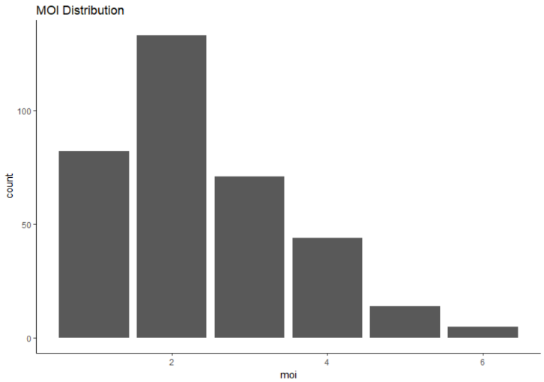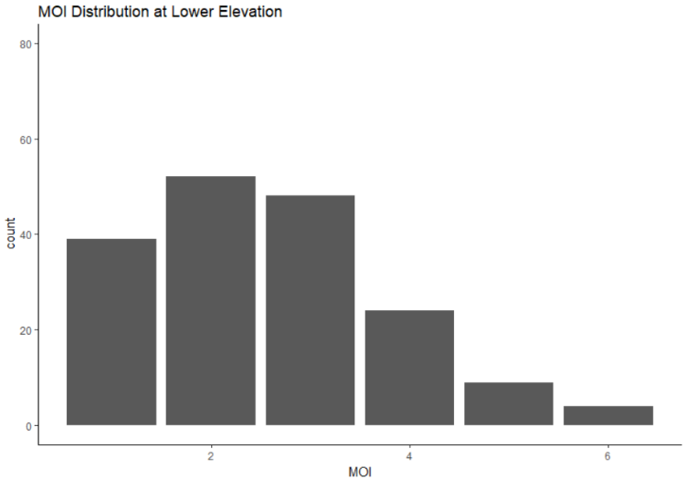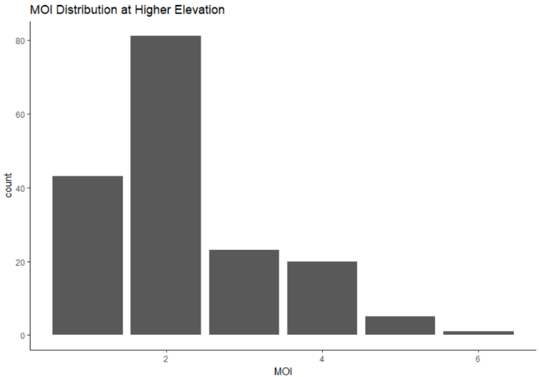
Additional Figure S1: MOI distribution. A) Overall distribution of MOI B) Distribution of MOI at lower elevation C) Distribution of MOI at higher elevation

