Additional file 10
The predicted 3D structural diagram of P. vivax multidrug resistance protein 1 (PvMDR1)

The 3D structure of P. vivax multidrug resistance protein 1 (PvMDR1) was predicted using SWISS-MODEL (https://swissmodel.expasy.org/interactive) online software, with 7qks used as a template, and the variant sites were edited using PyMoL 2.3.4 software. PvMDR1 as the digestive vesicle membrane protein of P. vivax, accounts for about 2/3 of the amino acid chain immerses in digestive vesicle; all 12 transmembrane domains are α-helical structures spanning 62th-84th aa、99th-121th aa、171th-193th aa、197th-216th aa、281th-303th aa、323th-345th aa、825th-847th aa、867th-889th aa、940th-962th aa、966th-985th aa、1062th-1084th aa and 1100th-1121th aa; the two segments of the β-sheet structure reside outside the digestive vesicle, with both extending about 4 aa in sequence length [46].

The 3D spatial structure of PvMDR1 was shown as the shape of a "V", with the two arms of the "V" and the apical base being inside and outside the digestive vesicle, respectively, and the TMD of PvMDR1 being between them (Fig. 1a). The peptide chain lengths of PvMDR1 in the intra-vesicular, transmembrane, and extra-vesicular membrane surfaces were 53.2% (779 aa/1464 aa), 24.5% (358 aa/1464 aa), and 22.3% (327 aa/1464 aa), respectively.

Of the 52 amino acids affected by SNPs, 12 were in the TMD, namely c.516C>T（G172G），c.543C>T（Y181Y），c.553T>C（F185L），c.2499G>T（M833I），c.2524T>A（F842I），c.2533C>T（L845F），c.2873C>T（T958M），c.2927A>T（Y976F），c.3201C>T（L1067L），c.3210C>T（F1070F），c.3226T>C（F1076L）, and c.3358C>T（L1120L）；of these, three were in the 3rd TMD, three in the 7th TMD, one in the 9th TMD, and one in the 10th TMD, three in the 11th TMD and one in the 12th TMD (Fig. 1b); the SNPs immersed in the digestive vesicle included 22 synonymous mutations and 15 non-synonymous mutations, and were mainly concentrated in the middle and end of the PvMDR1 peptide chain; the remaining 3 SNPs were on the surface of the outer membrane of the digestive vesicle.

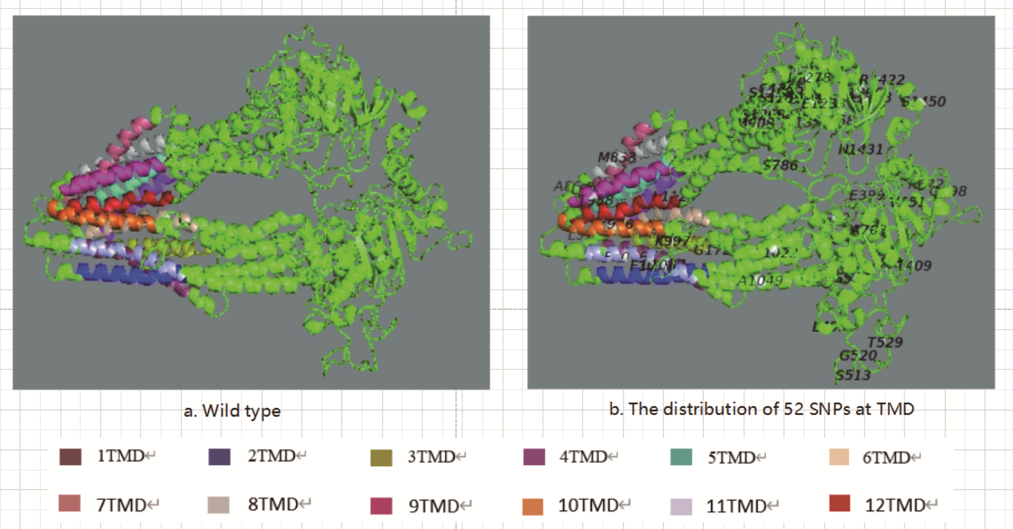

Fig.1 The spatial distribution of 52 amino acids affected by 52 SNPs at PvMDR1

