Supplemental File 2: Child Regularity Questionnaire
Please complete this questionnaire by picking the best answer for the following questions:

1. In the past week, how often did you feel puffy and uncomfortable in the belly?
- Never
- Almost Never
- Sometimes
- Often
- Almost Always

2. In the past week, how often did you strain or squeeze to try and pass a poop?
- Never
- Almost Never
- Sometimes
- Often
- Almost Always

3. In the past week, how often did you finish pooping but it still felt like there was some poop that didn’t come out?
- Never
- Almost Never
- Sometimes
- Often
- Almost Always

4. In the past week, how often did you have gas (fart)?
- Never
- Almost Never
- Sometimes
- Often
- Almost Always

5. In the past week, how often did you feel discomfort or hurt in your tummy below your belly button?
- Never
- Almost Never
- Sometimes
- Often
- Almost Always

6. In the past week, how often did you poop?
- Never
- Almost Never
- Sometimes
- Often
- Almost Always

7. If you look at the picture chart attached, which pictures look like your poop did most often this past week?
(use attached picture chart)
- Type 1
- Type 2
- Type 3
- Type 4
- Type 5
- Type 6
- Type 7
- I did not look at my poop last week
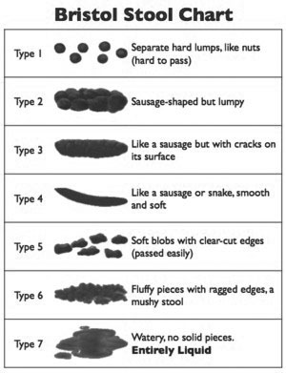
8. Did you miss school or playtime because of problems with your tummy or wanting or needing to poop?
  - Never
  - Less than 3 times this week
  - More than 3 times this week
  - At least once a day

9. What size is your poop closest to?
  - Grape
  - Golf ball
  - Baseball
  - Softball

