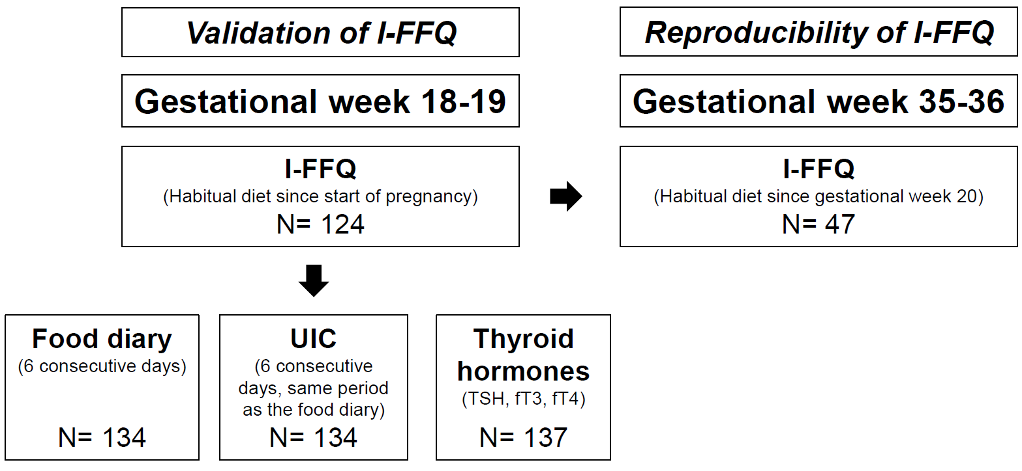
Figure S1 Overview of methods used in validation of the I-FFQ in Norwegian pregnant women
I-FFQ, iodine specific food frequency questionnaire; TSH, thyroid stimulating hormone; fT3, free triiodothyronine; fT4, free thyroxine

Table S1 Number of food items specified in the iodine specific food frequency questionnaire (I-FFQ) and the food diary, and number of frequency alternatives in the I-FFQ.
Food item | Food diary - Number of food items | I-FFQ - Number of food items | Frequency response in I-FFQ
Seafood as dinner or warm lunch | 5 | 21 | 5 frequency alternatives:  - Never  - Less than 1/month  - 1-3 times/month  - 1-2 times/week  - 3 times or more/week
Seafood as spread | 4 | 14 | 5 frequency alternatives:  - Never  - Less than 1/month  - 1-3 times/month  - 1-2 times/week  - 3 times or more/week
Milk, yoghurt and other milk containing drinks | 6 | 13 | 7 frequency alternatives:  - Never  - Less than 1/week  - 1-3 times/week  - 4-6 times/week  - 1 time/day  - 2 times/day  - 3-4 times or more/day
Cheese and cheese products | 8 | 7 | 7 frequency alternatives:  - Never  - Less than 1/week  - 1-3 times/week  - 4-6 times/week  - 1 time/day  - 2 times/day  - 3-4 times or more/day
Other foods made with milk and dairy products | 5 | 4 | 7 frequency alternatives:  - Never  - Less than 1/week  - 1-3 times/week  - 4-6 times/week  - 1 time/day  - 2 times/day  - 3-4 times or more/day
Eggs | 1 | 1 | 6 frequency alternatives:  - Less than 1 egg/week  - 2-3 eggs/week  - 4-5 eggs/week  - 6-7 eggs/week  - 8 or more eggs/week
Total food items | 28 | 60
In addition, the I-FFQ and the food diary included questions regarding dietary supplements including type, brand and intake frequency.

