Figure 2 Framework for Analysis of the Social Determinants of Health

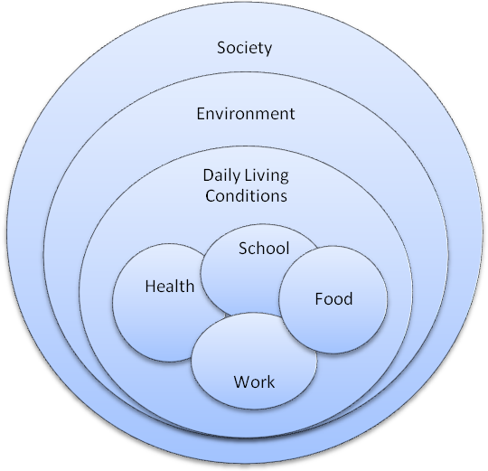
Limited work opportunity means that people cannot always afford to meet the recurrent expenses of food, health and education.
Children without a basic education then find it difficult when they are young adults to escape this cycle of poverty and deprivation.
People live in an environment they report negatively affects their health, resulting in high health care expenditures and poor health.
Families then become “locked” into a system of poverty which distances them from wider society both functionally and spatially. Solutions therefore require structural or ‘systematic’ approaches. Health and health access are therefore not a distinct sector or “slice” of life. It is meshed with the reality of daily living conditions with its backdrop of surrounding environmental space and limited access to various forms of social support.

