Additional file 1: Overview of data collections

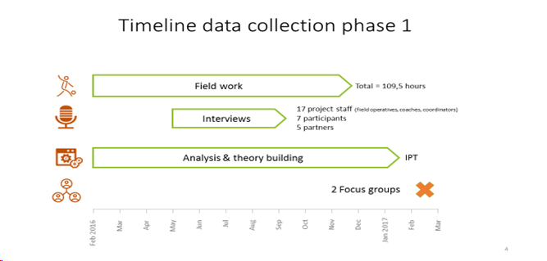
Interviews
ID | Province | Practice | Role
R1 | Vlaams-Brabant | BLe | Field operative
R2 | Oost-Vaanderen | SCoG | Social partner’s staff member
R3 | Oost-Vlaanderen | GP | Staff member
R4 | Limburg | LHB | Field operative
R5 | Limburg | LHB | Field operative
R6 | Vlaams-Brabant | BLe | Staff member
R7 | Oost-Vlaanderen | SGN | Social partner’s staff member
R8 | Vlaams-Brabant | BLe | Field operative
R9 | Vlaams-Brabant | BLe | Field operative
R10 | Oost-Vlaanderen | VJ | Staff member
R11 | Oost-Vlaanderen | SWCoG | Social partner’s staff member
R12 | Oost-Vlaanderen | OS | Social partner’s field operative
R13 | Vlaams-Brabant | LSS | Staff member
R14 | Oost-Vlaanderen | GP | Field operative
R15 | Oost-Vlaanderen | VJ | Staff member
R16 | Oost-Vlaanderen | LSS | Field operative
R17 | Oost-Vlaanderen | VJ | Field operative
R18 | Oost-Vlaanderen | VJ | Field operative
R19 | Vlaams-Brabant | LSS | Field operative
R20 | Vlaams-Brabant | SWCoL | Social partner’s staff member
R21 | Limburg | LHB | Field operative
R22 | Oost-Vlaanderen | VJ | Field operative
R23 | Vlaams-Brabant | LSS | Participant
R24 | Oost-Vlaanderen | GP | Participant
R25 | Oost-Vlaanderen | GP | Participant
R26 | Oost-Vlaanderen | GP | Participant
R27 | Oost-Vlaanderen | GP | Participant
R28 | Oost-Vlaanderen | GP | Participant
R29 | Limburg | LHB | Participant

Focus group participants
Respondents ID FG1 | Province | Practice | Role
FG1a | Antwerpen | CoL | Field operative
FG1b | Antwerpen | CoL | Field operative
FG1c | Limburg | YCoH | Field operative
FG1d | Limburg | YCoH | Field operative
FG1e | Oost-Vlaanderen | BRo | Field operative
FG1f | Vlaams-Brabant | YCoL | Field operative
Respondents ID FG2 | Province | Practice | Role
FG2a | Oost-Vlaanderen | VJ | Field operative
FG2b | Oost-Vlaanderen | VJ | Staff member
FG2c | Oost-Vlaanderen | SNG | Field operative
FG2d | Oost-Vlaanderen | SG | Staff member
FG2e | Oost-Vlaanderen | WCG | Field operative
FG2f | West-Vlaanderen | BRoe | Field operative
FG2g | West-Vlaanderen | VA | Field operative

