Figure legends
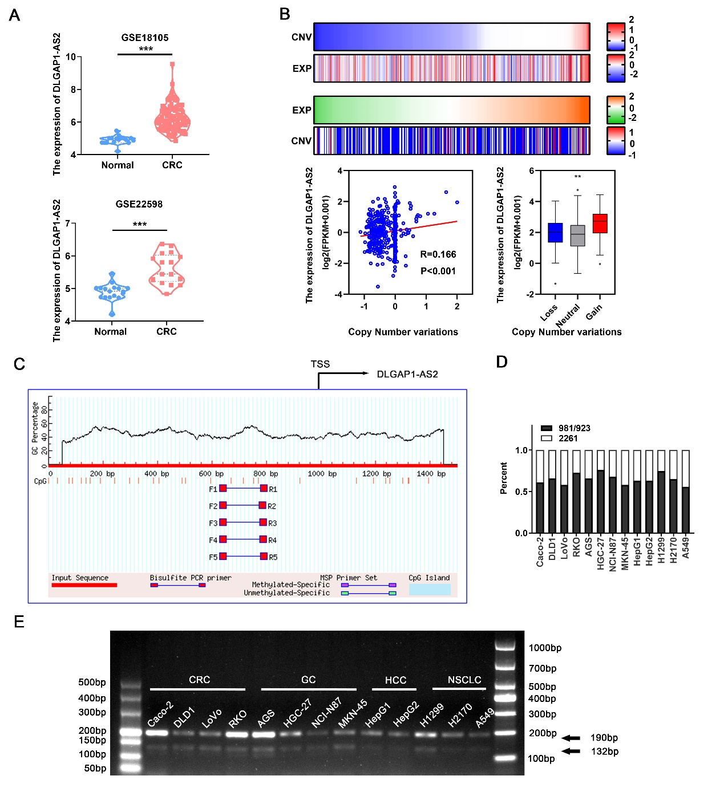
Fig.S1 The expression and transcript analyses of DLGAP1-AS2. (A) The expression of DLGAP1-AS2 in GEO datasets. (B) The copy number variations (CNVs) and expression of DLGAP1-AS2 in the TCGA CRC cohort. Correlation analyses between the CNV and expression of DLGAP1-AS2 in the TCGA CRC cohort. (C) CpG island prediction of DLGAP1-AS2 promoter using Methprimer (http://www.urogene.org/methprimer/). (D) The distribution of DLGAP1-AS2 transcripts in different types of cancer cells. (E) The relative levels of the two transcripts of DLGPA1-AS2 (981bp or 923 bp) in other types of cancer cells were detected with a semi-quantitative RT-PCR method. The bands with 190bp or 132 bp length represent the 981bp or 923 bp transcript of DLGAP1-AS2, respectively.
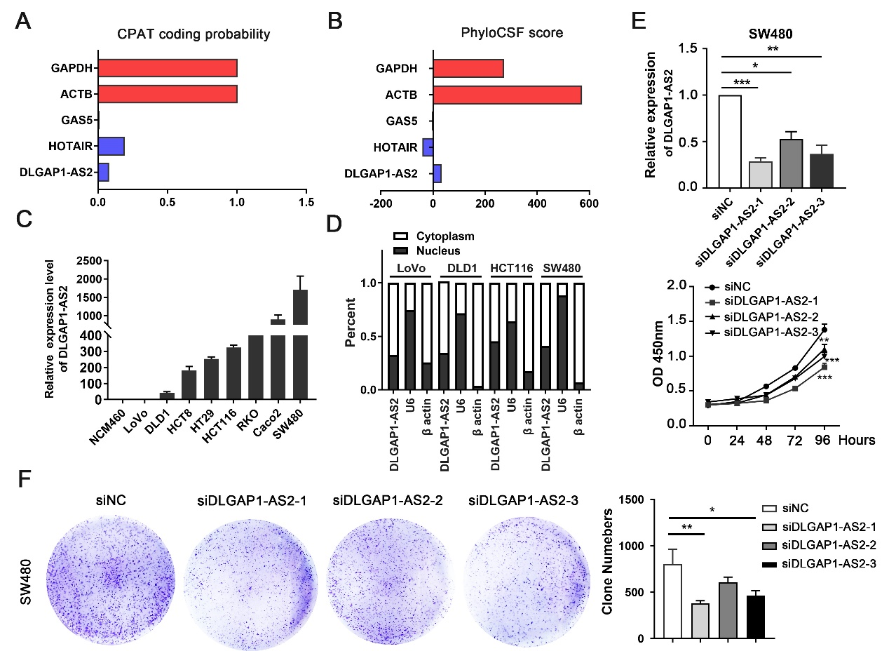
Fig.S2 Characterization of the protein-coding potential, subcellular localization and function for DLGAP1-AS2 in CRC. (A) The protein coding potential of DLGAP1-AS2 by using Coding Potential Assessment Tool (CPAT, http://lilab.research.bcm.edu/cpat/). GAPDH and ACTB served as the positive controls of coding genes, and GAS5 and HOTAIR served as the negative control of non-coding genes. (B) The protein coding potential of DLGAP1-AS2 predicted by the PhyloCSF software. (C) The RNA levels of DLGAP1-AS2 in CRC cell lines. (D) The distribution of DLGAP1-AS2 981bp transcript in CRC cell lines. β-actin served as the cytoplasmic internal control. U6 served as the nuclear internal control. (E) The effects of DLGAP1-AS2 knockdown on CRC cell proliferation. (F) The effects of DLGAP1-AS2 knockdown on CRC colony formation.
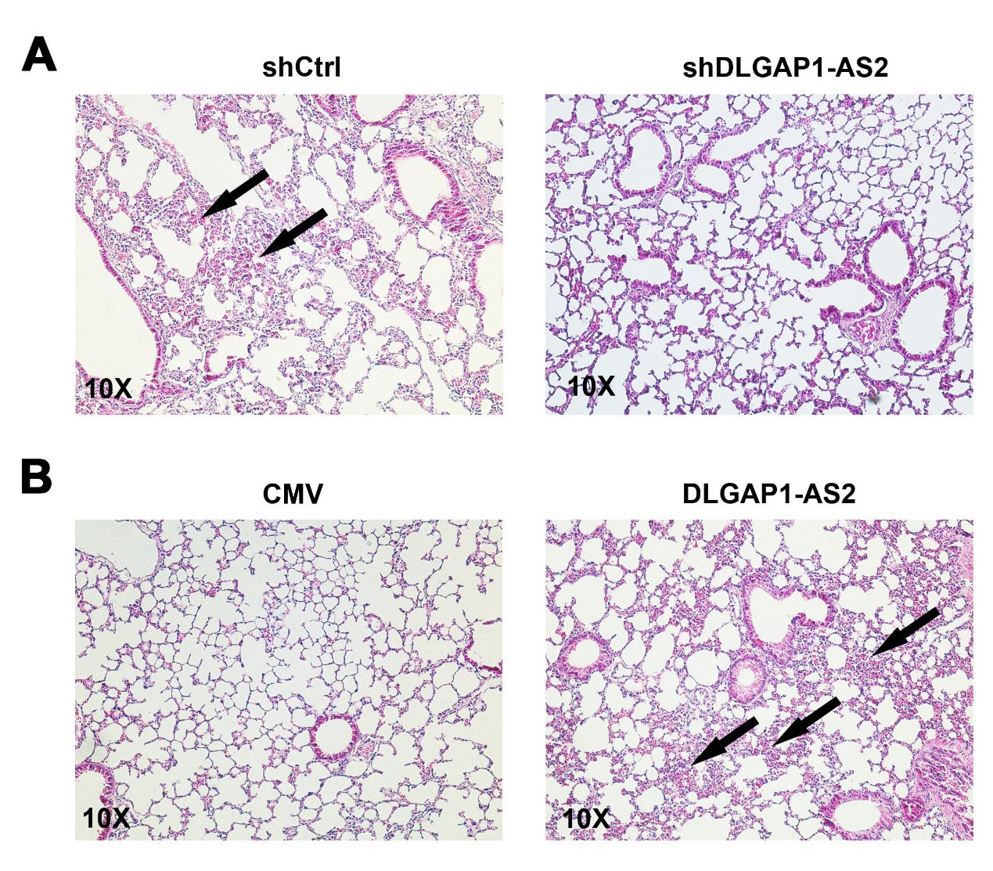
Fig.S3 HE staining for lung tissues from a lung metastasis mouse model.

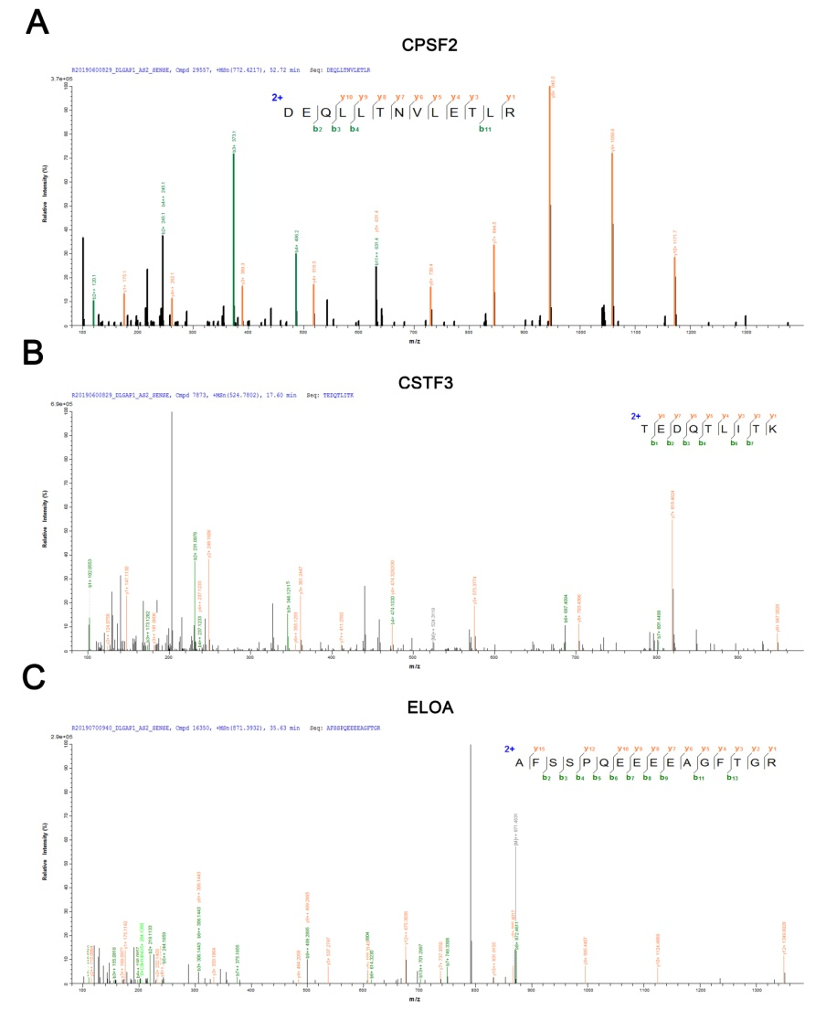
Fig.S4 Mass spectrometry analyses in samples from streptavidin pull down assays. (A-C) DLGAP1-AS2 Sense and Antisense RNA were biotinylated, transcribed in vitro and incubated with HCT116 cell lysates for RNA pull-down assays. After silver staining, the DLGAP1-AS2 sense-specific bands CPSF2, CSTF3 and ELOA were excised and analyzed using mass spectrometry.
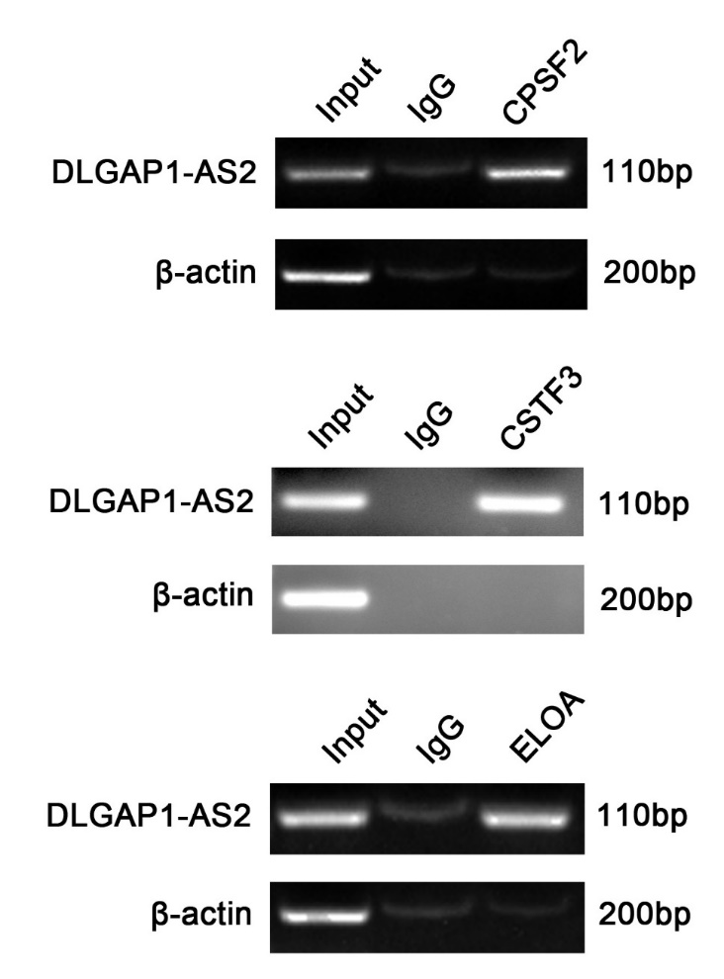
Fig.S5 RIP assays. RIP assays were performed to confirm the association of CPSF2, CSTF3 and ELOA with DLGAP1-AS2 using the indicated antibodies. Semi-quantitative RT-PCR were used to detect the enrichment of DLGAP1-AS2.
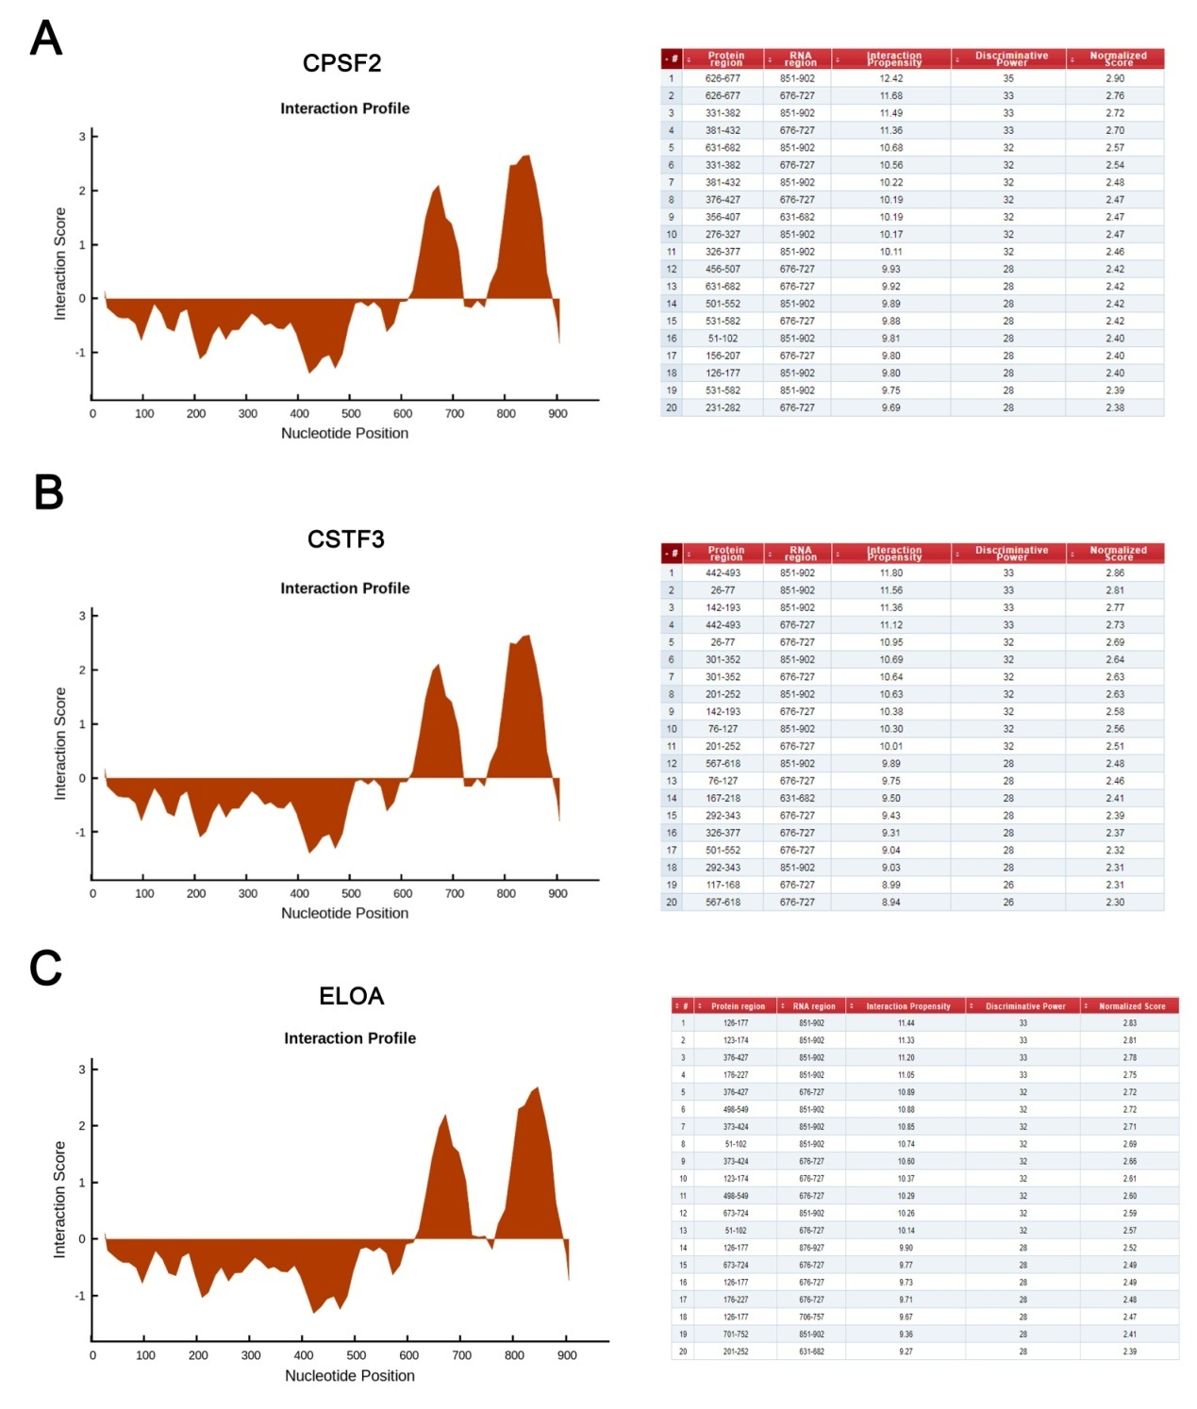
Fig.S6 Graphic illustration of predicted DLGAP1-AS2 secondary structure. (A-C) The software catRAPID predicted the interaction site between DLGAP1-AS2 and CPSF2, CSTF3 and ELOA.

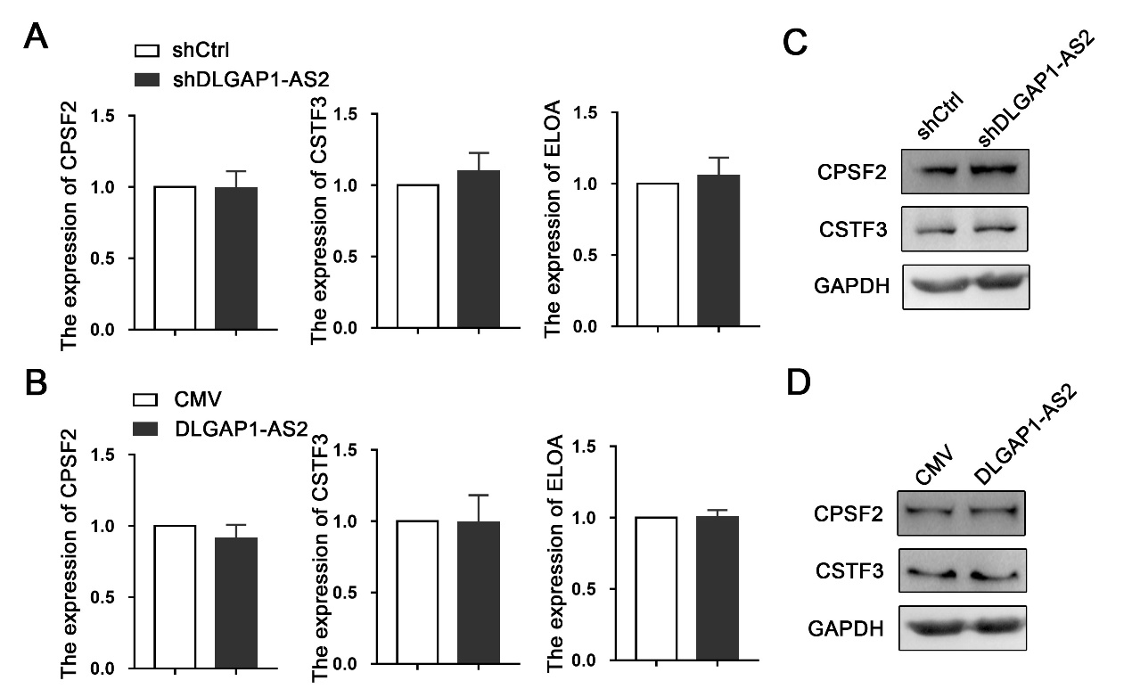
Fig.S7 The effect of DLGAP1 on CPSF2, CSTF3 and ELOA in CRC. (A) The mRNA levels of CPSF2, CSTF3 and ELOA were quantified by qRT-PCR in CRC cells with DLGAP1 knockdown.(B) The mRNA levels of CPSF2, CSTF3 and ELOA were quantified by qRT-PCR in CRC cells with DLGAP1-AS2 overexpression. (C-D) Immunoblotting for the protein levels of CPSF2 and CSTF3 after DLGAP1-AS2 knockdown or over-expression. GAPDH served as the internal control.

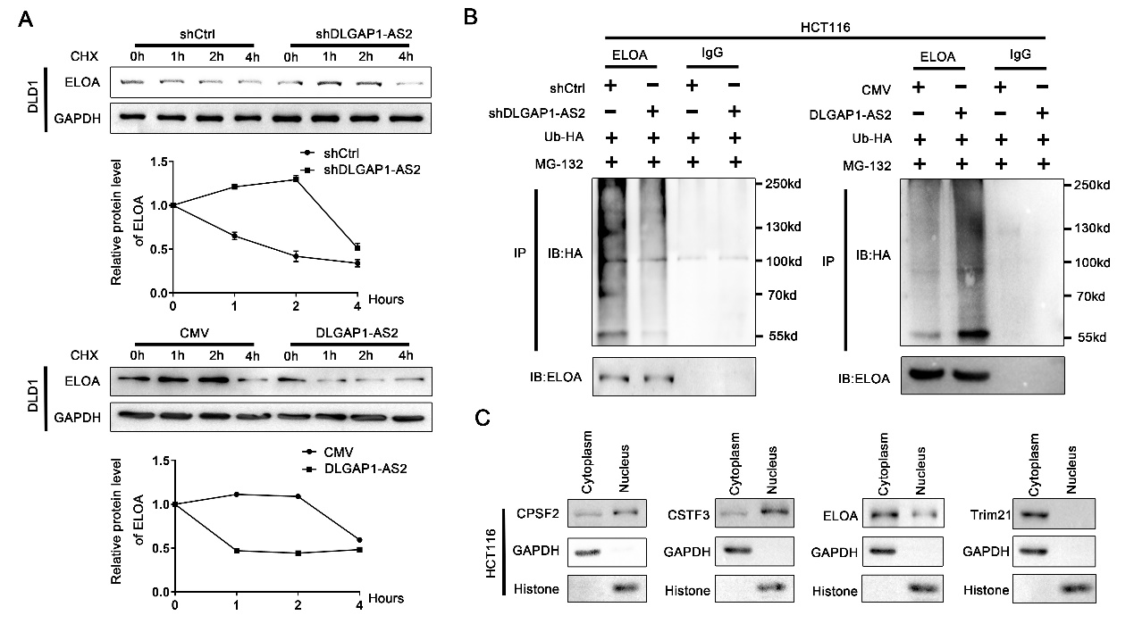
Fig.S8 DLGAP1-AS2 promoted the degradation of ELOA. (A) DLGAP1-AS2 promoted the degradation of ELOA in CRC cell. (B) DLGAP1-AS2 promoted the ubiquitination modification of endogenous ELOA. HCT116 cells transfected with HA-Ub or DLGAP1-AS2 plasmids were treated with MG132 for 4 hours before harvest. Ubiquitinated ELOA was measured by western blotting using an anti-HA antibody following the immunoprecipitation of ELOA. (C) The location of CPSF2, CSTF3, ELOA and Trim21 in HCT116 cells.

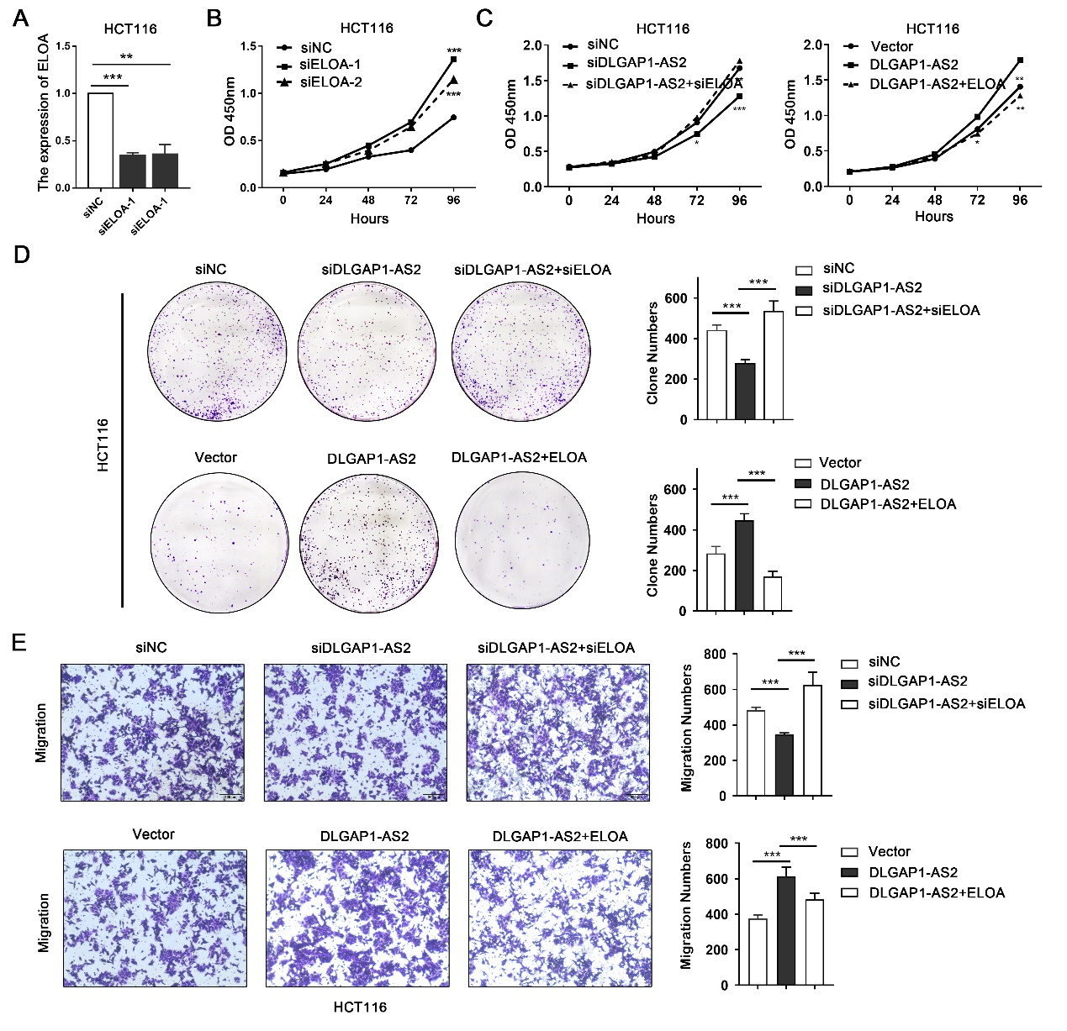
Fig.S9 The function of ELOA and ELOA as the downstream of DLGAP1-AS2. (A-B) siRNA-mediated silencing of ELOA promotes cell proliferation in HCT116 cells. (C) CCK-8 assays for HCT116 cells co-transfected with different siRNAs and/or plasmids. (D-E) Clone and Transwell assays for HCT116 cells transfected with DLGAP1-AS2 and ELOA.

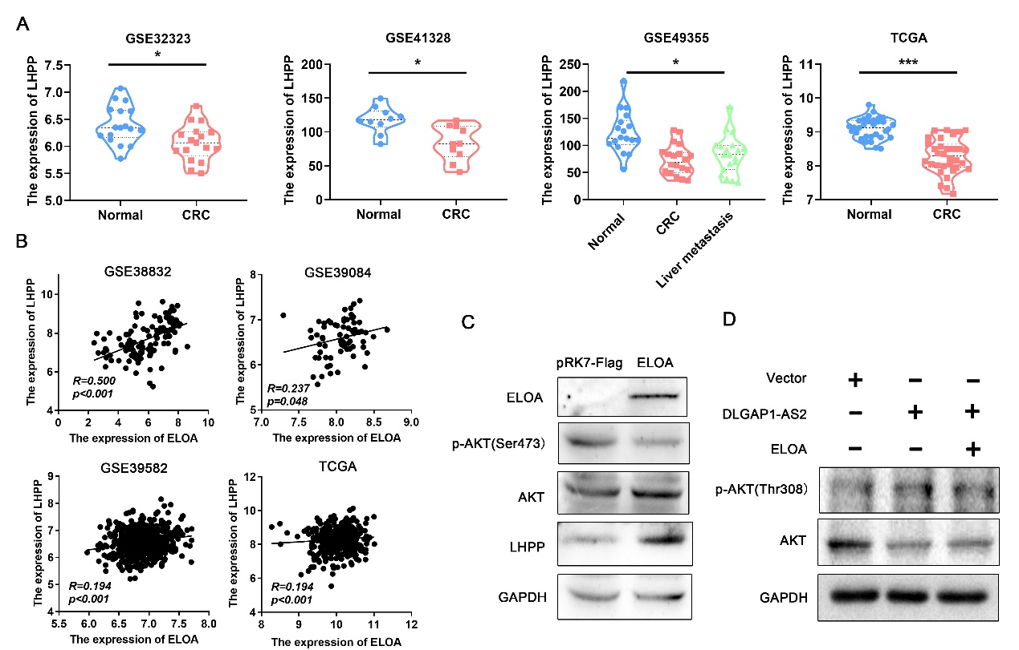
Fig.S10 The expression of LHPP and its relationship to ELOA in CRC. (A) Evaluation of LHPP expression in CRC tissues and their paired normal tissues based on the GEO and TCGA datasets. (B) The relationship between ELOA and LHPP. (C)The effect of ELOA on AKT pathway (pAKT at Ser473). (D) The effect of DLGAP1-AS2/ELOA on the AKT pathway (pAKT at Thr308).

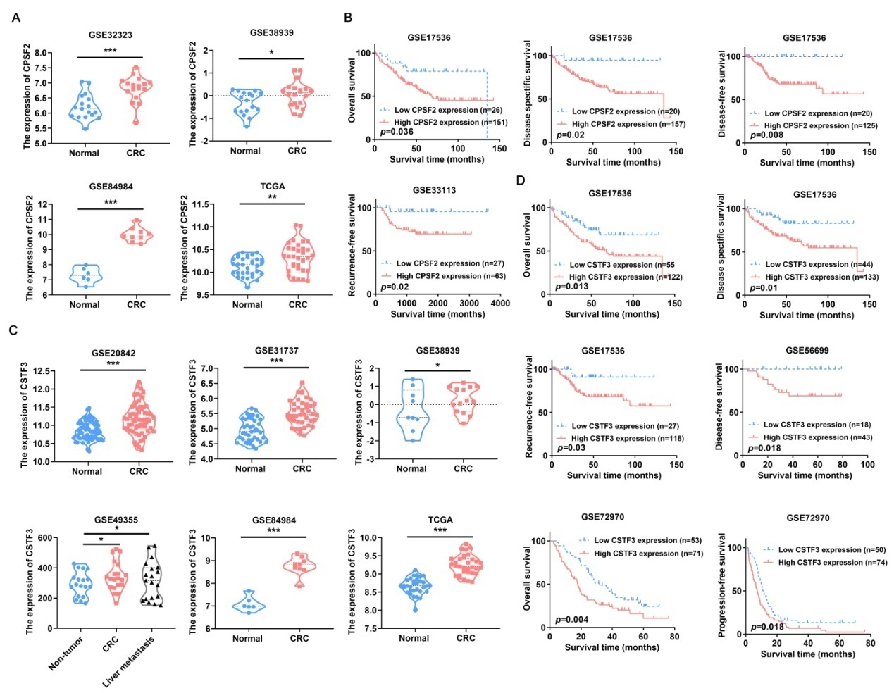
Fig.S11 CPSF2 and CSTF3 are associated with poor clinical outcomes in patients with CRC. (A) Evaluation of the mRNA expression of CPSF2 in CRC tissues and their paired normal tissues based on the GEO and TCGA datasets. (B) Kaplan-Meier plots of overall survival and disease-free survival versus CPSF2 from GEO datasets. (C) Evaluation of the expression of CSTF3 in CRC tissues and their paired normal tissues based on the GEO and TCGA datasets. (D) Kaplan-Meier plots of overall survival and disease-free survival versus CSTF3 from GEO datasets.

Fig.S12 The effect of CPSF2 or CSTF3 on AKT. (A) The inhibiting efficiencies of siRNAs in the mRNA expression of CPSF2 or CSTF3 in HCT116 cells. (B) The validation of CPSF2 and CSTF3 overexpression in HCT116 cells. (C) The effect of CPSF2 or CSTF3 on the phosphorylation of AKT at Thr308.

Tab.S1 Primer sequence
Primer | sequence
DLGAP1-AS2(981)-F | GCAGTGAAGCATCAGAAAAGTATAGT
DLGAP1-AS2(981)-R | GACTTGATGTCAAAGCTGGGAG
DLGAP1-AS2(923)-F | GCAGTGAAGCATCAGAAAAGTATAGT
DLGAP1-AS2(923)-R | TCATATTTGAATTTTGTTGCATCAC
DLGAP1-AS2(2261)-F | TTTACTTTATTCTTTGGGCTTCTCTG
DLGAP1-AS2(2261)-R | CTAGTCATGTCATAGCAGTGAAGAAATA
CSTF3-F | TTATGAACGCCTTGTTGCCC
CSTF3-R | ATCACTACAGTGAATGCTGCAA
ELOA-F | TTCCAGCCAAAGCGAAAAGC
ELOA-R | TGCTGGTGCAAGGTCATCAT
β-actin-F | AGTGTGACGTGGACATCCGCAAAG
β-actin-R | ATCCACATCTGCTGGAAGGTGGAC
CPSF2-F | TGAAAGGTGAAGGCAGTCGT
CPSF2-R | AGGTAACCCGGGCTTTGATA
IL7-F | GGGTGAAGCCCAACCAACAA
IL7-R | CAGTGTTCTTTAGTGCCCATCAA
IL18-F | TGACCAAGGAAATCGGCCTC
IL18-R | GCCATACCTCTAGGCTGGCT
IL23A-F | CTCTGCTCCCTGATAGCCCT
IL23A-R | GGAGGCTGCGAAGGATTTTG
CD82-F | CAGTGATCCTGGGCTTCGG
CD82-R | AAGACATAGGCCCCCATCCT
CDK2-F | GCATCTTTGCTGAGATGGTGAC
CDK2-R | GCTTGTTAGGGTCGTAGTGC
LHPP-F | ATAACGCCTTCCAGGTGCTC
LHPP-R | ATCAGGCCAGAGGTCTCCTT
LHPP-1-F | TCCCACCCTCTTCCCTGTAAA
LHPP-1-R | CGGGACTCTGTGCTTTTCTGG
LHPP-2-F | CACCACATGGAGACAAACACT  ATAAGCAAGAAGACGAAGAAA
LHPP-2-R | ATAAGCAAGAAGACGAAGAAA
LHPP-3-F | TGCATTTTTCCTCCCAAGTGA
LHPP-3-R | CGGGTGGGCCTCTCCCAGTC
PDK1-F | GGCCAGGTGGACTTCTACG
PDK1-R | ACATTCTGGCTGGTGACAGG
CMPK2-F | ATGCCATAGCCACTGAGGTG
CMPK2-R | CGAAACACACTGTTGGCCTC

Tab.S2 siRNA sequences
siRNA | sequence
si-DLGAP1-AS2-1-sense  sense（5'-3'）  sense（5'-3'） | GCGCCUAAGAAAUGCCUGUTT
si-DLGAP1-AS2-1-antisense | ACAGGCAUUUCUUAGGCGCTT
si-DLGAP1-AS2-2-sense  sense（5'-3'）  sense（5'-3'） | CACAGACAAGACCCUUUCATT
si-DLGAP1-AS2-2-antisense | UGAAAGGGUCUUGUCUGUGTT
si-DLGAP1-AS2-3-sense  sense（5'-3'）  sense（5'-3'） | GGACUAUGCUUAACCCAUUTT
si-DLGAP1-AS2-3-antisense | AAUGGGUUAAGCAUAGUCCTT
si-ELOA-1633-sense | CCUUCCCUCGAGCUGAUAUTT
si-ELOA-1633-antisense | AUAUCAGCUCGAGGGAAGGTT
si-ELOA-1314-sense | GGAGACAGAUAUGGAGGAUTT
si-ELOA-1314-antisense | AUCCUCCAUAUCUGUCUCCTT
si-CPSF2-399-sense | GGAAGCAUGUUCACCAGAUTT
si-CPSF2-399-antisense | AUCUGGUGAACAUGCUUCCTT
si-CPSF2-509-sense | GCAACCAUUCCUGUUUAUATT
si-CPSF2-509-antisense | UAUAAACAGGAAUGGUUGCTT
si-CSTF3-1398-sense | GCAGCACUCAUGGAAUAUUTT
si-CSTF3-1398-antisense | AAUAUUCCAUGAGUGCUGCTT
si-CSTF3-240-sense | CCAUAUGACCUUGAUGCUUTT
si-CSTF3-240-antisense | AAGCAUCAAGGUCAUAUGGTT
Negative control-sense | UUCUCCGAACGUGUCACGUTT
Negative control-antisense | ACGUGACACGUUCGGAGAATT

Tab.S3 Related sequence information for plasmid construction
Primer | sequence
sh-DLGAP1-AS2-F | CCGGAAGCGCCTAAGAAATGCCTGTCTCGAGGTATAGCTTAACGTAGGCATTTTTTTG
sh-DLGAP1-AS2-R | AATTCAAAAAAAGCGCCTAAGAAATGCCTGTCTCGAGGTATAGCTTAACGTAGGCATT
sh-ELOA-F | CCGGAACCTTCCCTCGAGCTGATATCTCGAGATATCAGCTCGAGGGAAGGTTTTTTTG
sh-ELOA-R | AATTCAAAAAAACCTTCCCTCGAGCTGATATCTCGAGATATCAGCTCGAGGGAAGGTT
DLGAP1-AS2(981)-F | GTGAACCGTCAGATCGAATTCGTCTTTCAGGATGAATGCCATCC
DLGAP1-AS2(981)-R | TAATCCAGAGGTTGAGGATCCATTTTTTAAAGCAATTTTTTATTTTATTTTT
CPSF2-F | ctgcacctcggttctaagcttATGACGTCTATTATCAAATTAACTACCCT
CPSF2-R | gattgaattccccggggatccTTATACAATGGCATATTGTTCATATAAAAG
CPSF2-1-375-F | ctgcacctcggttctaagcttATGACGTCTATTATCAAATTAACTACCCT
CPSF2-1-375-R | gattgaattccccggggatccTTATTTTTCAGAAGGATTATCAATTAGGA
CPSF2-376-782-F | ctgcacctcggttctaagcttATTACAGAAATAGAGTTGAGGAAACGTG
CPSF2-376-782-F | acgacgatgacaagaagcttATGACGTCTATTATCAAATTAACTACCCT
CSTF3-F | gattacgcttctaggggatccGCCACCATGTCAGGAGACGG
CSTF3-R | ggttctagaatcgatgatatcCTACCGAATCCGCTTCTGCTG
CSTF3-1-374-F | gattacgcttctaggggatccGCCACCATGTCAGGAGACGG
CSTF3-1-374-R | ggttctagaatcgatgatatcCTAAGGGTCAATATCCTCAATTGCC
CSTF3-375-717-F | gattacgcttctaggggatccGCCACCACCTTGGTATATATCCA
CSTF3-375-717-R | ggttctagaatcgatgatatcCTACCGAATCCGCTTCTGCTG
ELOA-F | acgacgatgacaagaagcttATGCACGGAGGGCGGAGC
ELOA-R | attgaattccccggggatccTTATCGTCGGGAGAATCTGTTCTTG
ELOA-1-250-F | acgacgatgacaagaagcttATGCACGGAGGGCGGAGC
ELOA-1-250-R | attgaattccccggggatccTTAGGCCCCGAGTCTGTCCTGAA
ELOA-251-500-F | acgacgatgacaagaagcttATGAGCCAAGAACGACACCTG
ELOA-251-500-R | attgaattccccggggatccTTATCTCAGCTTGGCTAAATCAG
ELOA-501-798-F | acgacgatgacaagaagcttATGAAGGTGCCTGATGTGTTGC
ELOA-501-798-R | attgaattccccggggatccTTATCGTCGGGAGAATCTGTTCTTG
LHPP-positive-F | gcgtgctagcccgggctcgagTCCCACCCTCTTCCCTGTAAA
LHPP-positive-R | cagtaccggaatgccaagcttCGGGTGGGCCTCTCCCAG
LHPP-negative-F | gcgtgctagcccgggctcgagTCCTGCTGGAAGGACCAGC
LHPP-negative-R | cagtaccggaatgccaagcttCTCCCTCCCTCCATGGAGTC
h-Trim21-gRNA1 | CATGTTGGCTAGCTGTCGAT
h-Trim21-gRNA2 | TCATCTCAGAGCTAGATCGA

Tab.S4 The sequences for DLAGP1-AS2 and its deletion fragments used in the in vitro transcription
Primer | sequence
DLGAP1-AS2-sense-F | TAATACGACTCACTATAGGGAGAGTCTTTCAGGATGAATGC
DLGAP1-AS2-sense-R | ATTTTTTAAAGCAATTTTTTATTT
DLGAP1-AS2-antisense-F | GTCTTTCAGGATGAATGC
DLGAP1-AS2-antisense-R | TAATACGACTCACTATAGGGAGAATTTTTTAAAGCAATTTTTTATTT
DLGAP1-AS2-70-981-F | TAATACGACTCACTATAGGGAGAACACAGACAAGACCCTTTCAAT
DLGAP1-AS2-70-981-R | ATTTTTTAAAGCAATTTTTTATTTTAT
DLGAP1-AS2-1-379-F | TAATACGACTCACTATAGGGAGAGTCTTTCAGGATGAATGCC
DLGAP1-AS2-1-379-R | TTCTTTACACATAAAGTTGGC
DLGAP1-AS2-380-981-F | TAATACGACTCACTATAGGGAGAGCTAACTCCTGCCAACATC
DLGAP1-AS2-380-981-R | ATTTTTTAAAGCAATTTTTTATTT
DLGAP1-AS2-1-620-F | TAATACGACTCACTATAGGGAGAGTCTTTCAGGATGAATGC
DLGAP1-AS2-1-620-R | AATCCCATTACGTGGC
DLGAP1-AS2-621-981-F | TAATACGACTCACTATAGGGAGAACGGATTATGTGATGCAACA
DLGAP1-AS2-621-981-R | ATTTTTTAAAGCAATTTTTTATTT

Tab.S5 Antibody information
Antibody | Company | Cat No.
ELOA mouse antibody | Santa Cruz Biotechnology | sc-373811
ELOA rabbit antibody | proteintech | 10502-1-AP
CstF-77 antibody | Santa Cruz Biotechnology | sc-376575
CPSF2 antibody | proteintech | 17739-1-AP
Trim21 | proteintech | 12108-1-AP
Flag tag Antibody Mouse Monoclonal | sigma | MA1-91878
Flag tag Antibody Rabbit Polyclonal | proteintech | 20543-1-AP
HA-Tag Rabbit mAb | CST | CST 3724
Myc-Tag Rabbit mAb | abmart | M2002L
GAPDH Antibody | ABclonal | AC033
LHPP | proteintech | 15759-1-AP
AKT | proteintech | 10176-2-AP
p-AKT | proteintech | 66444-1-Ig
p-AKT(Thr308) | CST | 13038T

Tab.S6 Relationships between DLGAP1-AS2 expression and clinical pathologic factors of the patients with CRC
Characteristic | Number  (n=111) | P_{a} value | P_{b} value | Overall Survival  HR(95%CI)_{b}
Age(years)
＜60 | 62 | 0.960 | 0.234 | 1.491（0.772-2.879）
≥60 | 49
Gender
Male | 66 | 0.404 | 0.224 | 0.651（0.325-1.302）
Female | 45
Size
＜5 | 69 | 0.576 | 0.202 | 1.532（0.796,2.948）
≥5 | 42
Location
Colon | 57 | 0.741 | 0.920 | 1.034（0.538,1.989）
Rectum | 54
Tumor differentiation
High | 5 | 0.903 | 0.01 | 2.423（1.239,4.738）
Medium | 87
Poor | 19
TNM
1 | 18 | 0.01 | ＜0.001 | 4.429（2.682,7.312）
2 | 32
3 | 50
4 | 11
Lymph node metastasis
0 | 51 | 0.031 | ＜0.001 | 4.751（2.838,7.955）
1 | 30
2 | 30
Gene expression |  |  | P_{c} | HR(95%CI)_{c}
Low | 31 | 0.021 | 0.030 | 3.967  (1.296,12.139)
High | 80

Tab.S7 Relationships between ELOA expression and clinical pathologic factors of the patients with CRC
Characteristic | Number  (n=146) | Low Expression | High  Expression | P_{a} value | P_{b} value | Overall Survival  HR(95%CI)_{b}
Age(years)
＜60 | 68 | 45 | 23 | 0.414 | 0.013 | 1.673（1.115-2.511）
≥60 | 78 | 54 | 24
Gender
Male | 81 | 55 | 26 | 0.559 | 0.629 | 0.649（1.152-2.044）
Female | 65 | 44 | 21
Size
＜5 | 78 | 51 | 27 | 0.576 | 0.679 | 0.922（0.628-1.354）
≥5 | 67 | 47 | 20
Location
Colon | 62 | 44 | 18 | 0.302 | 0.009 | 0.527（0.326-0.851）
Rectum | 84 | 52 | 29
Tumor
differentiation
High | 17 | 9 | 8 | 0.298 | 0.204 | 1.283（0.874-1.883）
Medium | 108 | 74 | 34
Poor | 21 | 16 | 5
TNM
I/II | 96 | 58 | 38 | 0.007 | ＜0.001 | 2.864（1.932-4.248）
III/IV | 50 | 41 | 9
Expression |  |  |  |  | P_{c} | HR(95%CI)_{c}
Low | 99 |  |  | 0.021 | 0.058 | 0.490 (0.234-1.025)
High | 47

