Appendix B: Comparison of exported EchoPAC (r) systolic strain rate values and CAMM plot-based values in a three-chamber view representing the six traditional strain rate curves.
The EchoPAC (r) screenshot of the source image is provided below. CAMM, curved anatomical M-mode.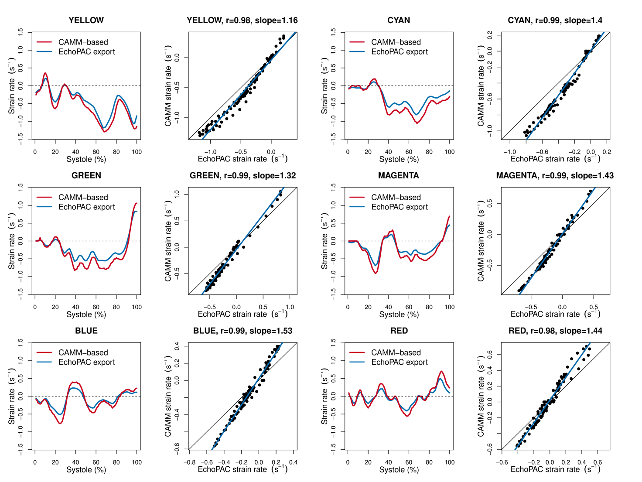
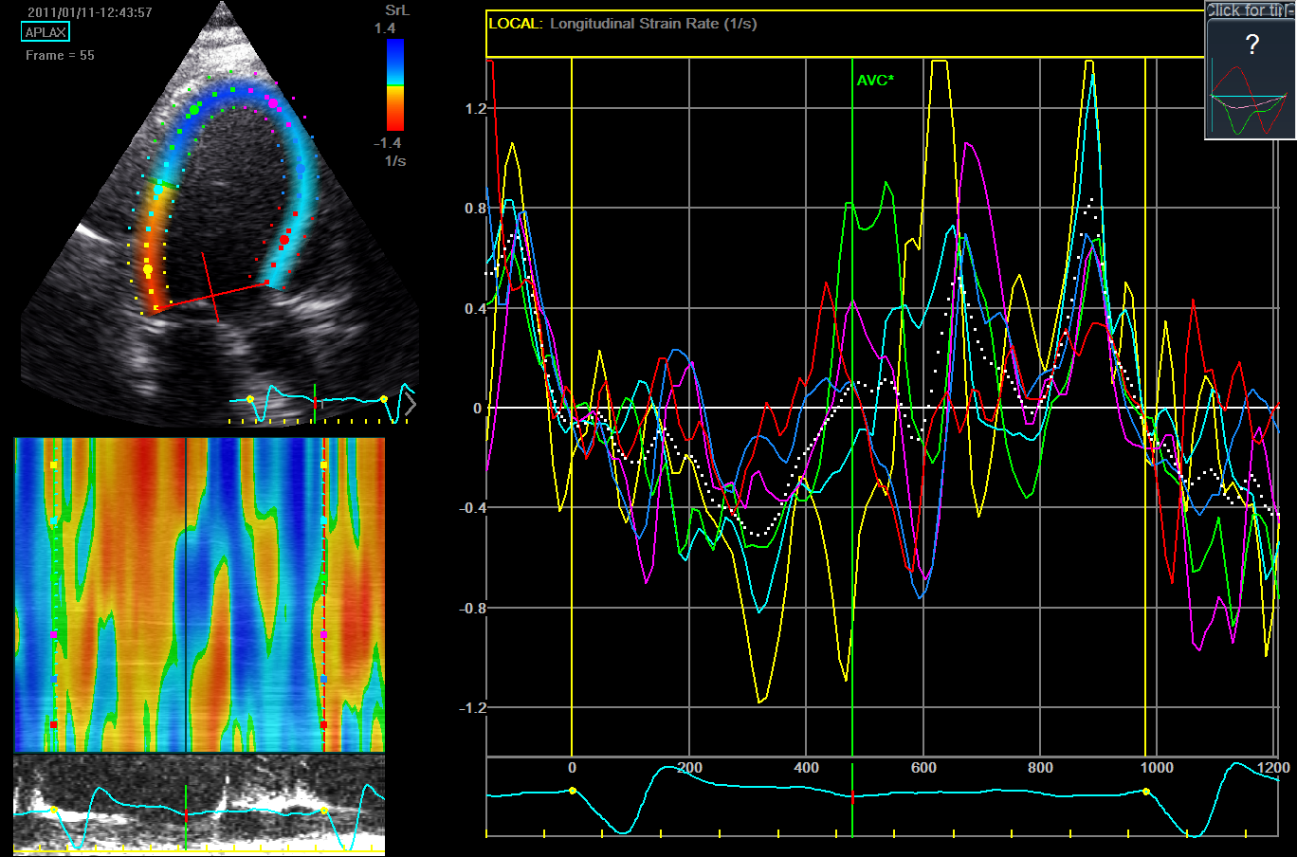
Index of contractile asymmetry in the three-chamber projection in this case was 0.51 s⁻¹.

