Additional file 4
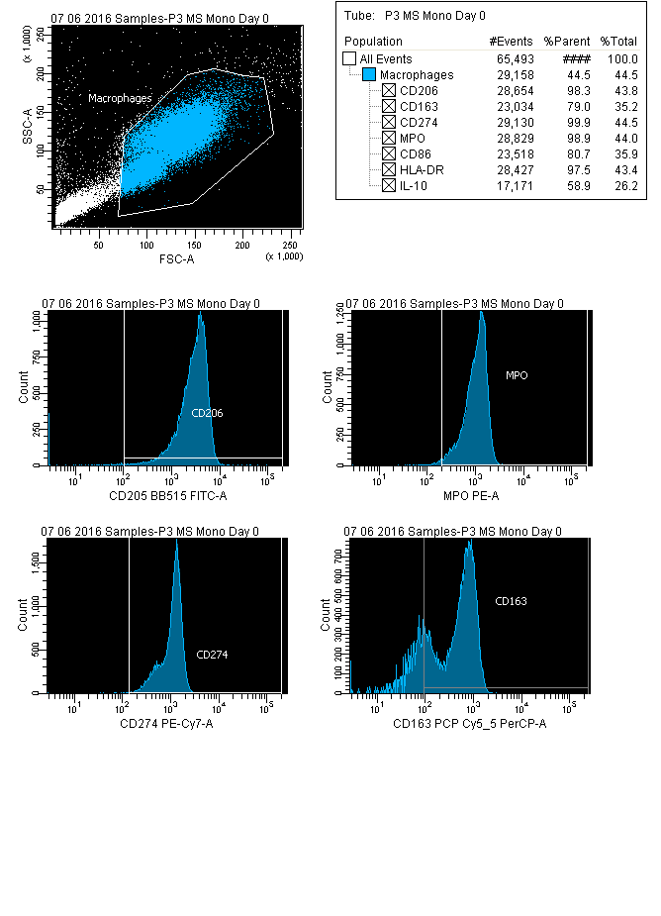
Representative flow cytometry panels showing a multiple-stained macrophage population, after staining for M1 (CD86, HLA-DR, CD274, MPO) and M2 (CD206, CD163, intracellular IL-10) markers. The data indicates that the markers used are thus expressed and indeed cross the threshold.

