Supplementary Material

Title
Meta-analysis of stroke-related gene expression profiles across species

Author
Ruslan Rust^{1,2}

Affiliation
¹ Institute for Regenerative Medicine, University of Zurich, 8952 Schlieren, Switzerland,
² Neuroscience Center Zurich, University of Zurich and ETH Zurich, Zurich, Switzerland

Correspondence
Ruslan Rust
Institute for Regenerative Medicine (IREM)
University of Zurich, Campus Schlieren
Wagistrasse 12
8952 Schlieren / Zurich, Switzerland
ruslan.rust@irem.uzh.ch, +41 44 63 7688

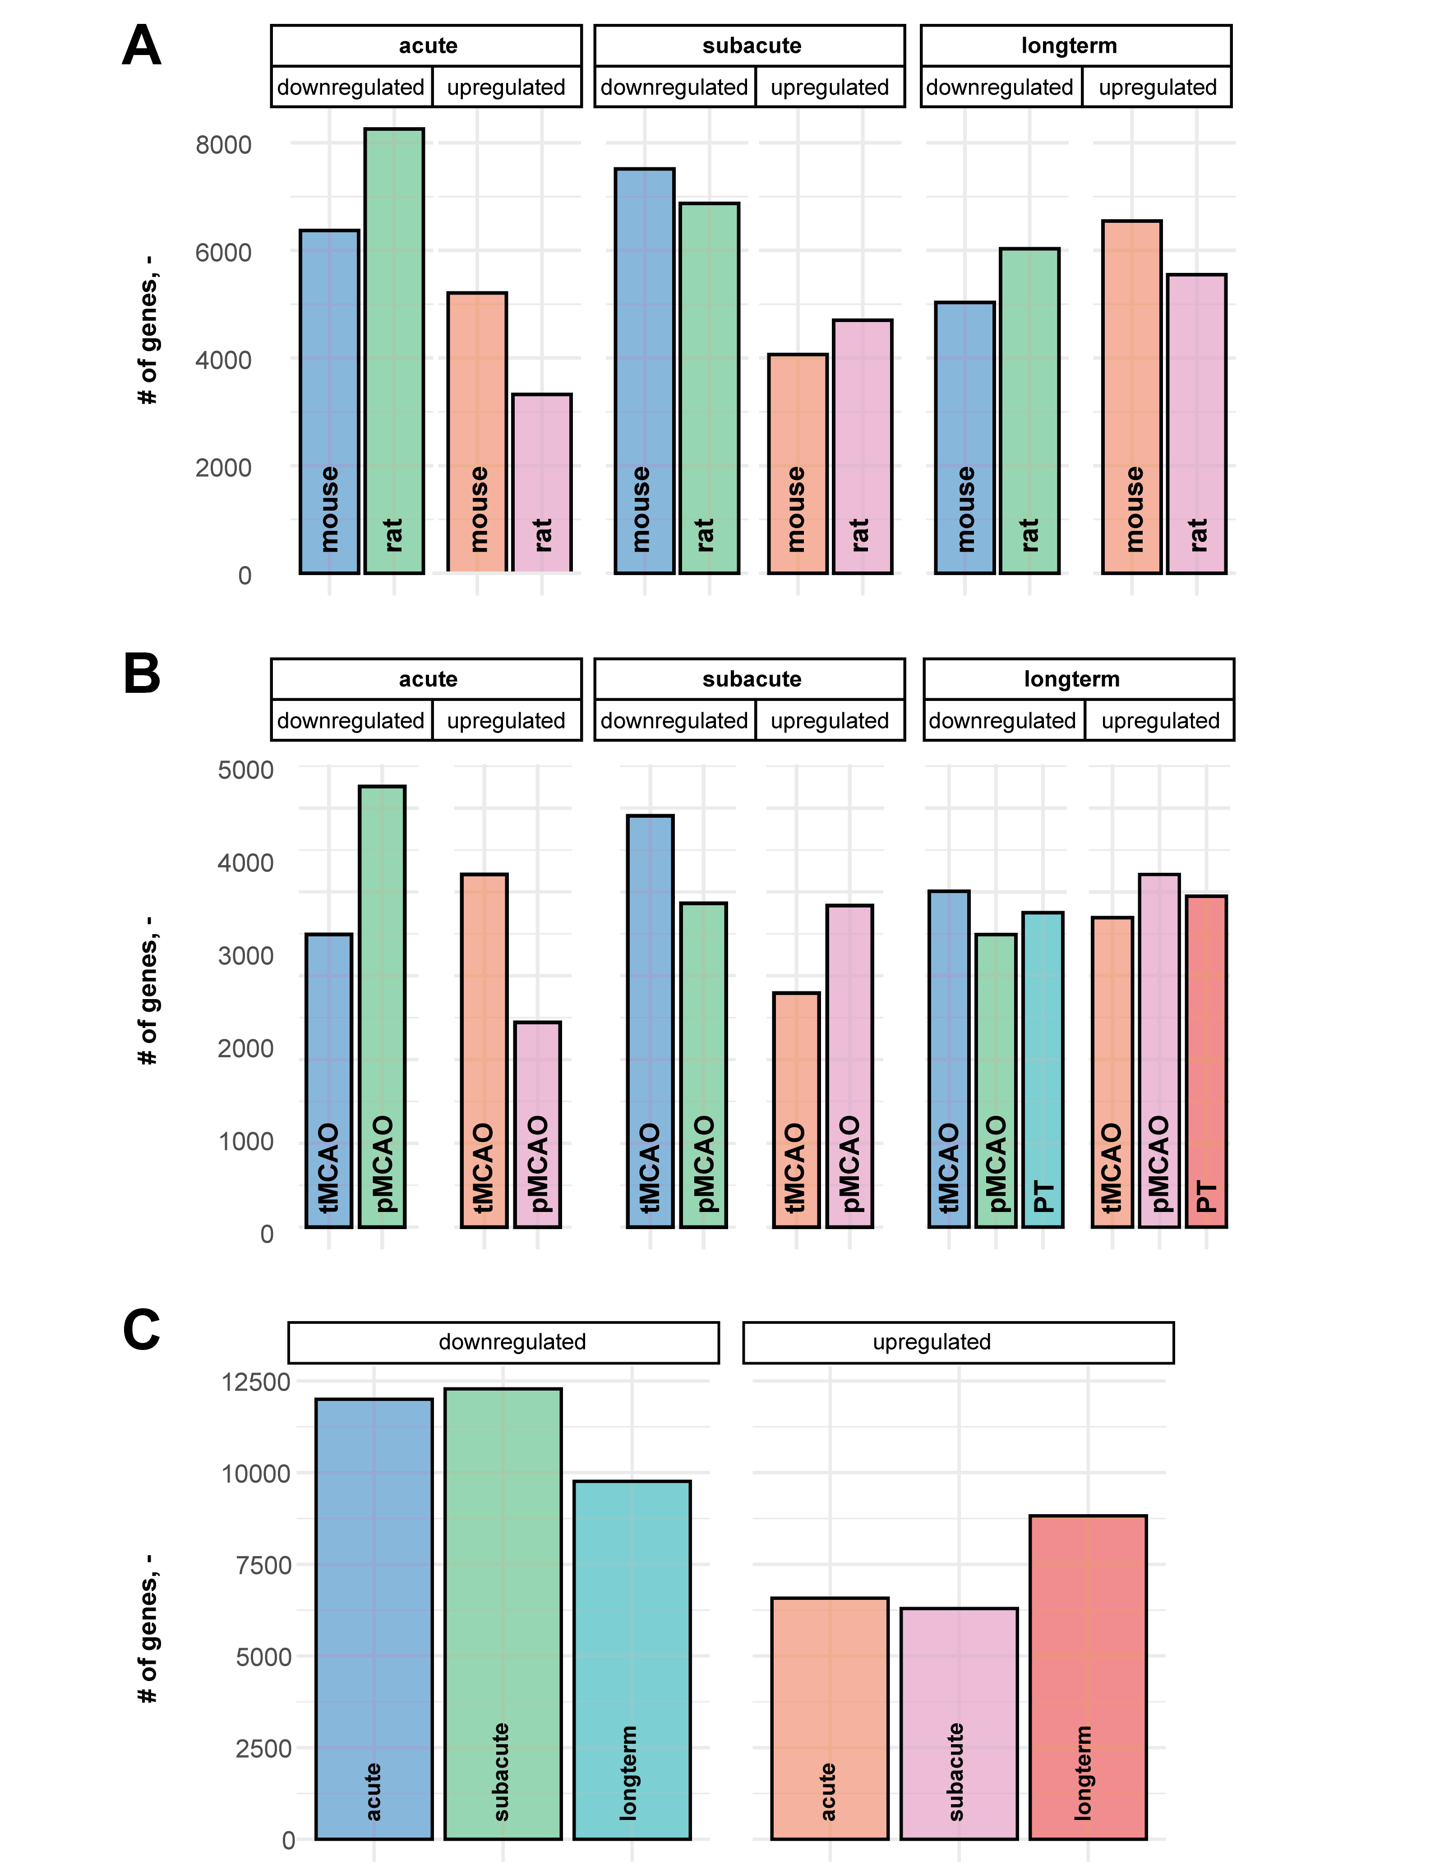Suppl. Fig 1: Gene expression profile after stroke. Ratio of up- and downregulated genes in stroked brain tissue across (A) species (B) stroke model and (C) time period.

Suppl. Fig. 2: Gene set enrichment of most enriched biological processes at different time points. Gene ontology analysis of top20 enriched pathways between (A) long-term and subacute time period and (B) between subacute and acute time period.

Identification of studies via databases and registers

Records removed before screening:
Duplicate records removed (n = 20)
Records removed for other reasons (n = 105)
Records identified from*:
NCBI GEO (n = 338)

Identification

Reports excluded:
No brain tissue (n = 120)
No control group (n = 16)
Missing data (n = 43)

Reports assessed for eligibility
(n = 213)

Screening

Studies included
(n = 34)
Included

Suppl. Fig. 3: PRISMA flow diagram for search criteria

