Appendix 1. Search strategy

Quality of life in community dwelling cancer patients 80 years and older: a systematic review
Inger Helen Hardeland Hjelmeland, Faculty of Health and Social Sciences, Western Norway University of Applied Sciences, Stord, Norway and VID Specialized University, Ulriksdal 10, 5009 Bergen, Norway
Jorunn Drageset, Faculty of Health and Social Sciences, Western Norway University of Applied Sciences, Inndalsveien 28, 5063 Kronstad, Bergen, Norway and Department of Global Health and Primary Care, University of Bergen, Postboks 7804, 5020 Bergen, Norway
Øyvind Nordvik, Faculty of Health and Social Sciences, Western Norway University of Applied Sciences, Bergen, Norway, Inndalsveien 28, 5063 Kronstad, Bergen, Norway
Elisabeth Grov Beisland, Faculty of Health and Social Sciences, Western Norway University of Applied Sciences, Bergen, Norway, Inndalsveien 28, 5063 Kronstad, Bergen, Norway

Content
Description of the search 1
Cochrane 2
Epistemonikos 2
Campbell? 3
Medline (Ovid) 3
EMBASE 3
CINAHL 4
PsycINFO 5
Scopus 5
Duplicates 6

Description of the search

Focus 1:
Neoplasms
Medical Oncology
Keywords:
Cancer* OR neoplas* OR oncolog* OR malign* OR tumor* OR tumour* OR carsinoma* OR metasta*
Focus 2:
Aged 80 years and over
Aged
Frail elderly
Keywords:
aged or elder* or aging or ageing or old* OR geriatric* OR octogeneri* OR nonageneri* OR centenari*

Focus 3:
Independent living/
Housing
Housing for the elderly
Keywords:
"Community dwelling" OR "Community living" OR "Home dwelling" OR (Living W2 home) OR (living W2 independent*) OR Housing OR Homebound OR Lodging* OR "Senior housing"

Cochrane
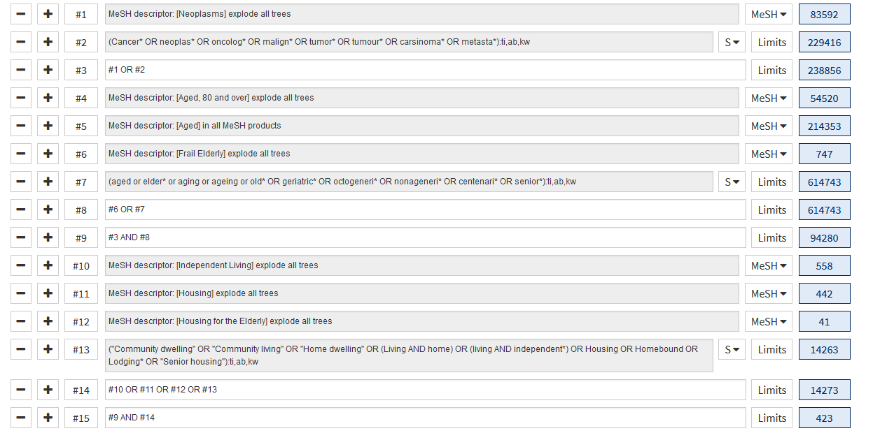

This search yealded 423 hits, of which 16 systematic reviews, 0 protocols, and 407 primary clinical studies.

Epistemonikos

(title:((title:((title:(Cancer* OR neoplas* OR oncolog* OR malign* OR tumor* OR tumour* OR carsinoma* OR metasta*) OR abstract:(Cancer* OR neoplas* OR oncolog* OR malign* OR tumor* OR tumour* OR carsinoma* OR metasta*))) OR abstract:((title:(Cancer* OR neoplas* OR oncolog* OR malign* OR tumor* OR tumour* OR carsinoma* OR metasta*) OR abstract:(Cancer* OR neoplas* OR oncolog* OR malign* OR tumor* OR tumour* OR carsinoma* OR metasta*)))) AND (title:(aged OR elder* OR aging OR ageing OR old* OR geriatric* OR octogeneri* OR nonageneri* OR centenari* OR senior*) OR abstract:(aged OR elder* OR aging OR ageing OR old* OR geriatric* OR octogeneri* OR nonageneri* OR centenari* OR senior*))) OR abstract:((title:((title:(Cancer* OR neoplas* OR oncolog* OR malign* OR tumor* OR tumour* OR carsinoma* OR metasta*) OR abstract:(Cancer* OR neoplas* OR oncolog* OR malign* OR tumor* OR tumour* OR carsinoma* OR metasta*))) OR abstract:((title:(Cancer* OR neoplas* OR oncolog* OR malign* OR tumor* OR tumour* OR carsinoma* OR metasta*) OR abstract:(Cancer* OR neoplas* OR oncolog* OR malign* OR tumor* OR tumour* OR carsinoma* OR metasta*)))) AND (title:(aged OR elder* OR aging OR ageing OR old* OR geriatric* OR octogeneri* OR nonageneri* OR centenari* OR senior*) OR abstract:(aged OR elder* OR aging OR ageing OR old* OR geriatric* OR octogeneri* OR nonageneri* OR centenari* OR senior*)))) AND (title:("Community dwelling" OR "Community living" OR "Home dwelling" OR (Living AND home) OR (living AND independent*) OR Housing OR Homebound OR Lodging* OR "Senior housing") OR abstract:("Community dwelling" OR "Community living" OR "Home dwelling" OR (Living AND home) OR (living AND independent*) OR Housing OR Homebound OR Lodging* OR "Senior housing"))
Hits: Systematic reviews: 20, Broad synthesis: 1, Primary studies: 108

Campbell
Hits: 0.

Medline (Ovid)

Ovid MEDLINE(R) and Epub Ahead of Print, In-Process, In-Data-Review & Other Non-Indexed Citations and Daily <1946 to September 20, 2021>

1 exp neoplasms/ 3537345
2 (Cancer* or neoplas* or oncolog* or malign* or tumor* or tumour* or carsinoma* or metasta*).ab,kf,ti. 3544792
3 1 or 2 4627410
4 aged/ or "aged, 80 and over"/ or frail elderly/ 3302878
5 (aged or elder* or aging or ageing or old* or geriatric* or octogeneri* or nonageneri* or centenari* or senior*).ab,kf,ti. 2415141
6 4 or 5 5012858
7 Independent Living/ 8299
8 housing/ or housing for the elderly/ 20301
9 ("Community dwelling" or "Community living" or "Home dwelling" or (Living adj2 home) or (living adj2 independent*) or Housing or Homebound or Lodging* or "Senior housing").ab,kf,ti. 71626
10 7 or 8 or 9 86993
11 3 and 6 and 10 1666
Hits: 1666.

EMBASE

Embase <1974 to 2021 Week 37>

1 exp neoplasm/ 4805623
2 (Cancer* or neoplas* or oncolog* or malign* or tumor* or tumour* or carsinoma* or metasta*).ab,kf,ti. 4686343
3 1 or 2 5934941
4 aged/ or frail elderly/ or very elderly/ 3226557
5 (aged or elder* or aging or ageing or old* or geriatric* or octogeneri* or nonageneri* or centenari* or senior*).ab,kf,ti. 3331558
6 4 or 5 5640210
7 independent living/ 5651
8 ("Community dwelling" or "Community living" or "Home dwelling" or (Living adj2 home) or (living adj2 independent*) or Housing or Homebound or Lodging* or "Senior housing").ab,kf,ti. 87883
9 7 or 8 89635
10 3 and 6 and 9 2316

Hits: 2316.

CINAHL

Tuesday, September 21, 2021 11:39:13 AM

# | Query | Results
S11 | S3 AND S6 AND S10 | 964
S10 | S7 OR S8 OR S9 | 58,622
S9 | TI ( "Community dwelling" OR "Community living" OR "Home dwelling" OR (Living N2 home) OR (living N2 independent*) OR Housing OR Homebound OR Lodging* OR "Senior housing" ) OR AB ( "Community dwelling" OR "Community living" OR "Home dwelling" OR (Living N2 home) OR (living N2 independent*) OR Housing OR Homebound OR Lodging* OR "Senior housing" ) OR SU ( "Community dwelling" OR "Community living" OR "Home dwelling" OR (Living N2 home) OR (living N2 independent*) OR Housing OR Homebound OR Lodging* OR "Senior housing" ) | 54,446
S8 | (MH "Housing for the Elderly") OR (MH "Housing") | 12,668
S7 | (MH "Community Living") OR (MH "Assisted Living") OR (MH "Community Reintegration") | 21,985
S6 | S4 OR S5 | 1,235,663
S5 | TI ( aged or elder* or aging or ageing or old* OR geriatric* OR octogeneri* OR nonageneri* OR centenari* OR senior* ) OR AB ( aged or elder* or aging or ageing or old* OR geriatric* OR octogeneri* OR nonageneri* OR centenari* OR senior* ) OR SU ( aged or elder* or aging or ageing or old* OR geriatric* OR octogeneri* OR nonageneri* OR centenari* OR senior* ) | 1,235,663
S4 | (MH "Aged") OR (MH "Aged, 80 and Over") OR (MH "Frail Elderly") | 880,340
S3 | S1 OR S2 | 828,532
S2 | TI ( Cancer* OR neoplas* OR oncolog* OR malign* OR tumor* OR tumour* OR carsinoma* OR metasta* ) OR AB ( Cancer* OR neoplas* OR oncolog* OR malign* OR tumor* OR tumour* OR carsinoma* OR metasta* ) OR SU ( Cancer* OR neoplas* OR oncolog* OR malign* OR tumor* OR tumour* OR carsinoma* OR metasta* ) | 772,443
S1 | (MH "Neoplasms+") | 591,927

Hits: 964.

PsycINFO

APA PsycInfo <1987 to September Week 2 2021>

1 exp neoplasms/ 53366
2 (Cancer* or neoplas* or oncolog* or malign* or tumor* or tumour* or carsinoma* or metasta*).ab,ti,tw. 84727
3 1 or 2 87226
4 geriatric patients/ 12141
5 older adulthood/ 5613
6 (aged or elder* or aging or ageing or old* or geriatric* or octogeneri* or nonageneri* or centenari* or senior*).ab,ti,tw. 644098
7 4 or 5 or 6 644644
8 "activities of daily living"/ or aging in place/ or independent living programs/ 6871
9 ("Community dwelling" or "Community living" or "Home dwelling" or (Living adj2 home) or (living adj2 independent*) or Housing or Homebound or Lodging* or "Senior housing").ab,ti,tw. 34873
10 8 or 9 40529
11 3 and 7 and 10 345

Hits: 345 .

Scopus

( TITLE-ABS-KEY ( "Community dwelling" OR "Community living" OR "Home dwelling" OR ( living W/2 home ) OR ( living W/2 independent* ) OR housing OR homebound OR lodging* OR "Senior housing" ) AND TITLE-ABS-KEY ( cancer* OR neoplas* OR oncolog* OR malign* OR tumor* OR tumour* OR carsinoma* OR metasta* ) AND TITLE-ABS-KEY ( aged OR elder* OR aging OR ageing OR old* OR geriatric* OR octogeneri* OR nonageneri* OR centenari* OR senior* ) )

Hits: 2654.

Duplicates

When all references were imported to an EndNote library there was all together 12 722 references in the library. After the first remove of duplicates both using EndNote and manually, 8497 references remained. There were still some duplicates that needed to be assessed in more detail.(e.g. same authors, title and sidenumbers, but different year). 8497 references were imported to an EndNote-base. 4078 of these references were duplicates. Removing of duplicates resulted in a total of 4419 references.

Appendix 2. PRISMA 2020 flow diagram

Identification of studies via databases and registers

Records identified from*:
Databases
Medline(n=1666)
Cohcrane(n= 423)
EMBASE(n=2316)
Epistemonikos(n=129)
Campell(n=0)
CINAHL(n=964)
PsycINFO(n=345)
Scopus(n=2654)
(n = 8497)

Registers (n = )
Records removed before screening:
Duplicate records removed (n = 4078)
Records marked as ineligible by automation tools (n = 0)
Records removed for other reasons (n =0 )

Identification

Records screened
(n = 4419)
Records excluded**
(n =4413 )

Reports sought for retrieval
(n =1 )
Reports not retrieved
(n =1 )

Screening

Reports excluded: (n=5)
Reason 1 (n =1 )
Reason 2 (n = 4)

Reports assessed for eligibility
(n = 8)

Studies included in review
(n = 3)

Included

Reason 1: Wrong outcome
Reason 2: Wrong population group

From: Page MJ, McKenzie JE, Bossuyt PM, Boutron I, Hoffmann TC, Mulrow CD, et al. The PRISMA 2020 statement: an updated guideline for reporting systematic reviews. BMJ 2021;372:n71. doi: 10.1136/bmj.n71

For more information, visit: http://www.prisma-statement.org/

