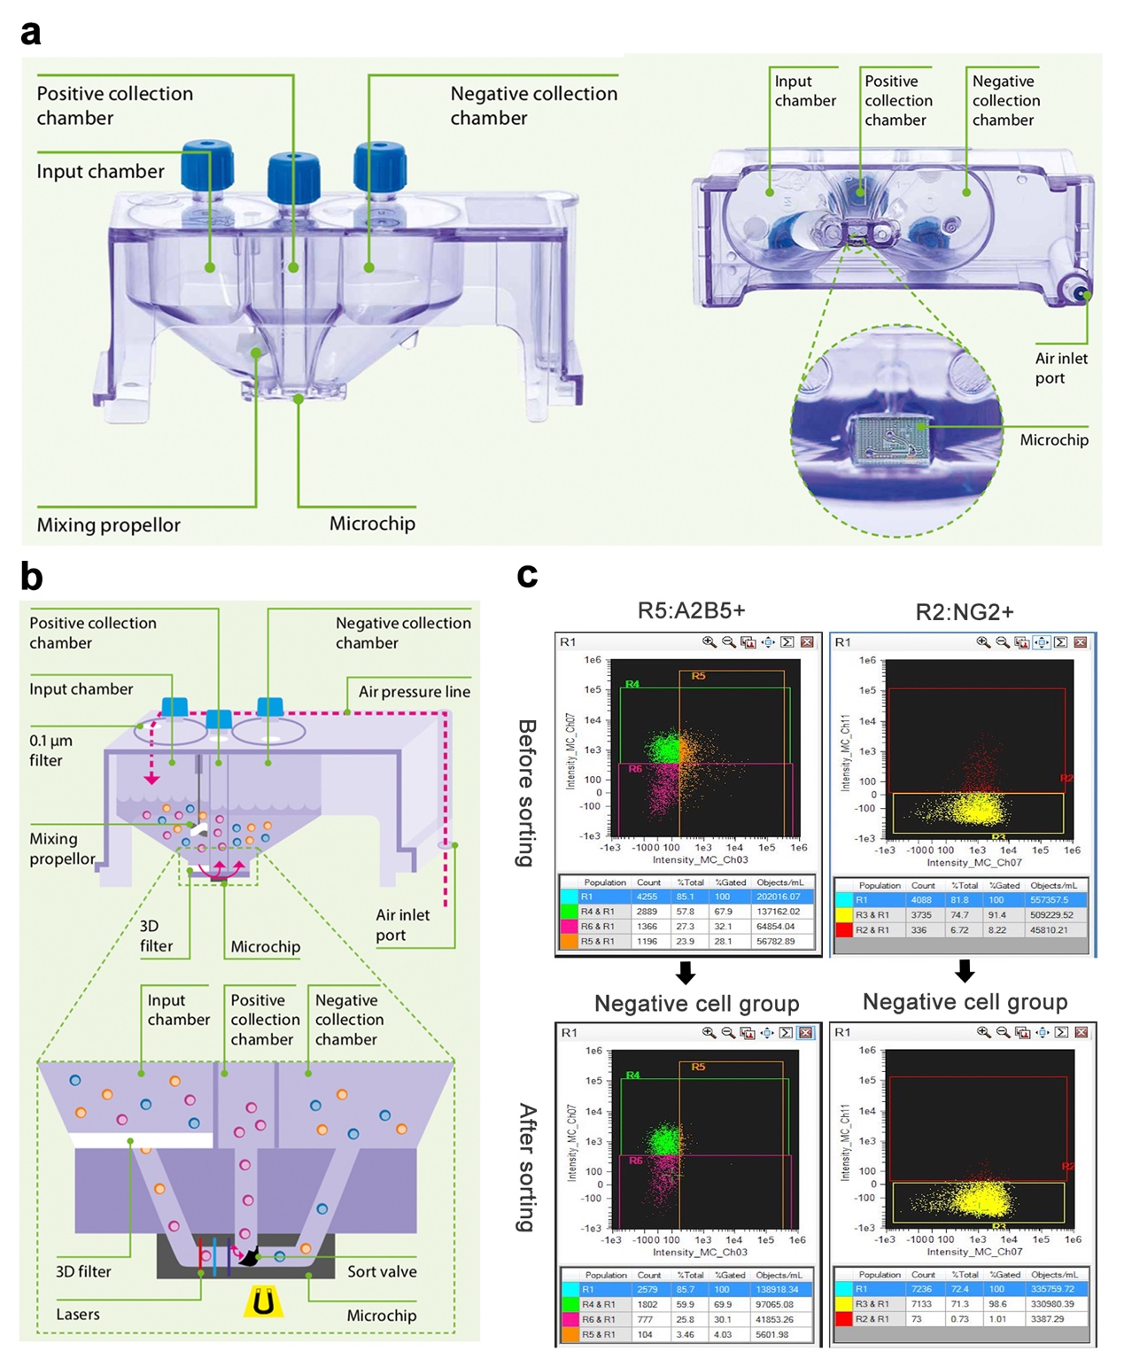
Fig S1. MACSQuant®Tyto® cell sorting. a MACSQuant®Tyto® Cartridge and the bottom view of the Cartridge with a zoomed-in image of the microchip. b Sorting mechanism of MACSQuant®Tyto®. c Flow cytometry using the FlowSight® imaging flow cytometer used to evaluate the sorting effect of A2B5+ and NG2+ cells. In the negative cell group, the proportion of A2B5+ cells dropped from 28.1 to 4.03%, and the proportion of NG2+ cells decreased from 8.22 to 1.01%.

