Additional file 1

***Contents***

* Additional file 1: Figure S1
* Additional file 1: Figure S2
* Additional file 1: Figure S3
* Additional file 1: Figure S4
* Additional file 1: Table S1
* Additional file 1: Table S2
* Additional file 1: Table S3

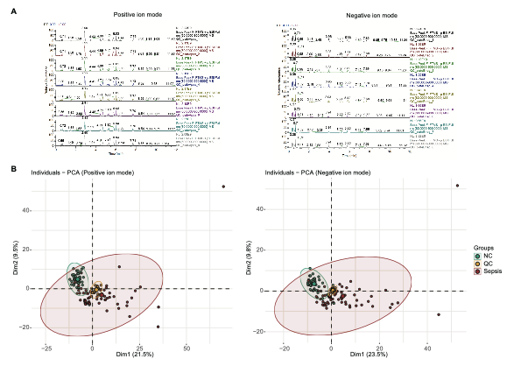

**Additional file 1: Figure S1 Quality control (QC) of experimental data.** (A) Comparison of the total ion chromatogram (TIC) of QC samples in positive ion mode (left) and negative ion mode (right). (B) Principal component analysis (PCA) of the identified metabolites showing QC samples clustered together both in positive ion mode (left) and negative ion mode (right).



**Additional file 1: Figure S2 Evaluation parameters of the OPLS-DA model in positive ion mode (left) and negative ion mode (right).**

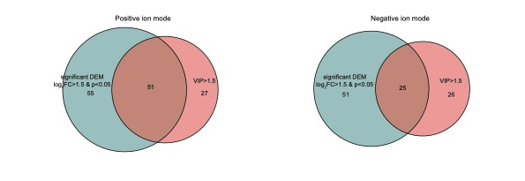

**Additional file 1: Figure S3 Venn diagram showing the hub metabolites in positive ion mode (left) and negative ion mode (right).**



**Additional file 1: Figure S4** **Cluster dendrogram and 16 metabolite coexpression modules defined by dendrogram branch cutting of all identified metabolites of patients with sepsis and normal controls.**