Figure S1. A, Heatmap of RMWs in OS tissue from the Target dataset and GSE21257 dataset. B, GO and KEGG analyses of DEGs.

Figure S2. Survival analysis of OS patients with differential expression of CSTF2, ADAR and WTAP in both TCGA and GEO datasets.

Figure S3. The correlation between risk RMW expression and clinical characteristics.
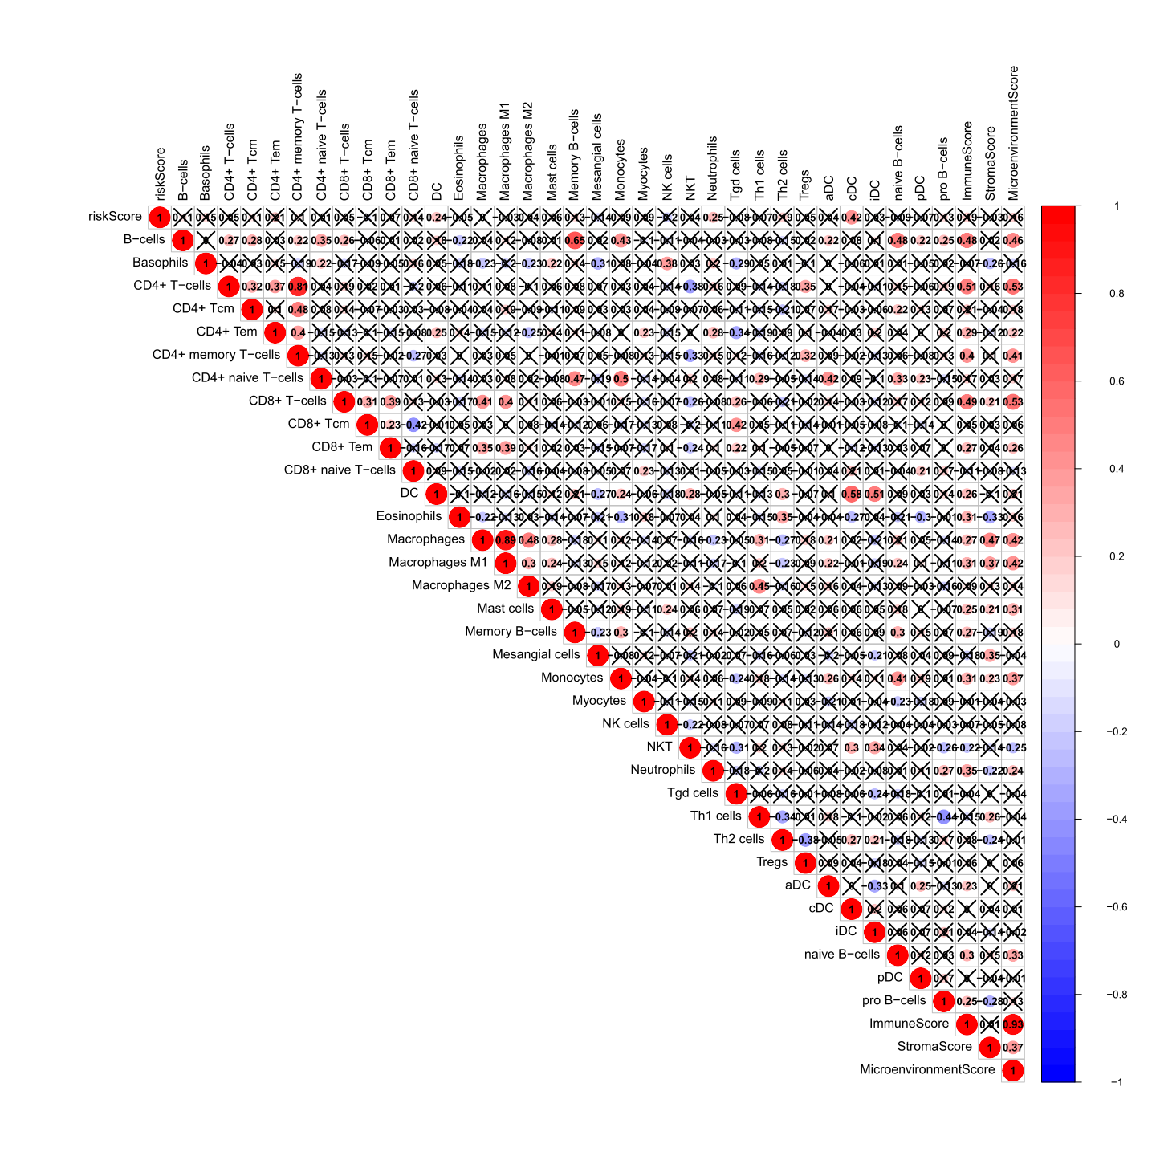Figure S4. The relationship between the risk score and immune infiltration was analysed using Pearson’s correlation analysis.

Table S1. Univariate Cox analysis revealed prognosis-related DEGs in the high- and low-risk groups
id | HR | HR.95L | HR.95H | p value
VWA8 | 0.997 | 0.995 | 0.999 | 0.001
MSN | 0.999 | 0.998 | 1.000 | 0.045
ALG13 | 0.961 | 0.927 | 0.996 | 0.027
CD44 | 0.971 | 0.949 | 0.993 | 0.011
ULK2 | 0.995 | 0.991 | 0.999 | 0.014
SRR | 0.994 | 0.987 | 1.000 | 0.039
BDH2 | 1.029 | 1.015 | 1.043 | 0.000
MX1 | 0.990 | 0.982 | 0.998 | 0.011
FAM98A | 0.937 | 0.892 | 0.985 | 0.010
SLC6A8 | 0.981 | 0.967 | 0.995 | 0.010
MRPL35 | 0.998 | 0.996 | 1.000 | 0.012
C6orf89 | 0.999 | 0.998 | 1.000 | 0.028

Table S2. The relationship between TF and prognosis-related DEGs
Prognosis_related_DEGs | TFs | cor | p value | FDR
VWA8 | BCL6 | 0.419189 | 6.52E-05 | 0.000603
VWA8 | NCAPG | 0.458489 | 1.02E-05 | 0.000146
MSN | ATF2 | 0.448992 | 1.63E-05 | 0.000201
MSN | BCL6 | 0.457092 | 1.09E-05 | 0.000147
MSN | LYL1 | -0.46368 | 7.85E-06 | 0.000116
MSN | RNF2 | 0.423834 | 5.30E-05 | 0.000535
CD44 | EGR2 | -0.40972 | 9.87E-05 | 0.000842
CD44 | TCF12 | 0.556529 | 3.19E-08 | 1.42E-06
CD44 | PIAS1 | 0.471934 | 5.13E-06 | 8.13E-05
CD44 | ATF1 | 0.504197 | 8.67E-07 | 2.41E-05
CD44 | SMAD3 | 0.512703 | 5.26E-07 | 1.67E-05
CD44 | DYRK1A | 0.467404 | 6.49E-06 | 9.93E-05
ULK2 | EGR2 | -0.42222 | 5.70E-05 | 0.00054
ULK2 | MAZ | -0.41396 | 8.21E-05 | 0.000715
ULK2 | BCL6 | 0.499934 | 1.11E-06 | 2.73E-05
ULK2 | TCF12 | 0.663043 | 4.73E-12 | 2.10E-09
ULK2 | RCOR1 | 0.417928 | 6.90E-05 | 0.000625
ULK2 | HSF2 | 0.406827 | 0.000112 | 0.000902
ULK2 | PBX1 | 0.478319 | 3.66E-06 | 6.25E-05
ULK2 | SMAD1 | -0.49687 | 1.32E-06 | 3.08E-05
ULK2 | ATF1 | 0.588517 | 3.15E-09 | 3.50E-07
ULK2 | LYL1 | -0.42723 | 4.55E-05 | 0.000491
ULK2 | RNF2 | 0.556478 | 3.20E-08 | 1.42E-06
ULK2 | DYRK1A | 0.527144 | 2.18E-07 | 8.81E-06
ULK2 | NCAPG | 0.520085 | 3.37E-07 | 1.15E-05
SRR | FOXO3 | -0.42675 | 4.65E-05 | 0.000491
SRR | RBL2 | 0.476599 | 4.01E-06 | 6.59E-05
SRR | MAZ | -0.4068 | 0.000112 | 0.000902
SRR | TCF12 | 0.444992 | 1.98E-05 | 0.000231
SRR | TRIM28 | 0.403873 | 0.000127 | 0.000988
SRR | SMAD3 | 0.478365 | 3.65E-06 | 6.25E-05
SRR | USF1 | -0.60625 | 7.82E-10 | 1.46E-07
SRR | DYRK1A | 0.560264 | 2.47E-08 | 1.37E-06
SRR | EHMT2 | -0.58447 | 4.29E-09 | 3.81E-07
BDH2 | BCL3 | -0.42849 | 4.29E-05 | 0.000477
BDH2 | BCL6 | -0.45384 | 1.29E-05 | 0.000168
BDH2 | DYRK1A | -0.42425 | 5.20E-05 | 0.000535
MX1 | BCL6 | 0.491688 | 1.76E-06 | 3.92E-05
MX1 | TCF12 | 0.457345 | 1.08E-05 | 0.000147
MX1 | LYL1 | -0.50236 | 9.64E-07 | 2.52E-05
MX1 | DYRK1A | 0.414562 | 8.00E-05 | 0.00071
FAM98A | TRIM28 | 0.60333 | 9.89E-10 | 1.46E-07
FAM98A | MEF2A | 0.432182 | 3.62E-05 | 0.000412
FAM98A | BRD4 | 0.575637 | 8.25E-09 | 6.11E-07
SLC6A8 | FOXO3 | -0.45309 | 1.34E-05 | 0.000169
SLC6A8 | RBL2 | 0.482701 | 2.89E-06 | 5.83E-05
SLC6A8 | MAZ | -0.40743 | 0.000109 | 0.000902
SLC6A8 | BCL3 | 0.40382 | 0.000127 | 0.000988
SLC6A8 | TCF12 | 0.480148 | 3.32E-06 | 6.25E-05
SLC6A8 | TRIM28 | 0.487543 | 2.22E-06 | 4.69E-05
SLC6A8 | PIAS1 | 0.422171 | 5.71E-05 | 0.00054
SLC6A8 | MEF2A | 0.422761 | 5.56E-05 | 0.00054
SLC6A8 | SMAD3 | 0.479062 | 3.52E-06 | 6.25E-05
SLC6A8 | RXRA | 0.504798 | 8.37E-07 | 2.41E-05
SLC6A8 | DYRK1A | 0.448412 | 1.68E-05 | 0.000201
SLC6A8 | EHMT2 | -0.57092 | 1.16E-08 | 7.37E-07
C6orf89 | RXRA | 0.521907 | 3.02E-07 | 1.12E-05

Table S3. Drug prediction using the CMap database.
cmap name | mean | n | enrichment | p | specificity | percent nonnull
lanatoside C | -0.531 | 6 | -0.81 | 0.00014 | 0.0213 | 100
zaprinast | -0.613 | 4 | -0.888 | 0.00036 | 0 | 100
strophanthidin | -0.617 | 4 | -0.884 | 0.00042 | 0 | 100
atractyloside | 0.5 | 5 | 0.81 | 0.0006 | 0.0111 | 100
helveticoside | -0.512 | 6 | -0.739 | 0.00066 | 0.013 | 83
Gly-His-Lys | -0.577 | 3 | -0.917 | 0.00096 | 0.0149 | 100
16-phenyltetranorprostaglandin E2 | -0.569 | 4 | -0.848 | 0.00097 | 0.0119 | 100
benfotiamine | -0.294 | 5 | -0.739 | 0.00246 | 0 | 60
mephenesin | -0.391 | 5 | -0.73 | 0.00302 | 0.0117 | 80
betulin | 0.617 | 3 | 0.883 | 0.0032 | 0.0063 | 100
propantheline bromide | 0.49 | 4 | 0.796 | 0.00332 | 0 | 100
karakoline | -0.417 | 6 | -0.654 | 0.00471 | 0 | 83
atropine oxide | -0.351 | 5 | -0.704 | 0.00495 | 0.0063 | 60
laudanosine | -0.361 | 4 | -0.777 | 0.00511 | 0 | 50
resveratrol | 0.389 | 9 | 0.535 | 0.0057 | 0.2941 | 66
physostigmine | 0.335 | 4 | 0.76 | 0.00627 | 0 | 75
kinetin | -0.397 | 4 | -0.731 | 0.01052 | 0 | 75
brinzolamide | -0.33 | 4 | -0.727 | 0.01128 | 0.0216 | 75
albendazole | -0.55 | 3 | -0.821 | 0.0114 | 0.0286 | 100
gramine | -0.268 | 4 | -0.718 | 0.01281 | 0.0328 | 50
fenbufen | 0.349 | 6 | 0.601 | 0.01283 | 0 | 66
tribenoside | 0.294 | 4 | 0.718 | 0.01297 | 0.0318 | 50
ifosfamide | -0.495 | 3 | -0.81 | 0.0135 | 0.0182 | 100
mebendazole | -0.366 | 5 | -0.644 | 0.0142 | 0.1165 | 80
ivermectin | 0.244 | 5 | 0.645 | 0.01574 | 0.1129 | 80
amodiaquine | 0.305 | 4 | 0.7 | 0.01667 | 0.0125 | 50
cefotaxime | 0.286 | 5 | 0.64 | 0.0172 | 0 | 80
latamoxef | 0.465 | 3 | 0.795 | 0.01747 | 0.029 | 100
clioquinol | 0.408 | 5 | 0.637 | 0.01788 | 0.1518 | 80
thiamine | 0.441 | 3 | 0.79 | 0.01867 | 0.0403 | 100
trazodone | 0.571 | 3 | 0.788 | 0.01921 | 0.0896 | 100
aminohippuric acid | -0.297 | 4 | -0.688 | 0.02037 | 0.0556 | 50
acebutolol | 0.287 | 5 | 0.622 | 0.02251 | 0.0278 | 60
lincomycin | 0.458 | 3 | 0.776 | 0.02269 | 0.0079 | 100
dantrolene | 0.207 | 6 | 0.569 | 0.0237 | 0.0513 | 50
dyclonine | -0.312 | 4 | -0.668 | 0.02727 | 0.0221 | 50
mefexamide | 0.258 | 4 | 0.666 | 0.02787 | 0.0245 | 50
pralidoxime | 0.397 | 4 | 0.657 | 0.03201 | 0.0638 | 75
esculin | 0.297 | 4 | 0.657 | 0.03203 | 0 | 75
nisoxetine | -0.286 | 4 | -0.654 | 0.03322 | 0.0366 | 50
cotinine | 0.292 | 6 | 0.546 | 0.03369 | 0.0455 | 50
alfadolone | 0.29 | 3 | 0.74 | 0.03413 | 0.0235 | 66
Y-27632 | -0.47 | 2 | -0.869 | 0.03428 | 0.0492 | 100
minaprine | 0.361 | 5 | 0.59 | 0.03565 | 0.02 | 80
isocarboxazid | 0.267 | 5 | 0.587 | 0.03687 | 0.0592 | 60
abamectin | 0.403 | 4 | 0.646 | 0.0374 | 0.04 | 75
betahistine | -0.408 | 4 | -0.646 | 0.03756 | 0.08 | 75
etifenin | -0.475 | 4 | -0.645 | 0.03804 | 0.0345 | 75
mesoridazine | -0.273 | 4 | -0.641 | 0.03965 | 0.0546 | 50
hydroflumethiazide | -0.173 | 5 | -0.574 | 0.04205 | 0.0567 | 60
gibberellic acid | -0.422 | 4 | -0.635 | 0.04297 | 0.0642 | 75
atropine methonitrate | -0.338 | 3 | -0.723 | 0.04383 | 0.0383 | 66
amprolium | 0.313 | 5 | 0.572 | 0.0458 | 0.0385 | 80
thioguanosine | 0.464 | 4 | 0.63 | 0.04683 | 0.2588 | 75
ellipticine | 0.447 | 4 | 0.628 | 0.04798 | 0.3039 | 75

