Table S1 Newcastle-Ottawa Scale (NOS) quality scale for cohort studies
Study | Selection of cohort |  |  |  | Comparability | Outcomes |  |  | Score
 | Representativeness of the exposed | Selection of the non exposed | Ascertainment of exposure | Initially healthy  subjects | Comparability of cohorts | Assessment of outcome | long enough follow-up | Adequacy follow up
baker2019 | 1 | 1 | 1 | 1 | 2 | 1 | 0 | 0 | 7
chan2020 | 1 | 1 | 1 | 1 | 2 | 1 | 1 | 0 | 8
coleman2018 | 1 | 1 | 1 | 1 | 2 | 1 | 1 | 0 | 8
hsu2018 | 1 | 1 | 1 | 1 | 2 | 1 | 0 | 0 | 7
lip2020 | 1 | 1 | 1 | 1 | 2 | 1 | 1 | 0 | 8
Table S2 Agency for Healthcare Research and Quality (AHRQ) quality scale for sub-analysis of RCTs
study | Define the source of information | List inclusion and exclusion criteria for exposed and unexposed subjects or refer to previous publications | Indicate time period used for identifying patients | Indicate whether or not subjects were consecutive if not population-based | Indicate if evaluators of subjective components of study were masked to other aspects of the status of the participants | Describe any assessments undertaken for quality assurance purposes | Explain any patient exclusions from analysis | Describe how confounding was assessed and/or controlled. | If applicable, explain how missing data were handled in the analysis | Summarize patient response rates and completeness of data collection | Clarify what follow-up, if any, was expected and the percentage of patients for which incomplete data or follow-up was obtained
bansilal2015 | yes | yes | unclear | yes | yes | no | yes | yes | unclear | yes | yes
brambatti2015 | yes | yes | unclear | yes | yes | no | yes | yes | unclear | yes | yes
ezekowitz2015 | yes | yes | unclear | yes | yes | no | yes | yes | unclear | yes | yes
plitt 2020 | yes | yes | unclear | yes | yes | no | yes | yes | unclear | yes | yes

Table S3 Stratified analysis of the risk of SSE among NVAF patients with diabetes on NOACs versus warfarin according to drug type and dose

Drug Type | HR | I², P
Rivaroxaban | 0.83(0.76, 0.90) | 0.0%, 0.510
Dabigatran | 0.85(0.75, 0.96) | 13.6%, 0.328
Apixaban | 0.70(0.62, 0.79) | 0.0%, 0.622
Edoxaban | 0.87(0.69, 1.10) | 0.0%, 0.476
Drug Dose | HR | I², P
Standard-dose | 0.77(0.67, 0.89) | 50.1%, 0.075
Lower-dose | 0.73(0.64, 0.83) | 7.3%, 0.370

Table S4 Stratified analysis according to drug type, drug dose and basic condition
Drug Type | HR | I², P
Rivaroxaban | 0.92(0.80, 1.07) | 73.8%, 0.004
Dabigatran | 0.81(0.62, 1.05) | 86.9%, 0.000
Apixaban | 0.71(0.54, 0.93) | 83.0%, 0.003
Edoxaban | 0.78(0.59, 1.02) | 45.6%, 0.159
Drug Dose
Standard-dose | 0.88(0.71, 1.10) | 92.2%, 0.000
Lower-dose | 0.79(0.56, 1.06) | 92.4%, 0.000
Complicating Disease
PAD | 0.95(0.42, 2.14) | 83.1%, 0.015
No PAD | 0.76(0.58, 1.01) | 79.8%, 0.026
CKD | 0.75(0.61, 0.92) | 0.0%, 0.470
No CKD | 0.80(0.51, 1.27) | 91.4%, 0.001
PAD: Complicating Peripheral artery Disease, CKD: Chronic Kidney Disease

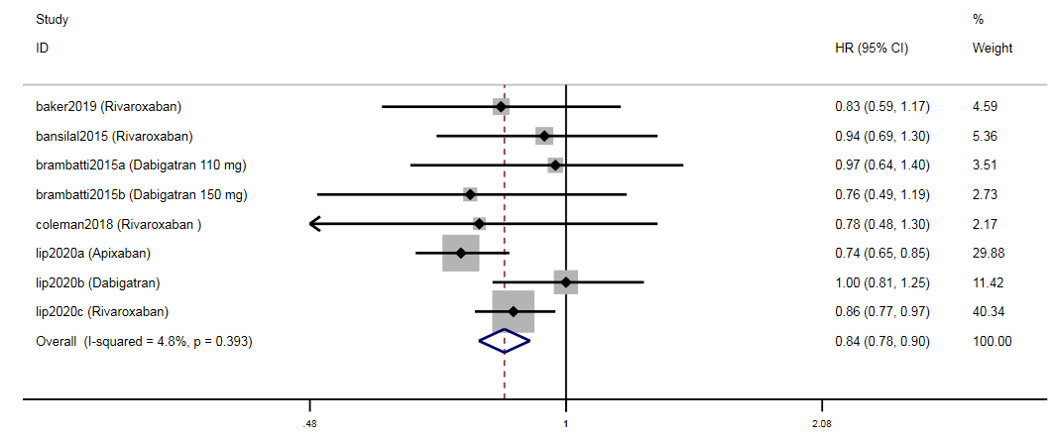
Fig. S1 Forest plot of the risk of ischemic stroke among NVAF patients with diabetes on NOACs versus warfarin.

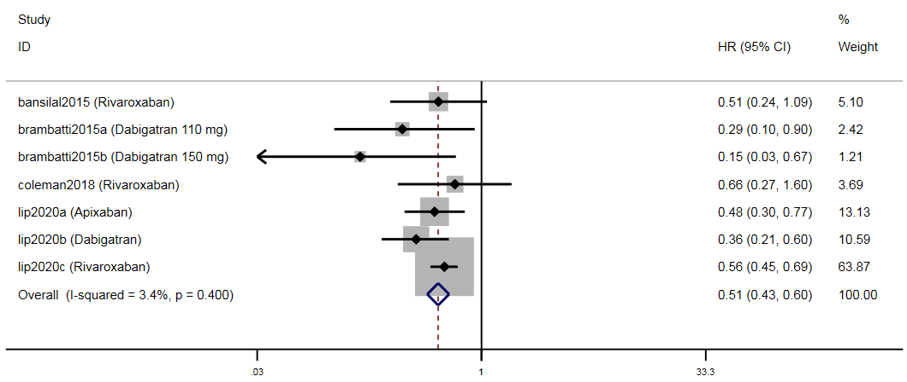
Fig. S2 Forest plot of the risk of hemorrhagic stroke among NVAF patients with diabetes on NOACs versus warfarin.

Fig. S3 Forest plot of the risk of intracranial bleeding among NVAF patients with diabetes on NOACs versus warfarin.
Fig. S4 Forest plot of the risk of gastrointestinal bleeding among NVAF patients with diabetes on NOACs versus warfarin.
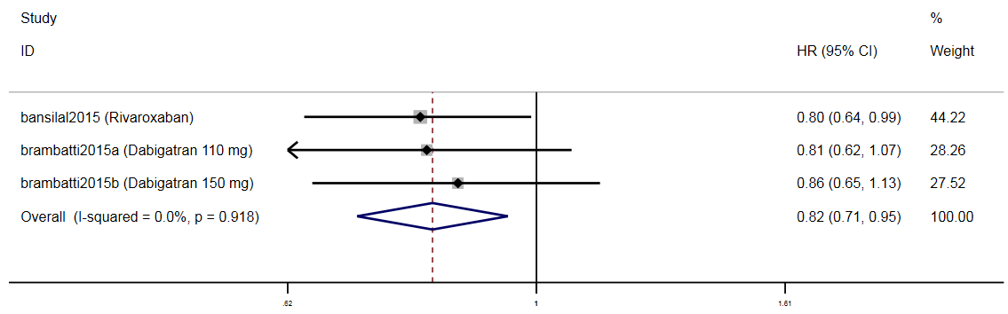
Fig. S5 Forest plot of the risk of vascular death among NVAF patients with diabetes on NOACs versus warfarin.
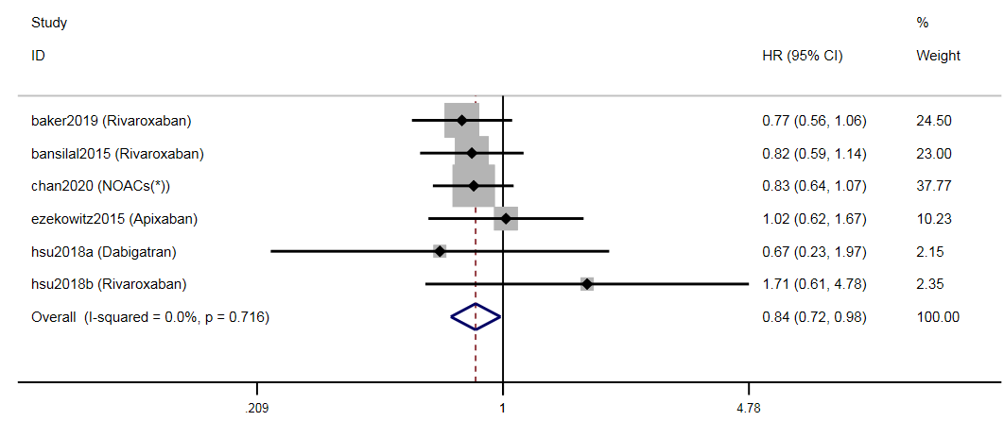
Fig. S6 Forest plot of the risk of myocardial infarction among NVAF patients with diabetes on NOACs versus warfarin.
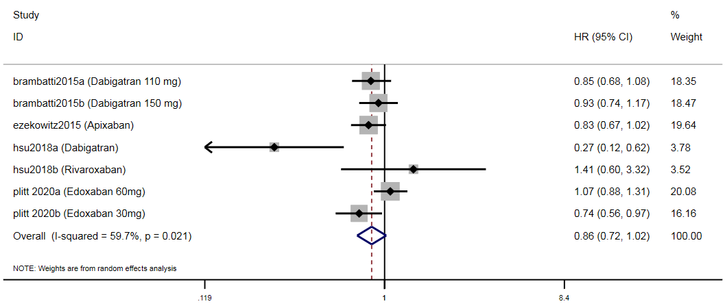
Fig. S7 Forest plot of the risk of all-cause mortality among NVAF patients with Diabetes on NOACs versus warfarin.

