MicroRNA-223 negatively regulates the osteogenic differentiation of periodontal ligament derived cells by directly targeting growth factor receptors
Running title: miR-223 inhibits PDLSCs osteogenesis
Zheng Zhang ^{1, 2, 3}, Minghui Wang ⁴, Youli Zheng ⁴, Yanmei Dai ^{1, 3}, Jiashu Chou ¹, Xiaowei Bian ⁴, Pengcheng Wang ⁵, Changyi Li ⁴, and Jing Shen ^{1, 3}

1. Tianjin Stomatological Hospital, School of Medicine, Nankai University, Tianjin 300041, China
2. State Key Laboratory of Natural and Biomimetic Drugs, Peking University, Beijing 100191, China
3. Tianjin Key Laboratory of Oral and Maxillofacial Function Reconstruction, Tianjin 300041, China
4. The School and Hospital of Stomatology, Tianjin Medical University, Tianjin 300070, China
5. Department of Stomatology, Beijing Shijitan Hospital, Capital Medical University, Beijing 100038, China

Zheng Zhang, Minghui Wang and Youli Zheng contributed equally to this work.

Correspondence:
Jing Shen, Tianjin Stomatological Hospital, School of Medicine, Nankai University, Tianjin 300041, China. E-mail: shenjing611@163.com
Changyi Li, The School and Hospital of Stomatology, Tianjin Medical University, Tianjin 300070, China. E-mail: lichangyi@tmu.edu.cn
Pengcheng Wang, Department of Stomatology, Beijing Shijitan Hospital, Capital Medical University, Beijing 100038, China. E-mail: xjztwpc@163.com

Supplementary table 1. The primer sequences used in the present study.
Species | Gene name | Primer sequence (5′-3′)
 |  | Forward primer | Reverse primer
Human | GAPDH | GCACCGTCAAGGCTGAGAAC | ATGGTGGTGAAGACGCCAGT
 | OPN | CGCAGACCTGACATCCAGT | GGCTGTCCCAATCAGAAGG
 | OCN | GTAGTGAAGAGACCCAGGCG | CTCCTGAAAGCCGATGTGGT
 | Runx2 | AGGCAGTTCCCAAGCATTTCATCC | TGGCAGGTAGGTGTGGTAGTGAG
 | FGFR2 | GCATCGCATTGGAGGCTA | TGTGATTGATGGACCCGTATT
 | TGFβR2 | GTATCGCCAGCACGATCCCA | CTCGTCATTCTTTCTCCATACAGC
 | U6 | GGTCTCGCTTCGGCAGCACA
 | miR-223 | TGTCAGTTTGTCAAATACCCCAAA

Supplementary table 2. The clinical characteristics of the participants.
 | Control group | Periodontitis group | p-Value
Number of subjects | 20 | 20
Age (year) | 42.55 ± 8.66 | 41.95 ± 8.12 | 0.82
Gender (F/M) | 10/10 | 9/10 | 1.00
Mean PI | 0.40 ± 0.26 | 2.00 ± 0.40 | < 0.001
Mean GI | 0.15 ± 0.24 | 1.90 ± 0.38 | < 0.001
Mean BI | 0.00 ± 0.00 | 3.08 ± 0.57 | < 0.001
Mean PD (mm) | 2.17 ± 0.34 | 4.51 ± 1.11 | < 0.001
Mean AL (mm) | 0.34 ± 0.13 | 3.60 ± 1.02 | < 0.001
Data are presented as mean ± standard deviation, or number of subjects.
AL, attachment loss; BI, bleeding index; GI, gingival index; PD, pocket depth; PI, plaque index.

Supplementary table 3. The target genes of miR-223.
FBXW7 | PHF19 | WDR77 | SRP19 | MAP4 | TMEM47 | PRKCE | TGFBR3 | RBBP4 | STYX | SESN3
RHOB | ARMC1 | SSRP1 | PFN2 | PHF20L1 | EPSTI1 | NRF1 | ZBTB41 | LRP12 | RRAS2 | PSD3
LELP1 | SLC25A32 | CTNNA2 | XKR6 | MPZ | PKP4 | CNOT2 | JMY | RORB | SH3D19 | TNRC6B
PTS | NDP | XPR1 | POU2F1 | MARCH3 | SOX11 | ERC1 | PLEKHA3 | SLC35F1 | SOX6 | ZIC1
TBC1D17 | ATP10D | DESI2 | ERO1LB | MYBL1 | PDE4D | VAV3 | CNDP1 | PFKFB3 | RAB10 | TBC1D15
RP11-192H23.4 | PEX16 | SHOX2 | SCARB1 | EIF4E3 | RALGPS2 | KIAA1468 | ATL2 | C8orf46 | CALML4 | ATG7
WDR62 | TNNI3K | ATP1B1 | SMARCD1 | RPS6KB1 | USP6NL | MTMR2 | TRPV2 | MBNL1 | RIMS3 | FAM83D
LACC1 | MID1IP1 | ARPP19 | MMP16 | CCT3 | BAI3 | MAFB | RNF4 | FOXP1 | DLEU1 | MEF2D
GTSF1 | SEPT8 | SCAF8 | RYBP | LHX8 | FGFR2 | VMP1 | SECISBP2L | HEY2 | HNMT | PHKG2
GALNT18 | ARPC5L | POMP | SLC24A2 | SCN1A | PDE3B | PLEKHH1 | KIAA1755 | NRXN3 | IFNLR1 | GPR22
GTPBP8 | FPGT-TNNI3K | NXF1 | ATP2B1 | KBTBD6 | CCNT2 | TSHZ3 | ZFX | TOP2B | NCOA1 | MCMBP
CCDC149 | RWDD1 | ADCYAP1 | PLAGL2 | G3BP1 | SPATA13 | GPR155 | DENND5B | KMT2C | RSBN1L | PPP1R15A
C18orf54 | RCN2 | PTBP2 | LRRC19 | ZEB1 | OPCML | WBP1L | GTDC1 | CARM1 | PRR14L | WDR7
SNX24 | PURB | KLF7 | FAM46A | ZFHX3 | HMGCS1 | SDC2 | AGO3 | FRMD4A | SRGAP3 | LRRC40
FBXO8 | CDK17 | PAX5 | SPRED1 | PDS5B | LIF | MTSS1 | FBXO28 | POLR1C | TRMT2B | AGMO
IL6ST | MEF2C | F3 | C10orf11 | RAP2A | PRKACB | PLCE1 | ANKFY1 | WDR43 | HDAC4
PDZD11 | APC | NUP210 | ACTRT3 | METAP1 | ZXDB | TSC22D1 | ZNF395 | PDPK1 | GLUL
ATP7A | LYPD6 | ULK2 | RASSF4 | ZZZ3 | RPS15A | IGF1R | PIK3C2A | PSMA5 | ZBTB40
FOXO1 | RASA1 | CLSTN1 | VHL | BRINP3 | TXLNG | CSNK1G1 | FAM168A | ZNF706 | C17orf75
ARMCX1 | SLC39A1 | PURA | NAA50 | CNOT1 | ZBTB10 | PA2G4 | CPEB3 | ELL2 | UBE2A
CYTIP | PROKR2 | KAT6A | RFTN2 | NF2 | TBC1D4 | DCUN1D3 | NUDT3 | E2F1 | MAP2K6
ECT2 | BRMS1L | NLRP3 | ANKRD17 | MFSD6 | RBPJ | PAPD5 | SP1 | RP11-10A14.4 | CCDC85C
SLC4A4 | TMEM178B | SLCO1A2 | MMP19 | FAM98A | TAOK3 | NFIC | RC3H1 | TGFBR2 | TET3
SLC37A3 | KIAA0226L | GPM6B | STIM1 | WASL | LONP2 | EPOR | SH2B3 | ABHD13 | NOVA2
LMO2 | SLC8A1 | KPNA3 | KLF12 | GABPB2 | KIF4A | CREBZF | MAT2B | MGA | CLPB
LAYN | CRIM1 | GFPT1 | COPS2 | DNAJC6 | UBE2W | RNF217 | SETBP1 | TIAL1 | WDR26
INPP5B | VAMP2 | MBNL3 | KLK15 | FZD4 | FNBP1L | ZXDA | SELT | HIPK2 | SNCA
RNF145 | SEPT6 | NUTF2 | FOXO3 | PHIP | ZCCHC14 | ELF2 | C11orf30 | TMED7 | VTI1A
ACSL3 | SREK1 | SLC23A2 | ST8SIA3 | STK39 | SCN3A | AEBP2 | UHMK1 | VPS39 | RP11-315D16.2
HSP90B1 | CTSV | MSMO1 | DOCK2 | APOBEC4 | GNA13 | GRAMD4 | ZBTB18 | EBF3 | ZNF507
NFIA | SRSF10 | CSPG5 | ITPR3 | ZC3H6 | C14orf142 | ENPP5 | KIAA0355 | FAM46C | KCNMB4
FAM199X | PRDM1 | TMEM64 | ARID1A | MSI2 | UCP3 | FBXL4 | ABCG4 | ZNF207 | GRHPR
HLF | SEPT4 | COPS8 | SYNCRIP | ZBTB4 | NFASC | MAP1B | PDS5A | MYCBP | RGS9BP
SP3 | CBLB | HHEX | KANSL1L | OTUD4 | UQCC1 | TSPAN5 | PHLPP1 | SRPK2 | PAX6
DNAJB13 | RNF34 | INPP4A | ELP4 | SCN2A | CEP41 | SPTLC2 | CBX5 | MBOAT2 | U2SURP
SIAH1 | NUCKS1 | UBXN1 | EYA3 | FAT1 | ZSCAN12 | FDX1L | ZFP3 | PCDH12 | CAND1
RGS1 | ST3GAL1 | NDNF | AKAP1 | TCERG1 | MYH10 | MOSPD1 | FUBP3 | CDYL | EIF5B
ACVR2A | SORBS1 | USP42 | BRPF3 | ZSWIM7 | TMEM170A | GLIPR1 | AIFM1 | FBXO30 | RBMS2
SYAP1 | NFIB | SGMS2 | SMOC1 | TMC5 | ATXN7L1 | ELK4 | ABI2 | TWIST1 | PKNOX1
USP16 | RERG | RAB8B | KIAA0226 | POLR3E | RBM20 | SPPL2A | CHUK | FAM160B1 | NLE1

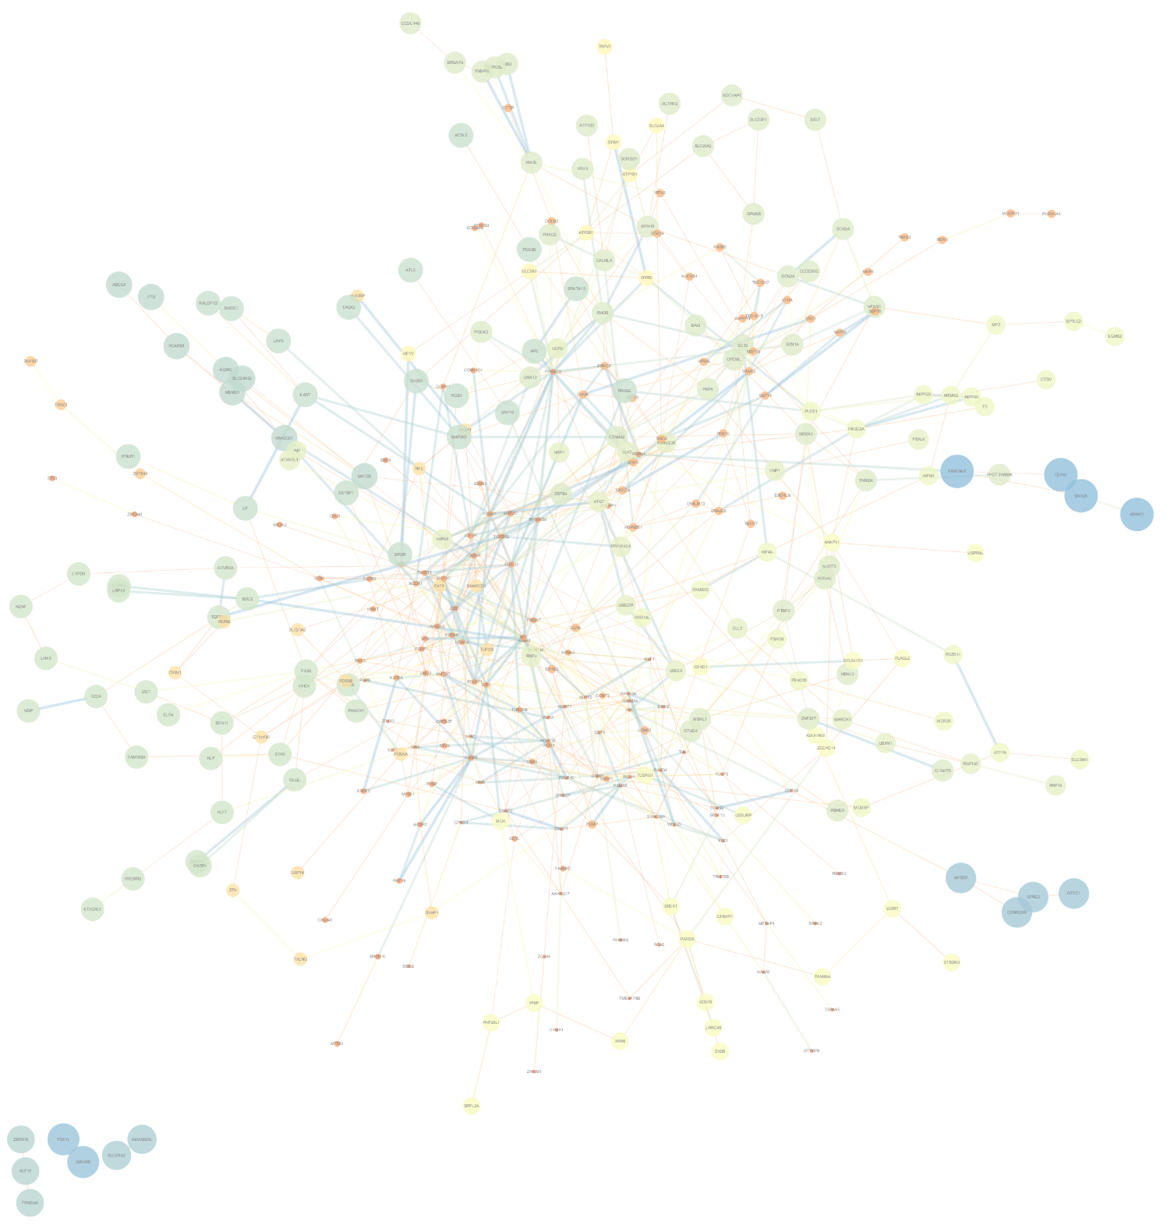
Supplementary Fig. 1 The PPI network of miR-223 target genes.

