A.
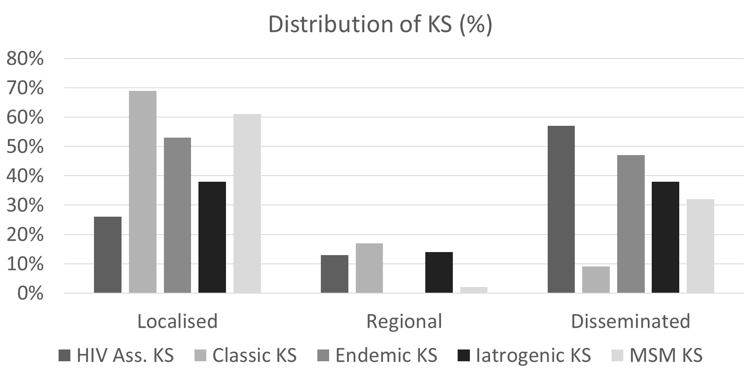
*
*
B.
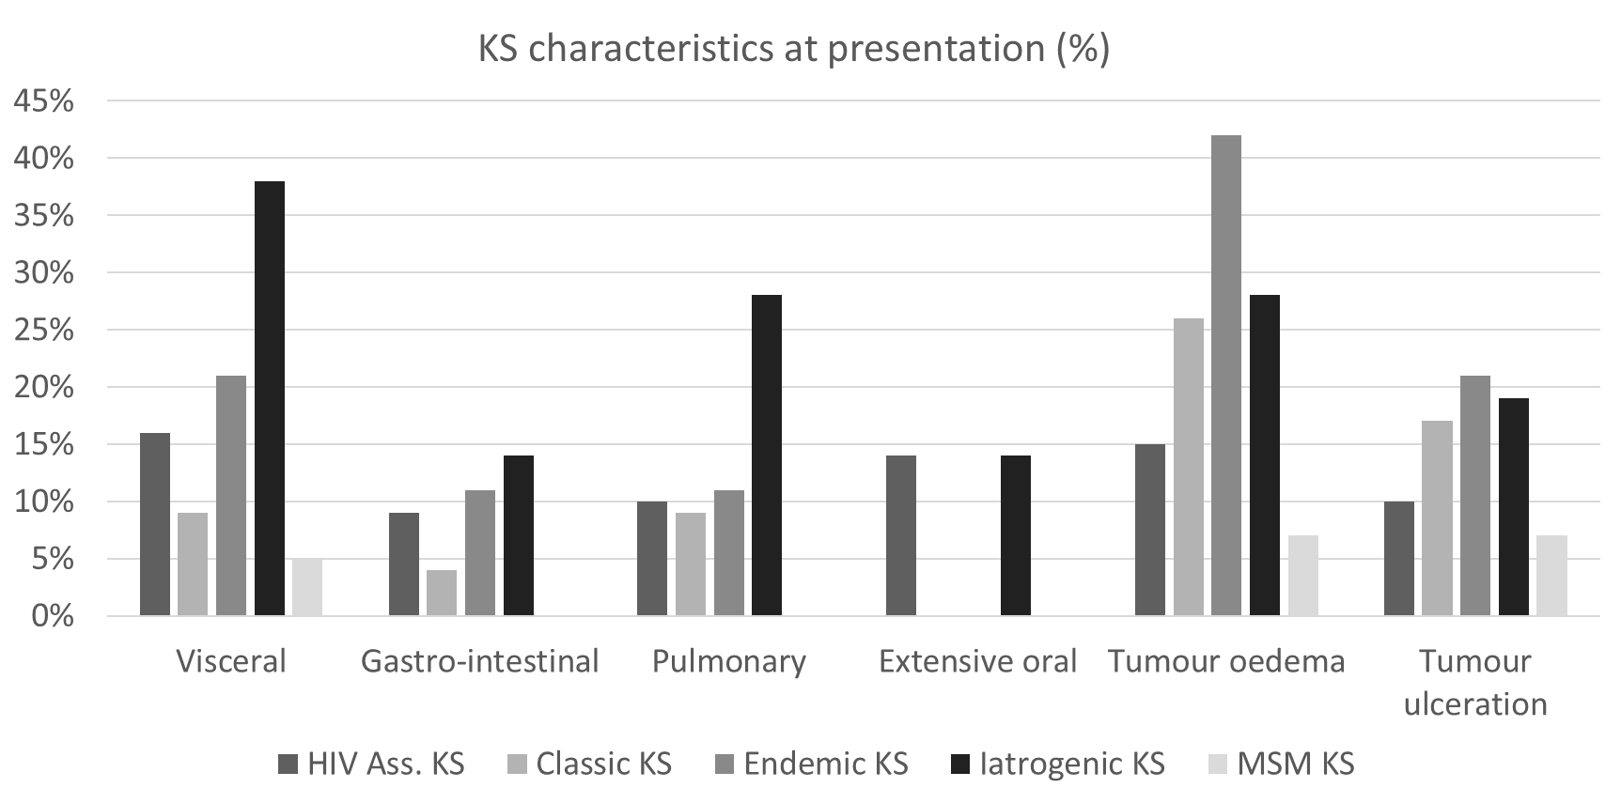
S1 (online only). Clinical Presentation of KS. A) Distribution of skin sites of KS. B) Characteristics of Advanced KS including sites of involvement for disseminated disease tumour oedema and tumour ulceration.

