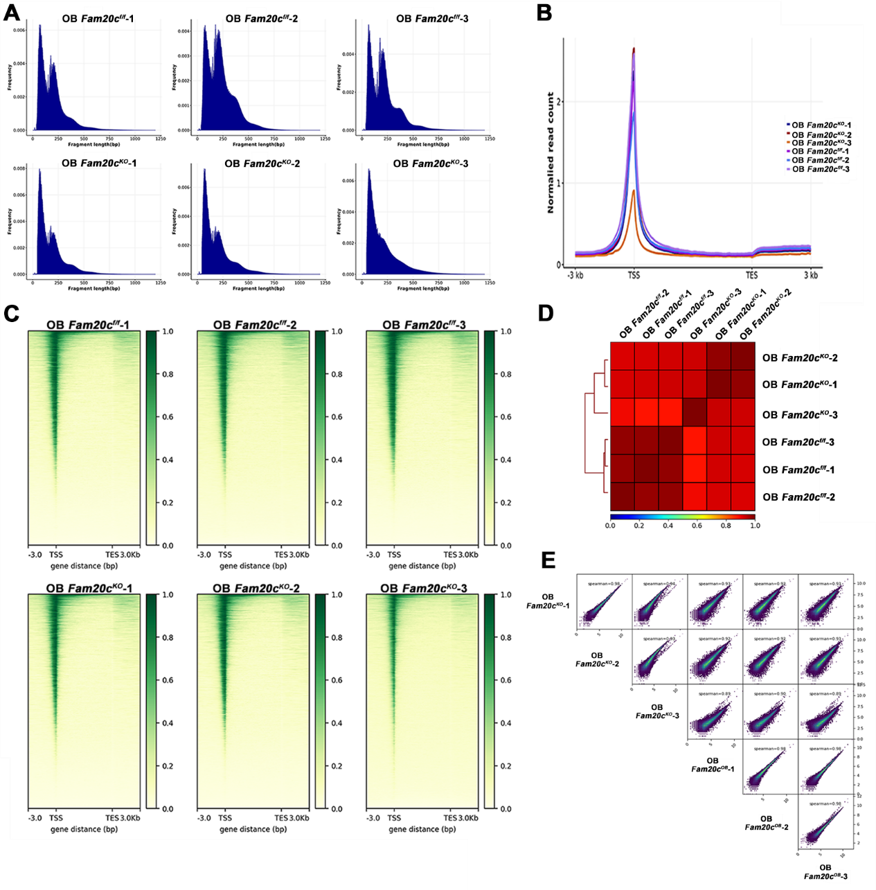
Figure S1 Quality control for ATAC-seq samples generated in this study.
A: Fragment length distribution map. The X-axis represents fragment length (bp), and the Y-axis represents frequency.
B: Reads distributions (from bigwig) across genes are presented as an average plot (average of reads signals across all genes).
C: Reads distributions (from bigwig) across genes are presented as a heatmap. The X-axis represents the normalized gene range coordinates, and the Y-axis represents the read enrichment. The larger the value, the more enriched. TSS stands for the gene start site, and TES stands for the gene stop site. -3.0 represents 3 kb upstream of TSS, and 3.0 kb represents 3 kb downstream of TES. Ensembl Mus musculus reference genome annotation (mm10_gencode) is used as regions for calculating enrichment of the ATAC signal at and around the TSS. The heatmap is made using deeptools.
D: The Pearson correlation results are shown by the heatmap.
E: The Pearson correlation results are shown by the heatmap scatterplot.

