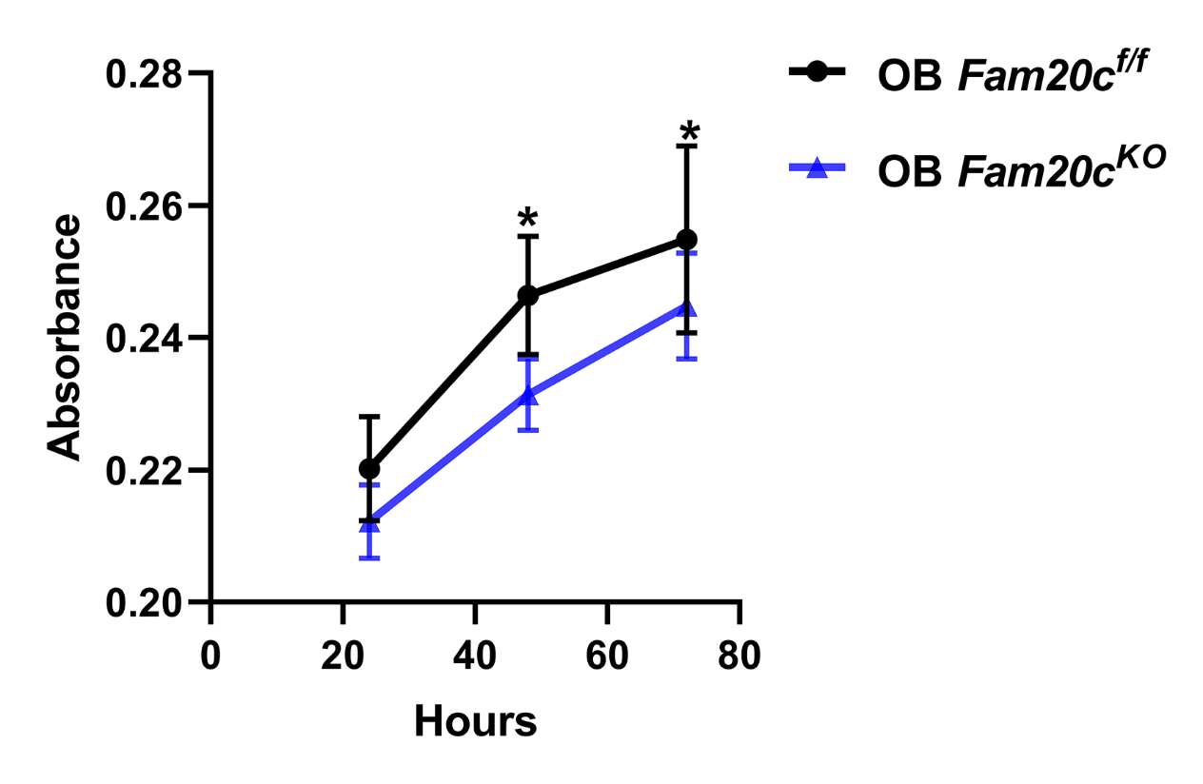
Figure S2 Cell proliferation assay of OB Fam20c^{f/f} and OB Fam20c^{KO} vitro.
X-axis represents hour, and the Y-axis represents absorbance. The black line represents OB Fam20c^{f/f}, and the blue line represents OB Fam20c^{KO}. *P <0.05, t test.

