Additional Material
Association of impaired sensitivity to thyroid hormones with hyperuricemia through obesity in the euthyroid population
Zhiyuan Wu, et al.
1 Additional Tables
Table S1: Basic characteristics of the participants according to obesity or not
Table S2: Logistic regression analysis for the association of thyroid hormone sensitivity and hyperuricemia among 28153 participants with available BMI data
Table S3: Mediation analyses of the association of continuous thyroid hormones sensitivity indices and hyperuricemia
Table S4: Estimated direct and indirect effect of thyroid hormones sensitivity indices (categorical) on hyperuricemia
2 Additional Figures
Figure S1: Flow chart of this current study
Figure S2: The violin plot and boxplot in distribution of thyroid hormone sensitivity indices between two groups
Figure S3: Unadjusted and adjusted dose-response relationship between thyroid hormone sensitivity indices and hyperuricemia using restricted cubic spline method among 28153 participants with available BMI data
Figure S4: Dose-response relationship between thyroid hormone sensitivity indices and obesity using restricted cubic spline method among 28153 participants with available BMI data
Table S1 Basic characteristics of the participants according to obesity or not
 | Overall | Non-obesity | Obesity ^{f} | P value
Participants, No. | 28153 | 22497 | 5656
Age, mean (SD), y | 47.4 (13.4) | 47.3 (13.5) | 48.0 (13.0) | <0.001
Sex |  |  |  | <0.001
Female | 10548 (37.5) | 9424 (41.9) | 1124 (19.9)
Male | 17065 (62.5) | 13073 (58.1) | 4532 (80.1)
Educational level |  |  |  | <0.001
Primary | 2570 (9.1) | 1984 (8.8) | 586 (10.4)
Secondary | 19956 (70.9) | 15942 (70.9) | 4014 (71.0)
Tertiary | 5627 (20.0) | 4571 (20.3) | 1056 (18.7)
Active physical activity ª | 11373 (40.4) | 9157 (40.7) | 2216 (39.2) | 0.038
Current smoking | 7278 (25.9) | 5517 (24.5) | 1761 (31.1) | <0.001
Current drinking | 14610 (51.9) | 11418 (50.8) | 3192 (56.4) | <0.001
BMI, mean (SD), kg/m^{2 b} | 25.3 (3.5) | 24.0 (2.5) | 30.4 (2.3) | <0.001
Hypertension ^{c}  Diabetes ^{d} | 6071 (21.6)  2864 (10.2) | 3946 (17.5)  1935 (8.6) | 2125 (37.6)  929 (16.4) | <0.001  <0.001
TSH, median [IQR], mIU/L | 1.9 [1.4, 2.7] | 1.9 [1.4, 2.7] | 2.0 [1.4, 2.7] | 0.004
FT4, median [IQR], pmol/L | 15.8 [14.3, 17.4] | 15.8 [14.2, 17.4] | 15.9 [14.3, 17.4] | 0.040
UA, mean (SD), μmol/L | 341.0 (89.4) | 329.4 (85.6) | 386.9 (89.3) | <0.001
Hyperuricemia ^{e} | 5968 (21.2) | 3889 (17.3) | 2079 (36.8) | <0.001

Abbreviations: SD, standard deviation; IQR, interquartile range; BMI, body mass index; TSH, thyrotropin; FT4, free thyroxine; UA, uric acid.
SI conversion factors: To convert FT4 to ng/dL, divided by 12.871.
ª Active physical activity refers to having moderate or intense exercise ≥80 minutes a weak.
^{b} BMI is calculated as weight in kilograms divided by height in meters squared. Data of BMI were available among 28153 participants.
^{c} Hypertension was defined as systolic blood pressure ≥140 mmHg or diastolic blood pressure ≥90 mmHg or self-reported diagnosis history of hypertension or use of any anti-hypertensive medication.
^{d} Diabetes was defined as fasting glucose ≥7.0 mmol/L or self-reported diagnosis history of diabetes or using any glucose-lowering medication.
^{e} Hyperuricemia was defined as serum uric acid ≥360 μmol/L in female and ≥420 μmol/L in male or using uric acid lowering medications.
f Obesity was defined using BMI ≥ 28.0 kg/m² for the Chinese population.
Table S2 Logistic regression analysis for the association of thyroid hormone sensitivity and hyperuricemia among 28153 participants with available BMI data

 | Model 1 |  |  | Model 2
 | OR (95% CI) | P value |  | OR (95% CI) | P value
TFQI
Group 1 | 1 [Ref] |  |  | 1 [Ref]
Group 2 | 1.048 (0.981-1.120) | 0.166 |  | 1.020 (0.952-1.092) | 0.579
Group 3 | 1.119 (1.033-1.212) | 0.006 |  | 1.023 (0.942-1.111) | 0.592
Group 4 | 1.354 (1.184-1.549) | <0.001 |  | 1.141 (0.994-1.127) | 0.061
PTFQI
Group 1 | 1 [Ref] |  |  | 1 [Ref]
Group 2 | 1.052 (0.984-1.124) | 0.138 |  | 1.024 (0.956-1.097) | 0.495
Group 3 | 1.114 (1.029-1.205) | 0.008 |  | 1.017 (0.938-1.104) | 0.680
Group 4 | 1.379 (1.209-1.573) | <0.001 |  | 1.151 (1.005-1.318) | 0.042
TSHI
Quartile 1 | 1 [Ref] |  |  | 1 [Ref]
Quartile 2 | 0.996 (0.917-1.081) | 0.916 |  | 1.018 (0.936-1.108) | 0.677
Quartile 3 | 1.056 (0.973-1.145) | 0.191 |  | 1.075 (0.989-1.169) | 0.088
Quartile 4 | 1.136 (1.048-1.231) | 0.002 |  | 1.108 (1.020-1.204) | 0.015
TT4RI
Quartile 1 | 1 [Ref] |  |  | 1 [Ref]
Quartile 2 | 0.993 (0.916-1.078) | 0.876 |  | 1.015 (0.934-1.104) | 0.721
Quartile 3 | 1.042 (0.961-1.131) | 0.315 |  | 1.094 (1.006-1.189) | 0.036
Quartile 4 | 1.086 (1.002-1.177) | 0.044 |  | 1.164 (1.071-1.265) | <0.001

Abbreviations: OR, odds ratio; CI, confidence interval; TFQI, thyroid feedback quantile-based index; PTFQI, parametric thyroid feedback quantile-based index; TT4RI, thyrotrophic thyroxine resistance index; TSHI, thyroid-stimulating hormone index.
Model 1: crude model; model 2: adjusted for sex, age (continuous), education level (categorical), current smoking (categorical), current drinking (categorical), active physical activity (categorical), hypertension (categorical) and diabetes (categorical).
Table S3 Mediation analyses of the association of continuous thyroid hormones sensitivity indices and hyperuricemia

 | β (95% CI) |  |  | Mediated  Proportion
 | Total Effect | Direct Effect | Indirect Effect
TFQI | 0.0090 (0.0043 to 0.0138) | 0.0061 (0.0020 to 0.0112) | 0.0029 (0.0017 to 0.0040) | 32.35% ª
PTFQI | 0.0090 (0.0043 to 0.0139) | 0.0061 (0.0020 to 0.0112) | 0.0029 (0.0017 to 0.0040) | 32.29% ª
TT4RI | 0.0045 (-0.0001 to 0.0093) | 0.0028 (-0.0012 to 0.0078) | 0.0018 (0.0006 to 0.0029) | 39.63% ^{b}
TSHI | 0.0065 (0.0018 to 0.0113) | 0.0042 (0.0001 to 0.0093) | 0.0024 (0.0012 to 0.0035) | 37.68% ª

Abbreviations: CI, confidence interval; TFQI, thyroid feedback quantile-based index; PTFQI, parametric thyroid feedback quantile-based index; TT4RI, thyrotrophic thyroxine resistance index; TSHI, thyroid-stimulating hormone index.
ª P value <0.001.
^{b} P value <0.05.

Table S4 Estimated direct and indirect effect of thyroid hormones sensitivity indices (categorical) on hyperuricemia

 | HUA, No./  Total No. | β (95% CI) ª |  |  | % Mediated
 |  | Total Effect | Direct Effect | Indirect Effect
TFQI
Group 1 | 2738 / 13420 | [Ref] | [Ref] | [Ref]
Group 2 | 1843 / 8704 | 0.0074 (-0.0035 to 0.0201) | 0.0035 (-0.0070 to 0.0157) | 0.0039 (0.0014 to 0.0060) | 53.10
Group 3 | 1069 / 4795 | 0.0187 (0.0040 to 0.0332) | 0.0126 (-0.0015 to 0.0225) | 0.0061 (0.0020 to 0.0093) | 32.54 ^{b}
Group 4 | 318 / 1234 | 0.0520 (0.0299 to 0.0785) | 0.0430 (0.0228 to 0.0692) | 0.0090 (0.0025 to 0.0161) | 17.31 ^{b}
PTFQI
Group 1 | 2711 / 13310 | [Ref] | [Ref] | [Ref]
Group 2 | 1825 / 8609 | 0.0080 (-0.0018 to 0.0214) | 0.0039 (-0.0057 to 0.0170) | 0.0041 (0.0017 to 0.0065) | 51.06
Group 3 | 1098 / 4953 | 0.0177 (0.0039 to 0.0313) | 0.0117 (-0.0013 to 0.0245) | 0.0059 (0.0022 to 0.0092) | 33.62 ^{b}
Group 4 | 334 / 1281 | 0.0558 (0.0329 to 0.0822) | 0.0457 (0.0224 to 0.0719) | 0.0101 (0.0035 to 0.0170) | 18.06 ^{b}
TT4RI
Quartile 1 | 1453 / 7018 | [Ref] | [Ref] | [Ref]
Quartile 2 | 1449 / 7035 | -0.0010 (-0.0127 to 0.0141) | -0.0008 (-0.0120 to 0.0120) | -0.0002 (-0.0036 to 0.0034) | 20.49
Quartile 3 | 1509 / 7053 | 0.0060 (-0.0056 to 0.0185) | 0.0032 (-0.0077 to 0.0152) | 0.0027 (-0.0006 to 0.0066) | 45.96
Quartile 4 | 1557 / 7047 | 0.0128 (0.0023 to 0.0255) | 0.0075 (-0.0031 to 0.0201) | 0.0053 (0.0021 to 0.0091) | 41.29 ^{b}
TSHI
Quartile 1 | 1435 / 7016 | [Ref] | [Ref] | [Ref]
Quartile 2 | 1431 / 7021 | -0.0010 (-0.0116 to 0.0144) | -0.0023 (-0.0117 to 0.0115) | 0.0013 (-0.0018 to 0.0047) | -129.42
Quartile 3 | 1509 / 7068 | 0.0083 (-0.0049 to 0.0229) | 0.0033 (-0.0088 to 0.0182) | 0.0049 (0.0012 to 0.0087) | 59.51
Quartile 4 | 1593 / 7048 | 0.0207 (0.0093 to 0.0330) | 0.0142 (0.0027 to 0.0263) | 0.0065 (0.0031 to 0.0100) | 31.30 ^{b}

Abbreviations: HUA, hyperuricemia; CI, confidence interval; TFQI, thyroid feedback quantile-based index; PTFQI, parametric thyroid feedback quantile-based index; TT4RI, thyrotrophic thyroxine resistance index; TSHI, thyroid-stimulating hormone index.
ª Refers to the pairwise comparison with group1 or quartile 1 as the reference group.
^{b} P value < 0.05.

Supplemental Figures

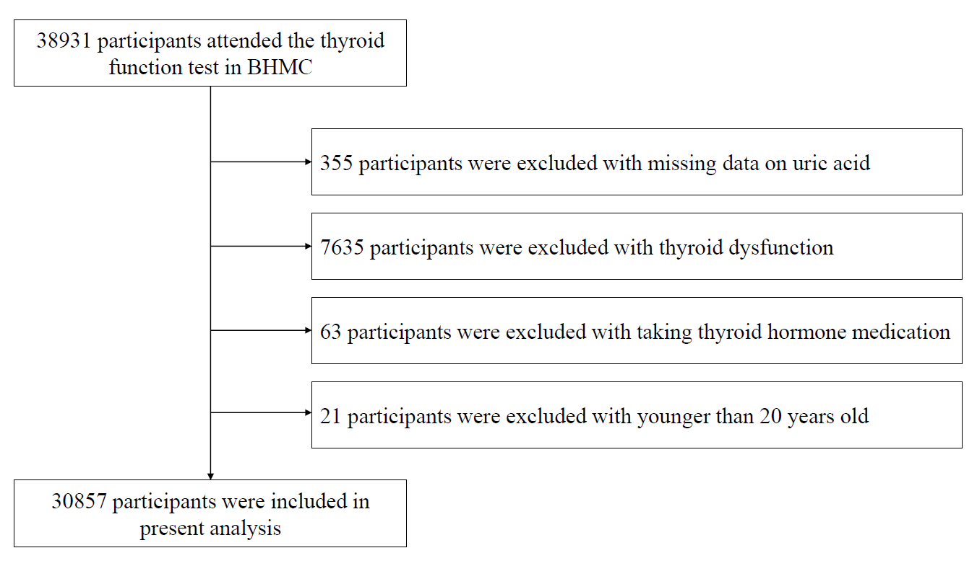
Figure S1 Flow chart of this current study
Abbreviations: BHMC, Beijing health management cohort.

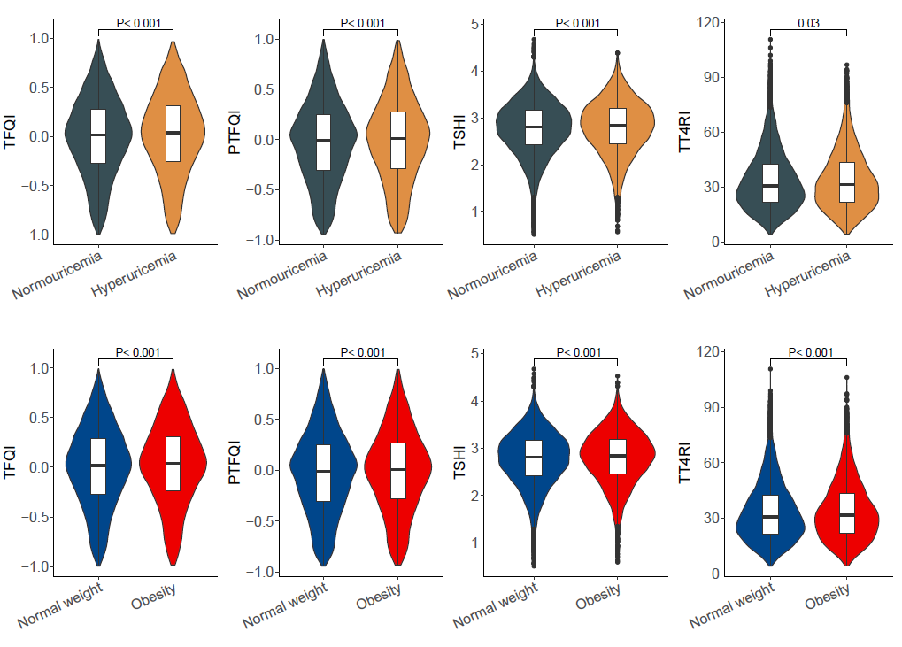
Figure S2 The violin plot and boxplot in distribution of thyroid hormone sensitivity indices between two groups
Abbreviations: TFQI, thyroid feedback quantile-based index; PTFQI, parametric thyroid feedback quantile-based index; TT4RI, thyrotrophic thyroxine resistance index; TSHI, thyroid-stimulating hormone index.
Obesity was defined using BMI ≥ 28.0 kg/m².

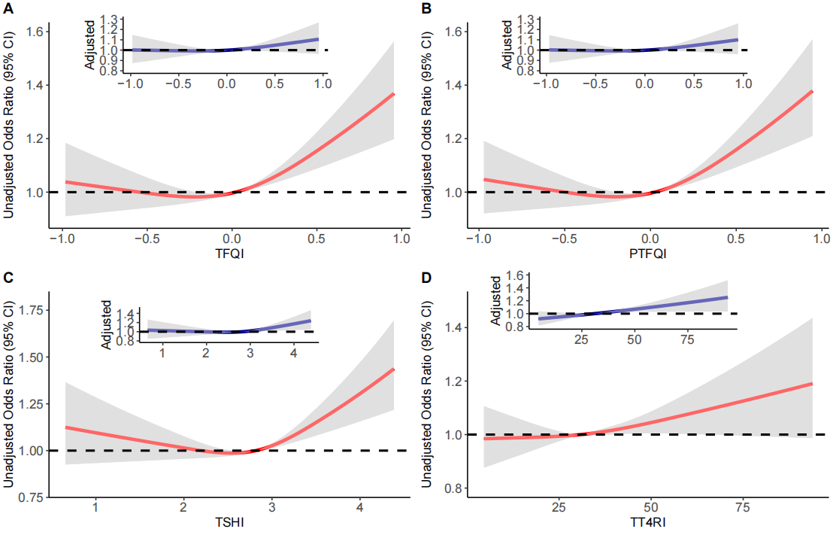
Figure S3 Unadjusted and adjusted dose-response relationship between thyroid hormone sensitivity indices and hyperuricemia using restricted cubic spline method among 28153 participants with available BMI data
Restricted cubic spline regression model was conducted using 3 knots at the 10th, 50th, and 90th percentiles; results were adjusted for sex, age (continuous), education level (categorical), current smoking (categorical), current drinking (categorical), active physical activity (categorical), hypertension (categorical) and diabetes (categorical).
Abbreviations: BMI, body mass index; TFQI, thyroid feedback quantile-based index; PTFQI, parametric thyroid feedback quantile-based index; TT4RI, thyrotrophic thyroxine resistance index; TSHI, thyroid-stimulating hormone index.

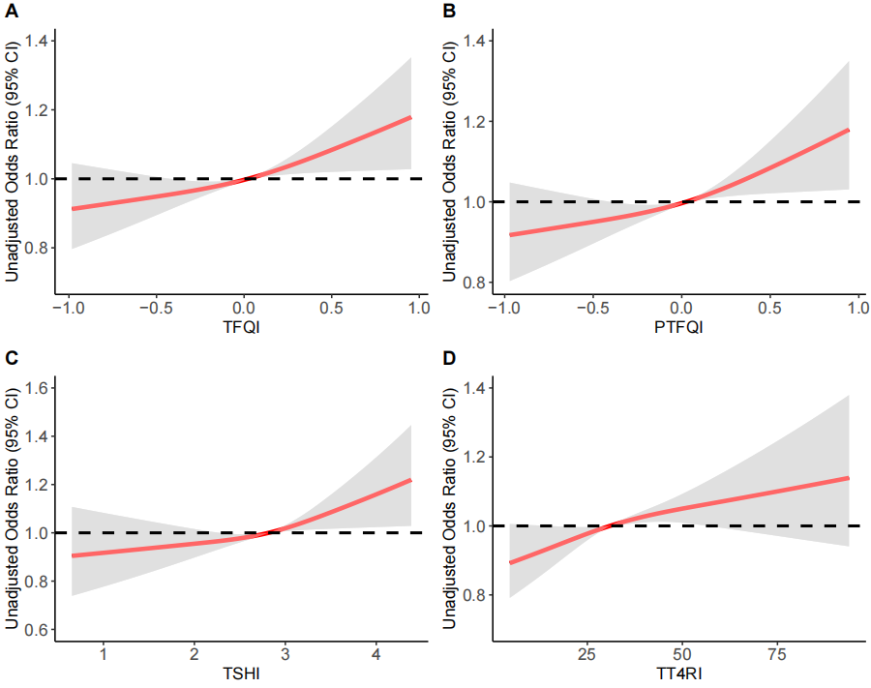
Figure S4 Dose-response relationship between thyroid hormone sensitivity indices and obesity using restricted cubic spline method among 28153 participants with available BMI data
Abbreviations: BMI, body mass index; TFQI, thyroid feedback quantile-based index; PTFQI, parametric thyroid feedback quantile-based index; TT4RI, thyrotrophic thyroxine resistance index; TSHI, thyroid-stimulating hormone index.
Obesity was defined using BMI ≥ 28.0 kg/m².

