**SUPPLEMENTARY MATERIAL**

**Figure 1:**

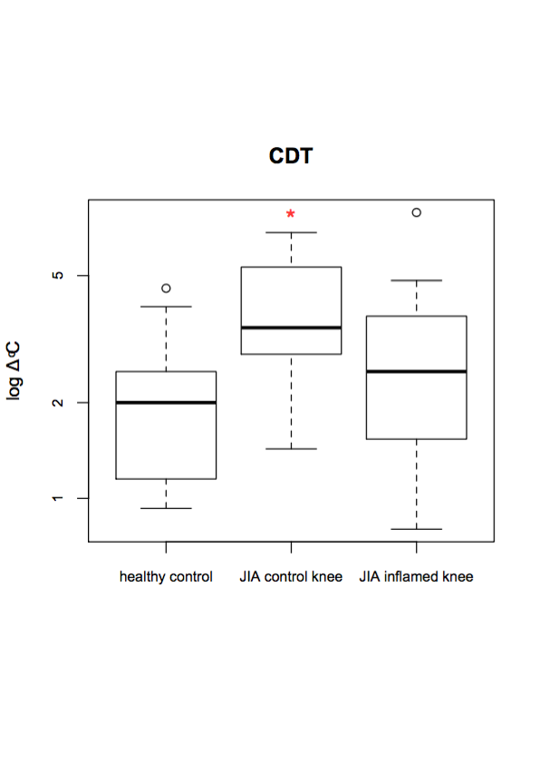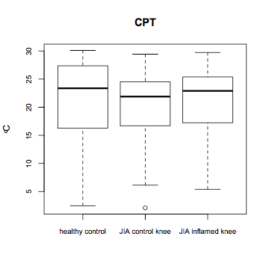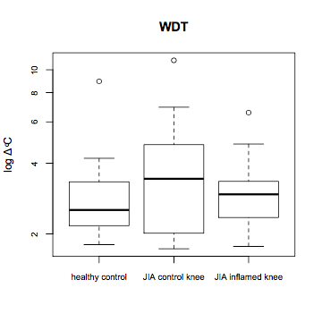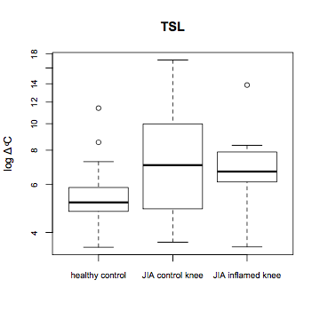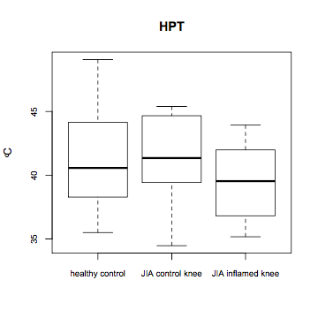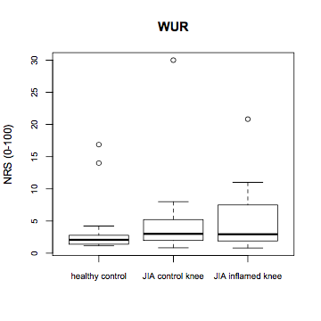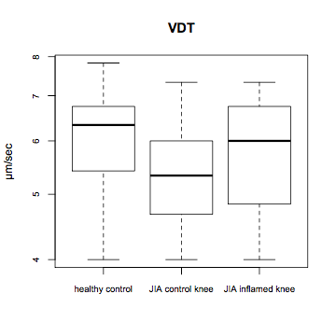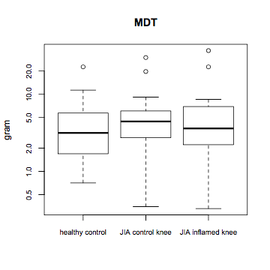

**Legend:** CDT, cold detection threshold; WDT, warm detection threshold; TSL, thermal sensory limen; CPT, cold pain threshold; HPT, heat pain threshold; MDT, mechanical detection threshold; MPT, mechanical pain threshold; VDT, vibration detection threshold; PPT, pressure pain threshold; WUR, wind-up ratio; ALL, allodynia. * Significant at 0.05

