SUPPLEMENTARY MATERIAL
Table S1: Average concentrations and RM ANOVA p-values the metabolites selected to be significant pertaining to the aim of this investigation
Metabolite (PubChem ID) | Group | RM ANOVA |  | P0 | P1 | P2 | P3
 |  | Intervention p-value | Interaction p-value | Average concentration ±standard deviation
α-Oleoylglycerol (5319879) | Placebo | 0.42 | 0.01 | 0.001 ± 3.8×10⁻⁴ | 0.001 ± 3.6×10⁻⁴ | 4.3×10⁻⁴ ± 3.1×10⁻⁴ | 0.001 ± 3.9×10⁻⁴
 | Beetroot |  |  | 0.001 ± 0.001 | 4.1×10⁻⁴ ± 2.6×10⁻⁴ | 4.8×10⁻⁴ ± 3.2×10⁻⁴ | 0.001 ± 3.9×10⁻⁴
β-Hydroxydecenedioate (121232666) | Placebo | 0.58 | 0.04 | 0.005 ± 0.001 | 0.006 ± 0.002 | 0.007 ± 0.002 | 0.005 ± 0.001
 | Beetroot |  |  | 0.006 ± 0.002 | 0.006 ± 0.002 | 0.006 ± 0.001 | 0.006 ± 0.003
β-Hydroxyphenylacetate (12122) ª | Placebo | 0.01 | 0.07 | 3.1×10⁻⁵ ± 4.6×10⁻⁵ | 2.8×10⁻⁵ ± 4.1×10⁻⁵ | 1.6×10⁻⁵ ± 3.1×10⁻⁵ | 2.0×10⁻⁵ ± 3.6×10⁻⁵
 | Beetroot |  |  | 4.3×10⁻⁵ ± 6.4×10⁻⁵ | 1.1×10⁻⁴ ± 1.3×10⁻⁴ | 3.2×10⁻⁵ ± 4.3×10⁻⁵ | 5.9×10⁻⁵ ± 4.3×10⁻⁵
β-Hydroxyvalerate (107802) | Placebo | 0.02 | 0.72 | 5.3×10⁻⁴ ± 4.2×10⁻⁴ | 6.0×10⁻⁴ ± 3.9×10⁻⁴ | 6.8×10⁻⁴ ± 4.5×10⁻⁴ | 5.2×10⁻⁴ ± 1.7×10⁻⁴
 | Beetroot |  |  | 0.001 ± 0.001 | 0.002 ± 0.002 | 0.001 ± 0.001 | 0.001 ± 0.001
p-Hydroxyphenylacetate (127) | Placebo | 0.02 | 0.92 | 0.001 ± 0.001 | 0.002 ± 0.002 | 0.001 ± 0.001 | 0.001 ± 0.001
 | Beetroot |  |  | 0.002 ± 0.001 | 0.003 ± 0.001 | 0.002 ± 0.001 | 0.002 ± 0.001
Arabitol (43925) | Placebo | 2.9×10⁻⁴ | 1.4×10⁻⁸ | 0.004 ± 0.001 | 0.005 ± 0.002 | 0.004 ± 0.001 | 0.003 ± 0.001
 | Beetroot |  |  | 0.005 ± 0.002 | 0.005 ± 0.002 | 0.007 ± 0.002 | 0.007 ± 0.002
Eicosanoate (10467) | Placebo | 0.01 | 0.95 | 4.2×10⁻⁴ ± 2.3×10⁻⁴ | 0.001 ± 4.1×10⁻⁴ | 4.6×10⁻⁴ ± 2.9×10⁻⁴ | 3.7×10⁻⁴ ± 2.0×10⁻⁴
 | Beetroot |  |  | 0.001 ± 4.4×10⁻⁴ | 0.001 ± 3.6×10⁻⁴ | 0.001 ± 0.001 | 0.001 ± 2.8×10⁻⁴
Glycerol (753) | Placebo | 0.33 | 0.03 | 0.084 ± 0.031 | 0.492 ± 0.157 | 0.083 ± 0.032 | 0.092 ± 0.036
 | Beetroot |  |  | 0.092 ± 0.052 | 0.399 ± 0.114 | 0.091 ± 0.032 | 0.094 ± 0.047
Hippurate (464) | Placebo | 0.02 | 0.73 | 0.002 ± 0.002 | 0.003 ± 0.004 | 0.003 ± 0.004 | 0.001 ± 0.002
 | Beetroot |  |  | 0.003 ± 0.003 | 0.005 ± 0.006 | 0.004 ± 0.004 | 0.004 ± 0.003
Mannitol (6251) | Placebo | 0.01 | 0.06 | 0.003 ± 0.004 | 0.005 ± 0.004 | 0.004 ± 0.003 | 0.003 ± 0.003
 | Beetroot |  |  | 0.004 ± 0.004 | 0.01 ± 0.013 | 0.02 ± 0.03 | 0.008 ± 0.009
Nonanoate (8158) | Placebo | 1.7×10⁻³ | 0.13 | 0.004 ± 0.002 | 0.004 ± 0.002 | 0.004 ± 0.001 | 0.003 ± 0.001
 | Beetroot |  |  | 0.005 ± 0.002 | 0.005 ± 0.001 | 0.005 ± 0.001 | 0.005 ± 0.001
Oxalate (971) | Placebo | 0.04 | 0.24 | 0.013 ± 0.005 | 0.015 ± 0.006 | 0.014 ± 0.004 | 0.016 ± 0.007
 | Beetroot |  |  | 0.016 ± 0.006 | 0.02 ± 0.006 | 0.016 ± 0.005 | 0.015 ± 0.004
Rhamnose (25310) | Placebo | 0.01 | 0.57 | 0.001 ± 0.001 | 0.002 ± 0.001 | 0.001 ± 0.001 | 0.001 ± 0.001
 | Beetroot |  |  | 0.001 ± 0.001 | 0.001 ± 0.001 | 0.001 ± 0.001 | 0.001 ± 0.001
Threonate (21145021) | Placebo | 0.01 | 0.94 | 0.01 ± 0.004 | 0.014 ± 0.005 | 0.011 ± 0.004 | 0.011 ± 0.005
 | Beetroot |  |  | 0.013 ± 0.005 | 0.018 ± 0.005 | 0.011 ± 0.002 | 0.013 ± 0.003
Undecanoate (8180) | Placebo | 7.9×10⁻⁴ | 0.15 | 7.7×10⁻⁵ ± 5.7×10⁻⁵ | 1.3×10⁻⁴ ± 4.7×10⁻⁵ | 1.2×10⁻⁴ ± 6.2×10⁻⁵ | 9.1×10⁻⁵ ± 3.6×10⁻⁵
 | Beetroot |  |  | 1.5×10⁻⁴ ± 4.8×10⁻⁵ | 1.8×10⁻⁴ ± 3.9×10⁻⁵ | 1.4×10⁻⁴ ± 5.5×10⁻⁵ | 1.4×10⁻⁴ ± 3. ×10⁻⁵
Xylose (135191) | Placebo | 0.01 | 0.02 | 0.016 ± 0.008 | 0.014 ± 0.008 | 0.007 ± 0.004 | 0.011 ± 0.007
 | Beetroot |  |  | 0.023 ± 0.013 | 0.012 ± 0.006 | 0.02 ± 0.012 | 0.017 ± 0.015
Table S2: Macro-nutrient composition of the beetroot juice and placebo supplements provided to athletes [adapted from Clifford et al. (2017)].
Macro-nutrient composition | Supplements
 | Beetroot | Placebo
 | (Per 250 mL serving)
Energy (kcal) | 81.0 | 76.8
Glycaemic content (g) | 16.4 | 16.4
Fats (g) | 0.4 | Trace amounts
Protein (g) | 2.8 | 2.8

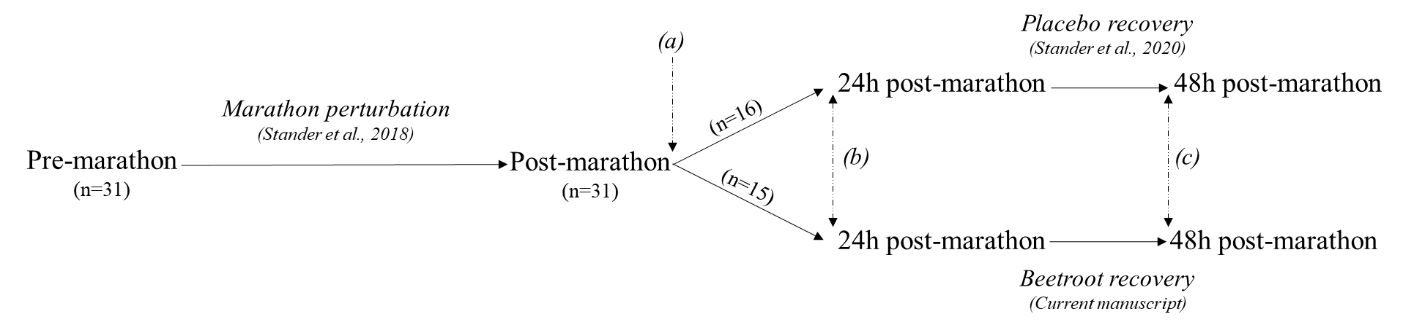

Fig. S1 The larger scope of this investigation consists of multiple objectives: Objective 1: Effects of a marathon on the serum metabolome of athletes (pre- vs post-marathon; n=31) (Stander et al. 2018); Objective 2: Metabolic recovery without the intervention of recovery aids, by comparing pre-, post- as well as 24 h and 48 h post-marathon samples of the athletes (n=16) that ingested placebo supplements (Stander et al. 2020); Objective 3: Effect of beetroot juice supplementation on metabolic recovery, by comparing pre-, post- as well as 24 h and 48 h post-marathon samples of the athletes (n=15) that ingested beetroot juice supplements (current investigation); Objective 4: The possible added advantage of beetroot juice supplementation aided recovery versus natural (placebo) recovery, by comparing profiles of Objectives 2 and 3 (current investigation). As indicated with dashed arrows, supplements were consumed (a) on the day of the marathon (immediately after P1 sampling, ±3 h post-race, and at 20:00); (b) on the first day after the marathon (upon waking-up, with lunch, and with supper), and (c) upon waking on the second day post-marathon

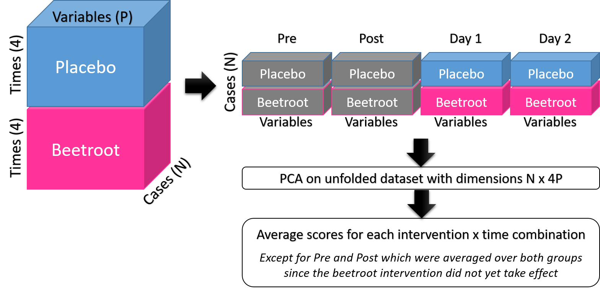
Fig. S2: A summary of the unfolded PCA of the beetroot and placebo interventions over time. Abbreviations: N: number of cases; P: number of variables.
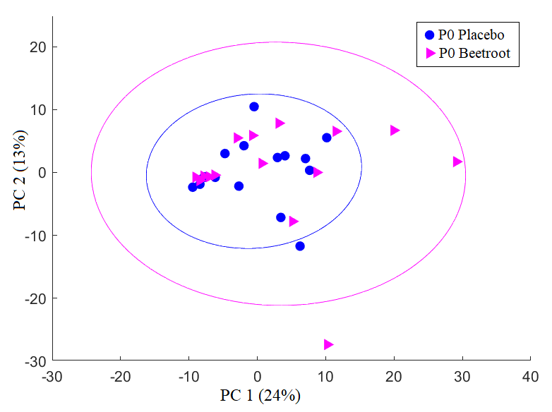  (a) | 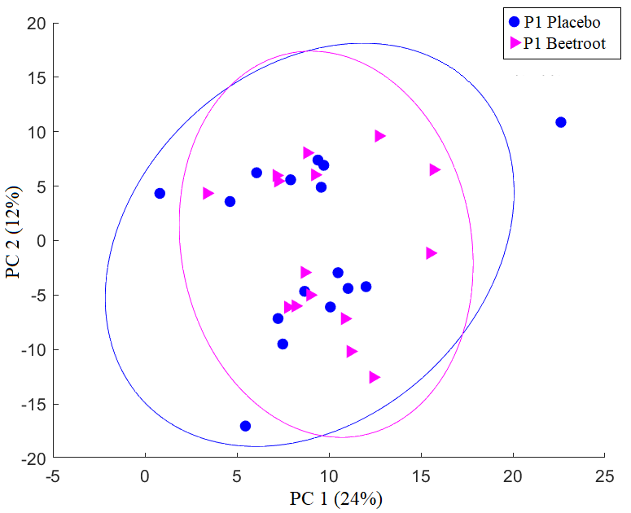  (b)
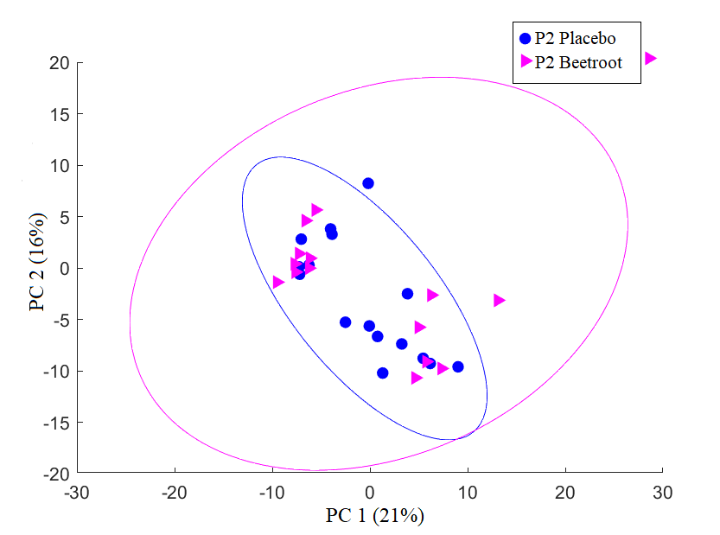  (c) | 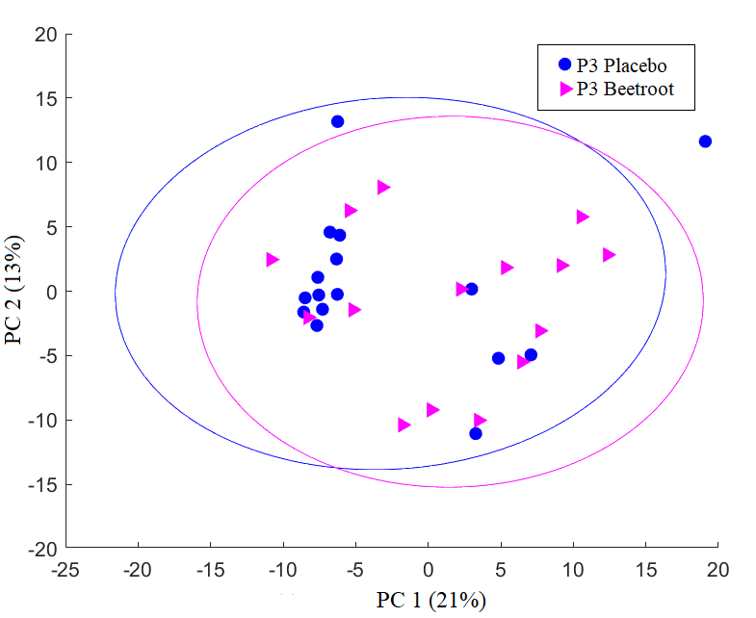  (d)
Fig. S3: Principal component analysis plots representing the inter-cohort differentiation of (a) pre-marathon [P0], (b) post-marathon [P1], (c) 24 h post-marathon [P2], and 48 h post-marathon [P3] metabolic profiles. Abbreviations: PC: principal component.

