Additional file 1: Table S1: Primers used in qRT-PCR.
 | Forward primers (5’-3’) | Reverse primers (5’-3’)
Tnfa | ATGTCTCAGCCTCTTCTCATTC | GCTTGTCACTCGAATTTTGAGA
Il6 | CTCCCAACAGACCTGTCTATAC | CCATTGCACAACTCTTTTCTCA
Ifnr | CTTGAAAGACAATCAGGCCATC | CTTGGCAATACTCATGAATGCA
Il1b | TCGCAGCAGCACATCAACAAGAG | AGGTCCACGGGAAAGACACAGG
Tgfb | CCAGATCCTGTCCAAACTAAGG | CTCTTTAGCATAGTAGTCCGCT
Il4 | TACCAGGAGCCATATCCACGGATG | TGTGGTGTTCTTCGTTGCTGTGAG
Aim2 | GTCACCAGTTCCTCAGTTGTG | CACCTCCATTGTCCCTGTTTTAT
Nlrp3 | ATTACCCGCCCGAGAAAGG | TCGCAGCAAAGATCCACACAG
Nlrc4 | ATCGTCATCACCGTGTGGAG | GCCAGACTCGCCTTCAATCA
Nlrp1 | CCACTGAGCTACTATGCAGTACA | ACAACATCTTCACACCACCATC
Irf9 | GCCGAGTGGTGGGTAAGAC | GCAAAGGCGCTGAACAAAGAG
Casp4 | ACAAACACCCTGACAAACCAC | CACTGCGTTCAGCATTGTTAAA
Myd88 | AGGACAAACGCCGGAACTTTT | GCCGATAGTCTGTCTGTTCTAGT
Ifi204 | ATGCTTCATGCTACAGTGGCTACAG | TCATTGATCTCCAGGATGCCTTTGC
Stat1 | TCACAGTGGTTCGAGCTTCAG | GCAAACGAGACATCATAGGCA
Stat2 | TCCTGCCAATGGACGTTCG | GTCCCACTGGTTCAGTTGGT
Irf7 | GAGACTGGCTATTGGGGGAG | GACCGAAATGCTTCCAGGG
Ikbke | ACCACTAACTACCTGTGGCAT | CCTCCCCGGATTTCTTGTTTC
Gbp2 | CTGCACTATGTGACGGAGCTA | GAGTCCACACAAAGGTTGGAAA

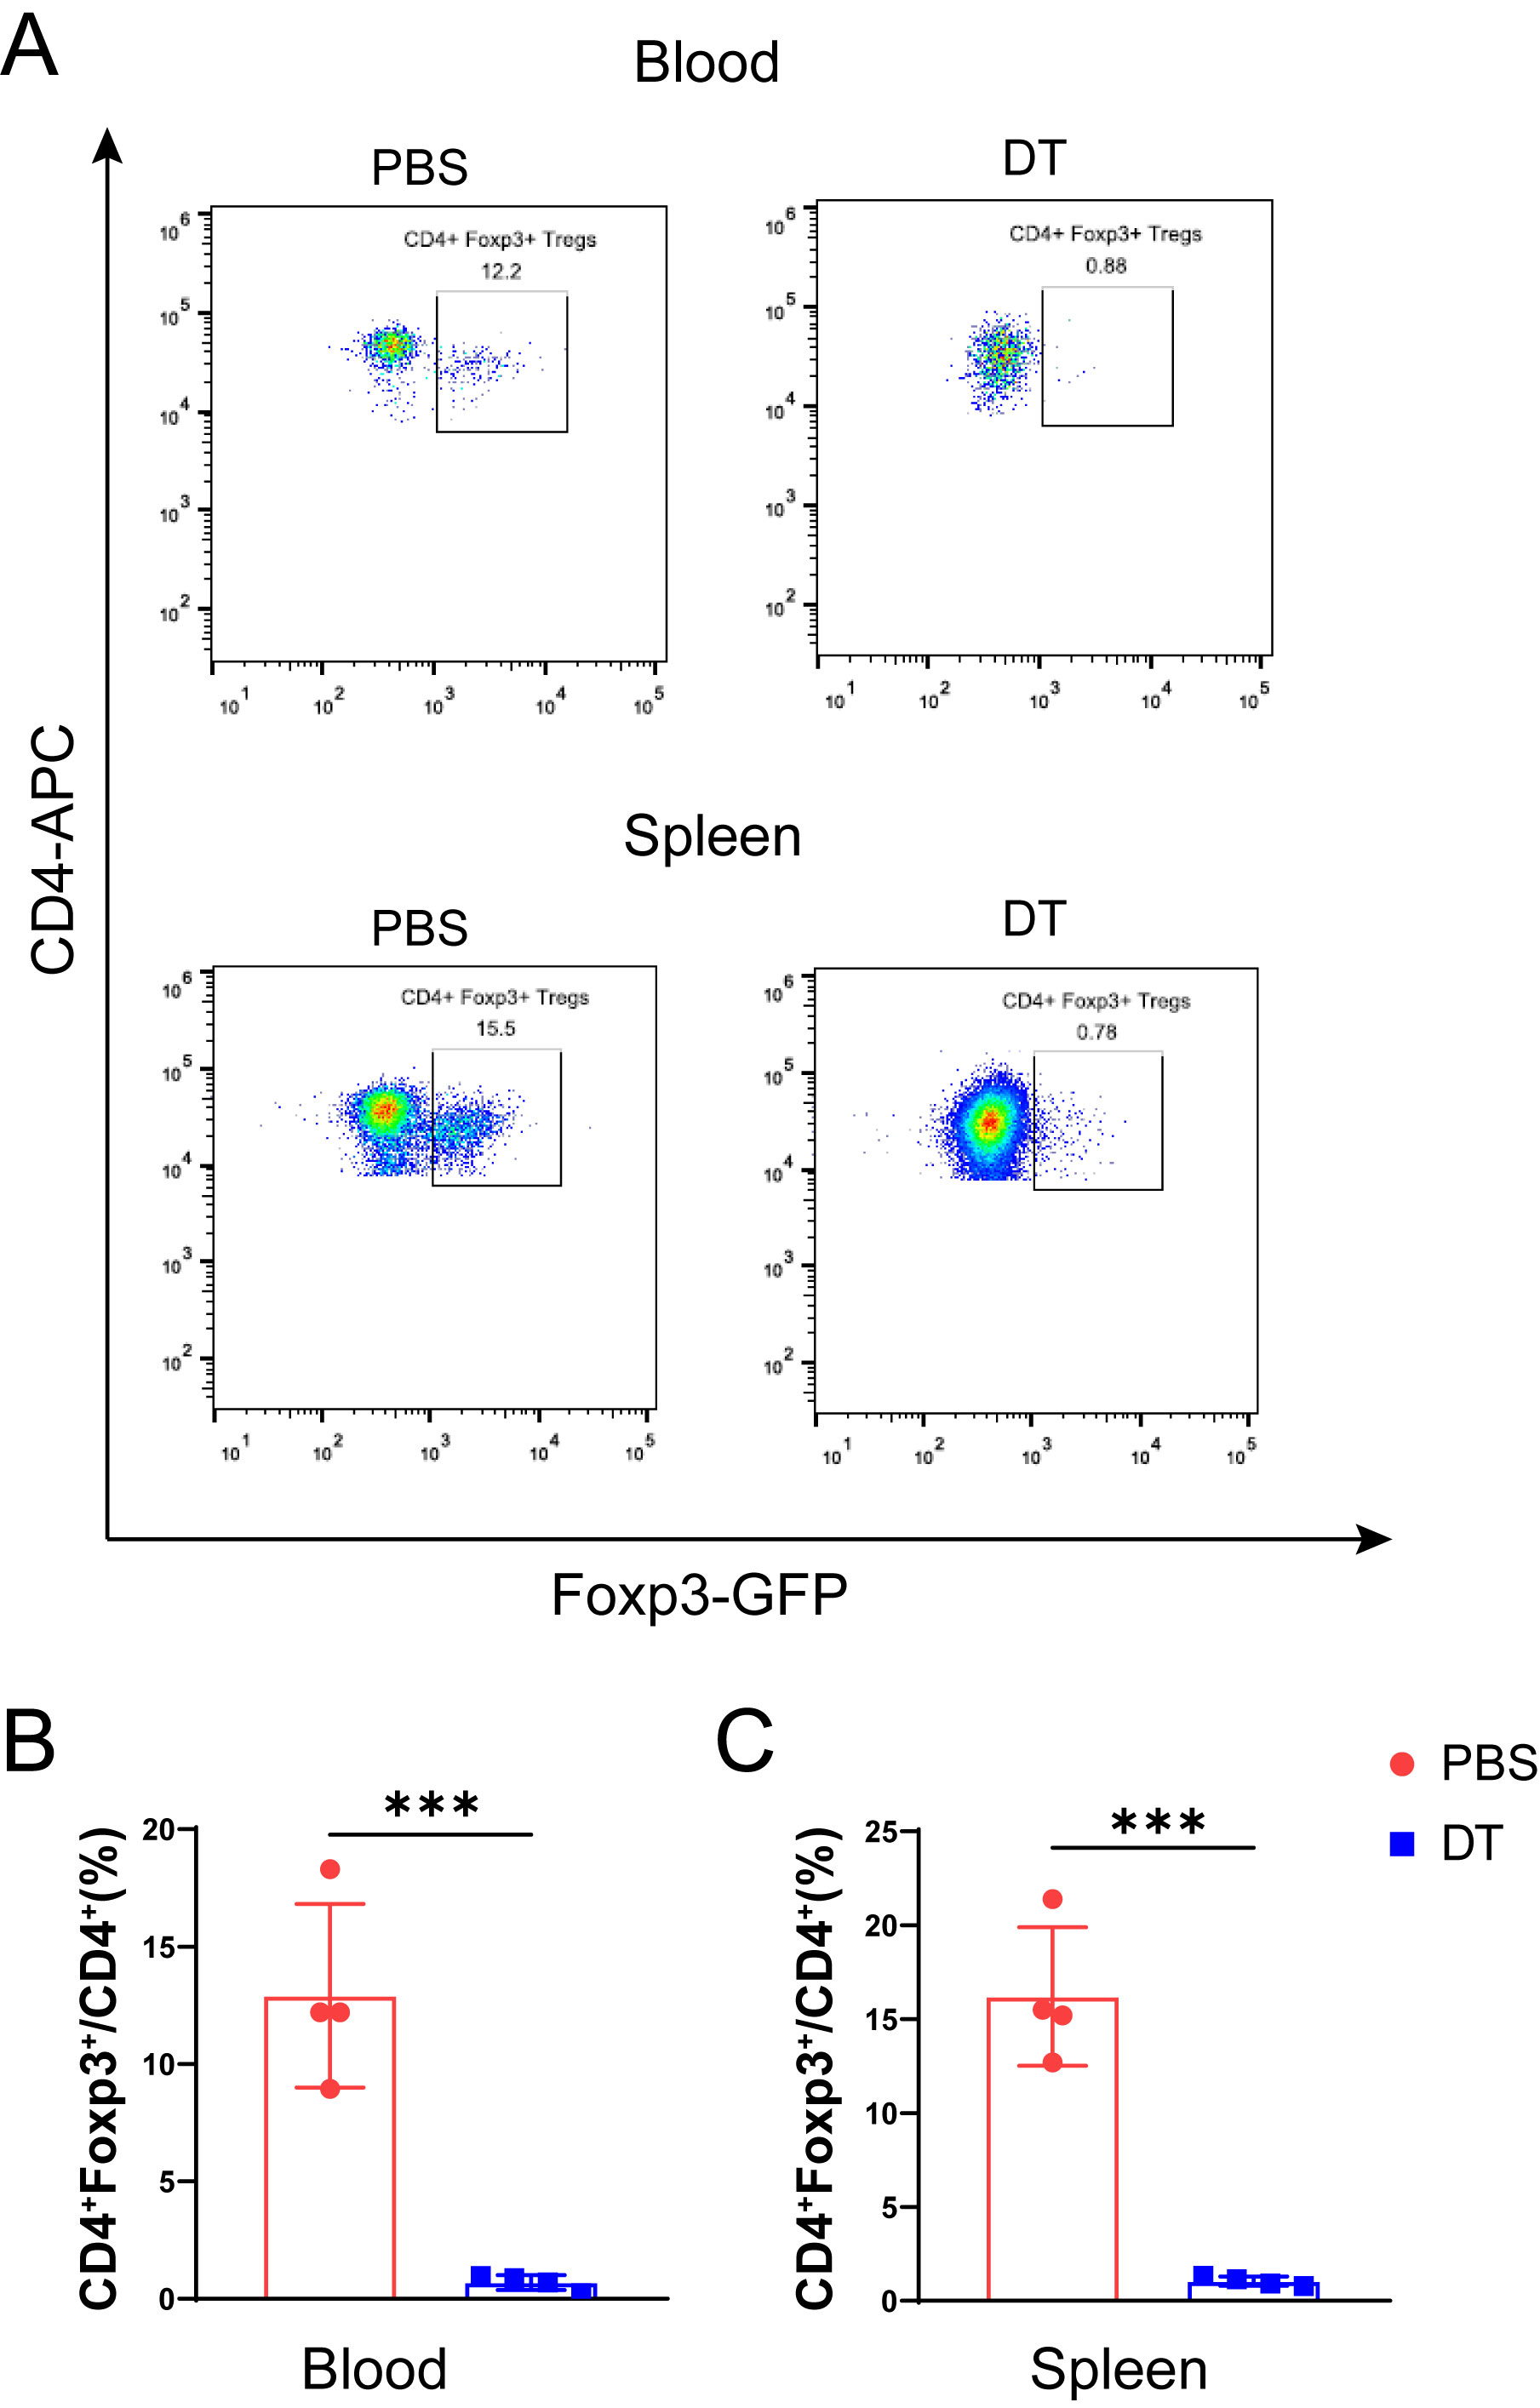
Additional file 1: Figure S1: DT successfully depletes Tregs in DEREG mice. A Representative flowcytometric images of CD4⁺Foxp3⁺ Tregs in blood and spleen from DEREG mice treated by PBS and DT. B, C Proportion of Tregs in CD4⁺ T cells in blood (B) and spleen (C) of DEREG mice treated by PBS and DT. N=4/group, two-tailed student’s t-test was used, ***p<0.001.

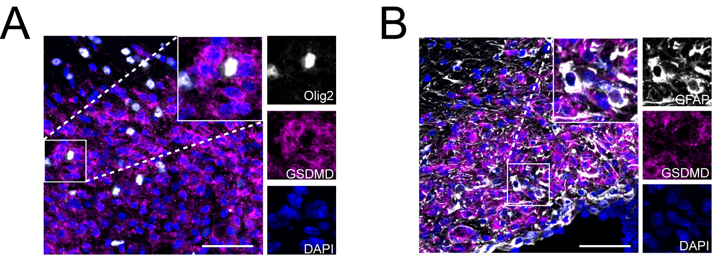
Additional file 1: Figure S2: Oligodendrocytes and astrocytes rarely undergo pyroptosis in LPC-induced demyelination. A, B Representative immunofluorescent double-labelling of Olig2 and GSDMD (A), GFAP and GSDMD (B) in lesion respectively, enlarged images of single channel were shown. Scale bar=50 μm.

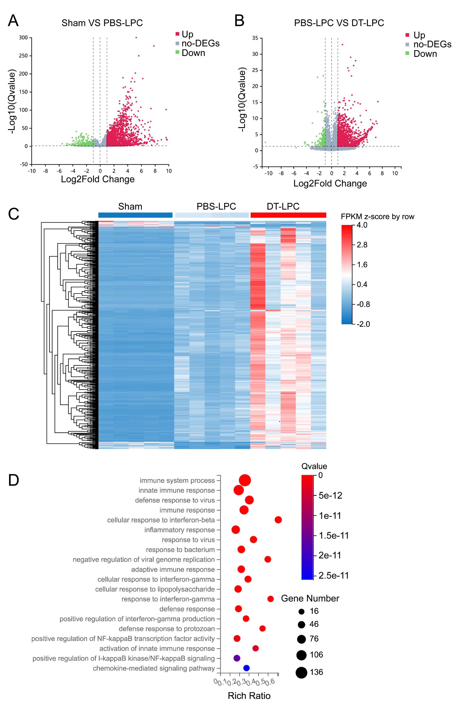
Additional file 1: Figure S3: RNA-sequencing reveals that depletion of Tregs significantly influences immune system and inflammatory response in LPC-induced demyelination. A, B Volcano plot of DEGs between sham and PBS-LPC group (A) as well as LPC group treated by PBS and DT (B). C Heat map of DEGs among groups. D Top 20 pathways enriched by GO biological processes analysis of DEGs common in sham VS PBS-LPC and PBS-LPC VS DT-LPC. For RNA-sequencing analysis, n=5 replicates for each group.

Additional file 1: Figure S4: The top ten key genes of KDA in RNA-seq were verified by qPCR. N=4-5/group, one-way ANOVA with Bonferroni’s test. *P<0.05, **p<0.01, ***p<0.001, ****p<0.0001.

