Table S1: Isolate geographic information and GeneBank accession number
Isolates | Provinces | Genbank accession number
PCV3/CN/Anhui-1/201810 | Anhui | MW089611
PCV3/CN/Chongqing-1/201608 | Chongqing | MW089507
PCV3/CN/Chongqing-1/202010 | Chongqing | OL619345
PCV3/CN/Chongqing-2/201608 | Chongqing | MW089508
PCV3/CN/Chongqing-2/202010 | Chongqing | OL619335
PCV3/CN/Chongqing-3/201608 | Chongqing | MW089509
PCV3/CN/Chongqing-3/202010 | Chongqing | OL619336
PCV3/CN/Chongqing-4/201608 | Chongqing | MW089510
PCV3/CN/Chongqing-4/202010 | Chongqing | OL619337
PCV3/CN/Chongqing-5/202010 | Chongqing | OL619338
PCV3/CN/Chongqing-6/202010 | Chongqing | OL619342
PCV3/CN/Chongqing-7/202010 | Chongqing | OL619343
PCV3/CN/Chongqing-8/202010 | Chongqing | OL619344
PCV3/CN/Chongqing-9/202010 | Chongqing | OL619346
PCV3/CN/Fujian-1/201608 | Fujian | MW089500
PCV3/CN/Fujian-2/201608 | Fujian | MW089501
PCV3/CN/Guangdong-1/201601 | Guangdong | MW089519
PCV3/CN/Guangdong-1/201805 | Guangdong | MW089582
PCV3/CN/Guangdong-2/201601 | Guangdong | MW089520
PCV3/CN/Guangdong-2/201805 | Guangdong | MW089583
PCV3/CN/Guangdong-3/201601 | Guangdong | MW089521
PCV3/CN/Guangdong-3/201805 | Guangdong | MW089584
PCV3/CN/Guangdong-4/201601 | Guangdong | MW089522
PCV3/CN/Guizhou-1/201803 | Guizhou | MW089575
PCV3/CN/Guizhou-2/201803 | Guizhou | MW089576
PCV3/CN/Hebei-1/201603 | Hebei | MW089516
PCV3/CN/Hebei-1/201612 | Hebei | MW089528
PCV3/CN/Hebei-1/201701 | Hebei | MW089530
PCV3/CN/Hebei-1/201703 | Hebei | MW089536
PCV3/CN/Hebei-1/201804 | Hebei | MW089577
PCV3/CN/Hebei-1/201805 | Hebei | MW089586
PCV3/CN/Hebei-1/201807 | Hebei | MW089591
PCV3/CN/Hebei-1/201808 | Hebei | MW089595
PCV3/CN/Hebei-1/201809 | Hebei | MW089601
PCV3/CN/Hebei-1/201810 | Hebei | MW089610
PCV3/CN/Hebei-1/201811 | Hebei | MW089612
PCV3/CN/Hebei-2/201603 | Hebei | MW089517
PCV3/CN/Hebei-2/201612 | Hebei | MW089531
PCV3/CN/Hebei-2/201804 | Hebei | MW089578
PCV3/CN/Hebei-2/201805 | Hebei | MW089587
PCV3/CN/Hebei-2/201808 | Hebei | MW089596
PCV3/CN/Hebei-2/201809 | Hebei | MW089602
PCV3/CN/Hebei-2/201811 | Hebei | MW089613
PCV3/CN/Hebei-3/201805 | Hebei | MW089589
PCV3/CN/Hebei-3/201808 | Hebei | MW089599
PCV3/CN/Hebei-3/201811 | Hebei | MW089614
PCV3/CN/Hebei-4/201808 | Hebei | MW089600
PCV3/CN/Hebei-4/201811 | Hebei | MW089615
PCV3/CN/Hebei-5/201811 | Hebei | MW089616
PCV3/CN/Hebei-6/201811 | Hebei | MW089617
PCV3/CN/Henan-1/201608 | Henan | MW089502
PCV3/CN/Henan-1/201706 | Henan | MW089552
PCV3/CN/Henan-1/201707 | Henan | MW089551
PCV3/CN/Henan-1/201805 | Henan | MW089588
PCV3/CN/Henan-1/201903 | Henan | MW089619
PCV3/CN/Hubei-1/201601 | Hubei | MW089518
PCV3/CN/Hubei-1/201611 | Hubei | MW089523
PCV3/CN/Hubei-1/201702 | Hubei | MW089541
PCV3/CN/Hubei-1/201706 | Hubei | MW089553
PCV3/CN/Hubei-1/201709 | Hubei | MW089563
PCV3/CN/Hubei-1/201806 | Hubei | MW089590
PCV3/CN/Hubei-1/201807 | Hubei | MW089592
PCV3/CN/Hubei-1/201809 | Hubei | MW089603
PCV3/CN/Hubei-1/202009 | Hubei | OL619331
PCV3/CN/Hubei-10/201706 | Hubei | MW089562
PCV3/CN/Hubei-10/201709 | Hubei | MW089572
PCV3/CN/Hubei-11/201702 | Hubei | MW089550
PCV3/CN/Hubei-11/201709 | Hubei | MW089573
PCV3/CN/Hubei-13/201709 | Hubei | MW089574
PCV3/CN/Hubei-2/201611 | Hubei | MW089524
PCV3/CN/Hubei-2/201702 | Hubei | MW089542
PCV3/CN/Hubei-2/201706 | Hubei | MW089554
PCV3/CN/Hubei-2/201709 | Hubei | MW089564
PCV3/CN/Hubei-2/201807 | Hubei | MW089593
PCV3/CN/Hubei-2/201809 | Hubei | MW089604
PCV3/CN/Hubei-2/202009 | Hubei | OL619332
PCV3/CN/Hubei-3/201611 | Hubei | MW089525
PCV3/CN/Hubei-3/201702 | Hubei | MW089543
PCV3/CN/Hubei-3/201706 | Hubei | MW089555
PCV3/CN/Hubei-3/201709 | Hubei | MW089565
PCV3/CN/Hubei-3/201807 | Hubei | MW089594
PCV3/CN/Hubei-3/201809 | Hubei | MW089605
PCV3/CN/Hubei-4/201611 | Hubei | MW089526
PCV3/CN/Hubei-4/201702 | Hubei | MW089544
PCV3/CN/Hubei-4/201706 | Hubei | MW089556
PCV3/CN/Hubei-4/201709 | Hubei | MW089566
PCV3/CN/Hubei-5/201611 | Hubei | MW089527
PCV3/CN/Hubei-5/201702 | Hubei | MW089545
PCV3/CN/Hubei-5/201706 | Hubei | MW089557
PCV3/CN/Hubei-5/201709 | Hubei | MW089567
PCV3/CN/Hubei-6/201702 | Hubei | MW089546
PCV3/CN/Hubei-6/201706 | Hubei | MW089558
PCV3/CN/Hubei-6/201709 | Hubei | MW089568
PCV3/CN/Hubei-7/201702 | Hubei | MW089547
PCV3/CN/Hubei-7/201706 | Hubei | MW089559
PCV3/CN/Hubei-7/201709 | Hubei | MW089569
PCV3/CN/Hubei-8/201702 | Hubei | MW089548
PCV3/CN/Hubei-8/201706 | Hubei | MW089560
PCV3/CN/Hubei-8/201709 | Hubei | MW089570
PCV3/CN/Hubei-9/201702 | Hubei | MW089549
PCV3/CN/Hubei-9/201706 | Hubei | MW089561
PCV3/CN/Hubei-9/201709 | Hubei | MW089571
PCV3/CN/Hunan-1/201604 | Hunan | MW089515
PCV3/CN/Hunan-1/201610 | Hunan | MW089511
PCV3/CN/Hunan-1/202010 | Hunan | OL619339
PCV3/CN/Hunan-1/202011 | Hunan | OL619357
PCV3/CN/Hunan-1/202012 | Hunan | OL619370
PCV3/CN/Hunan-10/202010 | Hunan | OL619353
PCV3/CN/Hunan-10/202011 | Hunan | OL619368
PCV3/CN/Hunan-11/202010 | Hunan | OL619354
PCV3/CN/Hunan-11/202011 | Hunan | OL619369
PCV3/CN/Hunan-12/202010 | Hunan | OL619355
PCV3/CN/Hunan-13/202010 | Hunan | OL619356
PCV3/CN/Hunan-2/202010 | Hunan | OL619340
PCV3/CN/Hunan-2/202011 | Hunan | OL619358
PCV3/CN/Hunan-2/202012 | Hunan | OL619371
PCV3/CN/Hunan-3/202010 | Hunan | OL619341
PCV3/CN/Hunan-3/202011 | Hunan | OL619359
PCV3/CN/Hunan-3/202012 | Hunan | OL619372
PCV3/CN/Hunan-4/202010 | Hunan | OL619347
PCV3/CN/Hunan-4/202011 | Hunan | OL619360
PCV3/CN/Hunan-4/202012 | Hunan | OL619373
PCV3/CN/Hunan-5/202010 | Hunan | OL619348
PCV3/CN/Hunan-5/202011 | Hunan | OL619361
PCV3/CN/Hunan-5/202012 | Hunan | OL619374
PCV3/CN/Hunan-6/202010 | Hunan | OL619349
PCV3/CN/Hunan-6/202011 | Hunan | OL619362
PCV3/CN/Hunan-7/202010 | Hunan | OL619350
PCV3/CN/Hunan-7/202011 | Hunan | OL619363
PCV3/CN/Hunan-8/202010 | Hunan | OL619351
PCV3/CN/Hunan-8/202011 | Hunan | OL619364
PCV3/CN/Hunan-9/202010 | Hunan | OL619352
PCV3/CN/Hunan-9/202011 | Hunan | OL619365
PCV3/CN/Jiangxi-1/201605 | Jiangxi | MW089514
PCV3/CN/Jiangxi-1/201607 | Jiangxi | MW089505
PCV3/CN/Jiangxi-1/201612 | Jiangxi | MW089532
PCV3/CN/Jiangxi-1/201704 | Jiangxi | MW089537
PCV3/CN/Jiangxi-1/201706 | Jiangxi | MW089540
PCV3/CN/Jiangxi-1/201804 | Jiangxi | MW089579
PCV3/CN/Jiangxi-1/201805 | Jiangxi | MW089585
PCV3/CN/Jiangxi-1/201808 | Jiangxi | MW089597
PCV3/CN/Jiangxi-2/201608 | Jiangxi | MW089506
PCV3/CN/Jiangxi-2/201612 | Jiangxi | MW089533
PCV3/CN/Jiangxi-2/201704 | Jiangxi | MW089538
PCV3/CN/Jiangxi-2/201804 | Jiangxi | MW089580
PCV3/CN/Jiangxi-2/201808 | Jiangxi | MW089598
PCV3/CN/Jiangxi-3/201612 | Jiangxi | MW089535
PCV3/CN/Jiangxi-3/201704 | Jiangxi | MW089539
PCV3/CN/Jiangxi-3/201804 | Jiangxi | MW089581
PCV3/CN/Liaoning-1/201607 | Liaoning | MW089503
PCV3/CN/Liaoning-2/201607 | Liaoning | MW089504
PCV3/CN/Liaoning-3/201607 | Liaoning | MW089512
PCV3/CN/Liaoning-4/201607 | Liaoning | MW089513
PCV3/CN/Shanxi-1/201612 | Shanxi | MW089529
PCV3/CN/Shanxi-1/201810 | Shanxi | MW089606
PCV3/CN/Shanxi-2/201810 | Shanxi | MW089607
PCV3/CN/Shanxi-3/201810 | Shanxi | MW089608
PCV3/CN/Shanxi-4/201810 | Shanxi | MW089609
PCV3/CN/Sichuan-1/201702 | Sichuan | MW089534
PCV3/CN/Sichuan-1/202009 | Sichuan | OL619333
PCV3/CN/Sichuan-1/202011 | Sichuan | OL619366
PCV3/CN/Sichuan-2/202009 | Sichuan | OL619334
PCV3/CN/Sichuan-2/202011 | Sichuan | OL619367
PCV3/CN/Tianjin-1/201812 | TianJIn | MW089618

Table S2: The result of positive/diversifying selection analyze results by different method
Method | positive/diversifying Amin acid selection site
Single-Likelihood Ancestor Counting | 137  5  24
Mixed Effects Model of Evolution | 3  214  137  5  156  24  20
Fast Unconstrained Bayesian AppRoximation | 137  5  156  214  150  3  24  56
Fixed Effects Likelihood | 137  5  24

Table S3: Potential B cell peptides predicted by IEDB tools.
Start | End | Peptide | Length
5 | 25 | AIFRRRPRPRRRRRHRRRYAR | 21
42 | 61 | KYSTMNVISVGTPQNNKPWH | 20
71 | 81 | EWETAISFEYY | 11
94 | 105 | ISPAQQTKTMFG | 12
113 | 159 | GAWTTNTWLQDDPYAESSTRKVMTSKKKHSRYFTPKPILAGTTTAHP | 47
169 | 178 | PTPWLNTYDP | 10
189 | 204 | IYVPEKTGMTDFYGTK | 16

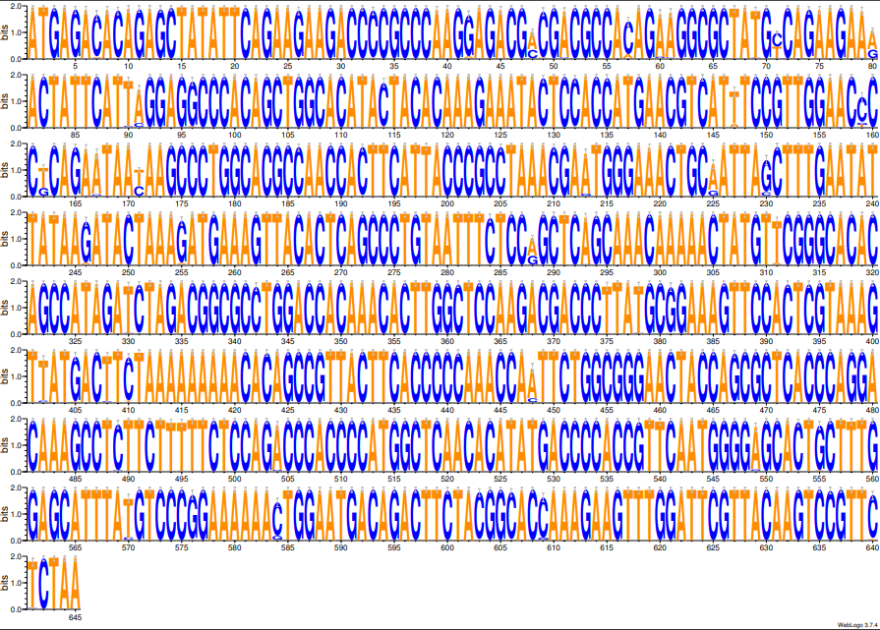
FigS1 Nucleotide sequence consistency pattern of our isolates.

