Figure S1. Schematic diagram showing the selection process of the patient population
OHS, open heart surgery; AR, aortic regurgitation; BD, Behcet’s disease.
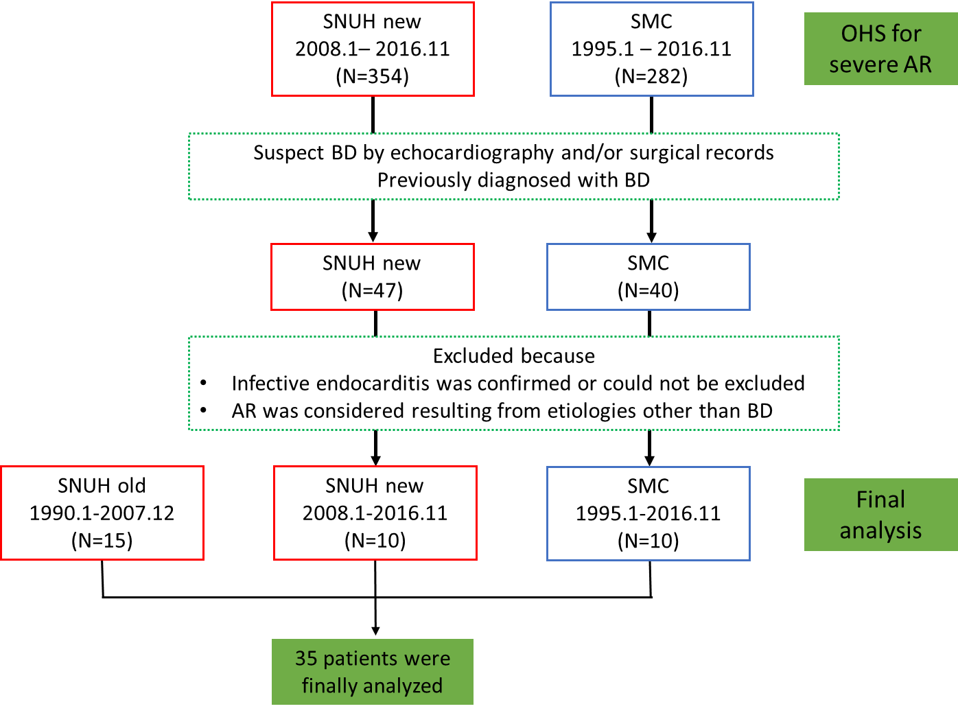

Figure S2. Kaplan-Meier estimates of freedom from paravalvular leakage (PVL) stratified by satisfaction of the International Study Group (ISG) criteria
The PVL developed more frequently in patients who did not meet the ISG criteria, whereas no patients who definitely met the ISG criteria had PVL. BD, Behcet’s disease

Figure S3. Kaplan-Meier estimates of freedom from paravalvular leakage (PVL) in patients who received postoperative immunosuppressive therapy (IST), stratified by the use of preoperative (preop) IST
Preoperative IST was not an independent predictor of less PVL development in patients who received postoperative IST.

