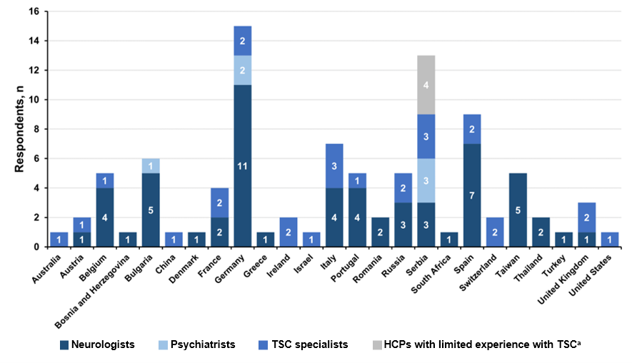
- Fig. S1 Country of residence of HCPs. HCPs, healthcare providers; TSC, tuberous sclerosis complex. ªHCPs with limited experience with TSC refer mainly to primary care physicians.

