Supplementary Material

Conspiracy Beliefs and COVID-19 Guideline Adherence in Adolescent Psychiatric Outpatients: The Predictive Role of Adverse Childhood Experiences

Andreas Goreis^{1,2}, Bettina Pfeffer^{1,2}, Heidi Zesch^{1,2}, Diana Klinger^{1,2}, Tamara Reiner^{1,2}, Mercedes M. Bock³, Susanne Ohmann^{1,2}, Petra Sackl-Pammer^{1,2}, Sonja Werneck-Rohrer^{1,2}, Harald Eder^{1,2}, Katrin Skala^{1,2}, Klara Czernin^{1,2}, Dunja Mairhofer^{1,2}, Bernhard Rohringer^{1,2}, Carolin Bedus¹, Ronja Lipp¹, Christine Vesely^{1,2}, Paul L. Plener^{1,2,4}, Oswald D. Kothgassner^{1,2}

Correspondence to: Mag. Dr. Oswald D. Kothgassner, Department of Child and Adolescent Psychiatry, Medical University of Vienna, E-Mail: oswald.kothgassner@meduniwien.ac.at

1: Model Assumptions of Our Confirmatory Analyses
In this supplementary material, we report assumption tests of multiple regression analyses. The two conspiracy beliefs variables (i.e., specific and generic) were highly correlated in our sample (r = .86, p < .001). However, they were modeled in separate analyses as separate predictors, and multicollinearity was not an issue or a statistical assumption for these two conspiracy beliefs variables. All subsequent assumption tests of the remaining variables are reported below.
Associations of Specific Conspiracy Beliefs and Adherence to Protective Guidelines
For our first multiple regression, the data met the assumption of collinearity (all VIFs < 1.06), normality (Shapiro-Wilk p = .459), and independent errors (Durbin-Watson value = 2.45). Supplementary Figure 1 depicts additional model diagnostics—and visual inspection demonstrates that the data also met the assumptions of homogeneity of variance and linearity.

Figure S1: Visual check of model assumptions for the multiple regression of COVID-19-specific conspiracy beliefs and adherence to protective guidelines.
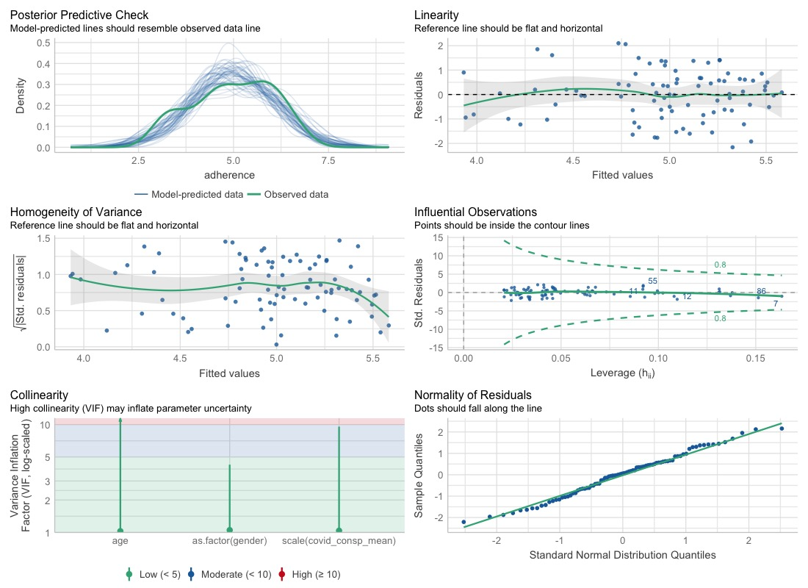

Associations of Generic Conspiracy Beliefs and Adherence to Protective Guidelines
For our second multiple regression, the data met the assumption of collinearity (all VIFs < 1.04), normality (Shapiro-Wilk p = .314), and independent errors (Durbin-Watson value = 2.48). Supplementary Figure 2 depicts additional model diagnostics—and visual inspection demonstrates that the data also met the assumptions of homogeneity of variance and linearity.

Figure S2: Visual check of model assumptions for the multiple regression of generic conspiracy beliefs and adherence to protective guidelines.
