**Supplemental Table and Figures**

**Supplemental Table 1. Percentage of Animals Presenting with Selected Early Clinical Signs on One or More Days Following TBI**

|  |  |  |  |  |  |
| --- | --- | --- | --- | --- | --- |
|  | **rHuIL-12 Dose Group (ng/kg)** | | | | |
| **Clinical Sign** | **0  (N= 18)** | **50  (N= 18)** | **100  (N= 18)** | **250  (N= 18)** | **500  (N= 18)** |
|  | **n (%)** | **n (%)** | **n (%)** | **n (%)** | **n (%)** |
| **Vomiting** | **13 (72.2)** | **12 (66.7)** | **9 (50)** | **11 (61.1)** | **13 (72.2)** |
| **Diarrhea** | **12 (66.7)** | **10 (55.6)** | **10 (55.6)** | **12 (66.7)** | **14 (77.8)** |

**Supplemental Figure 1. Decrease in Physical Activity.** Average score for decrease in activity, calculated per live animal, by dose groups. Scoring rubric: 1 = slight decrease; 2 = moderate decrease; 3 = severe decrease.

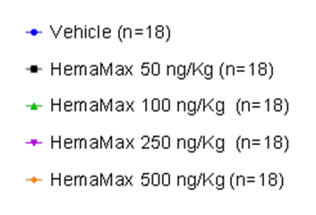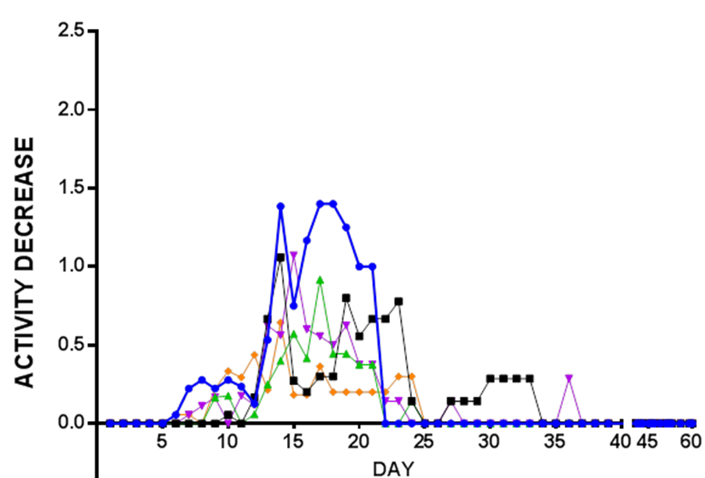

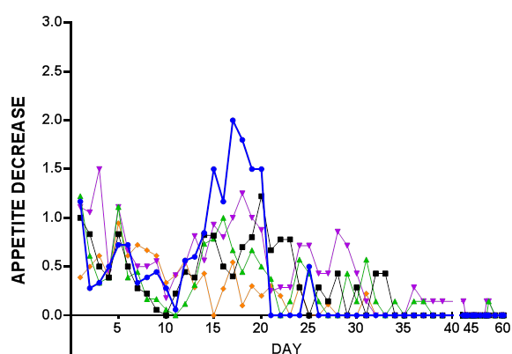**Supplemental Figure 2. Decrease in Appetite Score.** Average score for the decrease in appetite, calculated per live animal, by dose groups. Scoring rubric: 1 = slight decrease; 2 = moderate decrease; 3 = severe decrease.

**Supplemental Figure 3. Body Weight over Time.** Average percent body weight (± standard error of the mean) relative to baseline body weight, by dose group, over time.



**Supplemental Figure 4. Blood counts over time in surviving vs. non-surviving rhesus monkeys exposed to lethal TBI and treated 24 hours after TBI with either vehicle or rHuIL-12 (Average ± SEM).**

A) lymphocytes; B) neutrophils; C) platelets; D) reticulocytes. Normal ranges are as follows: lymphocytes, 1.85 to 8.71 x 109/L; neutrophils, 1.21 to 10.29 x 109/L; platelets, 252 to 612 x 109/L; reticulocytes, 29.9 to 103.9 x 109/L.

