Table S1: Features of univariable Cox proportional hazards models of breast cancer-specific survival in (a) ER-positive and (b) ER-negative patients. 95%CI: 95% confidence interval. †Hazard ratio has been constrained to this value.
(a) | Model | Hazard ratio (95%CI) | Log-likelihood | c-index (95%CI) | c-index optimism
 | PREDICT | 2.72† | -2860.6 | 0.687 (0.661-0.713) | -
 | Oncotype DX | 1.02 (1.02-1.02) | -2877.3 | 0.642 (0.616-0.668) | -0.002
 | EndoPredict | 1.51 (1.40-1.62) | -2891 | 0.614 (0.584-0.643) | -0.005
 | MammaPrint | 0.18 (-0.16-0.52) | -2869.4 | 0.652 (0.624-0.68) | 1.6 x 10⁻⁴
 | Prosigna | 8.59 (8.12-9.06) | -2874.6 | 0.647 (0.62-0.673) | -0.001
(b)
 | PREDICT | 2.72† | -1072 | 0.667 (0.63-0.704) | -
 | Oncotype DX | 0.99 (0.98-1) | -1082.6 | 0.514 (0.474-0.555) | 0.017
 | EndoPredict | 0.85 (0.64-1.06) | -1082.1 | 0.529 (0.486-0.572) | 0.011
 | MammaPrint | 1.26 (0.65-1.87) | -1082.9 | 0.513 (0.472-0.554) | 0.022
 | Prosigna | 1.02 (-0.13-2.17) | -1083.2 | 0.508 (0.467-0.55) | 0.029

Figure S1: 10-year breast cancer-specific survival predicted and observed in (a) ER-positive and (b) ER-negative patients.
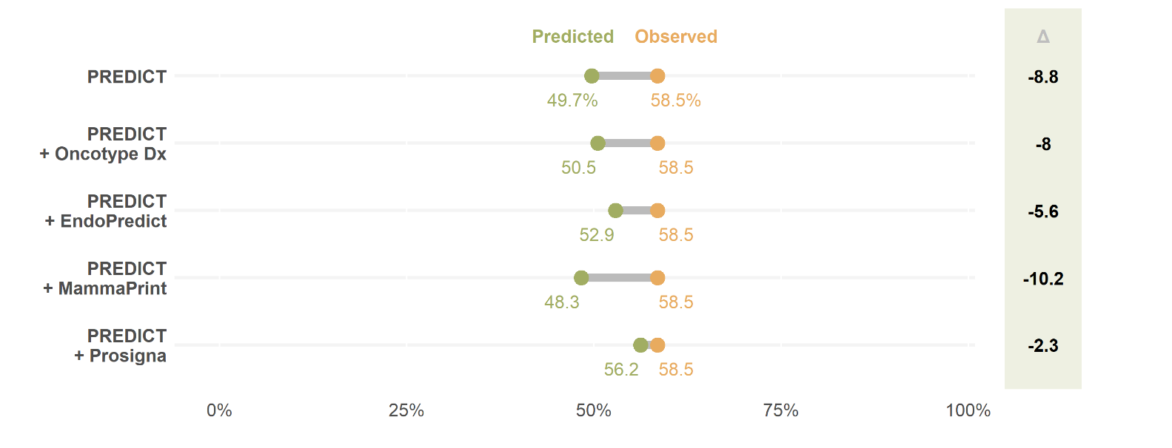
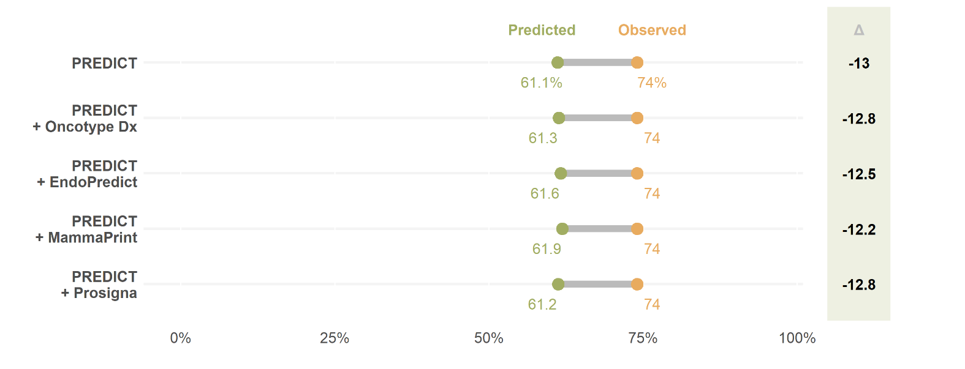
(b)
(a)

Figure S2: 10-year breast cancer-specific survival predicted and observed in (a) ER-positive, node-negative, (b) ER-positive, node-positive, (c) ER-negative, node-negative and (d) ER-negative, node-positive patients.
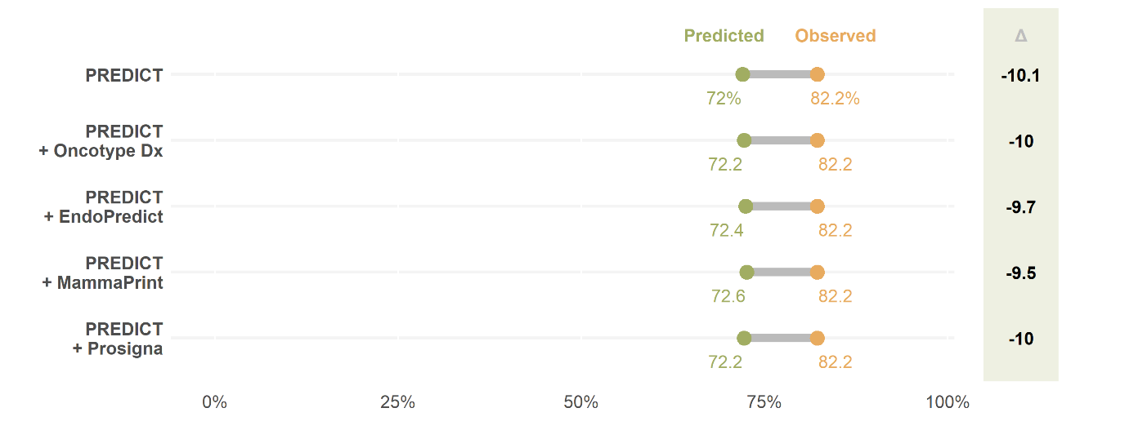
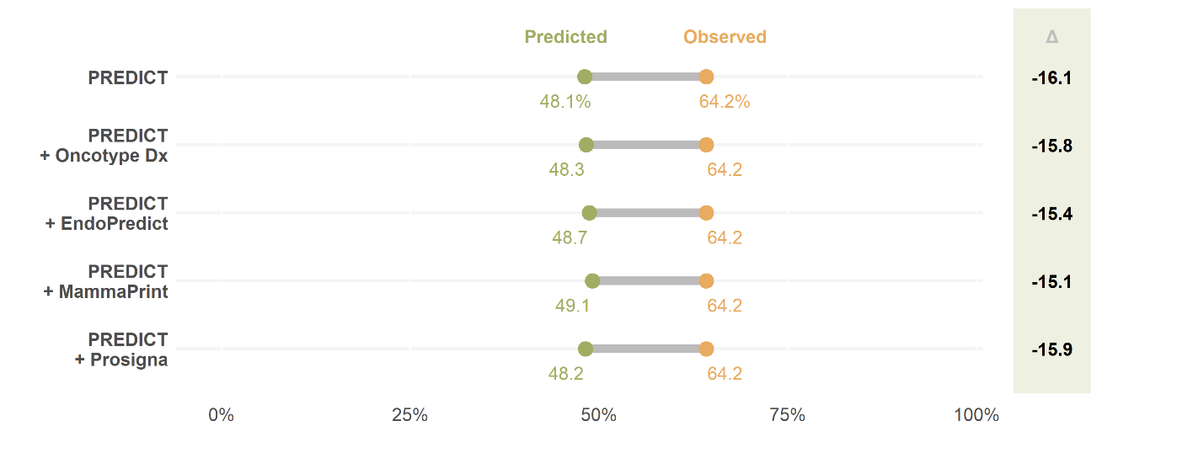
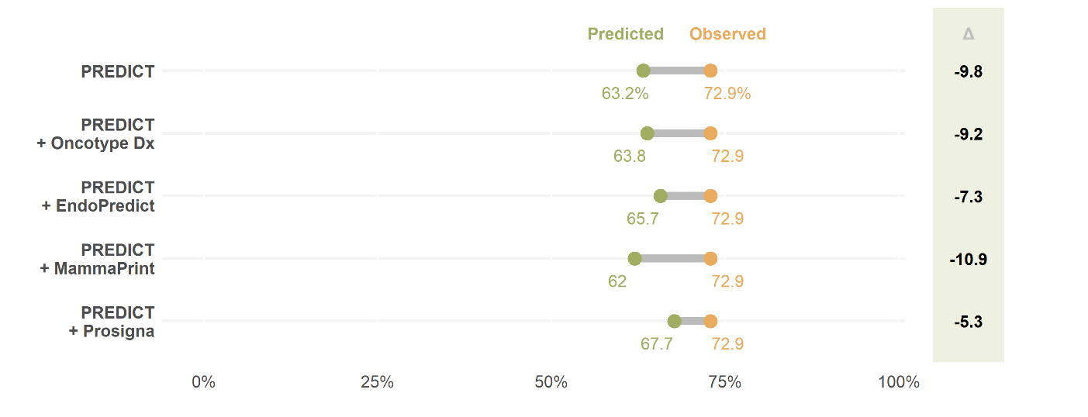
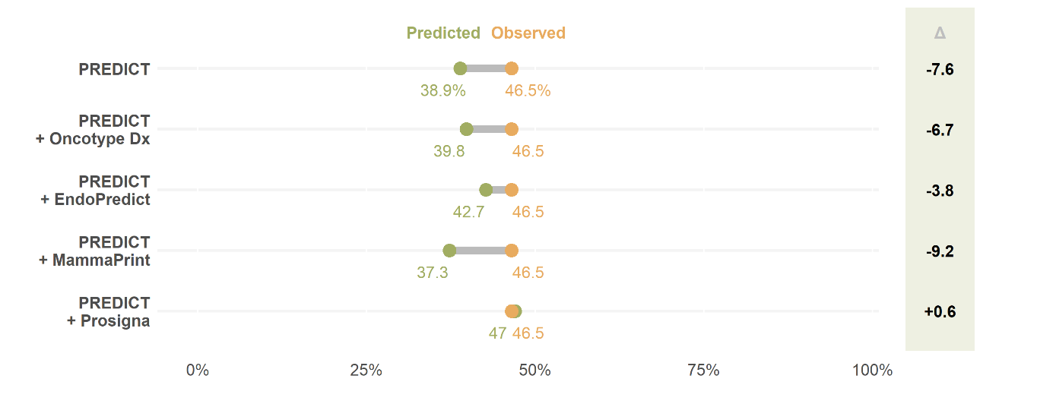
(a)
(b)
(c)
(d)

Figure S3: 10-year breast cancer-specific survival predicted and observed in patients with (a) ER-positive, grade 1, (b) ER-positive, grade 2, (c) ER-positive, grade 3, (d) ER-negative, grade 1, (e) ER-negative, grade 2, (f) ER-negative, grade 3 disease.
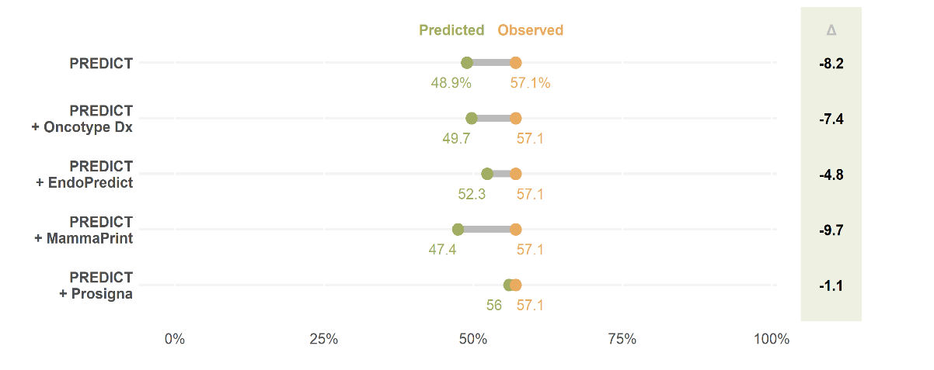
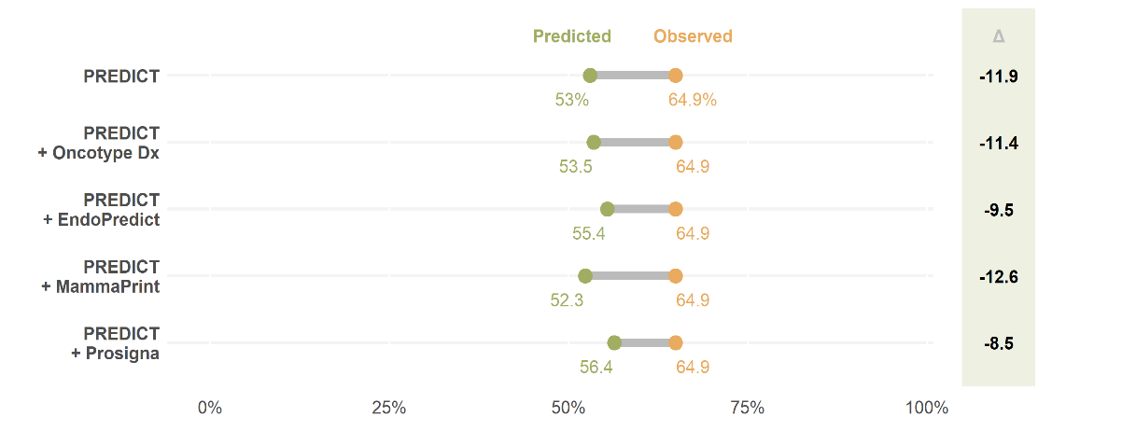
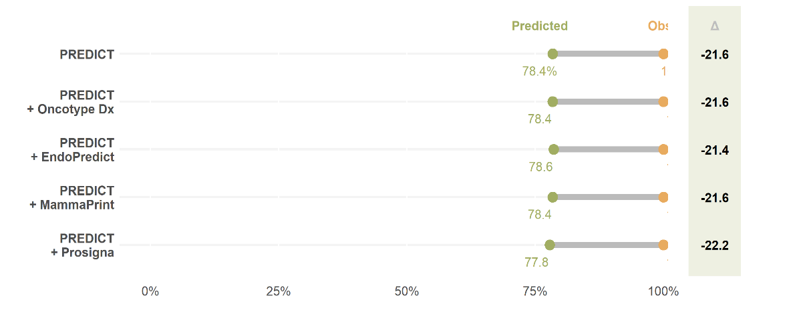
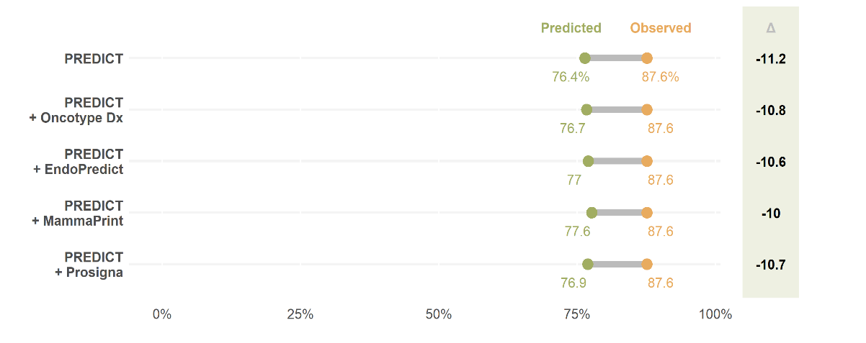
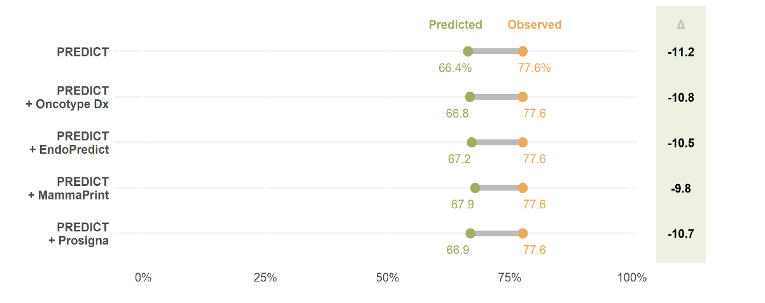
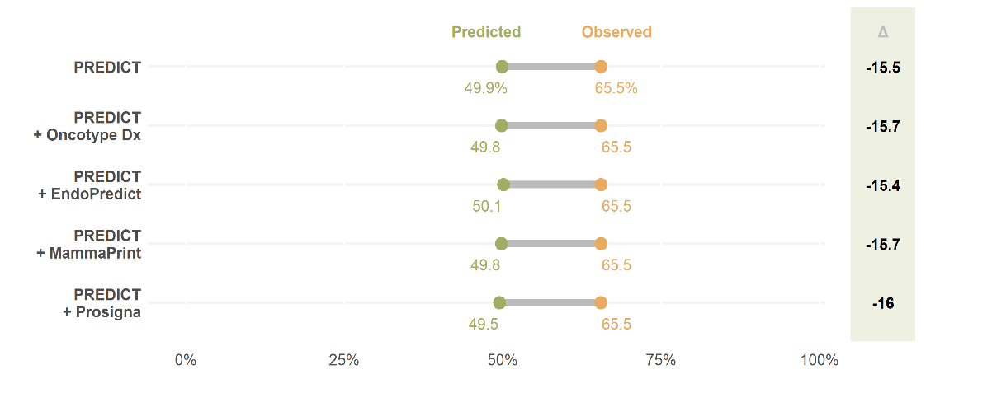
(d)
(e)
(f)
(a)
(b)
(c)

Figure S4: 10-year breast cancer-specific survival predicted and observed in patients with ER-positive disease diagnosed in the (a) 1980s, (b) 1990s, and (c) 2000s; and for ER-negative disease diagnosed in the (d) 1980s, (e) 1990s, and (f) 2000s.
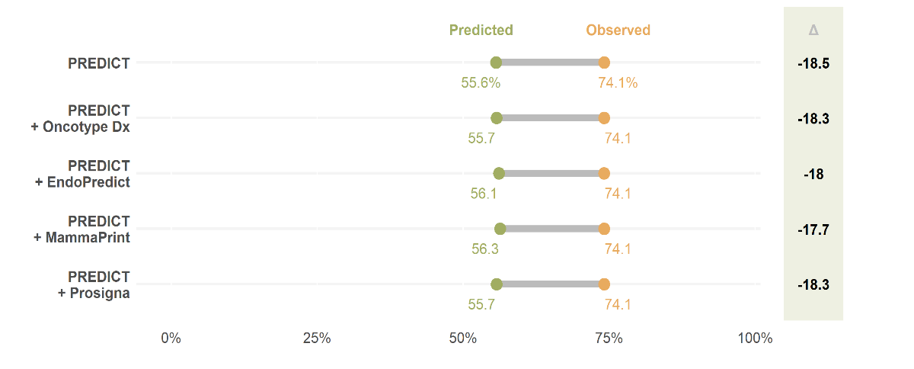
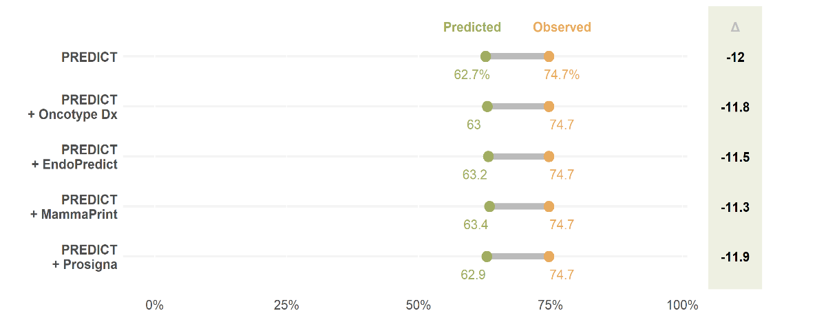
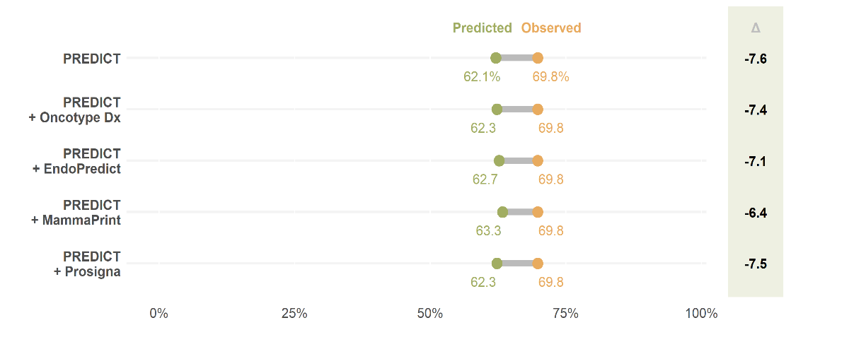
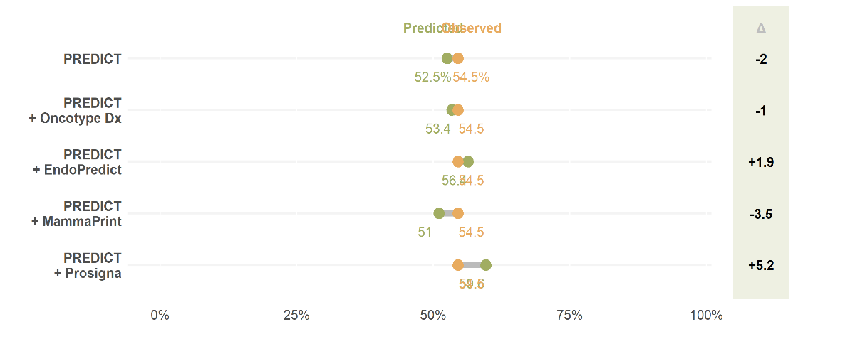
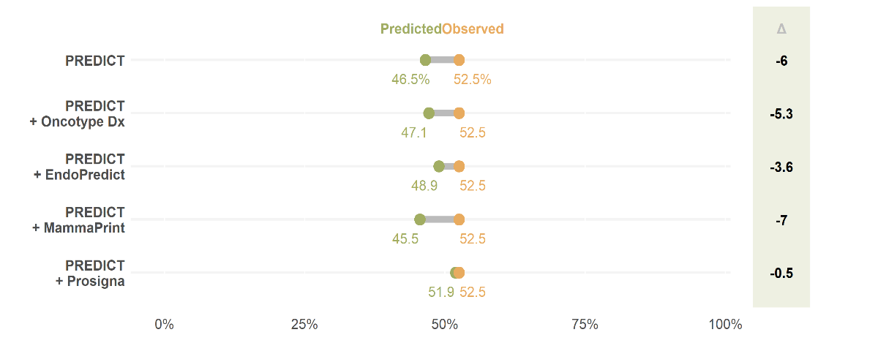
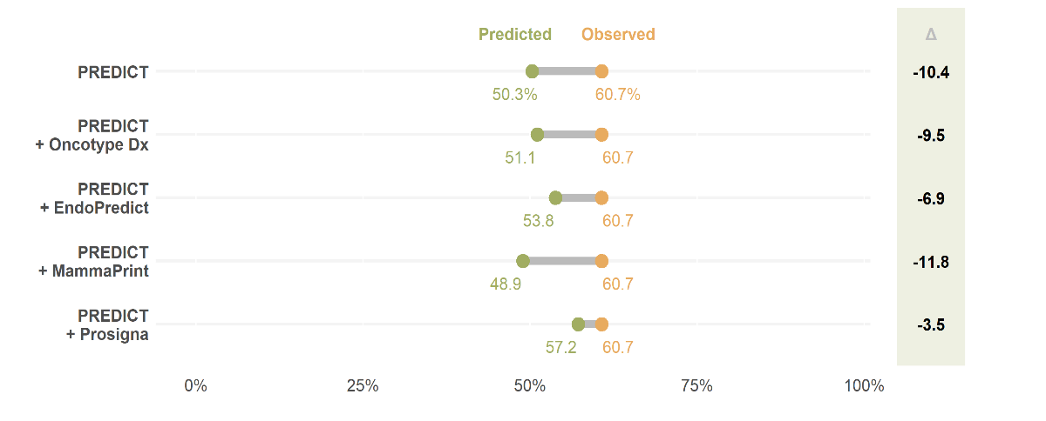
(a)
(b)
(c)
(d)
(f)
(e)

Figure S5: 10-year breast cancer-specific survival predicted and observed patients with ER-positive disease who make up the METABRIC population: (a) cohort 1, (b) cohort 2, (c) cohort 3, (d) cohort 4, (e) cohort 5.
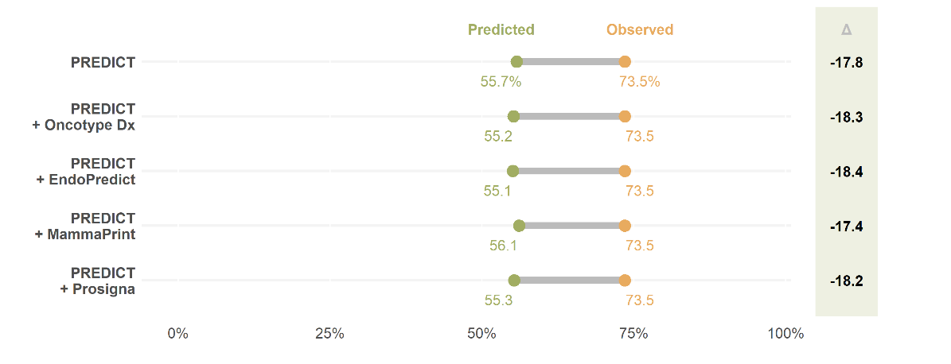
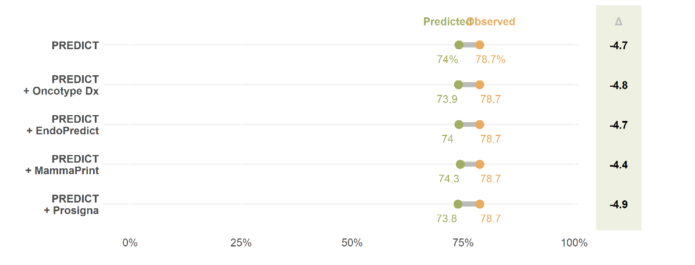
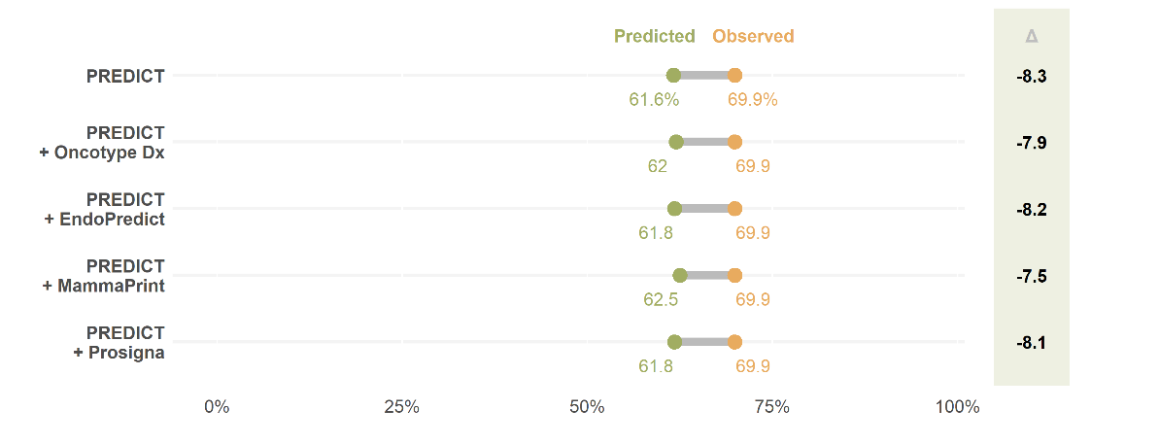
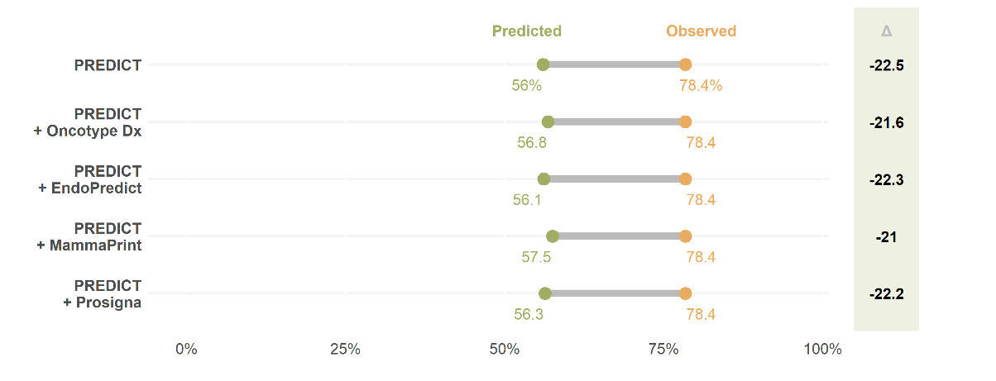
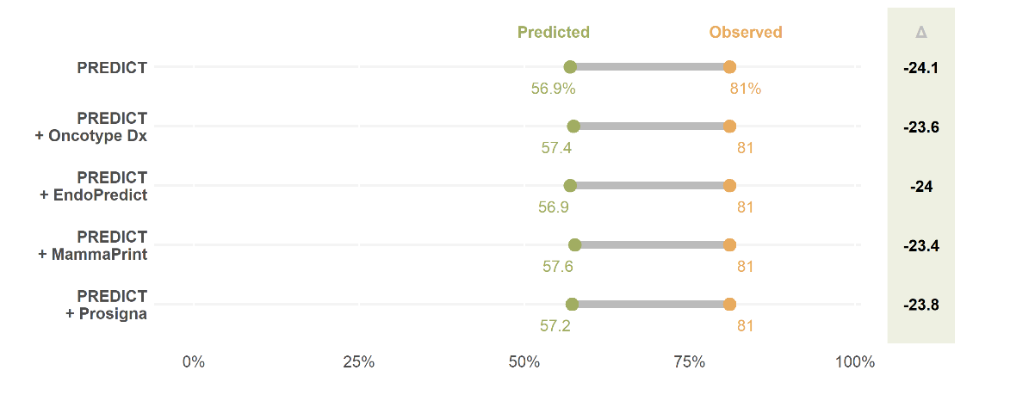
(a)
(b)
(c)
(d)
(e)

Figure S6: 10-year breast cancer-specific survival predicted and observed patients with ER-negative disease who make up the METABRIC population: (a) cohort 1, (b) cohort 2, (c) cohort 3, (d) cohort 4, (e) cohort 5.
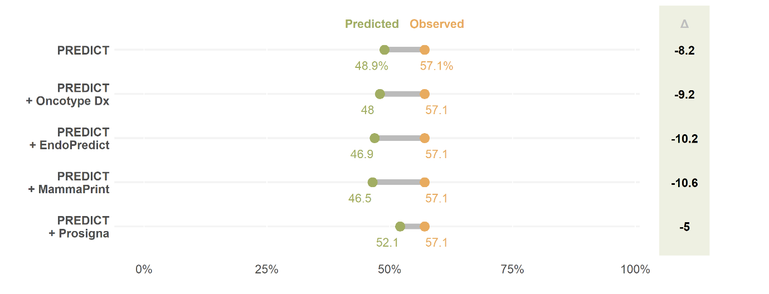
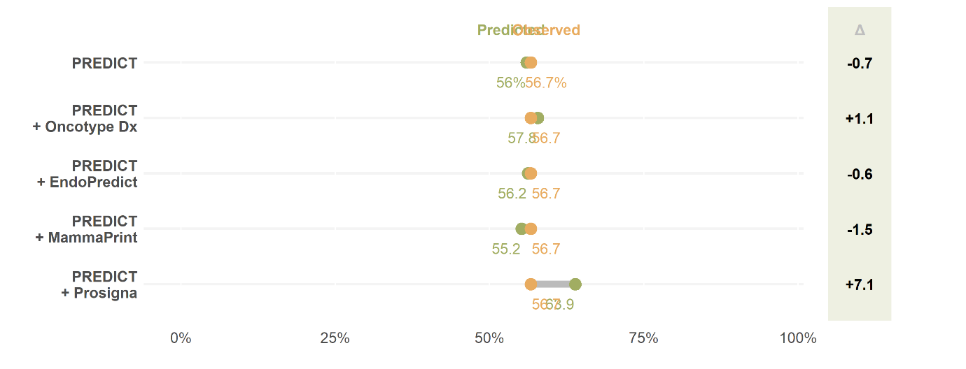
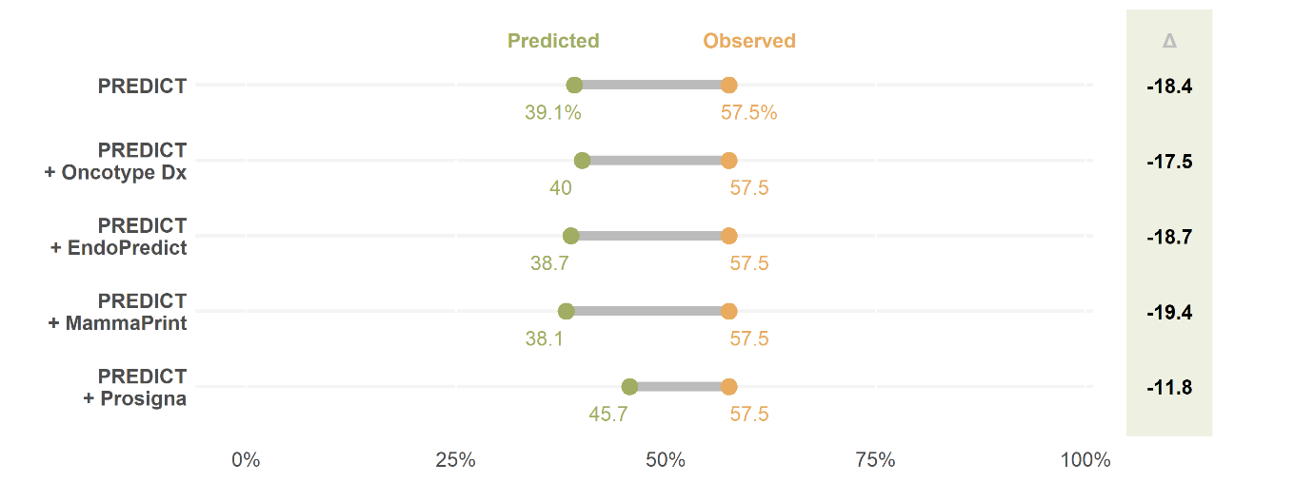
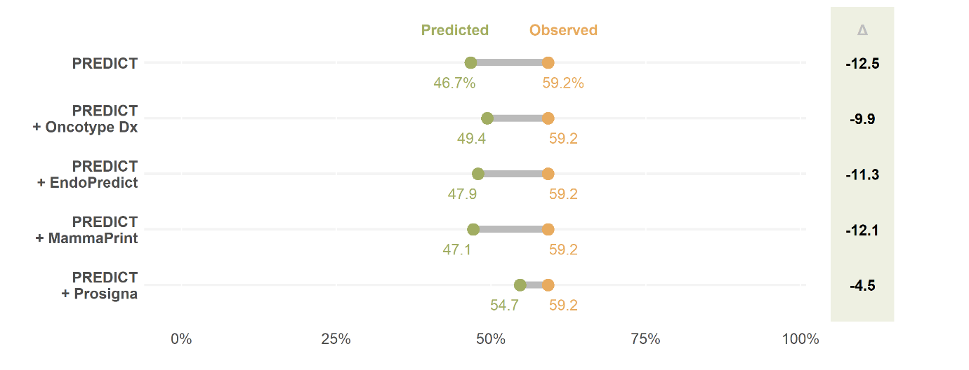
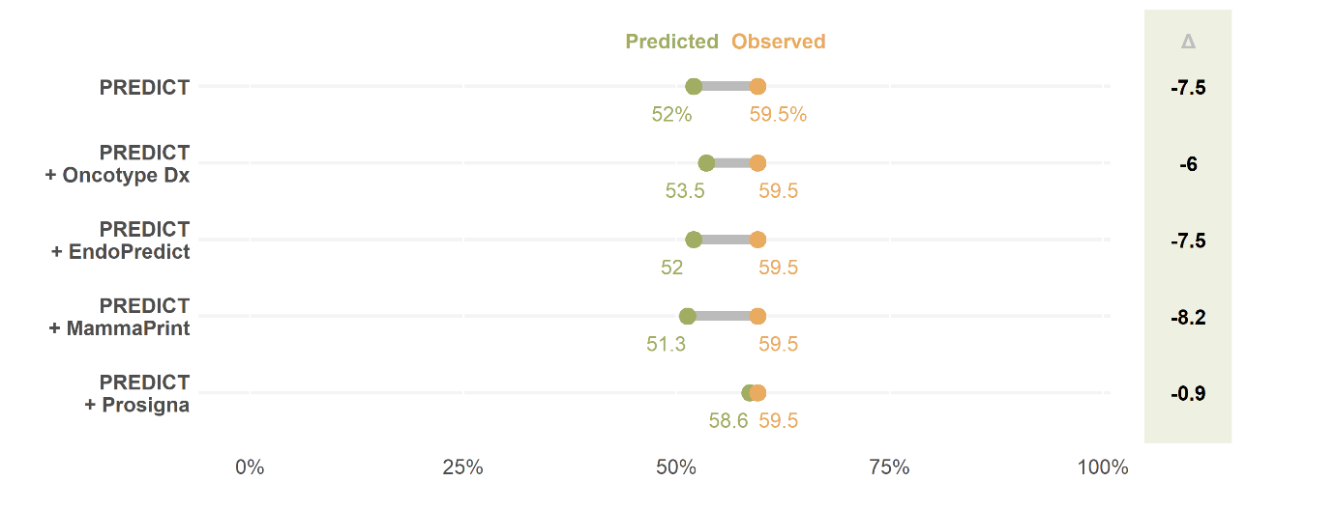
(e)
(d)
(c)
(b)
(a)

