Proposed tables and figures for main publication of the tenecteplase in wake up ischeamic stroke trial (TWIST)

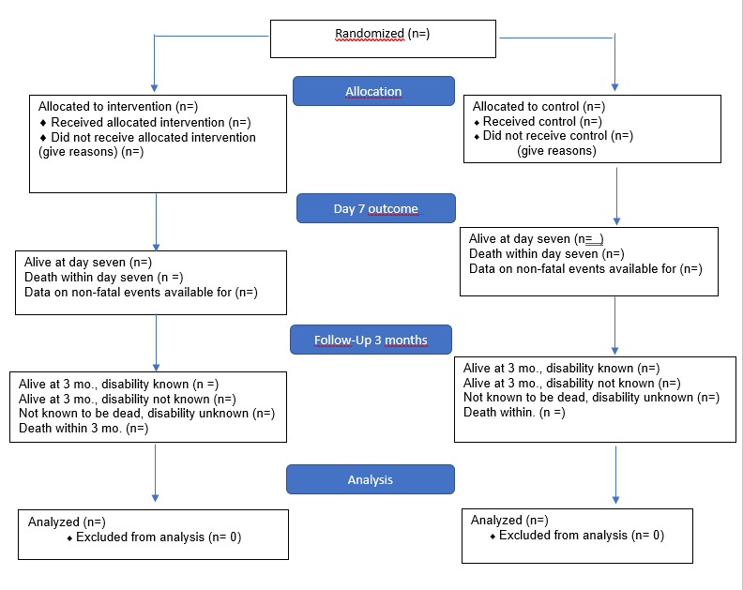

Figure 1. Consort 2010 Flow diagram

Table 1. Characteristics of Patients at Baselineª
 |  |  |  | Tenecteplase (n=?) |  | Control (n=?)
 | Age-yr
 |  | Mean (SD)
 |  | Median (IQR)
 | Age groups (years)
 |  | <60
 |  | 60-79
 |  | ≥80
 | Sex
 |  | Women
 |  | Men
 | Country— no. (%)
 |  | Norway
 |  | Sweden
 |  | Denmark
 |  | Finland
 |  | Estonia
 |  | Latvia
 |  | Lithuania
 |  | United Kingdom
 |  | Switzerland
 |  | New Zealand
 | Final diagnosis at discharge — no. (%)
 |  | Definite ischemic stroke
 |  | Probable ischemic stroke
 |  | Other diagnosis
 | Stoke risk factors and medical history— no. (%)
 |  | Hypertension
 |  | Diabetes mellitus
 |  | Atrial fibrillation
 |  | Active smoker
 |  | Previous stroke or TIA
 |  | Coronary artery disease
 |  | Current use of an anticoagulant agent
 |  | Current use of an antiplatelet agent
 | Pre-morbid modified Rankin Scale score
 |  | 0
 |  | 1
 |  | 2
 | Median NIHSS score (IQR)^{b}
 |  | Mild (0- 7)
 |  | Moderate (8–14)
 |  | Severe (≥15)
 | Endovascular treatment— no. (%)
 | Median time from last known to be well to randomisation — (IQR)- min
 | Median time from wake-up to randomisation — (IQR) - min
 | Median time from wake-up to hospital admission (IQR) - min
 | Median time from hospital arrival to initiation of therapy (IQR) - min
ªValues are means ±standard deviations(SD). IQR denotes interquartile range.
^{b}Scores on the National Institutes of Health Stroke Scale (NIHSS) range from 0 (normal) to 42 (death), with higher scores indicating greater deficit.
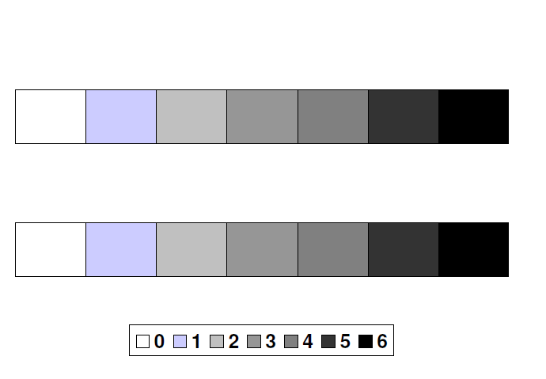

Figure II Bar chart showing the distribution of mRS scores in each treatment group

Table 2. Efficacy and safety outcomes (intention to treat population)ª
Outcome |  |  |  | Tenecteplase  (n=?) |  | Control  (n=?) |  | Unadjusted Effect Size^{h} (95% CI) |  | P Value |  | Adjusted Effect Size^{h} (95% CI) |  | P Value
Primary efficacy outcome
 | Score on the modified Rankin scale at 3 months^{b}
 |  | 0
 |  | 1
 |  | 2
 |  | 3
 |  | 4
 |  | 5
 |  | 6
 | Functional improvement^{c}
Secondary efficacy outcomes
 | Excellent functional outcome at 3 months^{d}
 | Good functional outcome^{e}
 | Response to treatment^{f}
Safety outcomes
 | Death within 3 months after intervention
 | Symptomatic intracranial hemorrhage
 |  | As defined by SITS- MOST
 |  | As defined by IST-3
 | Parenchymal hemorrhage type 2
 | Any intracranial haemorrhage
 | Poor functional outcome or death^{g}
ªAdjusted analyses included age, baseline NIHSS score and time since wake-up as covariates.
^{b}Scores on the modified Rankin scale range from 0 to 6, with 0 indicating no neurologic deficit, 1 no clinically significant disability (return to all usual activities), 2 slight disability (able to handle own affairs without assistance but unable to carry out all previous activities), 3 moderate disability requiring some help (e.g., with shopping, cleaning, and finances but able to walk unassisted), 4 moderately severe disability (unable to attend to bodily needs without assistance and unable to walk unassisted), 5 severe disability (requiring constant nursing care and attention), and 6 death.
^{c}Functional improvement was defined as an improvement of at least 1 point on the modified Rankin scale at 3 months and was assessed as a common odds ratio in an ordinal logistic-regression analysis.
^{d}Excellent functional outcome was defined as a score of 0 to 1 on the modified Rankin scale at 3 months.
^{e}Good functional outcome as a score of 0 to 2 on the modified Rankin scale at 3 months.
^{f}Response to treatment is defined as mRS 0 for patients with mild deficits at study entry (NIHSS <=7), mRS 0-1 for patients with moderate deficits (NIHSS 8-14), and mRS 0-2 for patients with severe deficits (NIHSS >14).
^{g}Poor functional outcome defined as patients with mRS score of 4-6 at 3 months.
^{h}Effect sizes are assessed as odds ratios, except for death within 3 months assessed as hazard ratios. The 95% confidence intervals for the secondary outcomes were not adjusted for multiple comparisons.

Table 3. Efficacy and safety outcomes (intention to treat population) stratified according to thrombectomy treatmentª
 |  |  |  | Patients not treated with thrombectomy |  |  |  |  | Patients treated with thrombectomy
Outcome |  |  |  | Tenecteplase  (n=?) | Control  (n=?) | Adjusted Effect Size^{h} (95% CI) | P-Value |  | Tenecteplase  (n=?) | Control  (n=?) | Adjusted Effect Size^{h} (95% CI) | P -Value
Primary efficacy outcome
 | Score on the modified Rankin scale at 3 months^{b}
 |  | 0
 |  | 1
 |  | 2
 |  | 3
 |  | 4
 |  | 5
 |  | 6
 | Functional improvement^{c}
Secondary efficacy outcomes
 | Excellent functional outcome at 3 months^{d}
 | Good functional outcome^{e}
 | Response to treatment^{f}
Safety outcomes
 | Death within 3 months after intervention
 | Symptomatic intracranial hemorrhage
 |  | As defined in SITS- MOST
 |  | As defined in IST-3
 | Parenchymal hemorrhage type 2
 | Any intracranial haemorrhage
 | Poor functional outcome or death^{g}

ªAdjusted analyses included age, baseline NIHSS score and time since wake-up as covariates.
^{b}Scores on the modified Rankin scale range from 0 to 6, with 0 indicating no neurologic deficit, 1 no clinically significant disability (return to all usual activities), 2 slight disability (able to handle own affairs without assistance but unable to carry out all previous activities), 3 moderate disability requiring some help (e.g., with shopping, cleaning, and finances but able to walk unassisted), 4 moderately severe disability (unable to attend to bodily needs without assistance and unable to walk unassisted), 5 severe disability (requiring constant nursing care and attention), and 6 death.
^{c}Functional improvement was defined as an improvement of at least 1 point on the modified Rankin scale at 3 months and was assessed as a common odds ratio in an ordinal logistic-regression analysis.
^{d}Excellent functional outcome was defined as a score of 0 to 1 on the modified Rankin scale at 3 months.
^{e}Good functional outcome as a score of 0 to 2 on the modified Rankin scale at 3 months.
^{f}Response to treatment is defined as mRS 0 for patients with mild deficits at study entry (NIHSS <=7), mRS 0-1 for patients with moderate deficits (NIHSS 8-14), and mRS 0-2 for patients with severe deficits (NIHSS >14).
^{g}Poor functional outcome defined as patients with mRS score of 4-6 at 3 months.
^{h}Effect sizes are assessed as odds ratios, except for death within 3 months assessed as hazard ratios. The 95% confidence intervals for the secondary outcomes were not adjusted for multiple comparisons.

Figure III
Kaplan Meier survival plot tenecteplase treated patients versus controls.

