Supplementary Figure 1: Flowchart of the data request process for industry data
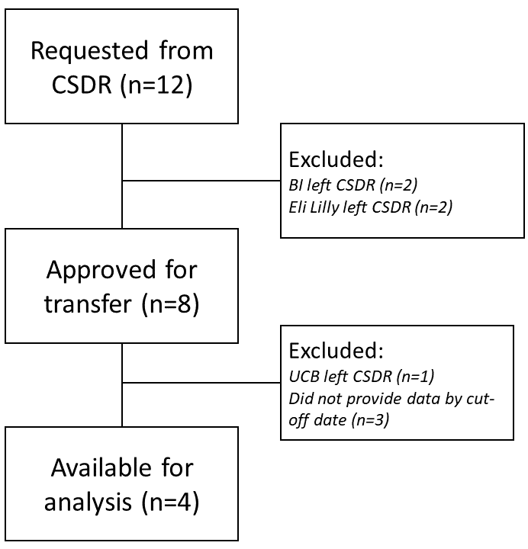

Supplementary Figure 2: Flowchart of the data request process for publicly funded trials
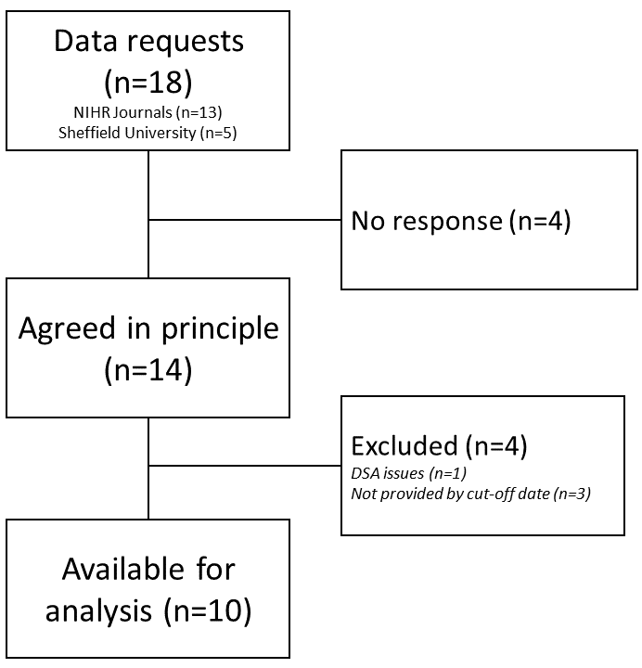

Supplementary Figure 3: Conditional power curves for trials with continuous outcome data following data transformations such that $∂={\frac{1}{3}∂}_{plan}$. For each data transformation scenario, four future treatment effect assumptions are used in the conditional power calculation
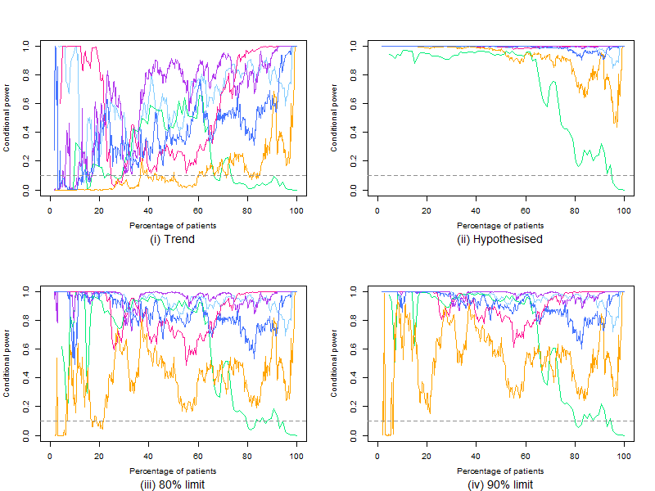
$$∂=\frac{1}{3}∂_{plan}$$
Supplementary Figure 4: Conditional power curves for trials with binary outcome data following data transformations such that $∂={\frac{1}{3}∂}_{plan}$. For each data transformation scenario, four future treatment effect assumptions are used in the conditional power calculation
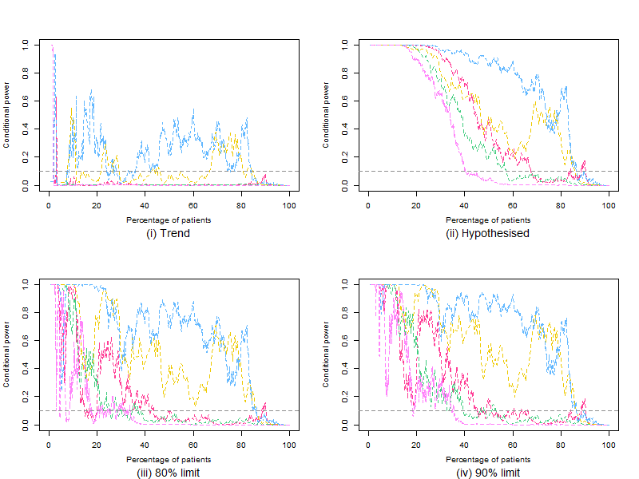
$$∂=\frac{1}{3}∂_{plan}$$

