Additional information

Fig. S1 Study design and patient eligibility criteria
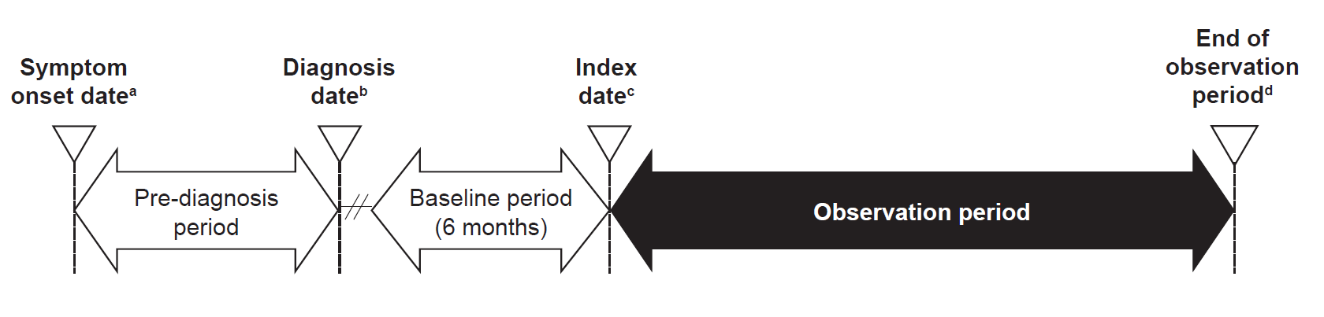
ªDate of first symptom of hereditary angioedema (HAE).
^{b}Date of documented diagnosis of HAE.
^{c}Date of first HAE-related visit at participating clinical center.
^{d}Earliest of last clinical visit, enrollment in a clinical trial for an investigational HAE treatment, death, or end of study.

Narrative S1 Patient death

During the observation period, one patient died and the cause of death was deemed to be related to HAE. At the time of death, the patient was prescribed Berinert® for LTP, as well as Berinert® and icatibant for on-demand treatment. No other details regarding the death, including individual HAE attack information, were reported for this patient.

