ELECTRONIC SUPPLEMENTARY MATERIAL

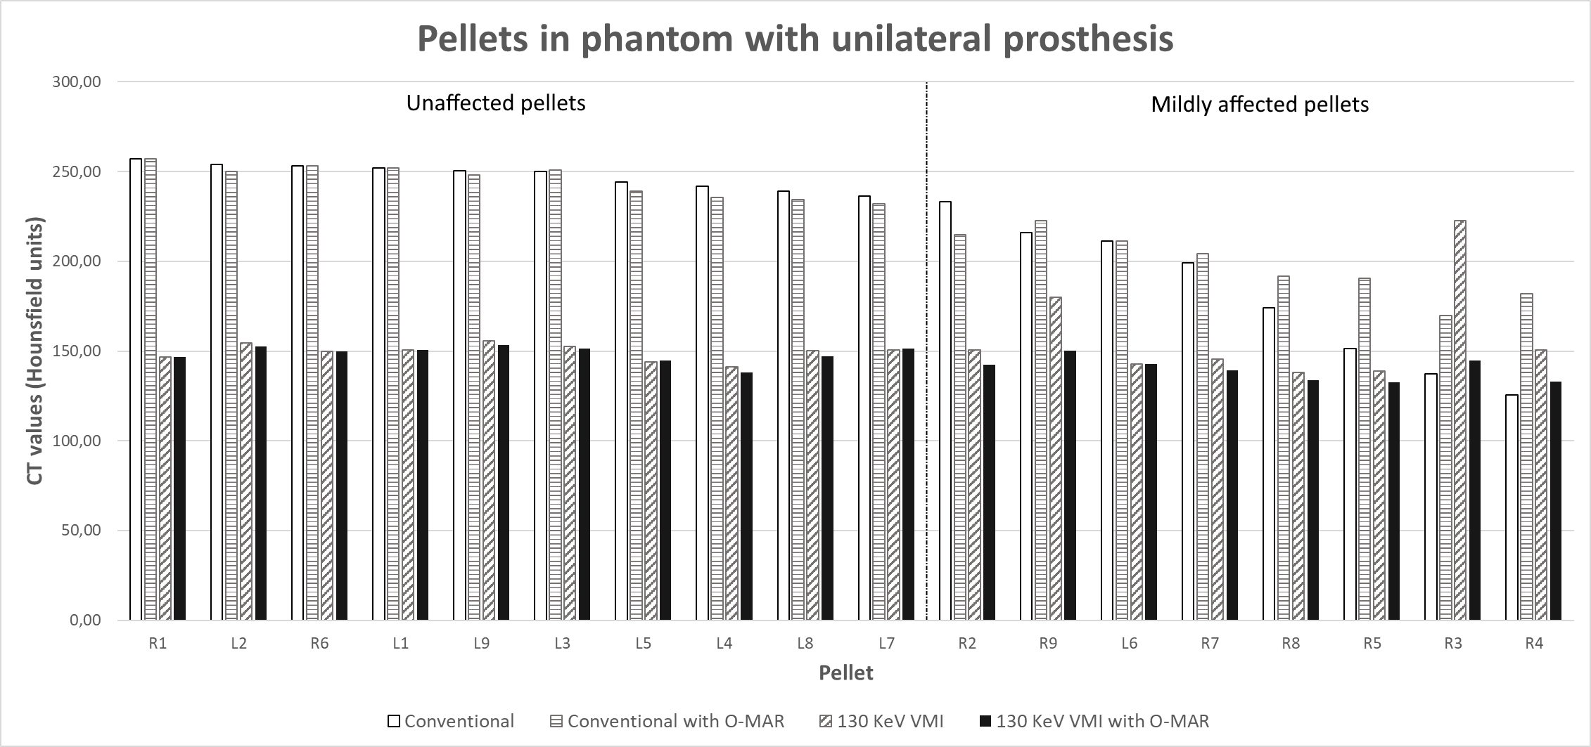
Supplementary materials 1: CT values in Hounsfield units of all pellets in the phantom with unilateral prosthesis. Unaffected pellets at the left, mildly affected pellets at the right.
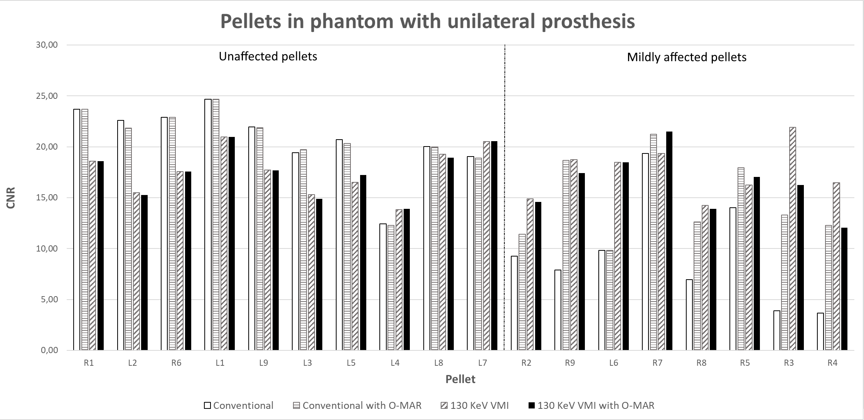
Supplementary materials 2: CNR of all pellets in the phantom with unilateral prosthesis. Unaffected pellets at the left, mildly affected pellets at the right.
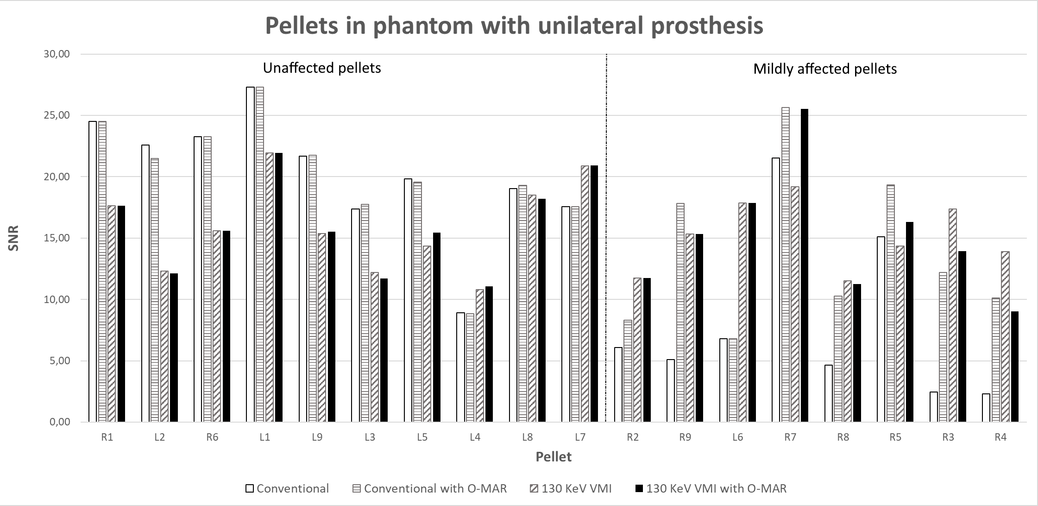Supplementary materials 3: SNR of all pellets in the phantom with unilateral prosthesis. Unaffected pellets at the left, mildly affected pellets at the right.
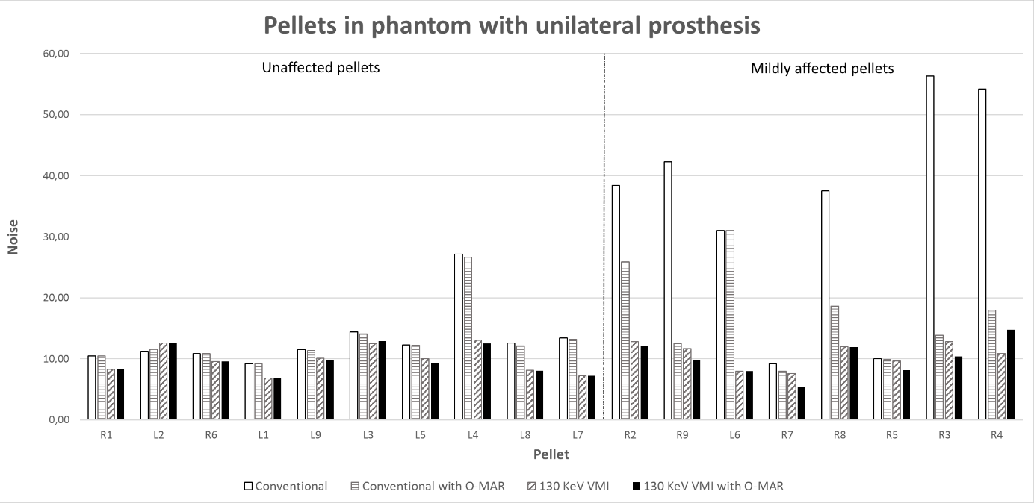
Supplementary materials 4: Noise of all pellets in the phantom with unilateral prosthesis. Unaffected pellets at the left, mildly affected pellets at the right.
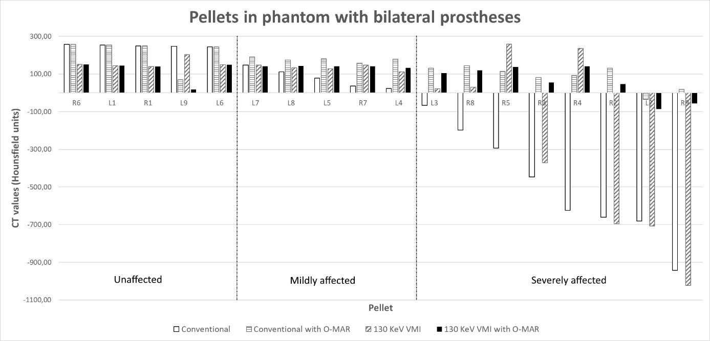Supplementary materials 5: CT values in Hounsfield units of all pellets in the phantom with bilateral prosthesis. Unaffected pellets at the left, mildly affected pellets at the middle, and severely affected pellets at the right.
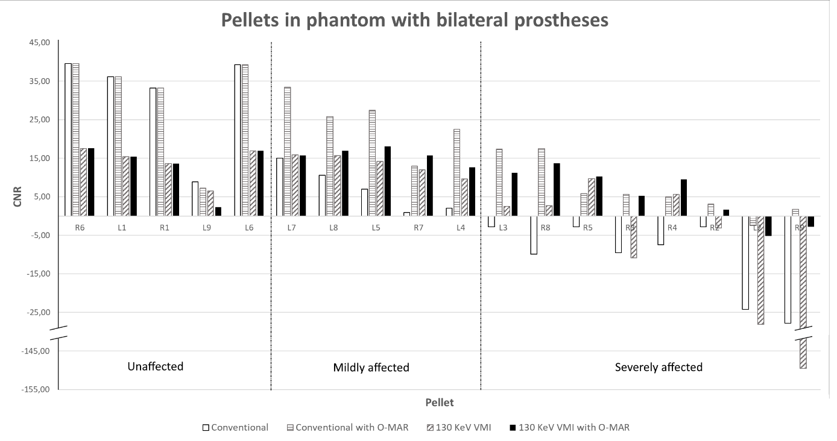
Supplementary materials 6: CNR of all pellets in the phantom with bilateral prosthesis. Unaffected pellets at the left, mildly affected pellets at the middle, and severely affected pellets at the right.
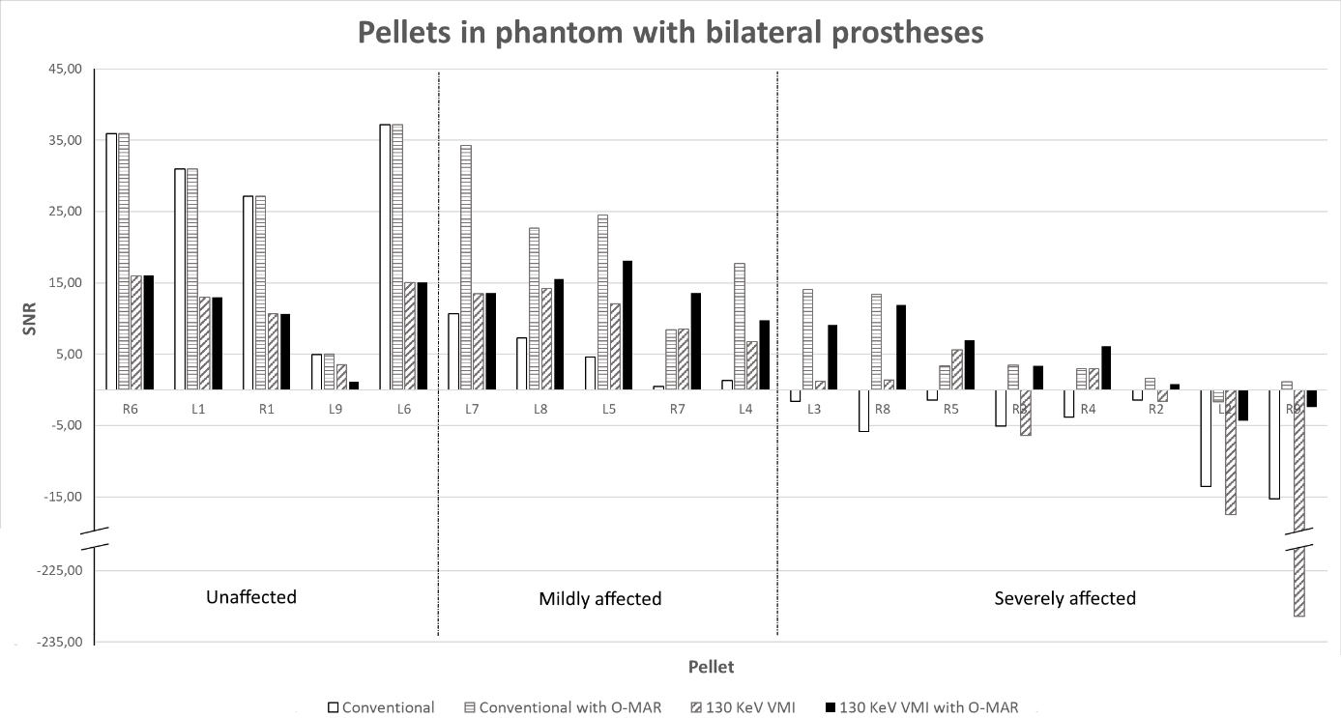
Supplementary materials 7: SNR of all pellets in the phantom with bilateral prosthesis. Unaffected pellets at the left, mildly affected pellets at the middle, and severely affected pellets at the right.

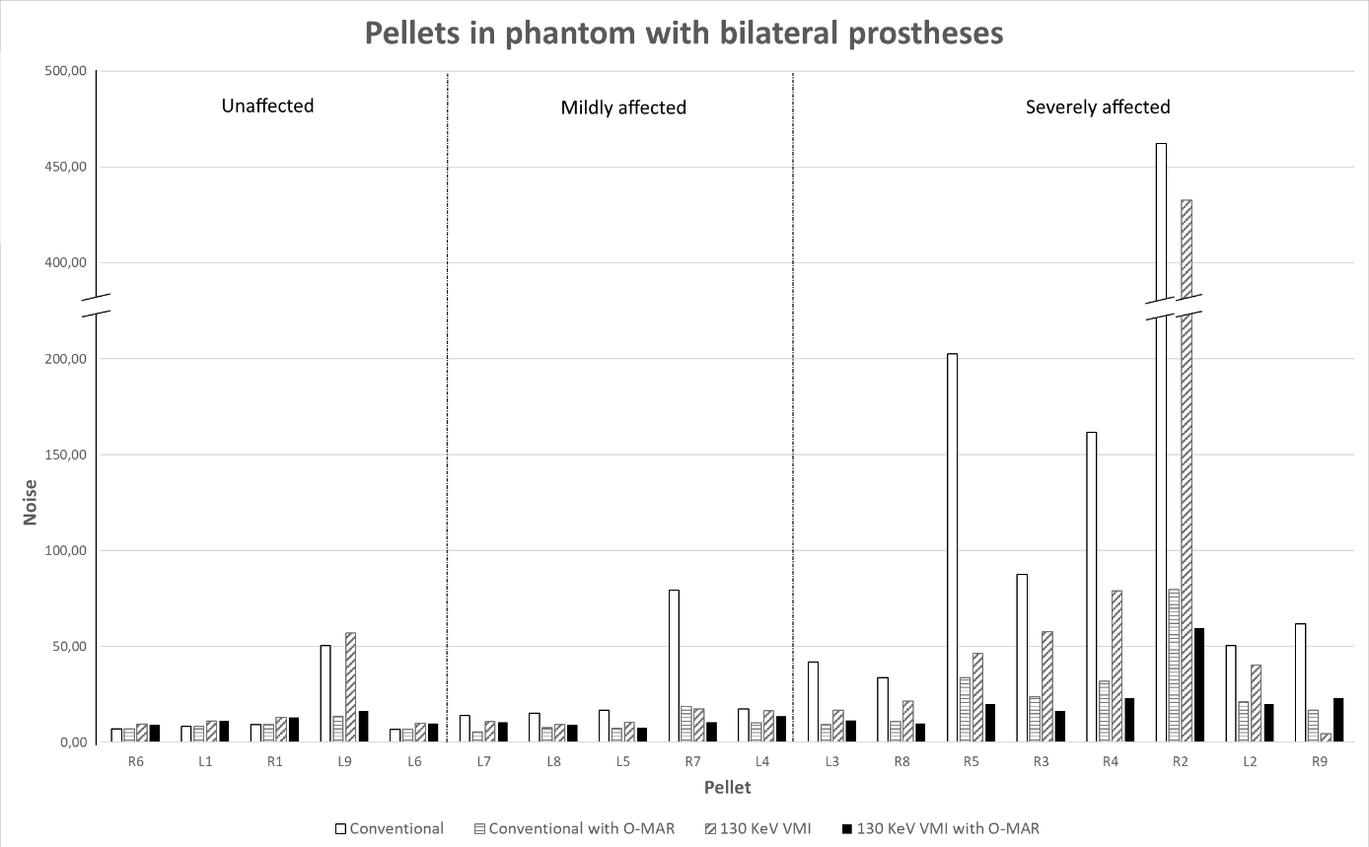
Supplementary materials 8: Noise of all pellets in the phantom with bilateral prosthesis. Unaffected pellets at the left, mildly affected pellets at the middle, and severely affected pellets at the right.

