Organizational Characteristics, Outcomes and Resource Use in 78 Brazilian Intensive Care Units: The ORCHESTRA Study

Authors: Soares et al. for the ORCHESTRA (ORganizational CHaractEriSTics in cRitical cAre) Study Investigators.

Electronic Supplementary Material

Content:

1) Patients and Methods
2) eTable 1. Main hospital characteristics
3) eTable 2. Comparisons of ICU organizational, structural and process characteristics according to the type of hospital.
4) eTable 3. Univariate analyses of organizational, structural and process characteristics associated with hospital mortality.
5) eTable 4. Univariate analyses of main patients’ characteristics associated with hospital mortality.
6) eTable 5. Multilevel multivariable analysis of characteristics associated with hospital mortality.
7) eTable 6. Subgroup analyses for association between the number of implemented protocols and hospital mortality. *
8) eTable 7. Univariate analyses of the characteristics associated with highest-efficiency in ICUs*
9) eFigures 1a to 1k
10) Hospital and ICU Survey

Patients and Methods (1,652 words)
Design and Setting
We performed a multicenter retrospective cohort study of critical care organization and outcomes in 78 ICUs at 51 hospitals in 11 Brazilian states. The complete list of investigators and centers appears at the Electronic Supplementary Material (ESM). The study was coordinated by the Department of Critical Care at the D’Or Institute for Research and Education (IDOR), Rio de Janeiro, Brazil, and was endorsed by the Brazilian Research in Intensive Care Network (BRICNet), an independent research network for performing investigator-initiated multicenter studies in critical care in Brazil. Local Ethics Committee at the IDOR (Parecer: 334.835). The Brazilian National Ethics Committee (CAAE: 19687113.8.1001.5249) approved the study and the need for informed consent was waived.

Selection of Centers, Data Collection and Definitions
Participating centers: The study flowchart is depicted in Figure 1. We restricted the study to ICUs registered in the BRICNet database and known to use the Epimed Monitor System®, (Epimed Solutions®, Rio de Janeiro, Brazil), a commercial cloud-based registry for quality improvement, performance evaluation and benchmarking purposes. 117 ICUs met these criteria and were invited to participate in the study. Of these, 88 ICUs agreed to participate. We excluded ICUs that initiated Epimed after July 2012 (n=2) and ICUs in which >10% of patients with missing core data (n=8), leaving 78 ICUs from 51 hospitals in the final cohort.
Within each participating ICU, the ICU director and/or chief nurse completed a survey about hospital and ICU organizational, structural and process characteristics. Domains for the survey were based on prior studies demonstrating potential structure-outcome links in critical care [1-7], and included: hospital and ICU type and bed capacity, presence of residence/fellowship in critical care or training programs certified by the Brazilian Association of Intensive Care (Associação Brasileira de Medicina Intensiva – AMIB), ICU staffing patterns, multidisciplinary clinical rounds, checklists, clinical pathways and protocols, regular debriefing and administrative multidisciplinary meetings, and family visiting policies (see page 25 of the ESM).
We defined board-certified intensivists and nurses as those who were board-certified in Intensive Care Medicine by AMIB. In summary, to apply for board-certification by AMIB, physicians should have completed a two- or three-year residence or fellowship training in internal medicine, surgery or anesthesiology followed by a two-year residence or fellowship training in critical care. Critical care nurses should have completed a two-year residence or fellowship training in critical care. According to Brazilian regulations, the ICU director and at least one intensivist responsible for the daily care plan in the ICU should be board-certified in critical care. In addition, at least one physician (not necessarily board-certified) and one graduate nurse per each 10 beds must be fully dedicated and present in the ICU 24/7, not including trainees. Auxiliary nurses (nurse technicians) also participate in patients’ care at a minimum rate of one per each two ICU beds. Residents and trainees were not considered in both nurses and physicians counts as well as in staffing/bed ratios estimations. We defined other key organizational variables as follows: a) regular multidisciplinary clinical rounds as those carried out at least five days per week and including at least two other healthcare providers in addition to the physician and nurse; b) checklists as structured evaluations using a digital or printed instrument with multiple components focused on prevention of common ICU complications and adherence to best practices; c) debriefing meetings as conferences allowing the ICU team to discuss individual and team level performance, identify errors, and plans to improve their performance and teamwork competencies; d) administrative/ managerial meetings as those discussing planning, staffing and other administrative or financial aspects of the ICU; and e) protocols as explicit, standardized and detailed written plans or clinical pathways that provide a set of guiding rules for caring for patients with a given condition.
For the purposes of the present study, we considered only protocols fully implemented when they were in use for at least six months and as jointly managed when at least two distinct care providers (e.g. a nurse and a physiotherapist) were responsible to lead, implement, monitor, evaluate and reassess them. We measured the availability of the following 10 protocols:
- Sepsis: according to the current recommendations of the Surviving Sepsis Campaign;
- Sedation: daily interruption or protocolized sedation in ventilated patients;
- Cerebrovascular accident: a systematic initial approach including risk stratification and checking for the eligibility to receive thrombolysis;
- Acute coronary syndromes: a systematic initial approach including risk stratification and checking for the eligibility to receive reperfusion therapies or interventions;
- Liberation from the mechanical ventilation: care provider-driven spontaneous breathing trials;
- Lung protective ventilation: ventilation with low tidal volumes in patients with acute lung injury/ARDS;
- Therapeutic hypothermia: in patients who experienced cardiac arrest;
- Catheter-associated bloodstream infection prevention: implementation of checklists during insertion and maintenance of vascular catheters;
- Ventilator-associated pneumonia (VAP) prevention: implementation of daily checklists to best practices to prevent VAP in ventilated patients;
- Early mobilization in ventilated patients: a protocolized early exercise and mobilization including physical and occupational therapy during periods of daily interruption of sedation in ventilated patients;
In order to guarantee data accuracy, validity and completeness we piloted the survey among three participating centers, provided respondents with explicit definitions of the survey domains. We ensured the reliability of all data by interviewing medical and/or nurse ICU directors from every participating center on site or by phone.

Patients
We included all consecutive patients aged ≥16 years old admitted to the participating ICUs during 2013. Readmissions and patients with missing core data (age, location before ICU admission, main ICU admission diagnosis, the Simplified Acute Physiology Score (SAPS 3) [8], ICU and hospital LOS and vital status at hospital discharge) were excluded (Figure 1). We obtained de-identified patient data from the Epimed Monitor System®. Briefly, data were prospectively entered in a structured electronic case report form, most typically by a trained case manager. Online or live training and feedback sessions occurred regularly in addition to at least six face-to-face meetings per year, during which users received updates and additional training. Key data elements included demographics, comorbidities based on the Charlson Comorbidity Index [9], functional status in the week before hospital admission adapted from the ECOG (Eastern Cooperative Oncology Group) performance status [10], location before ICU admission, scores including the SAPS 3 score [8] and the Sequential Organ Failure Score [11], ICU admission diagnosis, infection-related data, use of ICU support, ICU and hospital length-of-stay (LOS) and destination at hospital discharge.

Outcomes
The primary outcome of interest was in-hospital mortality at the patient level. The secondary outcome was efficient resource use defined as a lower than expected resource use per surviving patient adjusted by the severity of illness [3]. We evaluated outcomes and resource use for each ICU by estimating the standardized mortality rates (SMR) and standardized resource use (SRU) according to the SAPS 3, as proposed by Rothen et al [3]. We calculated the SMR by dividing observed by predicted mortality rates. The SRU estimates the average observed to expected ratio of resources (based on the length of ICU stay) used per surviving patient in a specific ICU adjusted for the severity of illness. Based on median SMR and median SRU, we assigned each unit to one of four groups: “most efficient” (all units whose SMR and SRU were below the median SMR and SRU); “least efficient” (units with both SMR and SRU above the median); “overachieving” (low SMR and high SRU) and “underachieving” (high SMR and low SRU) (eFigures 1a to 1k).

Data processing and Statistical Analysis
We screened data for missing information, implausible and outlying values, logical errors and insufficient details. In cases of inconsistent or implausible data, we contacted local investigators to provide the requested information. There was no missing information regarding hospital and ICU characteristics. Missingness for patients’ characteristics was minimal [previous functional status (n=3,476; 5.8%), mechanical ventilation, non-invasive ventilation, vasopressors and dialysis on the first day (n=171; 0.3%)]. In these cases, we performed single imputation using the reference or “normal” category as previously performed [8,12].
We described ICU and patient characteristics using standard descriptive statistics and reported continuous variables as mean ± standard deviation or median (25%-75% interquartile range, IQR), as appropriate. We tested the univariate association between eligible variables and outcomes using analysis of variance, Kruskal-Wallis, Student t test, Mann-Whitney test, chi-square test, and Fisher exact test, as appropriate.
Patient level variables of interest included age, gender, hospital LOS before ICU admission, diagnostic category, functional capacity before hospital admission, the Charlson Comorbidity Index, the use of MV on Day 1, SOFA and SAPS 3 scored. ICU level variables of interest included ICU type (medical-surgical vs. specialty), presence of training programs in critical care, ICU admission volume (number) during 2013, staffing patterns, organizational and process characteristics.
We investigated the association between organizational factors and hospital mortality adjusting for patients’ characteristics using multilevel multivariable logistic regression. A two-level model was fit with patient-level fixed effects at the first level and ICU-level fixed effects at the second level, as well as an ICU-specific random effect. We pre-specified several models to represent the patients and the unit organization dimensions. We inserted variables into the models if they were associated with outcome with a P value of <0.20 on univariate analysis. We did not consider variables either directly encompassed (i.e. age and hospital LOS before ICU admission) or indirectly considered (i.e. Charlson Comorbidity Index and SOFA score) for the SAPS 3 score estimation [8]. We forced several variables into the final model regardless of their statistical significance due to their clinical significance, including the presence of 24/7 intensivist, regular multidisciplinary rounds and nurse/bed ratios in the final model. In addition, we performed subgroup analyses stratifying patients according to the type of admission (medical vs. surgical) and the SAPS 3 tertiles. We used the Akaike information criterion, the likelihood ratios and the model residuals to choose among the alternative models. Two-tailed P-values <0.05 were considered statistically significant. We conducted all statistical analyses in R (http://www.r-project.org) and SPSS 21 (IBM Corp., Armonk, NY).

References
- Checkley W, Martin GS, Brown SM, Chang SY, Dabbagh O, Fremont RD, Girard TD, Rice TW, Howell MD, Johnson SB, O'Brien J, Park PK, Pastores SM, Patil NT, Pietropaoli AP, Putman M, Rotello L, Siner J, Sajid S, Murphy DJ, Sevransky JE; United States Critical Illness and Injury Trials Group Critical Illness Outcomes Study Investigators (2014) Structure, process, and annual ICU mortality across 69 centers: United States Critical Illness and Injury Trials Group Critical Illness Outcomes Study. Crit Care Med 42:344-356.
- Nguyen YL, Wunsch H, Angus DC (2010) Critical care: the impact of organization and management on outcomes. Curr Opin Crit Care 16:487-492.
- Rothen HU, Stricker K, Einfalt J, Bauer P, Metnitz PG, Moreno RP, Takala J. Variability in outcome and resource use in intensive care units. Intensive Care Med 33:1329-1336.
- Kahn JM, Goss CH, Heagerty PJ, Kramer AA, O'Brien CR, Rubenfeld GD (2006) Hospital volume and the outcomes of mechanical ventilation. N Engl J Med 355:41-50.
- Kim MM, Barnato AE, Angus DC, Fleisher LA, Kahn JM (2010) The effect of multidisciplinary care teams on intensive care unit mortality. Arch Intern Med 170:369-376.
- Wallace DJ, Angus DC, Barnato AE, Kramer AA, Kahn JM (2012) Nighttime intensivist staffing and mortality among critically ill patients. N Engl J Med 366:2093-2101.
- Pronovost PJ, Angus DC, Dorman T, Robinson KA, Dremsizov TT, Young TL (2002) Physician staffing patterns and clinical outcomes in critically ill patients: a systematic review. JAMA 288:2151-2162.7)
- Moreno RP, Metnitz PG, Almeida E, Jordan B, Bauer P, Campos RA, Iapichino G, Edbrooke D, Capuzzo M, Le Gall JR; SAPS 3 Investigators (2005) SAPS 3--From evaluation of the patient to evaluation of the intensive care unit. Part 2: Development of a prognostic model for hospital mortality at ICU admission. Intensive Care Med 31:1345-1355.
- Charlson ME, Pompei P, Ales KL, MacKenzie CR (1987) A new method of classifying prognostic comorbidity in longitudinal studies: development and validation. J Chronic Dis 40:373-383.
- Oken MM, Creech RH, Tormey DC, Horton J, Davis TE, McFadden ET, Carbone PP (1982) Toxicity and response criteria of the Eastern Cooperative Oncology Group. Am J Clin Oncol 5:649-655.
- Vincent JL, Moreno R, Takala J, Willatts S, De Mendonça A, Bruining H, Reinhart CK, Suter PM, Thijs LG (1996) The SOFA (Sepsis-related Organ Failure Assessment) score to describe organ dysfunction/failure. On behalf of the Working Group on Sepsis-Related Problems of the European Society of Intensive Care Medicine. Intensive Care Med 22:707-710.
- Vesin A, Azoulay E, Ruckly S, Vignoud L, Rusinovà K, Benoit D, Soares M, Azeivedo-Maia P, Abroug F, Benbenishty J, Timsit JF (2013) Reporting and handling missing values in clinical studies in intensive care units. Intensive Care Med 39:1396-1404.

eTable 1. Main hospital characteristics (n=51).
Characteristics
Type of hospital
Private, for profit | 32 (63%)
Private, philanthropic | 14 (27%)
Public | 5 (10%)
Number of hospital beds | 204±151; 176 (100 – 250)
≤ 150 | 20 (39%)
151 – 300 | 20 (39%)
> 300 | 11 (22%)
Total number of ICUs in the hospital
1 | 17 (33%)
2 -3 | 23 (45%)
>3 | 11 (22%)
ICU/Hospital beds ratio * | 17±9; 17 (9 – 21)
Intermediate or step-down unit(s)
No | 27 (53%)
Yes | 24 (47%)
Emergency Room or Department
No | 1 (2%)
Yes, open | 44 (86%)
Yes, referenced | 6 (12%)
Hospital certified by an Accreditation Organization
No | 21 (41%)
Yes, National | 20 (39%)
Yes, International | 10 (20%)
Rapid response team implemented for >6 months
No | 27 (53%)
Yes | 24 (47%)
Training programs in critical care
No | 29 (57%)
Yes | 22 (43%)
IQR = interquartile range; ICU = intensive care unit SD = standard deviation; IQR = interquartile range.
Results for continuous variables are reported as mean±SD and median (IQR).
* ICU/Hospital beds ratio = (ICU beds / Hospital beds) * 100

eTable 2. Comparisons of ICU organizational, structural and process characteristics according to the type of hospital.
Characteristics | Private, for profit | Private, philanthropic | Public | P-value
 | 58 (74%) | 14 (18%) | 6 (8%)
Hospital and ICU Characterization
Training programs in critical care
No | 27 (47%) | 7 (50%) | 4 (67%) | 0.640
Yes | 31 (53%) | 7 (50%) | 2 (33%)
ICU Type
Specialty | 14 (24%) | 2 (14%) | 0 | 0.291
Medical-surgical | 44 (76%) | 12 (86%) | 6 (100%)
Number of active ICU beds | 17±11; 13 (10 – 21) | 22±12; 20 (11 – 31) | 10±6; 10 (6 -14) | 0.044
≤10 | 19 (33%) | 3 (21%) | 4 (67%) | 0.309
10 – 20 | 24 (41%) | 5 (36%) | 1 (17%)
> 20 | 15 (26%) | 6 (43%) | 1 (17%)
ICU bed occupancy rate (%) | 71±14; 72 (61 – 80) | 76±13; 78 (67 – 87) | 88±9; 91 (79 – 87) | 0.007
Staffing Patterns
Board certified intensivists present in the ICU 24/7
No | 50 (86%) | 8 (57%) | 4 (67%) | 0.039
Yes | 8 (14%) | 6 (43%) | 2 (33%)
Average overall graduated nurse/bed ratio during shifts | 0.24±0.10  0.21 (0.16 – 0.28) | 0.23±0.15  0.19 (0.13 – 0.27) | 0.19 (0.11)  0.16 (0.10 – 0.28) | 0.273
Physiotherapists exclusively dedicated to the ICU 24/7
No | 20 (34%) | 1 (7%) | 4 (67%) | 0.024
Yes | 38 (66%) | 13 (93%) | 2 (33%)
Pharmacists exclusively dedicated to the ICU
No | 47 (81%) | 9 (64%) | 4 (67%) | 0.338
Yes | 11 (19%) | 5 (36%) | 2 (33%)

eTable 2. Comparisons of ICU organizational, structural and process characteristics according to the type of hospital. (cont.)
Characteristics | Private, for profit | Private, philanthropic | Public | P-value
 | 58 (74%) | 14 (18%) | 6 (8%)
Process and Organizational Characteristics
Regular multidisciplinary clinical rounds (≥5 days/week)
No | 2 (3%) | 6 (43%) | 3 (50%) | <0.001
Yes | 56 (97%) | 8 (57%) | 3 (50%)
Daily (7 days/week) checklists to assist in patients’ care
No | 27 (47%) | 10 (71%) | 5 (83%) | 0.079
Yes | 31 (53%) | 4 (29%) | 1 (17%)
Clinical protocols/pathways fully implemented for >6mo (n) | 8±2; 8 (6 – 9) | 7±4; 7 (5 – 9) | 2±1; 1 (1 – 2) | <0.001
Protocols jointly managed by different care providers
No | 41 (71%) | 12 (86%) | 5 (83%) | 0.447
Yes | 17 (29%) | 2 (14%) | 1 (17%)
Regular “debriefing meetings” in the ICU (at least monthly)
No | 18 (31%) | 7 (50%) | 4 (67%) | 0.125
Yes | 400 (69%) | 7 (50%) | 2 (33%)
Regular administrative and managerial meetings in the ICU (at least monthly)
No | 20 (34%) | 3 (21%) | 5 (83%) | 0.027
Yes | 38 (66%) | 11 (79%) | 1 (17%)
CI = confidence interval; ICU = intensive care unit; SD = standard deviation; IQR = interquartile range.
Results for continuous variables are reported as mean±SD and median (IQR).

eTable 3. Univariate analyses of organizational, structural and process characteristics associated with hospital mortality.
Characteristics | Survivors | Non-survivors | Odds-ratio | P-value
 | 51,112 (85.6%) | 8,581 (14.4%) | (95% CI)
Hospital and ICU Characterization
Training programs in critical care
No | 23,886 (46.7%) | 3,644 (42.5%) | 1.00 | <0.001
Yes | 27,246 (53.3%) | 4,937 (57.5%) | 1.19 (1.13 – 1.24)
ICU Type
Specialty | 9,109 (17.8%) | 942 (11.0%) | 1.00 | <0.001
Medical-surgical | 42,003 (82.2%) | 7,639 (89.0%) | 1.76 (1.64 – 1.90)
Number of active ICU beds
≤10 | 9,185 (18.0%) | 1,683 (19.6%) | 1.00 | <0.001
10 – 20 | 16,124 (31.5%) | 2,997 (34.9%) | 1.01 (0.95 – 1.08)
> 20 | 25,803 (50.5%) | 3,901 (45.5%) | 0.83 (0.78 – 0.88)
Staffing Patterns
Board certified intensivists present in the ICU 24/7
No | 36,950 (72.3%) | 6,239 (72.7%) | 1.00 | 0.426
Yes | 14,162 (27.7%) | 2,342 (27.3%) | 0.98 (0.93 – 1.03)
Average overall graduated nurse/bed ratio during shifts | 0.25±0.13  0.22 (0.17 – 0.29) | 0.23±0.11  0.20 (0.15 – 0.26) | 0.20 (0.16 – 0.25) | <0.001
Physiotherapists exclusively dedicated to the ICU 24/7
No | 10,999 (21.5%) | 2,124 (24.8%) | 1.00 | <0.001
Yes | 40,113 (78.5%) | 6,457 (75.2%) | 0.83 (0.79 – 0.88)
Pharmacists exclusively dedicated to the ICU
No | 35,220 (68.9%) | 6,110 (71.2%) | 1.00 | <0.001
Yes | 15,892 (31.1%) | 2,471 (28.8%) | 0.90 (0.85 – 0.94)

eTable 3. Univariate analyses of organizational, structural and process characteristics associated with hospital mortality. (cont.)
Characteristics | Survivors | Non-survivors | Odds-ratio | P-value
 | 51,112 (85.6%) | 8,581 (14.4%) | (95% CI)
Process and Organizational Characteristics
Regular multidisciplinary clinical rounds (≥5 days/week)
No | 6,300 (12.3%) | 1,724 (20.1%) | 1.00 | <0.001
Yes | 44,812 (87.7%) | 6,857 (79.9%) | 0.56 (0.53 – 0.59)
Daily (7 days/week) checklists to assist in patients’ care
No | 27,000 (52.8%) | 5,294 (61.7%) | 1.00 | <0.001
Yes | 24,112 (47.2%) | 3,287 (38.3%) | 0.70 (0.66 – 0.73)
Clinical protocols/pathways fully implemented for >6mo (n) | 7.6±2.3  8 (6 – 9) | 6.9±3.1  7 (5 – 9) | 0.90 (0.89 – 0.91) | <0.001
Protocols jointly managed by different care providers
No | 38,695 (75.7%) | 6,859 (79.9%) | 1.00 | <0.001
Yes | 12,427 (24.3%) | 1,722 (20.1%) | 0.78 (0.74 – 0.83)
Regular “debriefing meetings” in the ICU (at least monthly)
No | 19,705 (38.6%) | 3,745 (43.6%) | 1.00 | <0.001
Yes | 31,407 (61.4%) | 4,836 (56.4%) | 0.81 (0.77 – 0.85)
Regular administrative and managerial meetings in the ICU (at least monthly)
No | 17,972 (35.2%) | 3,610 (42.1%) | 1.00 | <0.001
Yes | 33,140 (64.8%) | 4,971 (57.9%) | 0.75 (0.71 – 0.78)
CI = confidence interval; ICU = intensive care unit SD = standard deviation; IQR = interquartile range.
Results for continuous variables are reported as mean±SD and median (IQR).

eTable 4. Univariate analyses of main patients’ characteristics associated with hospital mortality.
Characteristics | Survivors | Non-survivors | Odds-ratio | P-value
 | 51,112 (85.6%) | 8,581 (14.4%) | (95% CI)
Age (yrs) | 61.0±19.3  63 (47 – 77) | 70.2±17.5  70 (60 – 84) | 1.03 (1.02 – 1.03) | <0.001
Gender
Female | 25,723 (50.3%) | 4,198 (48.9%) | 1.00 | 0.017
Male | 25,389 (49.7%) | 4,383 (51.1%) | 1.06 (1.01 – 1.10)
Charlson comorbidity Index (points)
0 – 2 | 42,816 (83.8%) | 4,198 (48.9%) | 1.00 | <0.001
≥ 3 | 8,296 (16.2%) | 4,383 (51.1%) | 3.39 (3.23 – 3.56)
Chronic health status
Ambulant | 41,674 (81.5%) | 4,824 (56.2%) | 1.00 | <0.001
Minor assistance | 7,185 (14.1%) | 2,326 (27.1%) | 2.80 (2.65 – 2.96)
Major assistance or bedridden | 2,253 (4.4%) | 1,431 (16.7%) | 5.49 (5.10 – 5.90)
Hospital days prior to ICU admission * | 1.9±44.2; 0 (0 – 1) | 7.4±34.5; 1 (0 – 5) | 1.60 (1.57 – 1.63) | <0.001
Admission diagnostic category
Scheduled surgery | 15,835 (31.0%) | 817 (9.5%) | 1.00 | <0.001
Emergency surgery | 2,505 (4.9%) | 673 (7.8%) | 5.21 (4.66 – 5.82)
Cardiovascular | 10,680 (20.9%) | 754 (8.8%) | 1.36 (1.24 – 1.52)
Sepsis | 8,151 (15.9%) | 2,970 (34.6%) | 7.06 (6.51 – 7.67)
Respiratory | 1,897 (3.7%) | 761 (8.9%) | 3.51 (3.17 – 3.88)
Neurological | 4,833 (9.5%) | 874 (10.2%) | 7.78 (6.94 – 8.68)
Gastrointestinal | 1,977 (3.9%) | 343 (4.0%) | 3.36 (2.94 – 3.85)
Other medical admissions | 5,234 (10.2%) | 1,389 (16.2%) | 5.14 (4.69 – 5.64)
SAPS 3 (points) | 40.0±12.4  39 (32 – 48) | 61.0±15.9  60 (50 – 71) | 1.10 (1.09 – 1.10) | <0.001
SOFA score on Day 1 (points) | 1.8±2.4; 1 (0 – 3) | 5.8±4.2; 5 (2 – 9) | 1.41 (1.40 – 1.42) | <0.001

eTable 4. Univariate analyses of main patients’ characteristics associated with hospital mortality. (cont.)
Characteristics | Survivors | Non-survivors | Odds-ratio | P-value
 | 51,112 (85.6%) | 8,581 (14.4%) | (95% CI)
Mechanical ventilation on Day 1
No | 46,273 (90.5%) | 4,356 (50.8%) | 1.00 | <0.001
Yes | 4,839 (9.5%) | 4,225 (49.2%) | 9.27 (8.81 – 9.77)
* Ln (days + 0.5) was used for the odds-ratio estimation.
CI = confidence interval; ICU = intensive care unit; SAPS = Simplified Acute Physiology Score; SOFA = Sequential Organ Failure Score SD = standard deviation; IQR = interquartile range.
Results for continuous variables are reported as mean±SD and median (IQR).

eTable 5. Multilevel multivariable analysis of characteristics associated with hospital mortality.
 | Odds-ratio | P-value
 | (95% CI)
Variables at patient level
Admission diagnostic category
Scheduled surgery | 1.000
Emergency surgery | 0.935 (0.808-1.081) | 0.361
Cardiovascular* | 0.754 (0.664-0.855) | <0.001
Sepsis* | 1.130 (1.006-1.269) | 0.039
Neurological* | 0.923 (0.811-1.052) | 0.229
Respiratory* | 1.535 (1.331-1.770) | <0.001
Gastrointestinal* | 1.177 (1.000-1.386) | 0.050
Other medical admissions* | 1.322 (1.169-1.386) | <0.001
Functional status before hospital admission
Ambulant | 1.000
Minor assistance | 1.458 (1.350-1.575) | <0.001
Major assistance or bedridden | 2.177 (1.975-2.401) | <0.001
SAPS 3 (points) | 1.089 (1.086-1.092) | <0.001
Mechanical ventilation on Day 1
No | 1.000
Yes | 2.667 (2.475-2.873) | <0.001
Variables at center level
ICU admissions during 2013 (each 10 patients) | 0.980 (0.959-1.000) | 0.054
ICU Type
Specialty | 1.000
Medical-surgical | 1.309 (0.998-1.730) | 0.058
Board certified intensivists present in the ICU 24/7
No | 1.000
Yes | 1.036 (0.783-1.370) | 0.807
Average overall graduate nurse/bed ratio during shifts | 0.810 (0.292-2.245) | 0.685
Regular multidisciplinary clinical rounds (≥5 days/week)
No | 1.000
Yes | 1.108 (0.800-1.533) | 0.537
Clinical protocols/pathways fully implemented (n) | 0.944 (0.904-0.987) | 0.011
* These admission categories refer to medical diagnosis only.
CI = confidence interval; ICU = intensive care unit; SAPS = Simplified Acute Physiology Score.

eTable 6. Subgroup analyses for association between the number of implemented protocols and hospital mortality. *
 | Odds-ratio | P-value
 | (95% CI)
All patients (n=59,693) | 0.944 (0.904-0.987) | 0.011
Medical patients (n=39,863) | 0.952 (0.918-0.994) | 0.025
Surgical patients (n=19,830) | 0.903 (0.839-0.971) | 0.006
Patients stratified according to the SAPS 3 tertiles
1st tertile (<36 points) (n=19,990) | 0.831 (0.760-0.907) | <0.001
2nd tertile (36-48 points) (n=20,472) | 0.940 (0.873-0.970) | 0.002
3rd tertile (>48 points) (n=19,231) | 0.959 (0.921-0.999) | 0.045
* Estimates were adjusted for SAPS 3 score, need for mechanical ventilation, previous chronic health status, admission diagnostic category, ICU type, intensivists 24/7 in the ICU, average graduate nurse/bed ratio, regular clinical rounds and annual ICU admission volume.
CI = confidence interval; ICU = intensive care unit; SAPS = Simplified Acute Physiology Score.

eTable 7. Univariate analyses of the characteristics associated with highest-efficiency in ICUs*
Center Characteristics | ICU Efficiency
 | Lowest (n=28) | Highest (n=28) | Odds-ratio (95% CI) | P-Value
Type of hospital
Public | 4 (14%) | 0 | - | 0.111
Private (for profit / philanthropic) | 24 (86%) | 28 (100%) | -
Training (residence or fellow) programs in critical care
No | 18 (64%) | 10 (36%) | 1.00 | 0.033
Yes | 10 (36%) | 18 (64%) | 3.24 (1.09 – 9.67)
ICU Type
Specialty | 3 (11%) | 11 (39%) | 1.00 | 0.024
Medical-surgical | 25 (89%) | 17 (61%) | 0.19 (0.05 – 0.77)
Number of active ICU beds
≤10 | 8 (29%) | 12 (43%) | 1.00 | 0.323
10 – 20 | 12 (43%) | 8 (29%) | 1.50 (0.47 – 4.79)
> 20 | 8 (29%) | 8 (29%) | 0.64 (0.19 – 2.09)
Average physician/bed ratio
1st tertile | 6 (21%) | 10 (36%) | 1.00 | 0.158
2nd tertile | 14 (50%) | 7 (25%) | 0.30 (0.78 – 1.17)
3rd tertile | 8 (29%) | 11 (39%) | 0.83 (0.21 – 3.22)
Board certified intensivist 24/7 in the ICU
No | 19 (68%) | 23 (82%) | 1.00 | 0.217
Yes | 9 (32%) | 5 (18%) | 0.46 (0.13 – 1.60)
Average graduated nurse/bed ratio
1st tertile | 12 (43%) | 5 (18%) | ‘1.00 | 0.116
2nd tertile | 10 (36%) | 17 (61%) | 2.88 (0.76 – 10.99)
3rd tertile | 6 (21%) | 6 (21%) | 4.40 (1.04 – 18.60)
Board certified nurse 24/7 in the ICU
No | 27 (96%) | 23 (82%) | 1.00 | 0.084
Yes | 1 (4%) | 5 (18%) | 5.87 (0.64 – 53.93)

eTable 7. Univariate analyses of the characteristics associated with highest-efficiency in ICUs* (cont.)
Center Characteristics | ICU Efficiency
 | Lowest (n=28) | Highest (n=28) | Odds-ratio (95% CI) | P-Value
Pharmacist dedicated to the ICU
No | 24 (86%) | 22 (79%) | 1.00 | 0.485
Yes | 4 (14%) | 6 (21%) | 1.64 (0.41 – 6.58)
Routine clinical rounds (≥ 5 days/week)
No | 6 (21%) | 2 (7%) | 1.00 | 0.127
Yes | 22 (79%) | 26 (93%) | 3.54 (0.65 – 19.40)
Daily clinical checklists (7 days/week)
No | 20 (71%) | 13 (46%) | 1.00 | 0.057
Yes | 8 (29%) | 15 (54%) | 2.89 (0.95 – 8.72)
Clinical protocols/pathways fully implemented for >6mo (n)
1st tertile | 17 (61%) | 6 (21%) | ‘1.00 | 0.004
2nd tertile | 7 (25%) | 8 (29%) | 3.24 (0.82 – 12.83)
3rd tertile | 4 (14%) | 14 (50%) | 9.92 (2.38 – 42.25)
Protocols jointly managed by different care providers
No | 25 (89%) | 20 (71%) | 1.00 | 0.177
Yes | 3 (11%) | 8 (29%) | 3.33 (0.78 – 14.23)
Regular “debriefing meetings” in the ICU (at least monthly)
No | 12 (43%) | 9 (32%) | 1.00 | 0.408
Yes | 16 (57%) | 19 (68%) | 1.58 (0.53 – 4.71)
Regular administrative and managerial meetings in the ICU (at least monthly)
No | 8 (29%) | 10 (36%) | 1.00 | 0.567
Yes | 20 (71%) | 18 (64%) | 0.72 (0.23 – 2.22)
Efficiency was evaluated using the SMR and SRU estimated by the SAPS 3 Score. The “highest-efficiency” ICUs were those achieving both low SMR and SRU and the “lowest-efficiency” ICU were those achieving both high SMR and SRU during the period.
ICU = intensive care unit; SAPS = Simplified Acute Physiology Score; SMR = standardized mortality ratio; SRU = standardized resource use

eFigures 1a to 1k. Standardized mortality rates (SMR, X axis) and standardized resource use (SRU, Y axis) for the different participating intensive care units (ICU) according to different organizational, structure and process characteristics. Solid lines represent median values and dotted lines the stratification by tertiles.

eFigure 1a – Hospital type: private, philanthropic and public
eFigure 1b – Presence of training programs in critical care
eFigure 1c – ICU type: medical-surgical vs. specialty
eFigure 1d – Number of ICU beds
eFigure 1e – Physician/bed ratio
eFigure 1f – Intensivist physician in the ICU 24/7
eFigure 1g – Graduate nurse/bed ratio
eFigure 1h– Critical care nurse in the ICU 24/7
eFigure 1i – Presence of routine multidisciplinary rounds
eFigure 1j – Presence of daily checklists
eFigure 1k – Number of implemented protocols
eFigure 1l – Jointly managed clinical protocols

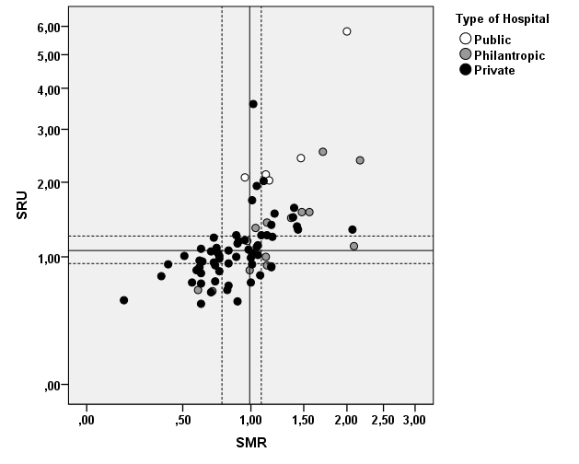eFigure 1a.

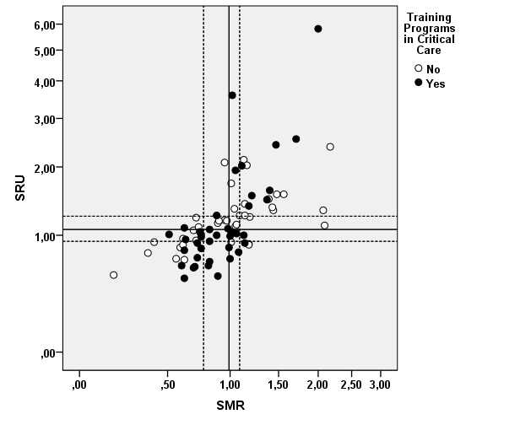eFigure 1b.

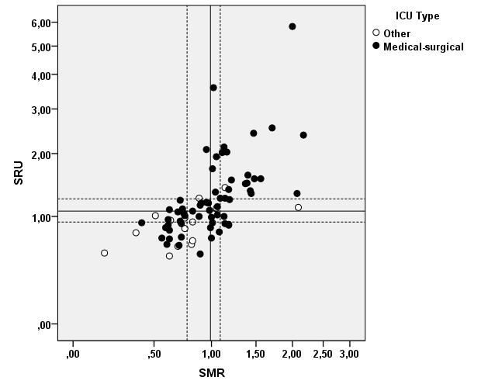eFigure 1c.

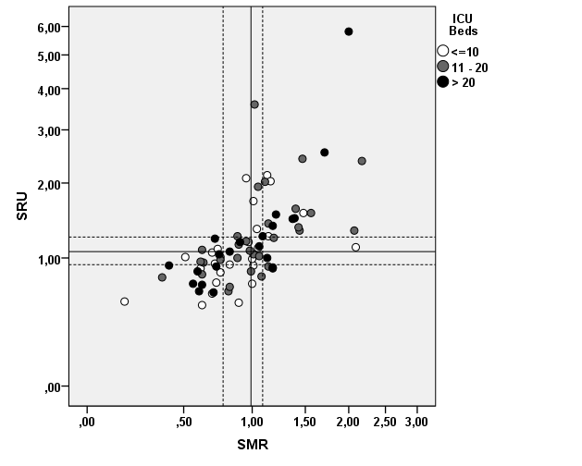eFigure 1d.

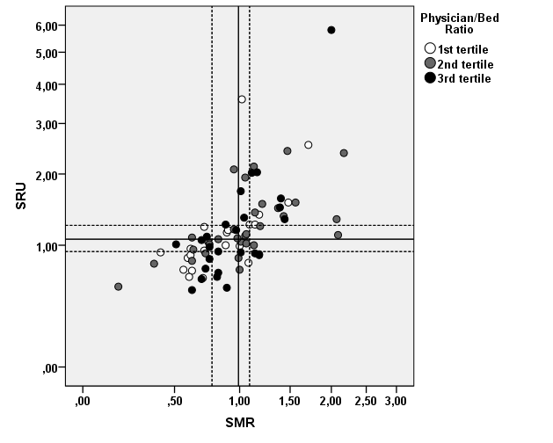eFigure 1e.

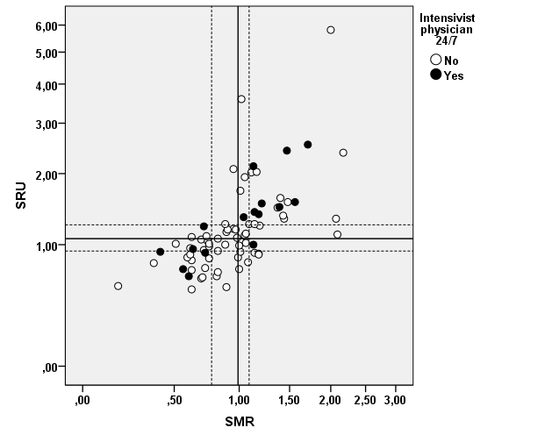eFigure 1f.

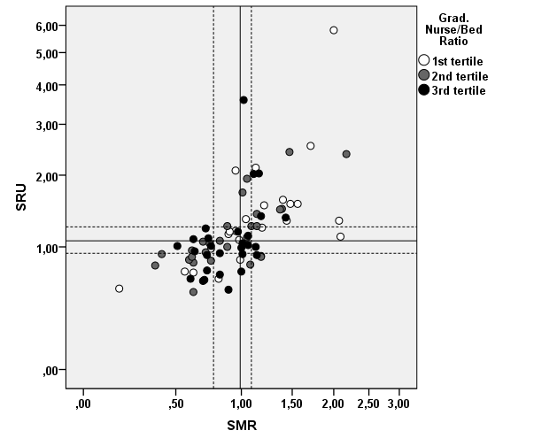eFigure 1g.

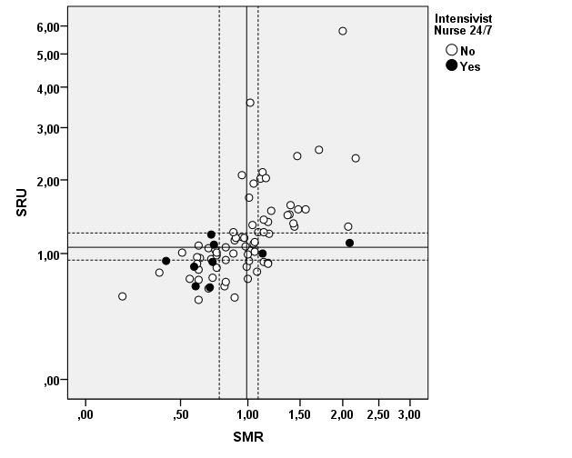eFigure 1h.

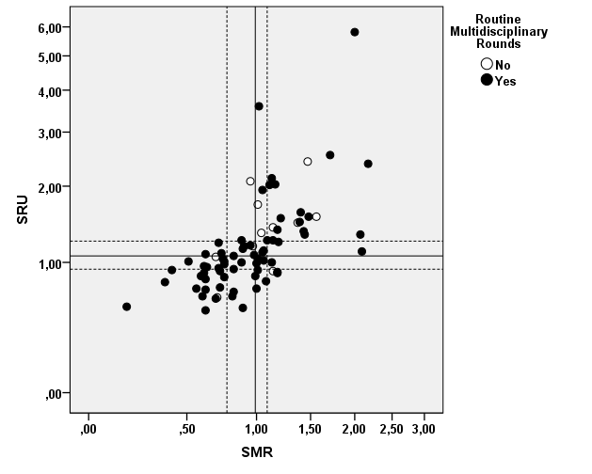eFigure 1i.

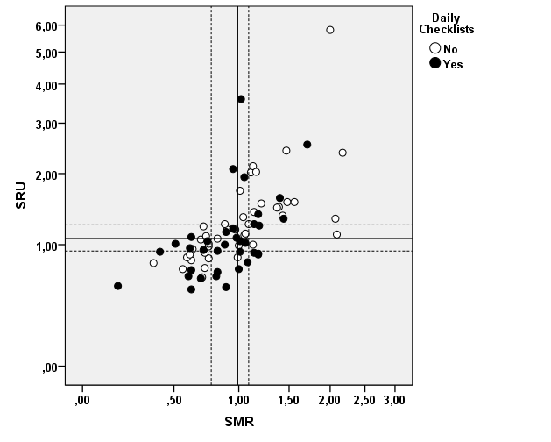eFigure 1j.

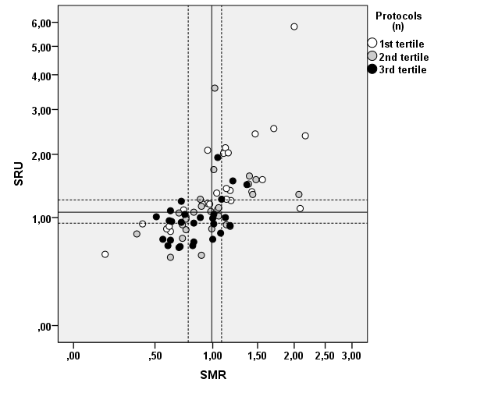eFigure 1k.

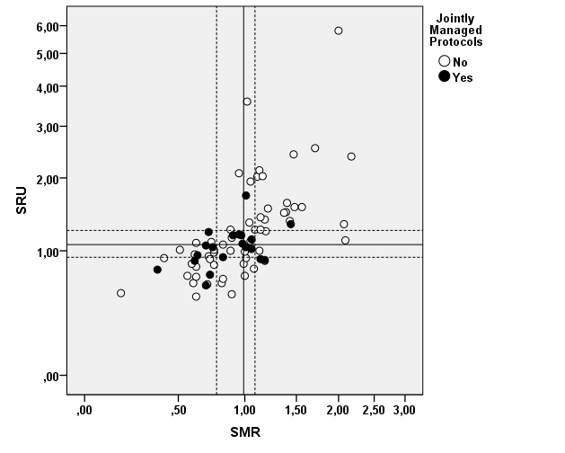eFigure 1l.

Organizational Factors and Patients’ Outcomes in Brazilian ICUs

Hospital Characterization Form

Hospital Name: ________________________________________________________________________
_____________________________________________________________________________________
Street Address: ________________________________________________________________________
City: _____________________________________ State: |...||...| ZIP Code: |...||...||...||...||...|-|...||...||...|
Principal Investigator: ___________________________________________________________________
Email: _______________________________________________________________________________
Phone: (___) _________________ Mobile: (___) ________________

Hospital Characteristics

Please, provide the following information that describes your hospital more appropriately:
1. Type of hospital (Public = 0; Private, philanthropic = 1; Private, for profit)) | | |
2. Number of hospital beds (i.e. active hospital beds) | | || || || |
3. Total number of ICUs in the hospital (including cardiac and coronary care, but excluding intermediate, ventilatory and step-down units) | | || |
4. Is (are) there intermediate or step-down unit(s) ? (including ventilatory units) | | yes || no |
5. Is there Emergency Room or Department ? (No = 0; Yes, open = 1; Yes, referenced = 2) | | |
6. Is the hospital certified by an Accreditation Organization? (No = 0; Yes, national = 1; Yes, International = 2) | | |
7. Is there a hospitalwide rapid response team formally implemented for >6 months ? | | yes || no |
8. Are there training programs or medical residence at your institution? (No = 0; Yes, but not in critical care = 1; Yes, including critical care= 2) | | |
9. Are there training programs for graduate nurses at your institution? (No = 0; Yes, but not specific to critical care = 1; Yes, including specific training in critical care= 2) | | |
10. Are there training programs for other care providers (physiotherapists, psychologists, clinical pharmacists or nutritionists) at your institution? (No = 0; Yes, but not specific to critical care = 1; Yes, including specific training in critical care= 2) | | |

ICU Characterization Form

Please, provide the following information that describes your ICU more appropriately. If there is more than one ICU at your hospital, please, fill an “ICU Form” for each of them:

ICU Name: ____________________________________________________________________________
Principal investigator at the ICU: ___________________________________________________________
Associate investigators: __________________________________________________________________
Phone: (___) _________________ Mobile: (___) ________________
Email : _______________________________________________________________________________

I – ICU Characteristics and Staffing Patterns

ICU Characterization
1. ICU Type: (General or mixed medical-surgical = 1; Surgical= 2; Clinic = 3; Neurological = 4; Coronary or cardiac = 5; Other = 6) | | | | 2. Number of active ICU beds | | || || |
Staffing Patterns: Physicians (* excluding trainees and residents)
3. Total number of physicians working in the ICU (Coordinators, diarists and on duty) | | || | | 4. Total number of intensivists (board certified in critical care by AMIB) | | || |
5. Physicians present in the ICU during day shifts (n) | | || | | 6. Physicians present in the ICU during night shifts (n) | | || |
7. Physicians present in the ICU during the weekends (n) | | || | | 8. Are there board certified intensivists present in the ICU during night shifts and weekends ? | | yes || no |
Staffing Patterns: Nurses (* excluding trainees and residents)
9. Number of graduated nurses working in the ICU (Coordinators, diarists and on duty) | | || | | 10. Number of intensivist nurses (board certified in critical care by AMIB) | | || |
11. Nurses present in the ICU during day shifts (n) | | || | | 12. Nurses present in the ICU during night shifts (n) | | || |
13. Nurses present in the ICU during the weekends (n) | | || | | 14. Are there board certified intensivist nurses present in the ICU during night shifts and weekends ? | | yes || no |
15. Number of undergraduate nurses working in the ICU (n) | | | || | | 16. Average number of undergraduate nurses during shifts (n) | | || |

I – ICU Characteristics and Staffing Patterns (cont.)

Staffing Patterns: Physiotherapists and Respiratory Therapists (* excluding trainees and residents)
17. Are there physiotherapists in the ICU? (No = 0; Yes, but not dedicated to the ICU= 1; Yes, dedicated to the ICU = 2) | | | | 18. In case of dedicated physiotherapists, they are present in the ICU: (Only during day shifts = 1; during day and night shifts = 2) | | |
Staffing Patterns: Other care providers (* excluding trainees and residents)
19. Psychologist (No = 0; Yes, but not dedicated to the ICU= 1; Yes, dedicated to the ICU = 2) | | | | 20. Nutritionist (No = 0; Yes, but not dedicated to the ICU= 1; Yes, dedicated to the ICU = 2) | | |
21. Clinical pharmacist (No = 0; Yes, but not dedicated to the ICU= 1; Yes, dedicated to the ICU = 2) | | |

II – Organizational Aspects and Processes of Care
Clinical Rounds
22. Are there formal clinical rounds ?  (No = 0, Yes, but not daily= 1; Yes, daily, except for the weekends= 2; Yes, daily, including the weekends = 3) | | | | 24. Which professionals do regularly participate ? (Check all that apply)  - Physicians  - Nurses  - Physiotherapists  - Psychologists  - Clinical pharmacists  - Nutritionists | | |  | |  | |  | |  | |  | |
23. Are clinical rounds held at bedside ?  (NO for all patients = 0, Yes, for specific patients = 1; Yes, for all patients in the ICU = 2) | | |
Checklists (defined as a structured evaluation using a digital or printed instrument with multiple components focused on prevention of common ICU complications and adherence to best practices)
25. Are checklists used during clinical rounds to assist patients’ care and management ?  (No = 0, Yes, but not daily= 1; Yes, daily, except for the weekends= 2; Yes, daily, including the weekends = 3) | | | | 27. Which professionals do regularly apply checklists? (Check all that apply)  - Physicians  - Nurses  - Physiotherapists  - Psychologists  - Clinical pharmacists  - Nutritionists | | |  | |  | |  | |  | |  | |
26. What are the roles of checklists during clinical rounds ?  (Only monitoring the adherence to best practices = 1; both monitor and actively guiding the implementation of adherence to best practices = 2) | | |

II – Organizational Aspects and Processes of Care (cont.)

Handover Procedures
28. Are there standardized handover procedures, particularly during shift changes?  (No = 0; Yes, verbal only = 1; Yes, written only = 2; Yes, both verbal and written = 3) | | | | 29. If you answered “Yes”, which care providers have standardized handover procedures?  (Only physicians = 0; Only nurses = 1; Physicians and nurses = 2; Physicians, nurses and other care providers = 3) | | |
Clinical Protocols (Protocol is defined as an explicit, standardized and detailed written plan or clinical pathway that provides a set of guiding rules for caring for patients with a given condition.
30. Are there clinical protocols and pathways fully implemented for > 6 months ? |  |  | |yes||no|
If you have answered “Yes” to the previous question, please indicate which protocols are implemented and which professional is (are) the main responsible(s) to each of them:
(Nurses = 1; Physicians = 2; Physiotherapists = 3; Clinical Pharmacists = 4; Nutritionists = 5; Psychologists = 6)
31. Sepsis (i.e. according to the current recommendations of the Surviving Sepsis Campaign)  Care provider responsible by the protocol: |  |  | |yes||no|  | |
32. Sedation (i.e. daily interruption or protocolized sedation in ventilated patients)  Care provider responsible by the protocol: |  |  | |yes||no|  | |
33. Cerebrovascular accident (i.e. systematic initial approach including risk stratification and checking for the eligibility to receive thrombolysis)  Care provider responsible by the protocol: |  |  | |yes||no|  | |
34. Acute coronary syndromes (i.e. systematic initial approach including risk stratification and checking for the eligibility to receive reperfusion therapies or interventions)  Care provider responsible by the protocol: |  |  | |yes||no|  | |
35. Liberation from the mechanical ventilation (i.e. care provider-driven spontaneous breathing trials)  Care provider responsible by the protocol: |  |  | |yes||no|  | |
36. Lung protective ventilation (i.e. ventilation with low tidal volumes in patients with acute lung injury/ARDS)  Care provider responsible by the protocol: |  |  | |yes||no|  | |
37. Therapeutic hypothermia in patients who experienced cardiac arrest  Care provider responsible by the protocol: |  |  | |yes||no|  | |
38. Catheter-associated bloodstream infection prevention (i.e. implementation of checklists during insertion and maintenance of vascular catheters)  Care provider responsible by the protocol: |  |  | |yes||no|  | |
39. Ventilator-associated pneumonia (VAP) prevention (i.e. implementation of daily checklists to best practices to prevent VAP in ventilated patients)  Care provider responsible by the protocol: |  |  | |yes||no|  | |
40. Early mobilization in ventilated patients (i.e protocolized early exercise and mobilization including physical and occupational therapy during periods of daily interruption of sedation in ventilated patients)  Care provider responsible by the protocol: |  |  | |yes||no|  | |

II – Organizational Aspects and Processes of Care (cont.)

Debriefing Meetings
41. Are “debriefing meetings” carried out on a regular basis (at least monthly) in the ICU ?  (Debriefing meetings allows individuals to discuss individual and team level performance, identify errors made, and develop a plan to improve their next performance. The best practices and tips should help teams to identify weak areas of teamwork and develop new strategies to improve teamwork competencies.) | |yes||no|
42. If you answered “Yes”, which care providers do attend the debriefing meetings ?  (Only physicians and nurses = 1; Physicians, nurses and other care providers = 2) | | |
Administrative and Managerial Meetings
43. Are managerial/administrative meetings carried out on a regular basis (at least monthly) in the ICU?  (i.e. meetings at which the planning, staffing, administrative aspects of ICU management, and even ICU finance are considered.) | |yes||no|
44. If you answered “Yes”, which care providers do attend the managerial / administrative meetings ?  (Only physicians and nurses = 1; Physicians, nurses and other care providers = 2) | | |
Teaching / Training Activities
45. Are training or teaching activities carried out on a regular basis (at least monthly) in the ICU ?  (i.e. multidisciplinary and collaborative training activities to foster improvement in patient’s care and sharing scientific knowledge, ability or skills) | |yes||no|
46. If you answered “Yes”, which care providers do attend the teaching / training activities ?  (Only physicians and nurses = 1; Physicians, nurses and other care providers = 2) | | |

III – Interaction with Families and Visiting Policies

Interaction with Families and Visiting Policies
47. Average number of visiting hours (total / day) | | | |
48. In general, is there a limit on how many family members can attend the bedside ? | |yes||no|
49. Is there a specific room for family conferences ? | |yes||no|
50. Is there a specific period of time for family conferences ? | |yes||no|
51. Do family members routinely receive a booklet or leaflet with information about the ICU ? | |yes||no|
52. Who usually are responsible to communicate with family members during family conferences? (Only physicians = 0; Only nurses = 1; Physicians and nurses together = 2; Physicians, nurses and other care providers = 3) | | |
53. Can family members participate in the discussion about the relative (i.e. the patient) care during the clinical rounds ? | |yes||no|
54. Can the family members participate in the patient’s care in the ICU ? | |yes||no|

