Supplementary Material:
Methods and Results

Hypnotic suggestions of safety improve well-being
in non-invasively ventilated patients
in the intensive care unit: results of a pilot study

Authors:
Barbara Schmidt¹, Jana Schneider¹, Teresa Deffner²*, Jenny Rosendahl³*

Affiliations:
¹Friedrich Schiller University, Institute of Psychology, Jena, Germany
²Jena University Hospital, Department of Anesthesiology and Intensive Care Medicine, Jena, Germany
³Jena University Hospital, Institute of Psychosocial Medicine, Psychotherapy and Psychooncology, Jena, Germany
*contributed equally

Methods
Trial design
The current pilot study used a pre-post design with subjective ratings of patients before and after the intervention. During the intervention, patients received non-invasive ventilation and their physiological responses were measured during the study by standard vital sign recordings in the ICU. The protocol of this study was published previously (Schmidt et al., 2020). Our study was approved by the ethics committee of the Friedrich- Schiller University, Jena, Germany (#2019–1463; July 15, 2019).

Participants
We included patients who had previous experience with non-invasive ventilation and were scheduled to receive non-invasive ventilation at the present recruitment day in the ICU of the Jena University Hospital. Patients were included when they reported that they are afraid of non-invasive ventilation or when they reported discomfort with the breathing mask, indicated by a score of at least 5 on a numeric rating scale (1=mask is comfortable/supportive to 9=mask is uncomfortable and disturbing). Exclusion criteria were a Glasgow Coma Scale value below 14, delirium, lack of orientation, being deaf or not fluent in German language. All patients signed an informed consent statement.

Intervention
Two female psychology master students trained by B.S. performed the intervention. The intervention was applied during a session of non-invasive ventilation. Before the non-invasive ventilation session started, patients rated their subjective valence, arousal and anxiety as well as their subjective breathing mask comfort (baseline). Then, a member of the clinical staff put the breathing mask on the patients’ face to start non-invasive ventilation (NIV, time = 0). The trained psychologist sat down next to the patient and explained the following procedure (pre). The intervention was designed by the first author of this manuscript and was applied via a verbatim text, so the intervention was standardized for every patient. The translated text of the intervention containing the experimental events that are described here (intro, relax, safety, post-hypnotic, wake-up) is available as supplementary material. The intervention started with a brief induction of a hypnotic state (intro, approximate duration = 2.5 minutes). Patients were then told to relax (relax, approximate duration = 3.5 minutes). After that, the psychologist suggested a feeling of safety (safety, approximate duration = 5 minutes). The psychologist told patients to imagine that they are in a safe place where they feel protected and calm (Schmidt, Hoffmann & Rasch, 2020; Schmidt, Deffner & Rosendahl, 2020; Schmidt & Holroyd, 2021) to induce comfort and helpfulness of the breathing mask. In addition, the psychologist applied post-hypnotic suggestions to reduce the aversiveness of the breathing mask for future treatments (post-hypnotic, approximate duration = 2 minutes). Then, the psychologist terminated the hypnotic state (wake-up, approximate duration = 1.5 minutes). Finally, a member of the clinical staff put off the breathing mask, and the patients again rated their subjective valence, arousal, and anxiety as well as their subjective comfort of the breathing mask (post). In total, the intervention lasted about 15 minutes. Figure 1 shows the main parts of the intervention.
[INSERT FIGURE 1 HERE]
Figure 1: Main events of the experiment. Upper left panel: The psychologist asks the patient about baseline ratings of valence, arousal, anxiety and breathing mask comfort (baseline). Upper right panel: A member of the medical staff puts on the breathing mask for non-invasive ventilation (NIV). Lower left panel: The psychologist applies the hypnosis intervention during non-invasive ventilation while the vital signs monitor is filmed by a camera. Lower right panel: Physiological parameters like breathing rate are evaluated according to the exact wording of the suggestions that are separated into meaningful parts and illustrated by key components of the suggestion text. Drawn by Sophie Elschner https://sophssketchpad.wordpress.com/
Outcomes
Primary outcomes were patients’ subjective ratings of valence and arousal using the Self-Assessment Manikin (Bradley & Lang, 1994) with values and little figurines ranging from 1 for “I feel very bad” to 9 for “I feel very good” for valence and from 1 for “I am very relaxed and calm” to 9 for “I am very excited and wide awake” for arousal. For patients’ anxiety ratings, we used the Faces Anxiety Scale that was developed for patients in the ICU (McKinley et al., 2003) ranging from 1 for “not anxious” to 5 for “very anxious”.
We further measured the aversiveness of the breathing mask as secondary outcome. Patients rated the breathing mask on a numeric rating scale ranging from 1 for “comfortable and supportive” to 9 for “uncomfortable and disturbing”.
As exploratory outcomes, we recorded physiological measures. A camera placed on the patient’s table recorded the patient´s vital sign monitor and the voice of the psychologist. We analyzed patients’ breathing rate, heart rate, mean arterial blood pressure, and blood oxygen level time-locked to the experimental phases described in the intervention section. We obtained average values for each experimental event by extracting the physiological parameters every 30 seconds.

Sample size
To detect a moderate effect size as revealed by a meta-analysis by Tefikow et al. (2013), that is, effects of Cohen’s d = 0.5, while requiring α=0.05 (two-sided) and aiming at a power of 1—β=0.85, a sample size of 31 is necessary (Faul et al., 2007).

Statistical methods
We compared subjective ratings before and after non-invasive ventilation and intervention using paired t-tests. Effect sizes Cohen’s d with 95% confidence intervals (CI) were estimated (Lakens, 2013). We analyzed the effect of the different experimental events on physiological parameters using repeated measures ANOVAs and computed eta squared effect sizes with 95% confidence intervals. We also performed post-hoc paired t-tests for physiological parameters to compare different time-points.

Results
Study flow
We screened 324 patients in the ICU who were scheduled for non-invasive ventilation on the recruitment day. Of those, 235 patients were excluded because they did not meet the eligibility criteria, or the time was too short for our intervention. Of the 89 patients who were informed about the study, we excluded 50 patients who neither reported that they are afraid of non-invasive ventilation nor rated the breathing mask as uncomfortable. Four patients were excluded because they refused the intervention. Thirty-five patients received the intervention, but it was not completed in two patients because non-invasive ventilation was aborted. One patient had to be excluded because of technical issues and one patient was not oriented any more after non-invasive ventilation and the intervention. Finally, 31 patients were analyzed (Figure 2).

[INSERT FIGURE 2 HERE]
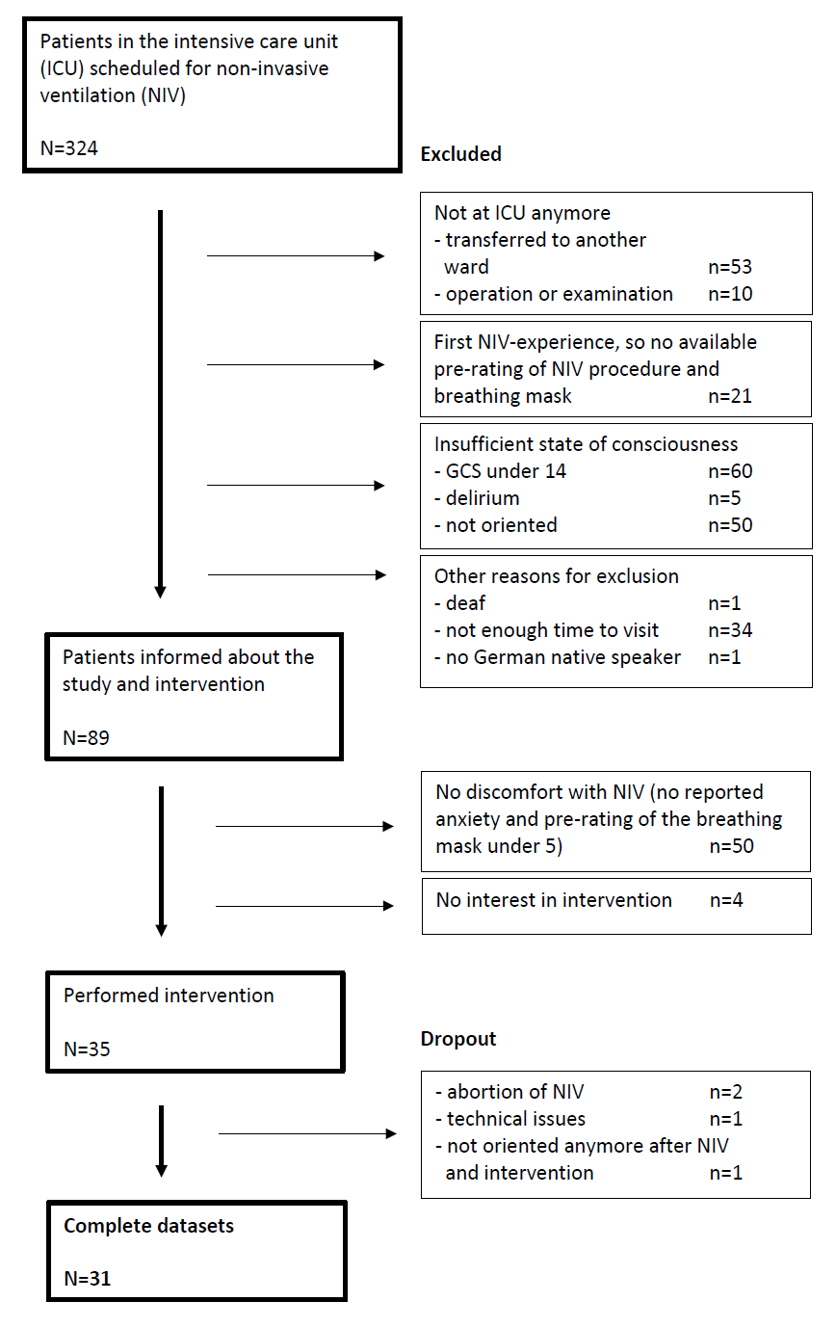
Figure 2: Flowchart of the study

Recruitment dates
Recruitment took place between September 2019 and August 2020 in the ICU of the Jena University Hospital.

Baseline data
In the final sample of our study, we obtained data from 31 patients receiving non-invasive ventilation in the ICU. Table 1 shows the demographic data of our study sample. Detailed diagnoses are listed in Supplementary Table S1. Please note that there are a variety of indications for non-invasive ventilation, including fast removal of the ventilation tube to reduce the risk for infection or muscular atrophy for patients (De Jong, Casey & Myatra, 2020).

Table 1: Demographic information about the final study sample N = 31
Demographic variable | Descriptive statistics
Age | M = 63.9 years, SD = 11.0 years, range = 43-81 years
Sex | 17 males (55%), 14 females (45%)
Glasgow Coma Scale score | 14 (9 patients, 29%), 15 (22 patients, 71%)
Indication for NIV | Cardiogenic reason (39%), post extubation (35%), chronic respiratory failure (26%)

Outcomes
The intervention was applied to all patients as planned without disruption or premature termination and was compatible with the medical procedure of non-invasive ventilation, showing the feasibility of the intervention. The analyses of primary outcomes included data of all 31 patients. Patients´ subjective ratings on well-being were significantly improved after the intervention compared to before the intervention. Patients rated their valence as significantly more positive, t(30) = 3.8, p < 0.001, d = 0.69 (95% CI 0.30-1.09) and reported significantly less arousal after the intervention compared to before the intervention, t(30) = 3.7, p < 0.001, d = 0.67 (95% CI 0.28-1.07). Patients were also significantly less anxious after the intervention compared to before the intervention, t(30) = 4.7, p < 0.001, d = 0.85 (95% CI 0.44-1.28).
For the secondary outcome of breathing mask comfort, we analyzed data of 28 patients due to missing data. Patients rated their subjective comfort of the breathing mask as significantly higher after the intervention compared to before the intervention, t(27) = 5.7, p < 0.001, d = 1.08 (95% CI 0.62-1.57). The results of the subjective ratings are shown in Figure 3.
[INSERT FIGURE 3 HERE]
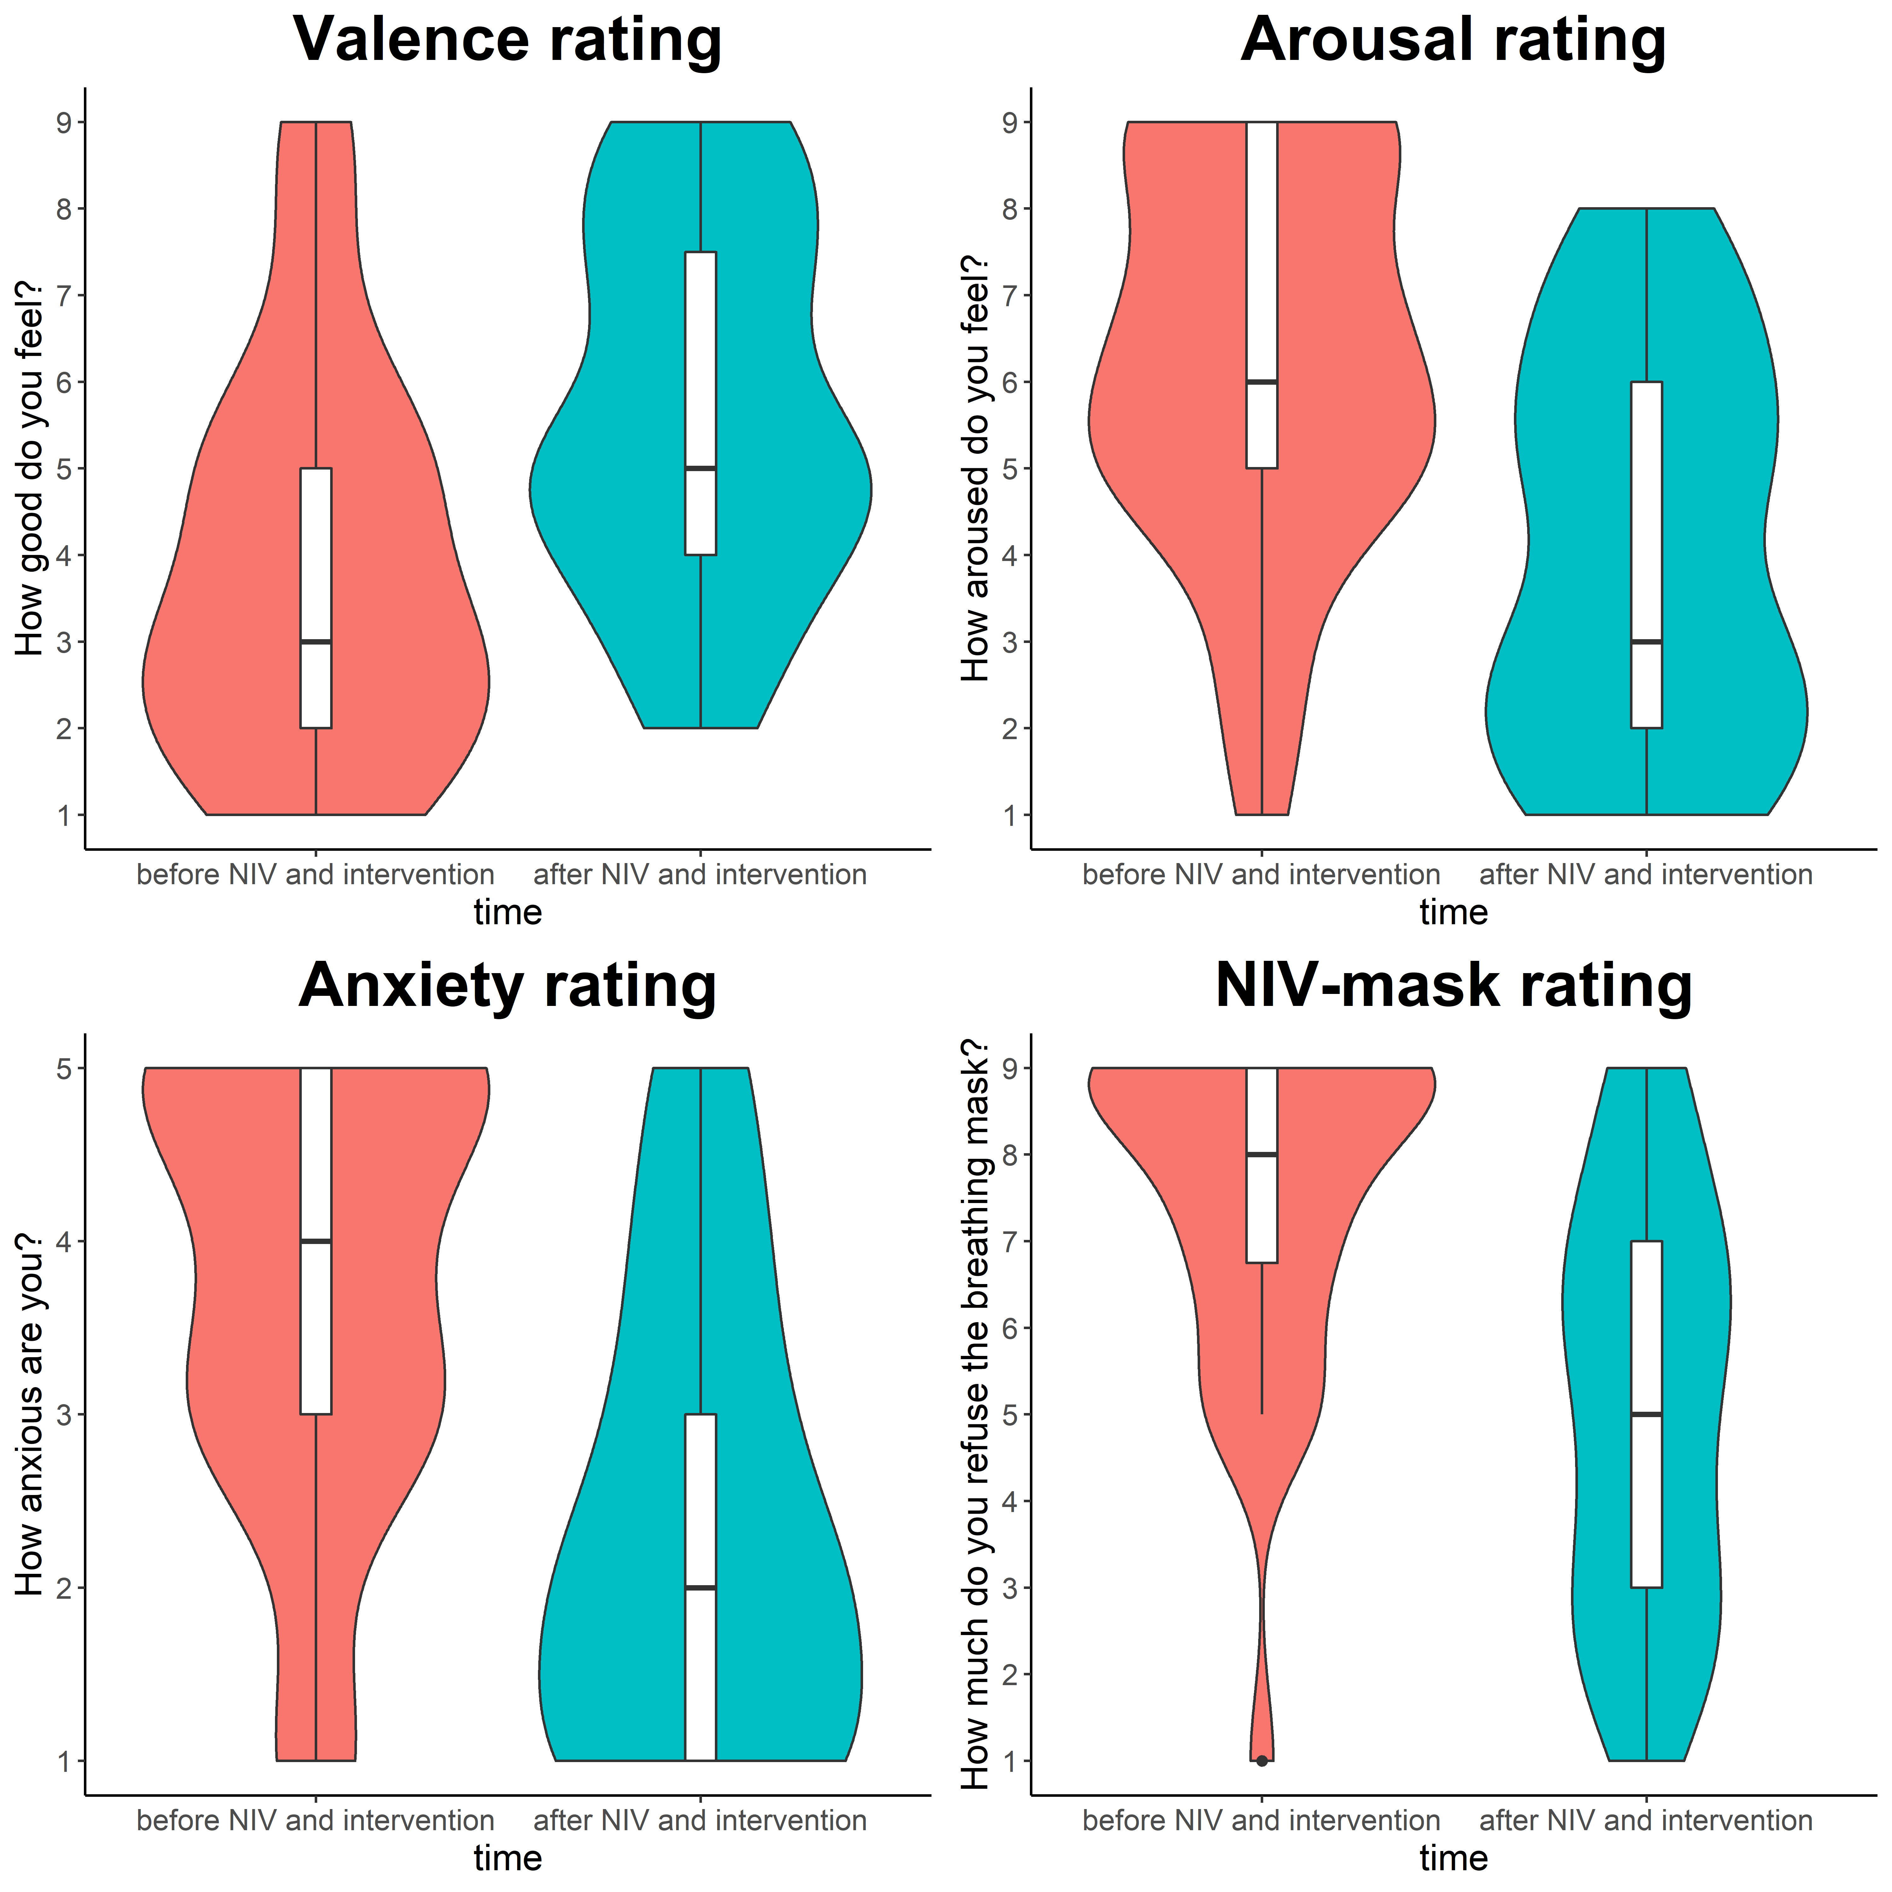
Figure 3: Subjective ratings of valence, arousal, anxiety (n =31) and NIV mask comfort (n=28) before and after non-invasive ventilation (NIV) and the intervention. The violin plots contain the median as black horizontal line and boxplots around the median. The colored areas indicate the probability density of the different rating scores.

Ancillary analyses
We analyzed physiological parameters of 25-29 patients due to missing data. For each of the physiological parameters, we performed an ANOVA with experimental events as within-subjects factor event (baseline, NIV, pre, intro, relax, safety, post-hypnotic, wake-up, post). For breathing rate, the main effect of event was significant, F(8,224) = 7.4, p < 0.001, η²_{G} = 0.21 (95% CI 0.10-0.28), indicating a reduction during the intervention. Heart rate decreased during intervention, the main effect of event was significant, F(8,224) = 5.7, p < 0.001, η²_{G} = 0.17 (95% CI 0.07-0.24). For mean arterial blood pressure, the main effect of event was also significant, F(8,192) = 7.5, p < 0.001, η²_{G} = 0.24 (95% CI 0.12-0.32) as well as the main effect of event on blood oxygen level, F(8,208) = 11.4, p < 0.001, η²_{G} = 0.30 (95% CI 0.19-0.38). Non-invasive ventilation is meant to increase blood oxygen levels; therefore, blood oxygen levels were increased during non-invasive ventilation (around 97% SpO2) compared to blood oxygen levels before non-invasive ventilation (around 95% SpO2; Figure 4). In addition, we observed a transient decrease of blood oxygen level during the introduction of hypnosis. This is not due to outliers and in line with the increase in blood pressure during the same period (Supplementary Table S2). All post-hoc paired t-tests of physiological parameters are reported in Supplementary Tables S3-S6.
[INSERT FIGURE 4 HERE]
No adverse events were observed during the intervention.
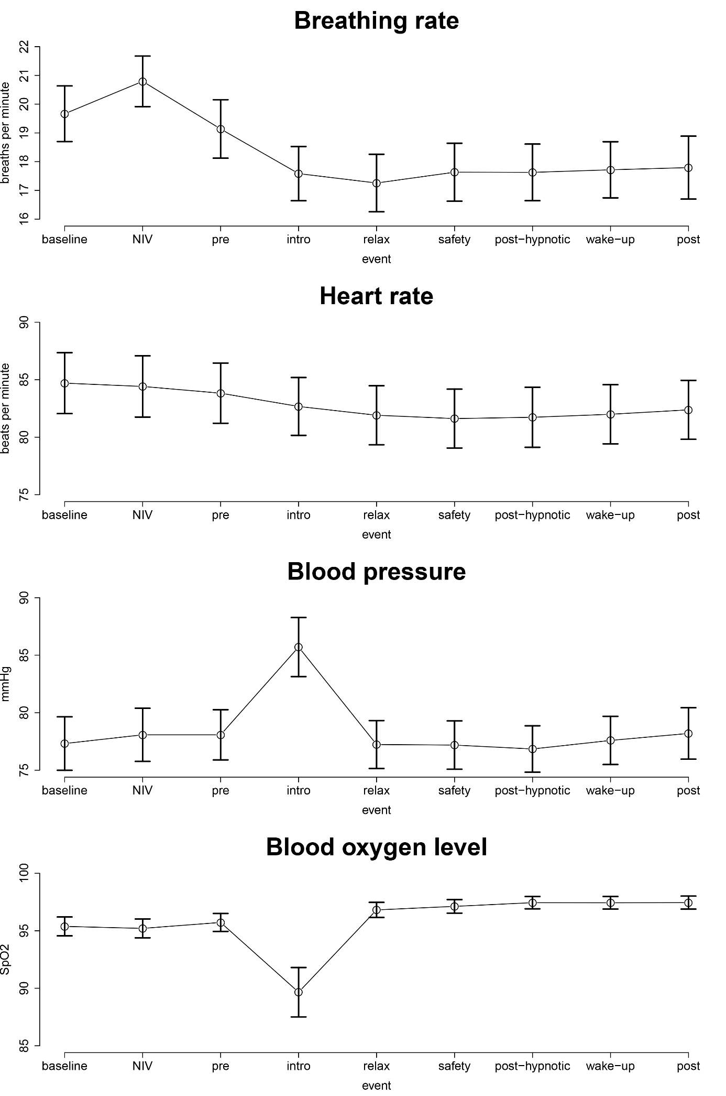
Figure 4: Time-courses of physiological measures during the experimental session with mean values for all events. Error bars indicate standard errors of the mean.

Acknowledgement
We thank Lisa Planer for help with data acquisition.

Conflict of interest
The authors declare no conflict of interest.

References
Bradley MM, Lang PJ. Measuring emotion: The self-assessment manikin and the semantic differential. J Behav Ther Exp Psychiat 1994;25:49-59.
Cohen J. A power primer. Psychological Bulletin 1992;112(1):155-159.
De Jong A, Casey JD, Myatra SN. Focus on noninvasive respiratory support before and after mechanical ventilation in patients with acute respiratory failure. Intensive Care Med 2020;46:1460–1463.
Faul F, Erdfelder E, Lang A-G, Buchner A. G*power 3: A flexible statistical power analysis program for the social, behavioral, and biomedical sciences. Behav Res Methods 2007;39:175-191.
Lakens D. Calculating and reporting effect sizes to facilitate cumulative science: a practical primer for t-tests and ANOVAs. Frontiers in Psychology 2013;4:863.
McKinley S, Coote K, Stein-Parbury J. Development and testing of a Faces Scale for the assessment of anxiety in critically ill patients. J Adv Nurs 2003;41:73-79.
Schmidt B, Deffner T, Rosendahl J. Feeling safe during intensive care: Protocol of a pilot study on therapeutic suggestions of safety under hypnosis in patients with non-invasive ventilation. OBM Integrative and Complementary Medicine 2020;5(2):8.
Schmidt B, Hoffmann E, Rasch B. Feel safe and money is less important! Hypnotic suggestions of safety decrease brain responses to monetary rewards in a risk game. Cerebral Cortex Communications 2020;1(1):tgaa050.
Schmidt B., Holroyd CB. Hypnotic suggestions of safety reduce neuronal signals of delay discounting. Scientific Reports 2021; doi: 10.1038/s41598-021-81572-2.
Tefikow S, Barth J, Maichrowitz S, Beelmann A, Strauss B, Rosendahl J. Efficacy of hypnosis in adults undergoing surgery or medical procedures: A meta-analysis of randomized controlled trials. Clinical Psychology Review 2013;33:623-636.

