Supplementary table S1. Arterial blood gas profiles in conscious and anesthetized rats.
 | CONS | MMB | KX | Chloral | PTB | PF | IFL
pH | 7.371 ± 0.049 | 7.337 ± 0.012 | 7.344 ± 0.035 | 7.313 ± 0.013 | 7.327 ± 0.064 | 7.346 ± 0.017 | 7.319 ± 0.053
pCO₂ (mmHg) | 50.4 ± 5.5 | 53.4 ± 3.3 | 49.7 ± 3.9 | 55.0 ± 3.1 | 59.0 ± 9.5 | 49.5 ± 5.6 | 58.0 ± 10.6
pO₂ (mmHg) | 90.3 ± 2.9 | 68.2 ± 7.2 | 79.7 ± 12.3 | 71.9 ± 8.9 | 70.7 ± 13.3 | 76.5 ± 5.5 | 192.9 ± 40.7
Data are expressed as mean ± SD (n = 6–7).

Supplementary figure S1. Typical time activity curves of [¹⁸F]FDG in the plasma and brain of conscious rats, and of rats anesthetized with different anesthetic agents: medetomidine/midazolam/butorphanol (MMB), ketamine/xylazine (KX), chloral hydrate (Chloral), pentobarbital (PTB), propofol (PF), and isoflurane (IFL). The asterisk and square indicate measured [¹⁸F]FDG SUV in the plasma and brain, respectively. Dotted and solid lines show calculated [¹⁸F]FDG SUV in plasma and brain by 2-tissue-3-compartment model analysis, respectively.

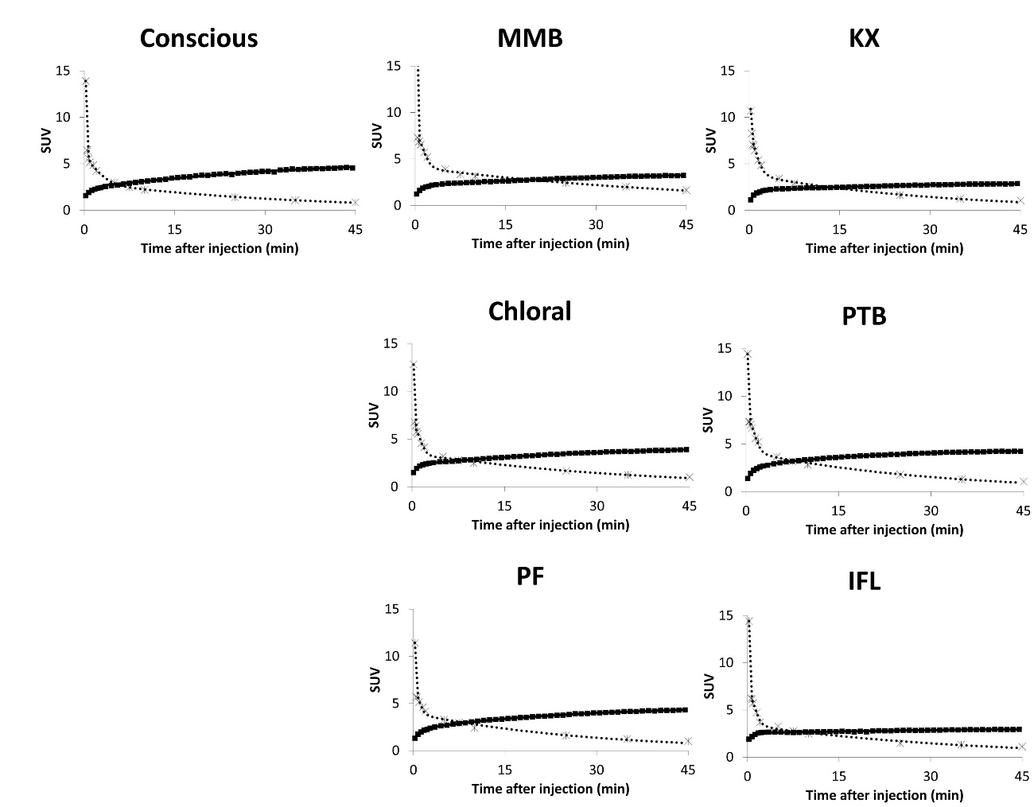

Supplementary figure S2. Correlation between blood glucose levels and [¹⁸F]FDG K₁. Correlation coefficients (R = -0.36728) were calculated by Pearson’s product moment correlation coefficient (n = 44).

