Can Microneedle Fractional Radiofrequency System Treatment impair the skin barrier function in Chinese Patients? A Prospective Clinical Trial
Xiujuan Wu¹*, Zhen Zhang²*, Jian Zhu, Sheng Lu¹, Chen Chen¹, Xianglei Wu^{3＃}, Xue Wang^{2＃}, Zongfeng Zhao^{4＃}
¹ Department of Dermatology, Shanghai Xuhui Central Hospital, Zhongshan-Xuhui Hospital, Fudan University, No.966, Huaihai Middale Road, Xuhui District, Shanghai 200031, China
² Department of Dermatology, Shanghai Ninth People’s Hospital, Shanghai Jiao Tong University School of Medicine, No.639, Manufacturing Bureau Road, Huangpu District, Shanghai 200011, China
³ Department of Laser and Aesthetic Medicine, Shanghai Ninth People’s Hospital, Shanghai Jiao Tong University School of Medicine, No.639, Zhizaoju Road, Huangpu District, Shanghai 200011, China
⁴ Department of Scientific Research, Shanghai Xuhui Central Hospital, Zhongshan-Xuhui Hospital, Fudan University, No.966, Huaihai Middle Road, Shanghai 200031, China
*These contributed equally to this work and should be considered as co-first authors.
＃Corresponding Authors:
Zongfeng Zhao, Department of Scientific Research, Shanghai Xuhui Central Hospital, Zhongshan-Xuhui Hospital, Fudan University, No.966, Huaihai Middle Road, Xuhui District, Shanghai 200031, China, sygao@shxh-centerlab.com
Xue Wang, Department of Dermatology, Shanghai Ninth People’s Hospital, Shanghai Jiao Tong University School of Medicine, No.639, Zhizaoju Road, Shanghai 200011, China, belongtogether@126.com
Xianglei Wu，Department of Laser and Aesthetic Medicine, Shanghai Ninth People’s Hospital, Shanghai Jiao Tong University School of Medicine, No.639, Zhizaoju Road, Huangpu District, Shanghai 200011, China,150392997@qq.com

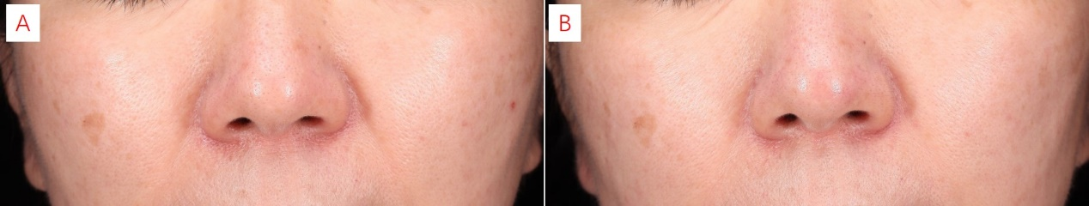

Supplement Figure 1: Improvement of facial enlarged pores before (a) and after (b) treatment.

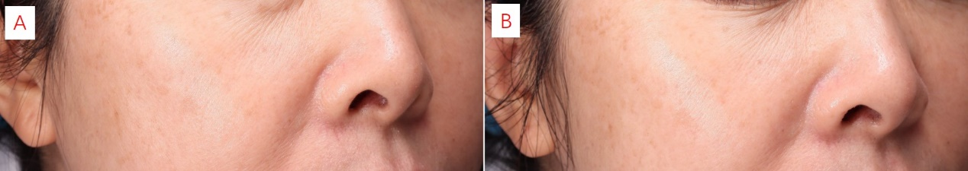
Supplement Figure 1: Photographs of facial skin laxity and photoaging before (a) and after (b) treatment.

