Appendix
Table S1. List of independent variables (i.e., covariates or features) used in machine learning models
Variable names | Definitions and/or ICD-10 codes
Male
Female
Age in year
Ethnicity Māori (Indigenous New Zealanders)
Ethnicity non Māori
Ethnicity European
Ethnicity Pacific peoples
Ethnicity Asian
Income
High income | High-income (>NZ$70,000/year)
Medium income | Medium-income (>=NZ$30,000/year & <=NZ$70,000/year (US$48,400, €36,600))
Low income | Low-income (<NZ$30,000/year (US$20,750, €15690))
On benefits

Having an offence record
NZ Deprivation low decile
NZ Deprivation mid decile
NZ Deprivation high decile
NZ Deprivation quintile | Value between 1 and 5
Birth country Oceania
Birth country North West Europe
Birth country South East Europe
Birth country North Africa and Middle East
Birth country South East Asia
Birth country North East Asia
Birth country Southern Central Asia
Birth country Americas
Birth country Sub Saharan
Current smoker
Ex-smoker
Non smoker
High skilled job
Low skilled job
Medium skilled job
Speaking another language not English not Te Reo (Indigenous language)
Official language Te Reo
Official language English
Having a spouse/partner
Single
Having stressful life events
In paid employment
No postgraduate qualification
Having postgraduate qualification
Owning a house
Rent usual residence
Use of CVD preventive medications in 2013 (at least 2 prescriptions): Any anti-hypertensive medication | 'Calcium Channel Blockers', 'Diuretics', 'Agents Affecting the Renin-Angiotensin System', 'Beta Adrenoceptor Blockers', ' Beta Adrenoceptor Blockers with Diuretics'
Use of CVD preventive medications in 2013 (at least 2 prescriptions): Any lipid-lowering medication | 'Lipid Modifying Agents'
Use of CVD preventive medications in 2013 (at least 2 prescriptions): Any prescribed anti-thrombotic agent | 'Antithrombotic Agents'
Use of CVD preventive medications in 2013 (at least 2 prescriptions): Any diabetes medication
Having Atrial fibrillation | I48
Having Hypertension | I10
Having CVD prior 2014 | CHD Definition: A healthcare user is counted as having CHD if they meet any one of the following conditions: 1. National Minimum Dataset (NMDS) diagnosis codes: ICD-10-AM: I20-I25  Stroke Definition: where the healthcare user had a publicly funded hospital discharge in a primary diagnosis of I60-164 (ICD-10-AM-II). Further information see data dictionary[66].
Having diabetes prior 2014 | E10–E14 (further information see data dictionary[66])
Having other chronic prior 2014 | Cancers, traumatic brain injuries, and gout (further information see data dictionary[66])

Table S2. Regression results for a traditional regression model (TRM1)
> model <- glm(y_train~ Age_in_year + male + current_smoker+ex_smoker
+non_smoker+Ethnicity_Maori + Ethnicity_European
+Ethnicity_Pacific + Ethnicity_Asian + Have_diabetes_prior_2014 + Have_Atrial_fibrillation
+ Have_Hypertension +Have_other_chronic_prior_2014, data=x_train, family=binomial(link=logit))

Deviance Residuals:
Min 1Q Median 3Q Max
-1.6332 -0.6841 -0.5558 -0.4501 2.3925

Coefficients: (1 not defined because of singularities)
Estimate Std. Error z value Pr(>|z|)
(Intercept) -2.893020 0.095469 -30.303 < 2e-16 ***
Age_in_year 0.017648 0.001203 14.671 < 2e-16 ***
male -0.190400 0.019608 -9.710 < 2e-16 ***
current_smoker 0.059694 0.047892 1.246 0.2126
ex_smoker -0.084145 0.043662 -1.927 0.0540 .
non_smoker -0.207757 0.043625 -4.762 1.91e-06 ***
Ethnicity_Maori 0.068278 0.039125 1.745 0.0810 .
Ethnicity_€opean -0.041472 0.039375 -1.053 0.2922
Ethnicity_Pacific 0.131307 0.058450 2.247 0.0247 *
Ethnicity_Asian -0.111918 0.057316 -1.953 0.0509 .
Have_diabetes_prior 0.634958 0.019786 32.091 < 2e-16 ***
Have_Atrial_fib. 0.811906 0.025163 32.265 < 2e-16 ***
Have_Hypertension 0.501165 0.089582 5.594 2.21e-08 ***
Have_other_chronic 0.364352 0.011434 31.865 < 2e-16 ***
---
Signif. codes: 0 ‘***’ 0.001 ‘**’ 0.01 ‘*’ 0.05 ‘.’ 0.1 ‘ ’ 1

(Dispersion parameter for binomial family taken to be 1)
Null deviance: 78450 on 78360 degrees of freedom [Of note is that this number equals to the size of the training dataset, that is 80% of the total study population (N=97,950 observations)]
Residual deviance: 74100 on 78360 degrees of freedom
AIC: 74130

Number of Fisher Scoring iterations: 4

Table S3. Prediction results for both traditional regression and machine learning models with sensitivity analysis
Prediction models |  |  | Traditional regression models |  | Machine learning models^{f}
 |  | All conventional variables (TRM1)^{e} | As per TRM1 but no ethnicity variables (TRM2) | As per TRM2 but no smoking variables (TRM3) | L1-regularised logistic regression | Classification trees | KNN | Random forest
30% high health cost users prevalence | Sensitivityª | 17.9% | 16.5% | 16.3% | 75.2% | 46.1% | 45.7% | 45.2%
 | Specificity^{b} | 95.1% | 95.1% | 95.4% | 78.4% | 91.2% | 78.6% | 83.9%
 | PPV/ Precision^{c} | 59.8% | 59.3% | 60.4% | 38.5% | 69.0% | 47.5% | 54.2%
 | F1^{d} | 26.4% | 25.8% | 25.6% | 50.9% | 55.3% | 46.5% | 49.3%
 | AUC | 0.56 | 0.56 | 0.56 | 0.66 | 0.73 | 0.48 | 0.70
20% prevalence (the base case) | Sensitivityª | 4.9% | 4.9% | 4.6% | 78.9% | 19.5% | 38.0% | 37.8%
 | Specificity^{b} | 99.2% | 99.2% | 99.2% | 83.5% | 98.0% | 85.9% | 88.6%
 | PPV/ Precision^{c} | 61.2% | 62.5% | 61.8% | 22.1% | 71.2% | 40.1% | 45.2%
 | F1^{d} | 9.1% | 9.0% | 8.6% | 34.5% | 30.6% | 39.0% | 41.2%
 | AUC | 0.53 | 0.53 | 0.53 | 0.62 | 0.73 | 0.45 | 0.70
10% prevalence | Sensitivityª | * | * | * | 72.5% | 11.4% | 29.2% | 29.9%
 | Specificity^{b} | * | * | * | 91.2% | 99.7% | 92.9% | 94.2%
 | PPV/ Precision^{c} | * | * | * | 12.3% | 78.5% | 31.1% | 35.8%
 | F1^{d} | * | * | * | 21.0% | 19.8% | 30.1% | 32.6%
 | AUC | 0.50 | 0.50 | 0.50 | 0.57 | 0.62 | 0.45 | 0.67
5% prevalence | Sensitivityª | * | * | * | 76.2% | 10.9% | 25.2% | 25.6%
 | Specificity^{b} | * | * | * | 95.8% | 100.0% | 96.5% | 97.2%
 | PPV/ Precision^{c} | * | * | * | 15.0% | 92.1% | 26.9% | 32.2%
 | F1^{d} | * | * | * | 25.0% | 19.5% | 26.0% | 28.5%
 | AUC | 0.50 | 0.50 | 0.50 | 0.58 | 0.58 | 0.43 | 0.67
Note: * Results produced from the model were unstable due to a small number of CVD events in relation to the total observations.
^{a, b, c, d, e, f}: see Table 2.
The results for the traditional regression model as per TRM3 but no chronic condition variables were not reported as this model had very poor predictive power.

Table S4. Prediction results when a limited set of variables were used for both traditional regression and machine learning models
Evaluation criteria | Traditional regression models | Machine learning models^{f}
 | All conventional variables (TRM1)^{e} | L1-regularised logistic regression | Classification trees | KNN | Random forest
Sensitivityª | 55.3% | 0.1% | Not calculable | 50.9% | 52.1%
Specificity^{b} | 80.9% | 100.0% | 80.3% | 82.2% | 81.0%
PPV/ Precision^{c} | 4.5% | 100.0% | 0.0% | 15.2% | 5.6%
F1^{d} | 8.2% | 0.1% | Not calculable | 23.4% | 10.1%
AUC | 0.52 | 0.50 | 0.50 | 0.58 | 0.54
Note: ^{a, b, c, d, e, f}: see Table 2.

Table S5. Prediction results for both traditional regression and machine learning models with ethnicity variables excluded
Evaluation criteria | Traditional regression models | Machine learning models^{f}
 | All conventional variables (TRM1)^{e} | L1-regularised logistic regression | Classification trees | KNN | Random forest
Sensitivityª | 56.7% | 21.4% | 57.7% | 40.2% | 45.0%
Specificity^{b} | 80.9% | 98.2% | 84.8% | 84.9% | 85.3%
PPV/ Precision^{c} | 4.7% | 74.4% | 31.4% | 37.3% | 37.6%
F1^{d} | 8.7% | 33.3% | 40.6% | 38.7% | 41.0%
AUC | 0.52 | 0.60 | 0.70 | 0.46 | 0.69
Note: ^{a, b, c, d, e, f}: see Table 2.

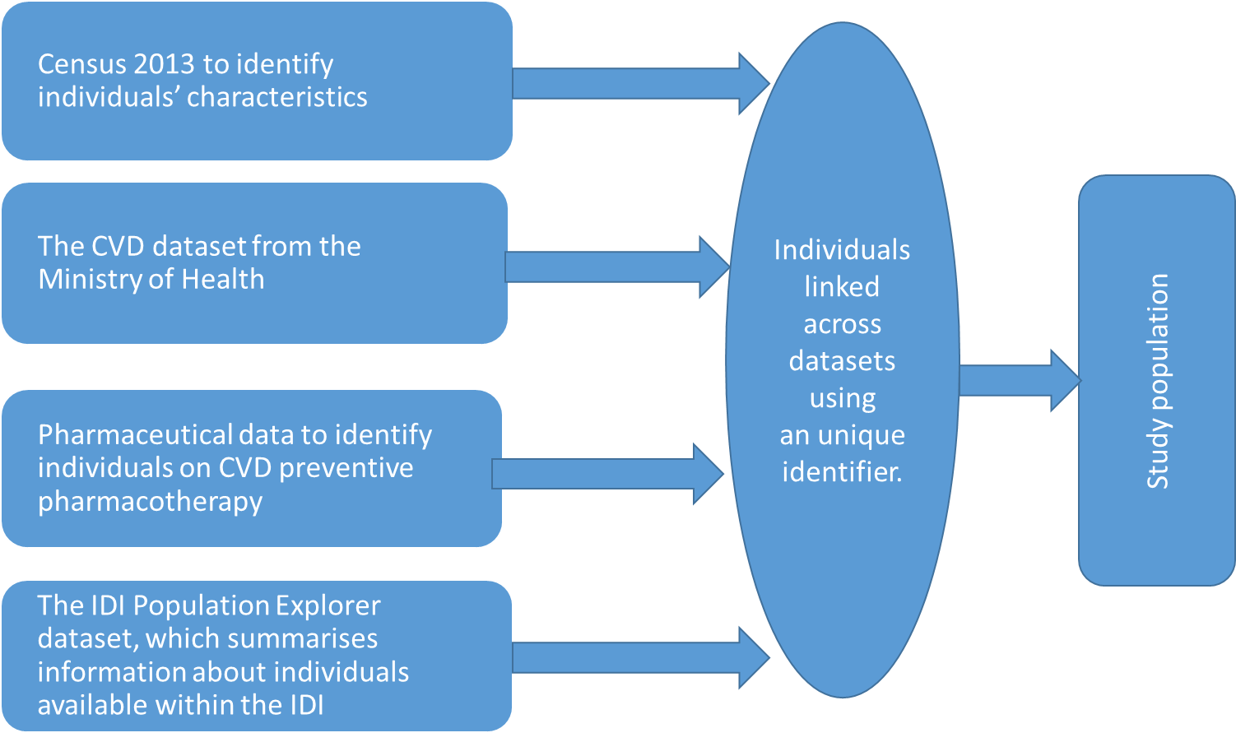
Figure S1. Datasets and data linkage in the IDI to create study population and independent variables

Figure S2. Important variables from a sensitivity analysis of 30% high-cost user prevalence
Notes: PRM=Pharmaceuticals; NAP=Non-admitted patients (i.e., outpatients and ED visits); Lab=Laboratory tests; NMD=Public hospitalisations (National minimum dataset); PHO=Primary health organisation (i.e., GP) enrolments. Chronic conditions other than CVD: diabetes, cancers and traumatic brain injuries. Deprivation quintiles on a one to five scale with five being the most deprived.

Figure S3. Important variables from a sensitivity analysis of 10% high-cost user
Notes: PRM=Pharmaceuticals; NAP=Non-admitted patients (i.e., outpatients and ED visits); Lab=Laboratory tests; NMD=Public hospitalisations (National minimum dataset); PHO=Primary health organisation (i.e., GP) enrolments. Chronic conditions other than CVD: diabetes, cancers and traumatic brain injuries. Deprivation quintiles on a one to five scale with five being the most deprived.

Figure S4. Important variables from a sensitivity analysis of 5% high-cost user prevalence
Notes: PRM=Pharmaceuticals; NAP=Non-admitted patients (i.e., outpatients and ED visits); Lab=Laboratory tests; NMD=Public hospitalisations (National minimum dataset); PHO=Primary health organisation (i.e., GP) enrolments. Chronic conditions other than CVD: diabetes, cancers and traumatic brain injuries. Deprivation quintiles on a one to five scale with five being the most deprived.

Reference
66. Stats NZ. IDI MOH Chronic Condition/Significant Health Event Cohort data, URL: https://datainfoplus.stats.govt.nz/Item/nz.govt.stats/ac775e86-9f66-486a-adb9-64b0f512c54c. 2015 [Accessed 7 May 2022].

