Supplemental Digital Content
Prognostic Implications of Blood Lactate Concentrations After Cardiac Arrest: A Retrospective Study

Antonio Maria Dell’Anna, Claudio Sandroni, Irene Lamanna, Ilaria Belloni, Katia Donadello, Jacques Creteur, Jean-Louis Vincent, Fabio Silvio Taccone

Figure S1. Flow-chart of the study. ABG=arterial blood gas analysis; CPC=cerebral performance category.

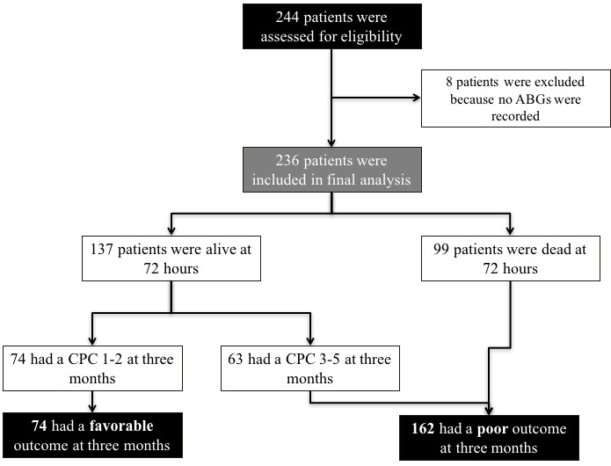

Figure S2. Time course of blood lactate concentrations from admission to 48 hours after arrest, according to the occurrence of favourable (CPC 1-2) or poor (CPC 3-5) neurological outcome at 3 months. Data are shown as median [25th – 75th interquartiles].
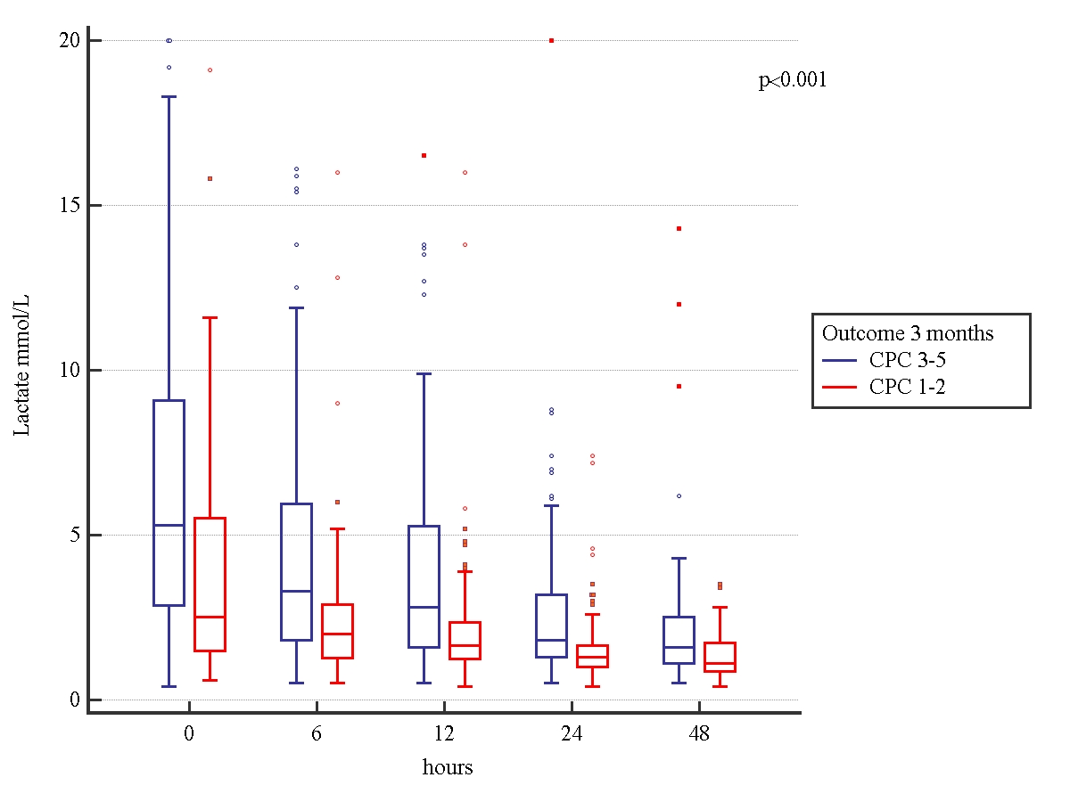

Figure S3. Receiving operating characteristics (ROC) curves for the ability of different variables (heart rate [HR], mean arterial pressure [MAP], admission blood lactate concentration and admission cardiovascular SOFA [cSOFA]) to predict unfavourable neurological outcome at three months. The different areas under the curve are: 0.508 (95%CI 0.441-0.576), 0.631 (95%CI 0.564-0.695), 0.689 (95%CI 0.624-0.748) and 0.613 (95% CI 0.546-0.676), respectively.
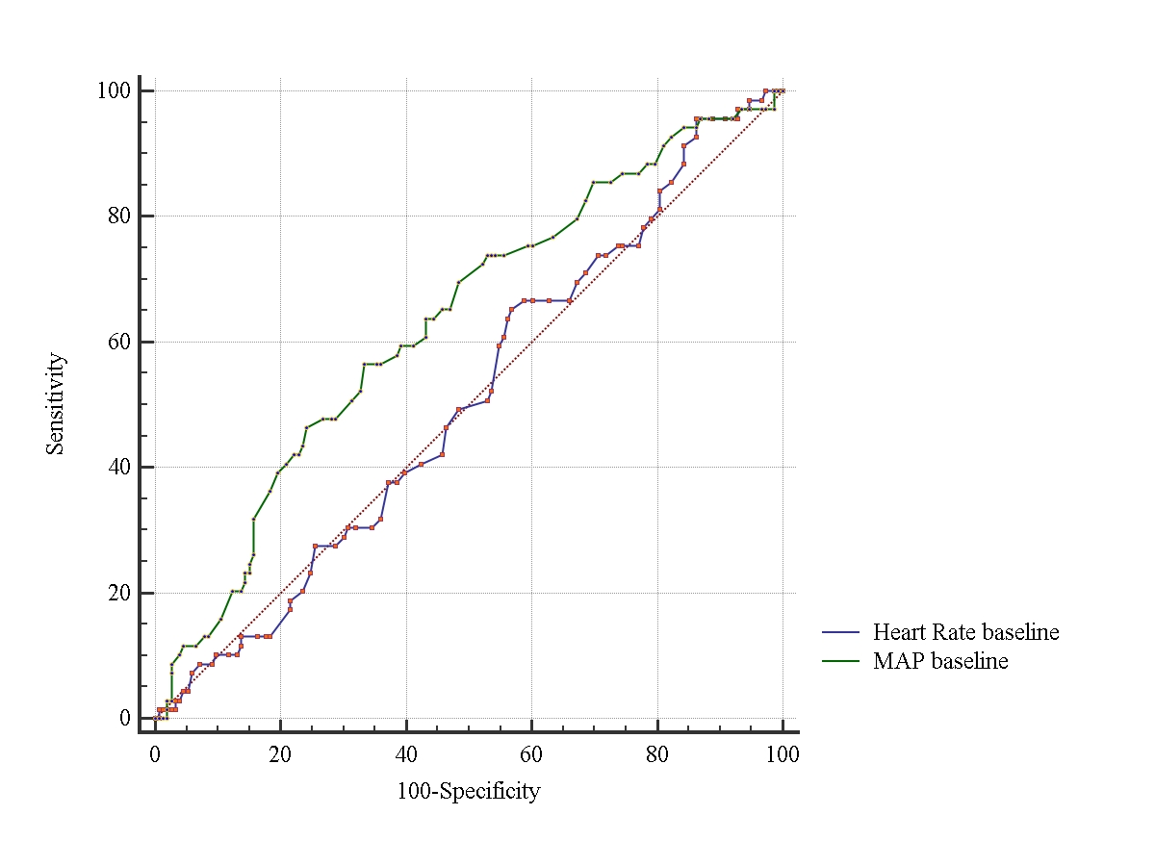
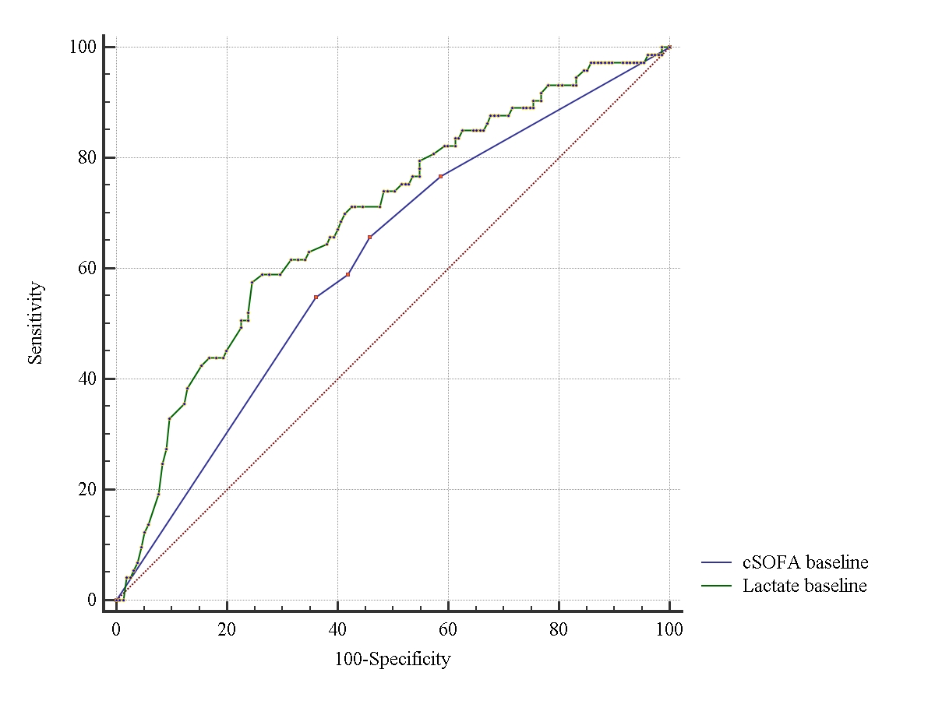

Table S1. Arterial blood gas (ABG) results according to the location of the cardiac arrest and neurological outcome
Parameter | OHCA  (137) |  |  | IHCA  (99)
 | CPC 1-2  (43) | CPC 3-5  (94) | P value | CPC 1-2  (31) | CPC 3-5  (68) | p value
ABG
Lactate admission (mEq/L) | 2.9 [1.6-6.6] | 4.7 [2.9-78.2] | 0.09 | 1.9 [1.3-3.3] | 5.6 [2.7-11.4] | <0.001
Lactate 6h (mEq/L) | 2.3 [1.5-3.2] | 2.9 [1.9-4.9] | 0.08 | 1.8 [1.1-2.5] | 3.1 [2.0-5.9] | 0.001
Lactate 12h (mEq/L) | 1.8 [1.3-2.8] | 2.5 [1.6-4.4] | 0.05 | 1.5 [1.2-2.3] | 2.6 [1.5-3.9] | 0.014
Lactate 24h (mEq/L) | 1.3 [1-2.1] | 1.8 [1.3-3.3] | 0.015 | 1.3 [0.9-1.6] | 1.9 [1.3-3.3] | 0.011
Lactate 48h (mEq/L) | 1.2 [0.9-1.9] | 1.5 [1.0-2.1] | 0.064 | 1.1 [0.8-1.7] | 1.8 [1.3-2.8] | 0.001
aDLC ₀₋₆ (mEq/L*h) | 0.08 [-0.06 to 0.6] | 0.13 [-0.07 to 0.61] | 0.877 | 0.09 [0-0.2] | 0.4 [0.1-0.7] | 0.045
aDLC ₀₋₁₂ (mEq/L*h) | 0.1 [0-0.3] | 0.1 [0-0.3] | 0.482 | 0 [0-0.1] | 0.3 [0.1-0.5] | <0.001
aDLC ₀₋₂₄ (mEq/L*h) | 0.07 [0.01-0.21] | 0.06 [0-0.2] | 0.532 | 0.03 [0-0.08] | 0.16 [0.03-0.35] | 0.006
rDLC₀₋₆ (%) | 23 [-27 to 58] | 32 [-22 to 57] | 0.846 | 21 [0-50] | 39 [1-63] | 0.477
rDLC₀₋₁₂ (%) | 32 [-16 to 72] | 39 [2-61] | 0.688 | 28 [-5 to 41] | 53 [22-73] | 0.003
rDLC₀₋₂₄ (%) | 54 [24-70] | 53 [0-78] | 0.349 | 38 [19-63] | 59 [47-79] | 0.043
AUC₀₋₄₈, mEq/L*h | 4.0±2.3 | 4.9±4.6 | 0.117 | 2.8±0.5 | 4.9±0.6 | 0.031
Peak lactate, mEq/L | 5.4±3.5 | 6.8±4.1 | 0.06 | 3.9±3.6 | 8.8±5.9 | <0.001
pH admission | 7.25 [7.16-7.35] | 7.25 [7.14-7.34] | 0.606 | 7.33 [7.21-7.41] | 7.28 [7.20-7.42] | 0.404
PaO₂ admission (mmHg) | 141 [72-191] | 127 [83-261] | 0.262 | 143 [86-260] | 105 [70-259] | 0.220
PaCO₂ admission (mmHg) | 45.4±12 | 42.9±16.6 | 0.434 | 40.5±12 | 41.0±13.8 | 0.876

CPC=Cerebral Performance Category; CPC 1-2=favourable outcome and CPC 3-5=poor outcome; ABG=arterial blood gas analysis; aDLC=absolute decrease in lactate concentration over time expressed as mEq/L*h; rDLC=relative decrease in lactate concentration over time expressed as %; AUC₀₋₄₈=area under the curve of lactate concentrations for the first 48 hours since admission

Table S2. Arterial blood gas (ABG) results according to the initial rhythm.

Parameter | VF/VT  (100) | Non-VF/VT  (136) | p value
ABG
Lactate admission (mEq/L) | 3.2 [2.3-6.9] | 4.7 [2.4-8.2] | 0.067
Lactate 6h (mEq/L) | 2.9 [2.4-4.2] | 2.9 [2.6-5.3] | 0.611
Lactate 12h (mEq/L) | 2.1 [1.6-3.3] | 2.4 [1.8-4.0] | 0.226
Lactate 24h (mEq/L) | 1.4 [1.1-2.3] | 1.6 [1.1-3.0] | 0.285
Lactate 48h (mEq/L) | 1.3 [1.0-1.9] | 1.5 [1.1-2.2] | 0.121
aDLC ₀₋₆ (mEq/L*h) | 0.14 [-0.09 to 0.43] | 0.26 [0-0.69] | 0.088
aDLC ₀₋₁₂ (mEq/L*h) | 0.11 [0-0.3] | 0.22 [0-0.4] | 0.051
aDLC ₀₋₂₄ (mEq/L*h) | 0.05 [0.01-0.18] | 0.09 [0.02-0.2] | 0.160
rDLC₀₋₆ (%) | 26 [-37 to 59] | 32 [0-57] | 0.210
rDLC₀₋₁₂ (%) | 30 [-11 to 55] | 44 [11-67] | 0.141
rDLC₀₋₂₄ (%) | 48 [10-71] | 55 [24-75] | 0.486
AUC₋₄₈, mEq/L*h | 4.8±4.6 | 4.4±3.4 | 0.543
Peak Lactate, mEq/L | 6.9±4.5 | 6.8 ±4.8 | 0.732
pH admission | 7.25 [7.11-7.33] | 7.22 [7.11-7.32] | 0.345
PaO₂ admission (mmHg) | 143 [82-242] | 131 [84-241] | 0.588
PaCO₂ admission (mmHg) | 44±16 | 46±18 | 0.673

ABG=arterial blood gas analysis; aDLC=absolute decrease in lactate concentration over time expressed as mEq/L*h; rDLC=relative decrease in lactate concentration over time expressed as %; AUC₀₋₄₈= area under the curve of lactate concentrations for the first 48 hours since admission

Table S3. Arterial blood gas (ABG) results according to the presence of shock on admission.

Parameter | Shock  (112) | No shock  (124) | p value
ABG
Lactate admission (mEq/L) | 7.8 [3.3-10.5] | 2.9 [1.7-4.9] | <0.001
Lactate 6h (mEq/L) | 4.8 [2.6-6.9] | 2.1 [1.5-3.1] | <0.001
Lactate 12h (mEq/L) | 3.6 [1.9-4.9] | 1.8 [1.3-2.6] | <0.001
Lactate 24h (mEq/L) | 1.8 [1.2-3.2] | 1.4 [1.0-2.3] | 0.007
Lactate 48h (mEq/L) | 1.6 [1.1-2.5] | 1.2 [0.9-1.8] | 0.004
aDLC ₀₋₆ (mEq/L*h) | 0.32 [0.11-0.64] | 0.08 [-.08 to 0.46] | 0.001
aDLC ₀₋₁₂ (mEq/L*h) | 0.21 [0.0-0.44] | 0.1 [0 - 0.2] | 0.001
aDLC ₀₋₂₄ (mEq/L*h) | 0.16 [0.03-0.29] | 0.05 [0-0.12] | <0.001
rDLC₀₋₆ (%) | 32 [6-50] | 21 [-30 to 55] | 0.051
rDLC₀₋₁₂ (%) | 41 [14 - 62] | 33 [-6 to 61] | 0.035
rDLC₀₋₂₄ (%) | 59 [36-78] | 45 [0-68] | 0.002
AUC₀₋₄₈, mEq/L*h | 5.4±4.3 | 4.1±3.9 | 0.020
Peak Lactate, mEq/L | 9.2±5.6 | 5.1±3.5 | <0.001
pH admission | 7.22 [7.11-7.34] | 7.28 [7.2-7.36] | 0.097
PaO₂ admission (mmHg) | 135 [80-281] | 120 [80.3-199.3] | 0.219
PaCO₂ admission (mmHg) | 42±17 | 43.7±14.8 | 0.182

ABG=arterial blood gas analysis; aDLC=absolute decrease in lactate concentration over time expressed as mEq/L*h; rDLC=relative decrease in lactate concentration over time expressed as %; AUC₀₋₄₈= area under the curve of lactate concentrations for the first 48 hours since admissi
Figure S4. Panel A: Correlation between decrease in lactate concentrations at 6 hours and blood lactate concentration on admission (r=0.67; p<0.001). Panel B: Correlation between decrease in lactate concentrations at 24 hours and blood lactate concentration on admission (r=0.88; p<0.001).

