1. cgMLST profile
Genome-wide gene-by-gene comparison approach was used to determine the genetic relatedness using SeqSphere+ version 4.1.9 (Ridom GmbH, Münster, Germany). The thresholds for interpreting clonality with cgMSLT were as follows: <35 allelic differences are considered related, 35 or more allelic differences are considered unrelated ^{[1]}.
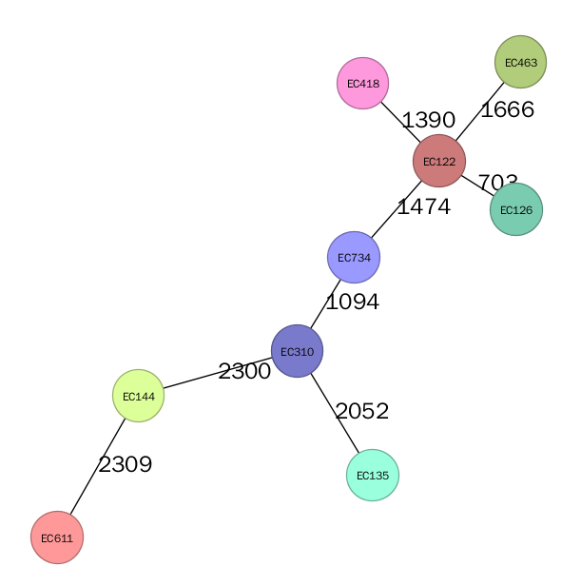
FIG.S1 Minimum spanning tree of E. coli isolates producing NDM-5. Distance based on a cgMLST of 2411 genes using the parameters “pairwise ignoring missing values” during calculation. Number of different alleles is indicated on the edges between connected isolates (nodes). Isolates are presented by their ID.
[1]. Xuewei Zhou,1,*† Silvia García-Cobos,1,*† Gijs J. H. M. Ruijs, et al. Epidemiology of Extended-Spectrum β-Lactamase-Producing E. coli and Vancomycin-Resistant Enterococci in the Northern Dutch–German Cross-Border Region. Front Microbiol. 2017; 8: 1914.

