Supplementary Figure 3. Association of serum calcium and incident diabetes stratified by predefined subgroups.
a) Serum total calcium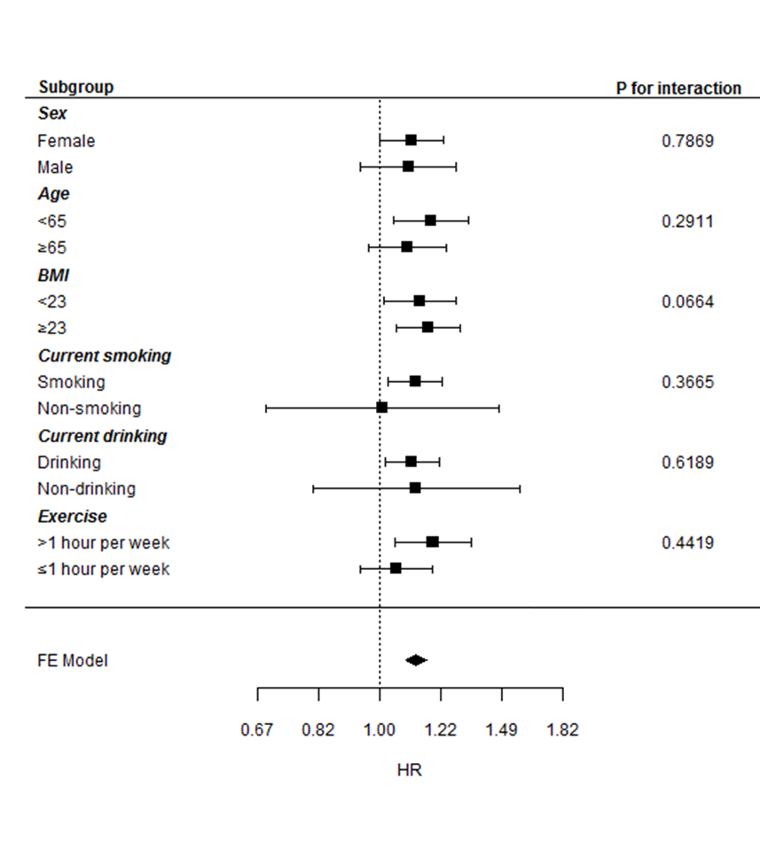 | b) Albumin-corrected calcium  