Online Resource 3

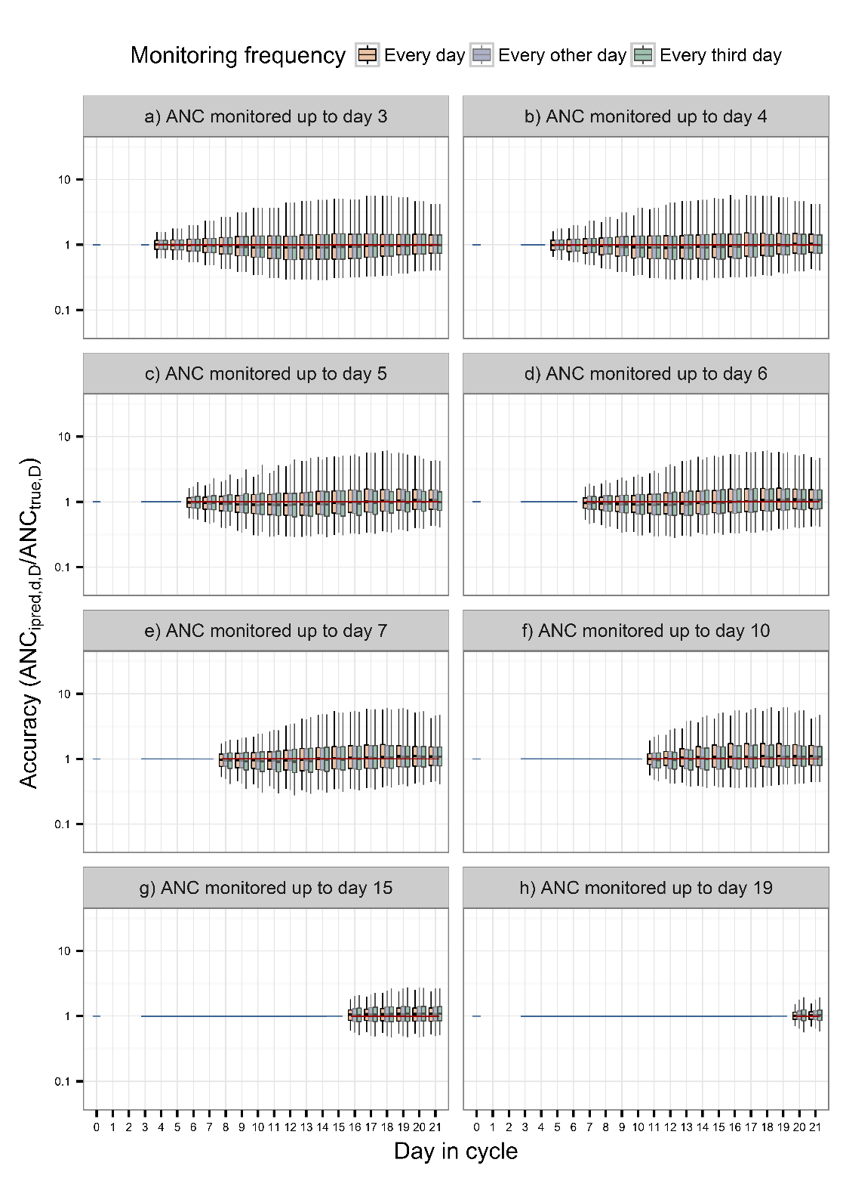
Fig. 1 Distribution of the absolute error for scenarios where the ANC was monitored until day 3, 4, 5, 6, 7, 10, 15 and 19. ANC_{ipred.,d,D} is the individual predicted ANC at day D, given data available up to day d and ANC_{true,D} is the true ANC at day D. Orange, blue and green boxes represent monitoring frequency every, every other and every third day. The horizontal line represents no prediction error, the blue and red lines illustrate days the ANC was monitored and predicted, respectively. The vertical line inside of each box is the median. Lower and upper hinges of the box represent the 25th and 75th percentiles, respectively. Lower and upper ends of the whiskers correspond to the 2.5th and 97.5th percentiles, respectively. This figure illustrates results based on when the mean transit time (MTT) was set to 141 hours.

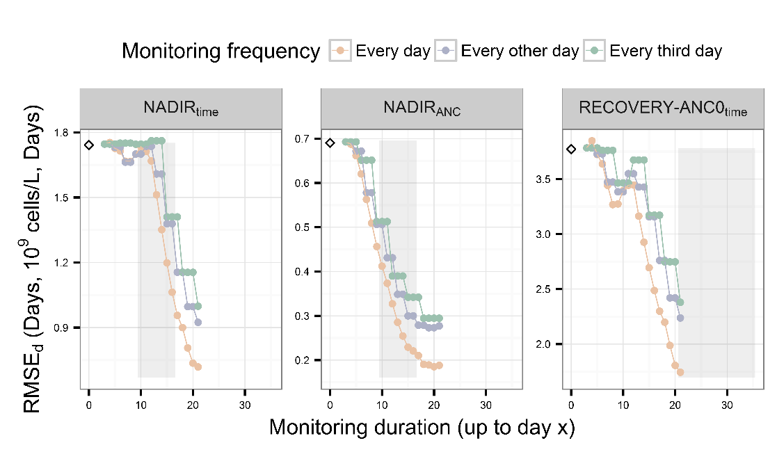
Fig. 2 Root-mean squared error at day d in the cycle (RMSE_{d}) of NADIR_{time}, NADIR_{ANC} and RECOVERY-ANC0_{time}. The dots represent the errors, connected by lines. Orange, blue and green colors indicate the daily, every other and every third day monitoring of the ANC, respectively. The empty diamond represents the RMSE_{d} of the scenario with data available only at baseline. The shaded grey areas represent the 95% confidence interval of the true times of nadir and recovery to baseline, respectively. This figure illustrates results based on when the mean transit time (MTT) was set to 141 hours.
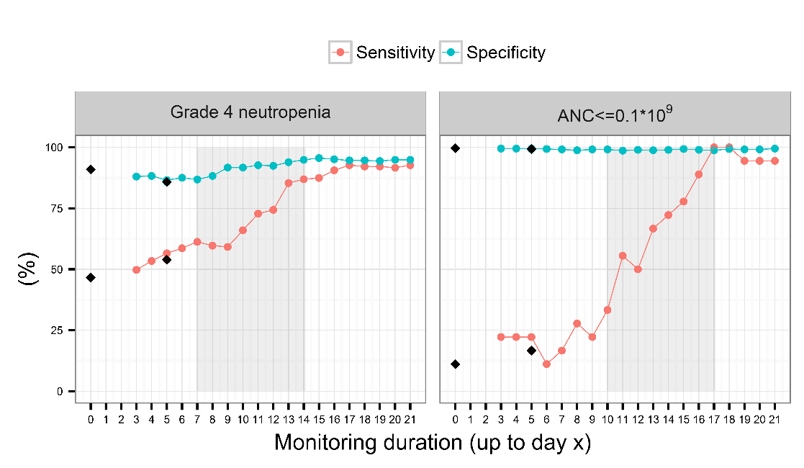
Fig 3. The dots represent the sensitivity and specificity for classification of Grade 4 neutropenia (left) and an ANC≤0.1·10⁹ cells/L (right), based on daily monitoring of the ANC, connected by lines. The diamonds represent the baseline and baseline and day 5 scenarios. The shaded grey areas represent the 95% confidence interval of the true times for occurrence of Grade 4 neutropenia (left) and an ANC≤0.1·10⁹ cells/L (right). This figure illustrates results based on when the mean transit time (MTT) was set to 141 hours.

Model-based prediction of myelosuppression and recovery based on frequent neutrophil monitoring
Cancer Chemotherapy and Pharmacology
Ida Netterberg¹, Elisabet I. Nielsen¹, Lena E. Friberg¹, Mats O. Karlsson^{1,2}
¹Department of Pharmaceutical Biosciences, Uppsala University, Uppsala, Sweden
²Corresponding author:
Mats Karlsson, PhD
E-mail: mats.karlsson@farmbio.uu.se

